Technology
Learning area

This document has been generated from the PDF version to support teachers.
The PDF version is the official publication.
First edition released January 2009
Technology learning area extract from second edition June 2009
© The State of Queensland (Queensland Studies Authority) 2009
Ground floor, 295 Ann Street Brisbane
PO Box 307 Spring Hill Queensland 4004 Australia
Phone: +61 7 3864 0299
Fax: +61 7 3221 2553
Email: office@qsa.qld.edu.au
Website: www.qsa.qld.edu.au
NOTE: This publication contains images that may cause distress to Indigenous Australians.

Special notes on terminology:
• When The Arts is referred to as a subject or key learning area, both words are capitalised. However, when the arts are referred to in a generic way, this is presented in lower case.
• Standards, as part of the terminology of the Year 10 Guidelines and the Essential Learnings,
is presented with an initial capital letter. However, standards in the generic sense is always lower case.

Organisation of the Year 10 learning areas
Each learning area is organised in the same way and includes a rationale, learning statements, Standards, and advice about assessment and planning courses of study. The advice can be used by teachers to guide their planning to best meet the learning needs of their students, using contexts that are relevant.

Rationale
Each learning area begins with a rationale that describes:
the discipline or the field of study on which the learning area is based
the school subject or subjects that are drawn from the learning area
the nature of Year 10 learners and learning in the learning area.
The rationale also features a pathways diagram that shows how the Year 10 learning area transitions from the Years 1–9 Essential Learnings and is the foundation for the pathways available in the senior phase of learning.

Learning statements
The learning statements identify what is important for students to be taught and what is important for students to learn. The learning statements continue the use of the terms used in the Years 1–9 Essential Learnings and Standards.

Knowledge and understanding
Knowledge and understanding describes concepts, facts and procedures of the learning area. These are presented under organisers that relate to the broad conceptual categories that are the focus of the learning area. In some Year 10 learning areas these organisers are identical to the Years 1–9 key learning area (KLA) organisers, while others use organisers that have greater similarity to the senior syllabuses.

Ways of working
The ways of working identify the processes associated with the particular learning area. These processes emphasise the higher-order thinking skills that support the development of deep understandings in Years 1–9 and have close connections to the processes described in the KLAs. The Year 10 learning area ways of working are at the same time more specific to the Years 11–12 syllabuses. For example, the broad social and environmental inquiry processes of the Years 1–9 Studies of Society and Environment (SOSE) KLA develop into the historical inquiry process in Year 10 History.

Standards
The Standards for each Year 10 learning area describe the expected qualities of a collection of student work on an A–E scale. The Standards descriptors are linked to the learning statements.
The Standards in Year 10 draw on the standards frameworks from Years 1–9 and Years 11–12 and relate both to the assessable elements of the Essential Learnings and the dimensions of the Years 11–12 syllabuses. Schools should use the Standards to:
make judgments about a collection of student work
develop criteria sheets / guides to making judgments to suit their course structure and individual assessment techniques.

Assessment
Year 10 learning areas include advice about planning a school-based assessment program and information about important assessment techniques for each learning area.
The specific guidance about assessment in the particular learning area includes assessment techniques, and the formats and conditions appropriate for developing assessment instruments.
This advice will assist transition to the assessment demands of specific Years 11–12 syllabuses and the senior phase of learning generally.

Course advice
Information about planning courses of study is provided for each Year 10 learning area. Examples of ways to plan using the Year 10 learning statements are described as:
- units — referring to term- or semester-length units planned around a particular topic or theme (contexts)
- courses — referring to a series of units over a year planned around a particular school subject.

Using the Year 10 learning areas: planning courses of study
Curriculum planning is a school-based decision. Schools may choose to use all or part of the information contained in the Guidelines, or use all or part of individual Year 10 learning areas to construct units or courses of study.
The Guidelines include five broad options for planning courses of study using the Year 10 learning areas:
- units
- Year 10 courses
- Years 9–10 or Years 8–10 courses
- Years 10–12 courses
- integrated multidisciplinary or transdisciplinary courses.

Units
Term- or semester-length units can be planned from a selection of the learning statements. Units could serve as an introduction to a particular learning area or specific subject in Years 11–12. Schools may use units as a marketing tool to “sell” specific Years 11–12 subjects.

Year 10 courses
Stand-alone single-year courses in Year 10 can be developed around the learning statements of a single Year 10 learning area or across one or more learning areas. For example, Year 10 Geography would be planned from the Year 10 Geography learning statements, whereas Year 10 Home Economics would be planned from Year 10 Technology and Year 10 Health and Physical Education.

Years 9–10 or Years 8–10 courses
Two- and three-year courses across Years 9–10 or Years 8–10 can be developed from the learning statements of Year 10 learning areas and Years 1–9 Essential Learnings. For example, The Arts subjects in lower secondary could be developed from the specific organisers in the Years 1–9 Essential Learnings and the Year 10 learning area to create courses in Visual Art, Drama, Dance, Music and Media.
Structuring curriculum as Years 9–10 or Years 8–10 courses builds on the current practice of a large number of Queensland secondary schools. Many schools offer lower secondary courses of study using the key learning areas shaped as specific school subjects.
Traditionally, these courses have provided some degree of transition to senior subjects and have provided a “sampler” to help students make an informed decision when choosing senior subjects. Using the learning statements from the Year 10 Guidelines will further strengthen this approach.

Years 10–12 courses
Some schools have developed three-year courses across Years 10–12. These courses describe a coherent three-year senior phase of learning where Year 10 is a foundation year.
Years 10–12 courses can be developed using the Year 10 learning areas and the relevant senior syllabuses. For example, a three-year course in Physics would draw from the Year 10 Science learning area and the senior Physics syllabus. A three-year History course would draw from the Year 10 History learning area and either the senior Modern History or Ancient History syllabus.
Based on their learning experiences in the first year of the course, students should have options to decide to:
- continue the course in Years 11–12
- make an alternative decision within the learning area, for example, elect to do Chemistry rather than Physics or choose Ancient History rather than Modern History
- choose a different pathway, for example, choose not to participate in a senior science or history subject.

Integrated multidisciplinary or transdisciplinary courses
Integrated multidisciplinary or transdisciplinary courses are common in some school settings, particularly middle schools.
These courses can be planned from learning statements across learning areas. In many instances, an organiser that crosses the learning area is used to give coherence to the planning of these courses.

Using the Year 10 learning areas: assessment advice
Assessment is a fundamental and integral part of the teaching and learning process and must be planned and ongoing. Assessment is used to:
- promote, assist and improve learning
- substantially contribute to the construction of programs of teaching and learning
- provide information for students, teachers, parents and carers about the progress and achievements of individual students to help them achieve as well as they are able.
Assessment in Year 10 should be guided by the principles of assessment described in the QSA’s P–12 Assessment Policy. See Resources on page 8 for details.

School-based assessment
During Year 10, assessment should continue the approaches of school-based assessment begun in Years 1–9 and build towards the externally moderated system of Years 11–12. Assessment in Year 10 is:
- standards-based. The Guidelines set out content and achievement standards. The learning statements are the content standards for each Year 10 learning area. These are statements of what students are expected to know and do by the end of Year 10. The achievement standards are linked to each set of learning statements and are reference points that describe how well students have achieved the learning statements
- diagnostic. The Guidelines provide an opportunity to use assessment to determine the nature of students’ learning difficulties as a basis for providing feedback or intervention
- formative. The main focus of assessment in Year 10 is on improving student learning to assist their transition to the senior phase of learning
- summative. Assessment in Year 10 can indicate standards achieved at particular points for reporting purposes.
Year 10 assessment is an opportunity for schools and teachers to develop students’ assessment literacy or familiarity with the processes and practices used in the senior syllabuses.
To develop assessment literacy for Years 11–12, a Year 10 assessment program should introduce and apply important ideas about school-based assessment from the principles of exit assessment in the senior syllabuses. These principles are:
- continuous assessment, or gathering information on student achievement over a course of study, using assessment instruments administered at suitable intervals
- balance of assessment, or making judgments about students’ achievements using a variety of assessment techniques and a range of assessment conditions over the course of study
- fullest and latest information, or making judgments about student achievement based on information gathered from the range of learning statements and from the most recent assessment of achievement.
Each Year 10 learning area provides assessment advice about Standards and assessment techniques and instruments.

Standards
Each learning area has a set of broad standards expressed as descriptors of quality on an A–E scale. The Standards are linked to the learning statements.
Diagram 1 shows a typical Standards table.

Diagram 1: Sample Standards table (The Arts — Drama)
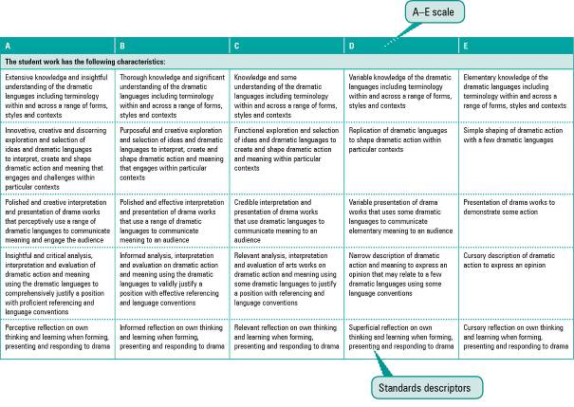

Assessment techniques and instruments
Each Year 10 learning area describes assessment techniques valued in the particular learning area and its related senior subjects.
The assessment advice is for guidance only, and is provided to assist teachers to develop an effective assessment program. It does not represent a required or mandatory approach.
The advice includes details about the typical formats of the assessment instruments and suggests conditions for implementing particular instruments in Year 10.
Teachers can use this information to develop assessment programs that:
- assist students to develop familiarity with the assessment in Years 11–12
- provide students with feedback on their learning
- provide evidence of student achievement.
Diagram 2 shows a typical assessment technique description.
Diagram 2: Sample assessment technique description
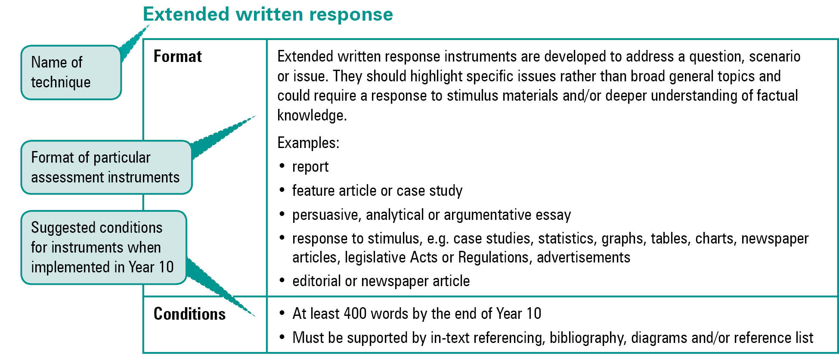
Quality assessment instruments have the following characteristics:
instrument descriptions
instrument-specific criteria sheets / guide to making judgments
instrument conditions.

Instrument descriptions
Instrument descriptions provide succinct and easily understood directions of what students must do.

Instrument-specific criteria sheets / guides to making judgments
Instrument-specific criteria sheets / guides to making judgments are developed from the Standards descriptors and provided to students before they respond to an assessment instrument, preferably at the beginning of a unit of work. These will help students understand the qualities the teacher will be looking for in their responses to the assessment instruments. Schools should note that not all aspects of knowledge and understanding and ways of working will be assessed in any one task. Aspects must be selected according to instrument demands.
Criteria sheets / guides to making judgments provide:
- descriptions of the qualities of student work in each of the selected aspects of knowledge and understanding and ways of working across A–E standards
- instrument-specific information on which teachers’ judgment will be based.

Instrument conditions
To develop assessment instruments that are realistic and achievable for students, teachers should give careful consideration to instrument conditions. All aspects of instrument conditions and demands need to be considered when making judgments about the student work.
Instrument conditions need to be stipulated on each instrument sheet, and detail:
- time and length requirements including:
- word length (written) or time length (spoken/signed)
- amount of time for the instrument (exam/test)
- notice of instrument (e.g. three weeks notice)
- amount of time for drafting or rehearsing
- access to resources, and any conditions which influence the access to material and human resources (e.g. seen or unseen question)
- drafting and/or rehearsing information
- details of scaffolding.

Assessment judgments and determining an overall result
Teachers make judgments about student work on individual assessment instruments, as well as making an overall judgment about a collection of student work (a folio).
The standard awarded for either an individual assessment instrument or a folio of work is an on-balance judgment about how the qualities of the student’s work match the typical Standards outlined in the learning area.
It is not necessary for a student to have met every descriptor for a particular standard in knowledge and understanding and ways of working to be awarded that standard.
Schools, in constructing their courses of study, decide which aspects of knowledge and understanding and ways of working will be covered and which ones may be reported on.
By using the Standards, schools will be able to report about student achievement in knowledge and understanding and ways of working. Schools will also be able to report on the overall standard for the course of study.
Recording student results for knowledge and understanding and ways of working for each assessment instrument on a student profile will help teachers in keeping records of student achievement.

Resources
Three useful references for developing quality assessment are:
- Learning P–12, QSA 2009, accessed 10 Jun 2009,
<www.qsa.qld.edu.au> (select Learning P–12 > Learning P–12).
Describes the relationships between the various syllabuses and guidelines produced by the QSA for the Preparatory Year through to Year 12.
- P–12 Assessment Policy, QSA 2009, accessed 10 Jun 2009, <www.qsa.qld.edu.au> (select Assessment > Overview > P–12 assessment policy).
Assessment in Year 10 should be guided by the principles of assessment described in this policy.
- Guidelines for Assessment Quality and Equity, Australian Curriculum, Assessment and Certification Authorities (ACACA) 1995, accessed10 Jun 2009, <http://acaca.bos.nsw.edu.au> (select ACACA documents > Guidelines for Assessment Quality and Equity.
Describes the characteristics of quality assessment instruments.

Technology learning area

Rationale
People in all cultures and contexts are affected by the pervasiveness, impact and opportunities of technological change and development. Technology education plays a vital role in preparing students to appropriately respond to technical advances and to shape technological futures. It provides the means to extend human capabilities to solve problems and to improve the human condition.
Technology is a broad field of study that draws from a range of disciplines and community activities including engineering, manufacturing, hospitality, and information and communication. Technology is used to design products, processes and services to meet human needs and wants, capitalise on opportunities and extend human capabilities. Technological products, processes and services have impacts and consequences on individuals, local and global communities, and environments.
The purpose of technology education in schools is to enable students to use technology successfully, responsibly and creatively. By working technologically, students develop knowledge and understanding and ways of working to expand their capabilities as confident, critical and creative designers and users of technology.
Students are challenged to extend their technological literacy when they:
- design technology solutions (products, processes and services)
- use resources (information, materials and systems)
- manage technological processes (efficiently, appropriately and safely)
- evaluate the appropriateness of solutions (aesthetic, cultural, economic, environmental, ethical, functional and social).
Year 10 learning activities and assessment should be accessible and meaningful, with students given opportunities to design, develop and use technologies, depending on their needs, interests, abilities, circumstances, learning styles and prior experiences.
Technology learners moving beyond the Year 9 Essential Learnings are developing their ability to:
- identify and analyse scenarios, developing solutions to increasingly open-ended design challenges
- use their increasing understanding of the impacts of technology to move beyond individual concerns to wider contexts of local and global communities and environments
- apply increasing dexterity to a wider range of tools and processes; finer degrees of measurement and device control are employed, with products that demonstrate increasing competence in technology skills and decision making
- refine team and individual work practices
- communicate design ideas and solutions concisely and effectively
- evaluate and reflect on the appropriateness of technological solutions.
Year 10 can mark the end of technology education for some students and the beginning of a particular pathway in such learning for others. The Year 10 Technology learning statements provide a foundation for senior subjects and round-off a general technology education.
Students will see that technology is the basis of many rewarding careers. Connections between differing disciplines of Technology facilitate links to specialist areas of study in the senior phase of learning, as outlined in Diagram 3 on page 10.
Diagram 3: Technology pathways
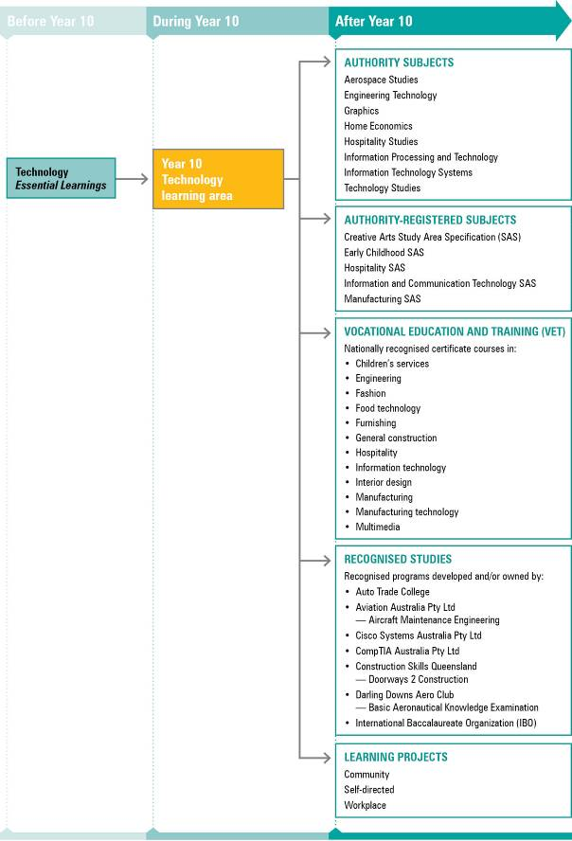
NOTE: For a full and current list of subjects, courses, and recognised studies visit the QSA website <www.qsa.qld.edu.au>.

Learning statements
The Year 10 Technology learning statements draw on the Year 9 Essential Learnings but increase their scope and depth. The learning statements comprise ways of working and knowledge and understanding.
The ways of working are based on the processes of technological literacy and the important skills required for working technologically.
Students build knowledge and understanding that enables them to develop solutions to design challenges by applying their knowledge of resources, and of relevant techniques and tools, with appropriate consideration of the impacts and consequences of their solutions. The knowledge and understanding component of Year 10 Technology is structured around three organisers:
- products, processes and services
- techniques and tools
- impacts and consequences.

Ways of working
Students are able to:
- investigate and analyse products, processes or services in response to design challenges or problems
- design solutions to challenges or problems, considering appropriateness, purpose and constraints, including budgets and timelines
- develop and use production plans to manage and refine procedures, using suitable techniques and tools, to make quality-controlled products, processes or services
- use safe and ethical practices relevant to specific contexts
- create products, processes or services to meet challenges or problems by manipulating or processing resources (information, materials and systems)
- communicate design solutions in response to challenges or problems using suitable modes and genres for presenting technical ideas and design concepts for a given audience and purpose
- use evaluation throughout the design and production process to validate and refine the effectiveness of solutions to challenges or problems
- analyse and evaluate the ethics and impacts of products, processes and services on local and global communities and environments
- reflect on learning, applying new understandings of technological processes to wider contexts.

Knowledge and understanding
Students know and understand:

Products, processes and services
Individual characteristics of different technological resources (information, materials or systems) will decide how they are applied in products, processes or services that have been designed to meet a challenge.
Information takes different forms that can be collected, analysed and organised.
e.g. Numerical and graphical data can be organised into searchable databases; client surveys can be analysed to identify needs and then used to develop the design solutions.
Materials have characteristics which are compared, contrasted and selected to meet detailed specifications and production standards.
e.g. Ingredients can be selected to develop menus; fabrics or resistant materials can be selected based on the demands of specific applications.
Systems incorporate multiple processes that work together to meet challenges and can be managed with tools.
e.g. Flowcharts, models, networks, manufacturing processes, project plans or digital control systems.

Techniques and tools
Techniques and tools are selected to manipulate resources to meet detailed specifications and predetermined standards, and their characteristics inform the selection for specific tasks.
Practical experiences with techniques and tools provide opportunities to develop skills.
e.g. Techniques and tools such as manufacturing systems, machine interfaces, food and textiles, manufacturing materials and systems, graphical information.
Safe practices are part of the control and management process.
e.g. A manufacturing plant has strategies to control risks and hazards, industry requirements, codes of practice, policies and procedures.
Design ideas are represented by specialist forms of technical communication.
e.g. Appropriate terminology, language, formats, graphical representation, techniques and conventions.

Impacts and consequences
Decisions made about the design, development and use of technology are based on that technology’s probable impact on people, their communities and environments at local and global levels.
New products and technologies are designed and developed to meet changing needs.
e.g. Sustainable energy solutions, mobile communication applications, disaster response systems, inductive cooking.
Impacts and consequences of products, processes and services include aesthetic, cultural, economic, environmental, ethical, functional and social factors.
e.g. Benefits, risks and ethics associated with ICTs (identity theft, privacy); use of sustainable wood products; energy-efficient systems; genetically modified products; recycled and reused materials.

Standards: Technology
A | B | C | D | E
The student work has the following characteristics:
Effective, discriminating application of knowledge of products, processes and services | Use of a comprehensive knowledge of products, processes and services | Use of knowledge of products, processes and services | Recall of basic knowledge of products, processes and services | Recall of basic facts
Precise and effective application of appropriate techniques and tools | Effective application of appropriate techniques and tools | Application of appropriate techniques and tools | Application of techniques and tools | Identification of techniques and tools
Insightful responses to impacts and consequences of decisions | Detailed responses to impacts and consequences of decisions | Responses to impacts and consequences of decisions | Identification of impacts and consequences of decisions | Recognition of contexts for decisions
Discerning interpretation and analysis of information and evidence related to design challenges | Interpretation of information and evidence related to design challenges | Relevant information applied to design challenges | Information applied to designs | Collection of information
Well-reasoned, original design ideas that address all criteria of challenges | Creative, practical design ideas that address all criteria of challenges | Practical design ideas that address all criteria of challenges | Design ideas that address aspects of challenges | Partial designs related to challenges
Innovative use of appropriate modes and genres for communicating technical ideas, design concepts and solutions to design challenges | Uses appropriate modes and genres for communicating technical ideas, design concepts and solutions to design challenges | Effective communication of technical ideas, design concepts and solutions to design challenges | Communication of ideas, including technical design concepts and solutions to design challenges | Use of non-technical language in design solutions
Quality products, processes or services developed by precise and controlled implementation of production processes | Successful products, processes or services completed by controlled implementation of production processes | Completed products, processes or services complying with design briefs | Parts of products, processes or services complying with elements of design briefs | Parts of products, processes or services
Development and use of safe and ethical practices for specific tasks | Adaptation and use of safe and ethical practices for specific tasks | Consistent recall and use of safe and ethical practices | Recall and use of safe and ethical practices with some supervision | Use of safe and ethical practices with supervision
Perceptive judgments about design solutions leading to refinement of products, processes or services | Informed judgments about design solutions leading to refinement of products, processes or services | Relevant judgments about design solutions leading to refinement of products, processes or services | Judgments about design solutions for products, processes or services | Judgments about elements of products, processes or services
Critical reflection in all stages of design process, verifying the validity and appropriateness of decisions and relating to wider contexts | Critical reflection in all stages of design process to verify the validity and appropriateness of decisions | Reflection in stages of the design process to validate decisions | Reflections identifying design decisions | Reflections focusing on products

Assessment

Planning an assessment program
Schools should refer to Using the Year 10 learning areas: assessment advice on page 5 when planning an assessment program. For Technology, the assessment program should include a range and balance of assessment types providing opportunities for students to demonstrate their learning across:
- the Standards
- types of assessment
- a range of assessment conditions
- problem-based learning.

Assessment techniques and instruments
The following advice has been designed to help schools use the Year 10 Technology learning area to build student learning towards assessment techniques that are valued in senior technology subjects.
Assessment of Technology in Year 10 involves students working on authentic, problem-solving situations, so assessment techniques focus on generating evidence by documenting these processes. The investigative analysis technique is included to prepare students for the increasing demands for higher-order thinking and communication in senior syllabuses.
Appropriate support (e.g. scribing, oral responses) should be provided so that literacy demands do not compromise students’ ability to demonstrate their Technology learning.
Project folios
Format | Project folios consist of projects documentation and may include these items:  • design briefs, design ideas, concept maps, management plans, working notes and sketches, procedures, data collection and analyses, test or survey results  • product development, construction, models and prototypes, trade displays, software development  • a diary or journal of relevant, significant tasks carried out by the student; documentation of planning, justifying, managing and evaluating; evidence of decision- making processes, group consultations, interactions with clients  • peer and self-reflection, including feedback from small or large group discussions or responses to evaluation questions.
Conditions | Class time and student time used.  Ongoing documentation.  Multimodal presentations:  • written  • using ICTs, including visual representation of designs (storyboarding, navigation charts, splash pages etc.); project management processes (e.g. Gantt chart, cost analysis); multimedia/oral presentation (e.g. a client proposal or product marketing presentation).  Individual and group work.
Investigative analyses
Format | Research assignments, reports or system evaluations that:  • use information to establish cause and effect, compare or contrast, indicate consequences or relationships  • modify or transform information from one form to another  • draw a conclusion based on information or data  • make and support a recommendation or propose action based on information or data  • analyse sustainable practice, ethical principles and their impacts on society, culture, the economy, and the environment  • consider appropriateness based on purpose and constraints.
Conditions | - Assignment or report  - Test based on an unseen question completed under supervised examination conditions  - 400–500 words

Course advice

Planning a course of study
The development of a course of study is a school-based decision. A school may decide to use all or part of the information contained in this learning area to construct a course of study. The Guidelines may be used to plan:
- the final year of a Years 8–10 Technology course
- part of a specialised Years 9–10 or Year 10 Technology course
- an integrated multidisciplinary or transdisciplinary course of study that combines learning statements from other learning areas
- term- or semester-length units of work
- the first year of a three-year senior course of study.

Considerations for planning courses of study in Year 10 Technology
Courses in Technology should include:
- ways of working and knowledge and understanding relevant to the context of the unit of study
- knowledge and understanding from all three organisers: Products, processes and services, Tools and techniques, and Impacts and consequences.

Examples of courses of study
Diagram 4 on page 16 describes examples of ways to plan and package courses of study using the Year 10 Technology learning statements. These examples do not preclude other ways of planning and packaging the learning statements. The examples are described as:
- units — referring to term- or semester-length units planned around a particular topic or theme (contexts)
- courses — referring to a series of units over a year planned around a particular school subject.
Diagram 4: Planning a Year 10 Technology course of study
