Science
Learning area

This document has been generated from the PDF version to support teachers.
The PDF version is the official publication.
First edition released January 2009
Science learning area extract from second edition June 2009
© The State of Queensland (Queensland Studies Authority) 2009
Ground floor, 295 Ann Street Brisbane
PO Box 307 Spring Hill Queensland 4004 Australia
Phone: +61 7 3864 0299
Fax: +61 7 3221 2553
Email: office@qsa.qld.edu.au
Website: www.qsa.qld.edu.au
NOTE: This publication contains images that may cause distress to Indigenous Australians.

Special notes on terminology:
• When The Arts is referred to as a subject or key learning area, both words are capitalised. However, when the arts are referred to in a generic way, this is presented in lower case.
• Standards, as part of the terminology of the Year 10 Guidelines and the Essential Learnings,
is presented with an initial capital letter. However, standards in the generic sense is always lower case.

Organisation of the Year 10 learning areas
Each learning area is organised in the same way and includes a rationale, learning statements, Standards, and advice about assessment and planning courses of study. The advice can be used by teachers to guide their planning to best meet the learning needs of their students, using contexts that are relevant.

Rationale
Each learning area begins with a rationale that describes:
the discipline or the field of study on which the learning area is based
the school subject or subjects that are drawn from the learning area
the nature of Year 10 learners and learning in the learning area.
The rationale also features a pathways diagram that shows how the Year 10 learning area transitions from the Years 1–9 Essential Learnings and is the foundation for the pathways available in the senior phase of learning.

Learning statements
The learning statements identify what is important for students to be taught and what is important for students to learn. The learning statements continue the use of the terms used in the Years 1–9 Essential Learnings and Standards.

Knowledge and understanding
Knowledge and understanding describes concepts, facts and procedures of the learning area. These are presented under organisers that relate to the broad conceptual categories that are the focus of the learning area. In some Year 10 learning areas these organisers are identical to the Years 1–9 key learning area (KLA) organisers, while others use organisers that have greater similarity to the senior syllabuses.

Ways of working
The ways of working identify the processes associated with the particular learning area. These processes emphasise the higher-order thinking skills that support the development of deep understandings in Years 1–9 and have close connections to the processes described in the KLAs. The Year 10 learning area ways of working are at the same time more specific to the Years 11–12 syllabuses. For example, the broad social and environmental inquiry processes of the Years 1–9 Studies of Society and Environment (SOSE) KLA develop into the historical inquiry process in Year 10 History.

Standards
The Standards for each Year 10 learning area describe the expected qualities of a collection of student work on an A–E scale. The Standards descriptors are linked to the learning statements.
The Standards in Year 10 draw on the standards frameworks from Years 1–9 and Years 11–12 and relate both to the assessable elements of the Essential Learnings and the dimensions of the Years 11–12 syllabuses. Schools should use the Standards to:
make judgments about a collection of student work
develop criteria sheets / guides to making judgments to suit their course structure and individual assessment techniques.

Assessment
Year 10 learning areas include advice about planning a school-based assessment program and information about important assessment techniques for each learning area.
The specific guidance about assessment in the particular learning area includes assessment techniques, and the formats and conditions appropriate for developing assessment instruments.
This advice will assist transition to the assessment demands of specific Years 11–12 syllabuses and the senior phase of learning generally.

Course advice
Information about planning courses of study is provided for each Year 10 learning area. Examples of ways to plan using the Year 10 learning statements are described as:
- units — referring to term- or semester-length units planned around a particular topic or theme (contexts)
- courses — referring to a series of units over a year planned around a particular school subject.

Using the Year 10 learning areas: planning courses of study
Curriculum planning is a school-based decision. Schools may choose to use all or part of the information contained in the Guidelines, or use all or part of individual Year 10 learning areas to construct units or courses of study.
The Guidelines include five broad options for planning courses of study using the Year 10 learning areas:
- units
- Year 10 courses
- Years 9–10 or Years 8–10 courses
- Years 10–12 courses
- integrated multidisciplinary or transdisciplinary courses.

Units
Term- or semester-length units can be planned from a selection of the learning statements. Units could serve as an introduction to a particular learning area or specific subject in Years 11–12. Schools may use units as a marketing tool to “sell” specific Years 11–12 subjects.

Year 10 courses
Stand-alone single-year courses in Year 10 can be developed around the learning statements of a single Year 10 learning area or across one or more learning areas. For example, Year 10 Geography would be planned from the Year 10 Geography learning statements, whereas Year 10 Home Economics would be planned from Year 10 Technology and Year 10 Health and Physical Education.

Years 9–10 or Years 8–10 courses
Two- and three-year courses across Years 9–10 or Years 8–10 can be developed from the learning statements of Year 10 learning areas and Years 1–9 Essential Learnings. For example, The Arts subjects in lower secondary could be developed from the specific organisers in the Years 1–9 Essential Learnings and the Year 10 learning area to create courses in Visual Art, Drama, Dance, Music and Media.
Structuring curriculum as Years 9–10 or Years 8–10 courses builds on the current practice of a large number of Queensland secondary schools. Many schools offer lower secondary courses of study using the key learning areas shaped as specific school subjects.
Traditionally, these courses have provided some degree of transition to senior subjects and have provided a “sampler” to help students make an informed decision when choosing senior subjects. Using the learning statements from the Year 10 Guidelines will further strengthen this approach.

Years 10–12 courses
Some schools have developed three-year courses across Years 10–12. These courses describe a coherent three-year senior phase of learning where Year 10 is a foundation year.
Years 10–12 courses can be developed using the Year 10 learning areas and the relevant senior syllabuses. For example, a three-year course in Physics would draw from the Year 10 Science learning area and the senior Physics syllabus. A three-year History course would draw from the Year 10 History learning area and either the senior Modern History or Ancient History syllabus.
Based on their learning experiences in the first year of the course, students should have options to decide to:
- continue the course in Years 11–12
- make an alternative decision within the learning area, for example, elect to do Chemistry rather than Physics or choose Ancient History rather than Modern History
- choose a different pathway, for example, choose not to participate in a senior science or history subject.

Integrated multidisciplinary or transdisciplinary courses
Integrated multidisciplinary or transdisciplinary courses are common in some school settings, particularly middle schools.
These courses can be planned from learning statements across learning areas. In many instances, an organiser that crosses the learning area is used to give coherence to the planning of these courses.

Using the Year 10 learning areas: assessment advice
Assessment is a fundamental and integral part of the teaching and learning process and must be planned and ongoing. Assessment is used to:
- promote, assist and improve learning
- substantially contribute to the construction of programs of teaching and learning
- provide information for students, teachers, parents and carers about the progress and achievements of individual students to help them achieve as well as they are able.
Assessment in Year 10 should be guided by the principles of assessment described in the QSA’s P–12 Assessment Policy. See Resources on page 8 for details.

School-based assessment
During Year 10, assessment should continue the approaches of school-based assessment begun in Years 1–9 and build towards the externally moderated system of Years 11–12. Assessment in Year 10 is:
- standards-based. The Guidelines set out content and achievement standards. The learning statements are the content standards for each Year 10 learning area. These are statements of what students are expected to know and do by the end of Year 10. The achievement standards are linked to each set of learning statements and are reference points that describe how well students have achieved the learning statements
- diagnostic. The Guidelines provide an opportunity to use assessment to determine the nature of students’ learning difficulties as a basis for providing feedback or intervention
- formative. The main focus of assessment in Year 10 is on improving student learning to assist their transition to the senior phase of learning
- summative. Assessment in Year 10 can indicate standards achieved at particular points for reporting purposes.
Year 10 assessment is an opportunity for schools and teachers to develop students’ assessment literacy or familiarity with the processes and practices used in the senior syllabuses.
To develop assessment literacy for Years 11–12, a Year 10 assessment program should introduce and apply important ideas about school-based assessment from the principles of exit assessment in the senior syllabuses. These principles are:
- continuous assessment, or gathering information on student achievement over a course of study, using assessment instruments administered at suitable intervals
- balance of assessment, or making judgments about students’ achievements using a variety of assessment techniques and a range of assessment conditions over the course of study
- fullest and latest information, or making judgments about student achievement based on information gathered from the range of learning statements and from the most recent assessment of achievement.
Each Year 10 learning area provides assessment advice about Standards and assessment techniques and instruments.

Standards
Each learning area has a set of broad standards expressed as descriptors of quality on an A–E scale. The Standards are linked to the learning statements.
Diagram 1 shows a typical Standards table.

Diagram 1: Sample Standards table (The Arts — Drama)
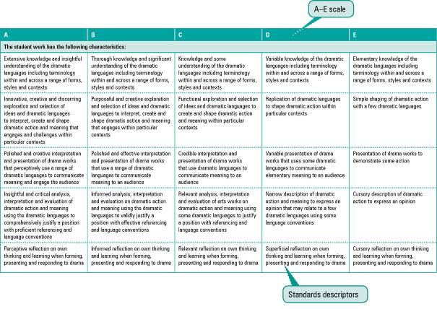

Assessment techniques and instruments
Each Year 10 learning area describes assessment techniques valued in the particular learning area and its related senior subjects.
The assessment advice is for guidance only, and is provided to assist teachers to develop an effective assessment program. It does not represent a required or mandatory approach.
The advice includes details about the typical formats of the assessment instruments and suggests conditions for implementing particular instruments in Year 10.
Teachers can use this information to develop assessment programs that:
- assist students to develop familiarity with the assessment in Years 11–12
- provide students with feedback on their learning
- provide evidence of student achievement.
Diagram 2 shows a typical assessment technique description.
Diagram 2: Sample assessment technique description
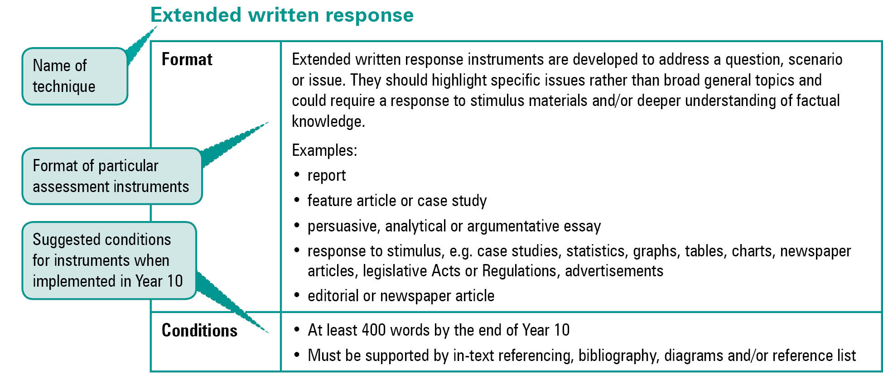
Quality assessment instruments have the following characteristics:
instrument descriptions
instrument-specific criteria sheets / guide to making judgments
instrument conditions.

Instrument descriptions
Instrument descriptions provide succinct and easily understood directions of what students must do.

Instrument-specific criteria sheets / guides to making judgments
Instrument-specific criteria sheets / guides to making judgments are developed from the Standards descriptors and provided to students before they respond to an assessment instrument, preferably at the beginning of a unit of work. These will help students understand the qualities the teacher will be looking for in their responses to the assessment instruments. Schools should note that not all aspects of knowledge and understanding and ways of working will be assessed in any one task. Aspects must be selected according to instrument demands.
Criteria sheets / guides to making judgments provide:
- descriptions of the qualities of student work in each of the selected aspects of knowledge and understanding and ways of working across A–E standards
- instrument-specific information on which teachers’ judgment will be based.

Instrument conditions
To develop assessment instruments that are realistic and achievable for students, teachers should give careful consideration to instrument conditions. All aspects of instrument conditions and demands need to be considered when making judgments about the student work.
Instrument conditions need to be stipulated on each instrument sheet, and detail:
- time and length requirements including:
- word length (written) or time length (spoken/signed)
- amount of time for the instrument (exam/test)
- notice of instrument (e.g. three weeks notice)
- amount of time for drafting or rehearsing
- access to resources, and any conditions which influence the access to material and human resources (e.g. seen or unseen question)
- drafting and/or rehearsing information
- details of scaffolding.

Assessment judgments and determining an overall result
Teachers make judgments about student work on individual assessment instruments, as well as making an overall judgment about a collection of student work (a folio).
The standard awarded for either an individual assessment instrument or a folio of work is an on-balance judgment about how the qualities of the student’s work match the typical Standards outlined in the learning area.
It is not necessary for a student to have met every descriptor for a particular standard in knowledge and understanding and ways of working to be awarded that standard.
Schools, in constructing their courses of study, decide which aspects of knowledge and understanding and ways of working will be covered and which ones may be reported on.
By using the Standards, schools will be able to report about student achievement in knowledge and understanding and ways of working. Schools will also be able to report on the overall standard for the course of study.
Recording student results for knowledge and understanding and ways of working for each assessment instrument on a student profile will help teachers in keeping records of student achievement.

Resources
Three useful references for developing quality assessment are:
- Learning P–12, QSA 2009, accessed 10 Jun 2009,
<www.qsa.qld.edu.au> (select Learning P–12 > Learning P–12).
Describes the relationships between the various syllabuses and guidelines produced by the QSA for the Preparatory Year through to Year 12.
- P–12 Assessment Policy, QSA 2009, accessed 10 Jun 2009, <www.qsa.qld.edu.au> (select Assessment > Overview > P–12 assessment policy).
Assessment in Year 10 should be guided by the principles of assessment described in this policy.
- Guidelines for Assessment Quality and Equity, Australian Curriculum, Assessment and Certification Authorities (ACACA) 1995, accessed10 Jun 2009, <http://acaca.bos.nsw.edu.au> (select ACACA documents > Guidelines for Assessment Quality and Equity.
Describes the characteristics of quality assessment instruments.

Science learning area

Rationale
Science is a dynamic, collaborative and future-thinking field of human endeavour that has emerged through a need to understand natural phenomena. Scientific understandings are constructed using theories, laws, models and concepts — they are open to questioning and are developed and modified over time. The discipline of science employs methods for observing the world, making predictions and testing hypotheses. It values ethical inquiry and a respect for evidence. Science contributes to the development of a sense of wonder and engagement with the natural world.
Science as a school subject is practical, with experiments and hands-on investigations at its heart. Practical activities engage students, producing excitement and curiosity. Investigations develop a deeper understanding of the nature of science and of a particular topic or context. They foster problem-solving skills that are transferable to new situations.
Science learning in Year 10 continues the development of scientifically literate individuals who:
- are able to connect scientific knowledge to everyday life and the world around them
- are interested in and can talk meaningfully about science
- can identify scientific questions, and investigate and draw evidence-based conclusions
- are sceptical and questioning of claims made by others
- can make informed decisions about the environment and their own health and wellbeing.
Year 10 students are able to ask increasingly sophisticated questions about new ideas and information. Science learning in Year 10 supports and focuses this. It encourages inquiry and develops critical thinking skills through the application of scepticism — evaluating beliefs using scientific reasoning and an enhanced understanding of the natural and physical world. Students should:
- ask for evidence to support a claim before accepting it as reasonable
- admit to being uncertain when evidence is lacking
- reject a claim as unreasonable when evidence does not support it.
Year 10 is the end of a general science education for some students and the initial stages of a particular direction in science for others. The Year 10 Science learning statements link the Science Essential Learnings to the senior sciences and round-off a general science education. These pathways are shown in Diagram 3 on page 10.
Diagram 3: Science pathways
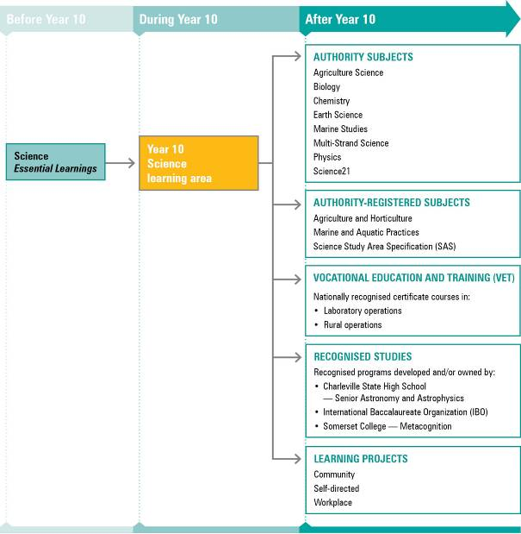
NOTE: For a full and current list of subjects, courses, and recognised studies visit the QSA website <www.qsa.qld.edu.au>.

Learning statements
Year 10 Science learning statements comprise ways of working and knowledge and understanding. These statements use the Essential Learnings framework but increase in scope and depth. The ways of working identify the processes and higher-order thinking that support the development of scientific literacy and a deeper understanding of scientific concepts and theories.
The knowledge and understanding learning statements describe interrelated and multidisciplinary concepts, facts and procedures, and are structured around five organisers:
- science as a human endeavour
- earth and beyond
- energy and change
- life and living
- natural and processed materials.

Ways of working
Students are able to:
- formulate research questions and/or testable hypotheses by identifying problems and issues that form the basis of justified scientific investigation
- design and carry out replicable investigations guided by scientific concepts and theories, using valid scientific methods and techniques
- assess and manage risk, and select and safely use appropriate scientific equipment and technologies to enhance the reliability, accuracy and precision of data
- analyse and interpret data, information and evidence by identifying trends, anomalies and relationships based on scientific concepts and theories, using qualitative and quantitative techniques
- evaluate data, information and evidence using qualitative and quantitative techniques, such as identifying sources of error and checking against scientific concepts and theories, to make a judgment regarding its reliability
- draw well-reasoned and justified conclusions that respond to scientific questions, only making claims that fit with data, information and evidence
- reflect on different perspectives, and evaluate historical and cultural influences that shape scientific knowledge and applications
- reflect on learning, apply new understandings to novel or new situations, and justify future applications
- organise information to convey meaning using scientific convention, terminology and argument, acknowledging sources appropriately and adhering to language conventions, in a variety of formats.

Knowledge and understanding
Students know and understand:

Science as a human endeavour
The nature of science is dynamic, creative and collaborative; it is socially and culturally embedded and is distinguished by openness to new ideas that are appraised against testable evidence and accepted views.
Science is a way of thinking that tries to answer questions about the way the universe operates by constructing increasingly predictive and testable theories (coherent sets of claims, concepts and laws) based on observation and evidence.
e.g. Views of the structure and age of the universe changed in light of scientific and technological advances that led to new evidence; atomic models changed over time in light of new evidence and the reinterpretation of existing evidence.
Many people (and their investigations) have contributed to the development of science and new scientific theories through open-minded and creative inquiry, and well-articulated and reasoned evidence, building a body of collaborative knowledge over time.
e.g. Florence Nightingale pioneered the use of statistical graphics in healthcare, which is now an essential tool of science-based medicine and epidemiology; Sir Isaac Newton’s insights into the connection between movement and force was built on the work of Galileo and led to our current understanding of how matter interacts.
Science provides useful knowledge which forms the basis of modern technological products and practices, and is the foundation of many rewarding careers.
e.g. Understanding the behaviour of electricity and magnetism is the basis of all communications technology; careers from agriculture to zoology are underpinned by a knowledge of science.
Personal and public policy decisions and priorities occur within particular ethical and social frameworks and they should be strongly influenced by scientific evidence.
e.g. The use of recycled water is one strategy to increase water security; bioethics studies the implications of, and helps develop policies about, advances in medicine and biological technologies.

Earth and beyond
Scientific understanding can be used to model the past and predict the future of the Earth and the universe.
Increasingly accurate models of the structure of Earth and the universe, based on scientific observations, ideas and theories, offer explanations for past events and provide predictions for the future.
e.g. Cosmic background radiation and red-shift provide two significant lines of evidence for the big bang; evidence from geology, seismology and astrophysics gives a clear picture of the age, structure and formation of Earth and the solar system.
Geological and cosmic processes have led to the development of a planet on which life can survive, and evidence of this can be interpreted and modelled to provide information about past and present events and make predictions.
e.g. Earth’s surface is shaped by volcanoes and earthquakes, which can be understood in terms of plate tectonics; Earth has liquid water and a suitable mean temperature for life, due to its distance from and the size of the star it orbits.
Patterns of change on Earth affect the environment (from local to global), are affected by humans and can be understood in terms of the interaction between various dynamic systems and natural cycles.
e.g. Anthropogenic climate change affects natural environments; a decline in catchments’ water quality has a significant negative impact on the Great Barrier Reef; knowledge of tides allowed Indigenous people to build fish traps.
All living things on Earth depend on its natural resources for clean air, water and food, and humans use vast quantities of natural resources for manufacturing, housing and transport.
e.g. Fossil fuels such as oil and other raw materials are used in the manufacture of almost every conceivable product; a primary cause in the decline of koala numbers is habitat destruction.

Energy and change
The interactions of objects can be qualitatively and quantitatively described and analysed, by identifying the relevant forces and energy transfers and transformations.
Newton’s laws of motion describe the result of forces acting on an object and can be analysed using vectors.
e.g. A car going around a corner is accelerating; the forces acting on an object on an inclined plane can be analysed using a free body force diagram; a woomera is a lever that increases the speed and distance a spear is thrown.
The motion of an object can be analysed using vectors, algebra and graphs.
e.g. Displacement-time and velocity-time graphs provide information about an object’s motion; there are useful mathematical relationships to approximate an object’s motion, such as:
Energy takes different forms, and the transfer and transformation of energy can be analysed qualitatively and quantitatively.
e.g. Particle theory explains heat transfer and electrical resistance; electromagnetic waves can be reflected, refracted and diffracted; there are useful mathematical relationships that can approximate energy transfers and transformations, such as:
The transfer and transformation of energy does not change the total energy in a closed system but it does reduce the useful energy available.
e.g. The electrical energy in a complete closed-circuit loop is conserved; the efficiency of an energy transfer or transformation is given by:
efficiency = useful energy output/total energy input x 100%
There are different ways of using energy and these have different social consequences and applications.
e.g. Electronics and communications technology have revolutionised how humans live, work and interact with each other; energy can be obtained from a variety of sources, such as solar power, nuclear power, coal power, hydro-electric power and biofuels.

Life and living
Organisms have evolved complex structures and mechanisms that allow them to interact within and across each level of biological organisation.
Biological systems have interrelated and interdependent structures and functions that enable them to maintain a dynamic equilibrium.
e.g. Organelles, cells, tissues and organs of a system have structures which underpin their function and are coordinated with other systems to maintain homeostasis; mangrove ecosystem stability is maintained by the interrelated systems that depend on and respond to tides.
There are mechanisms by which characteristics of individuals are passed on from one generation to the next and understanding this has led to the ability to influence reproduction and inheritance.
e.g. Genes are sections of DNA whose inheritance and expression can be analysed and predicted across generations; reproductive products, artificial selection and genetic technologies have led to an unprecedented ability to plan and manipulate reproduction.
Organisms have evolved specific structural, physiological and behavioural adaptations that allow them to interact with each other and their surroundings in order to obtain their needs.
e.g. Vestigial wings that act as flippers for swimming are one structural adaptation of penguins; Australian hammer-orchid flowers mimic female thynnid wasps and entice male wasps to visit them, resulting in the transfer of pollen from flower to flower.
Various mechanism of evolution act on gene pools and over time this leads to changes in populations.
e.g. Changes in populations can be mathematically modelled and represented graphically; antibiotics provide a selection pressure that leads to bacterial resistance.
Systematic observation establishes the contemporary relationships of organisms to their environment, community and each other, and historical relationships to their ancestors.
e.g. The flow of matter and energy through an ecosystem can be modelled with a food web; the accumulation of evidence from various lines of scientific inquiry supports the existence of a common ancestor for distinct species such as humans, chimpanzees and orangutans.
Natural events and human activities can have immediate and/or long-term effects on biological systems at all organisational levels, resulting in consequences that may be predicted and managed.
e.g. The HPV vaccine provides immunity against species of human papillomavirus associated with cervical cancer; an environmental impact study assesses the potential effect of a new development on a local environment.

Natural and processed materials
Materials have been classified by observation of their patterns of interactions with other materials, their physical properties and their structure.
The behaviour and structure of matter at sub-atomic, atomic and molecular levels is explained by the interactions of particles and the electrostatic forces between them.
e.g. An atom can form ionic and/or covalent bonds depending on its electron configuration; atoms can bond with other atoms to form molecules or lattices; the macroscopic properties of materials (such as density, air pressure, melting and boiling points) are explained using the particle model (kinetic theory).
Materials can be named, classified and represented symbolically based on their interactions with other materials and their structure.
e.g. The periodic table is organised into groups and periods, and elements within a group have similar chemical properties (such as alkaline earth metals); CO₂ represents a molecule of the compound carbon dioxide and Al₂O₃ represents the ionic compound aluminium oxide.
Chemical reactions can be classified by specific criteria and must be balanced when represented symbolically because they obey the law of conservation of mass.
e.g. HCl_{(aq)} + CaCO_{3(s)} CaCl_{2(aq)} + H₂O_{(l)} +CO_{2(g)} is an acid-carbonate reaction that is represented in the general form acid + carbonate salt + water + carbon dioxide; BaCl_{2(aq)} + K₂CO_{3(aq)} BaCO_{3(s)} + 2KCl_{(aq)} is a double replacement / precipitation reaction that is represented in the general form:
AY_{(aq)} + BZ_{(aq)} AZ_{(s)} + BY_{(aq)}
Chemical reactions underpin biological processes and have effects on the environment.
e.g. Sulfur dioxide reacts with moisture in the air to form the sulfuric acid in acid rain; Aerobic respiration is the chemical process in cells by which oxygen releases energy from glucose; The enzyme amylase begins the chemical process of digestion by breaking starch down into glucose.
Chemical and physical processes and techniques are used in identification and production of materials.
e.g. Mixtures can be separated using chromatography; steel is made through the extraction, separation and synthesis of iron and carbon; ochre, the coloured pigment used by Indigenous artists, is coloured by iron oxide (Fe₂O₃) and is made by grinding rock into powder and mixing it with a fluid.

Standards: Science (table continues over the page)
A | B | C | D | E
The student work has the following characteristics:
Comprehensive reproduction and explanation of a range of concepts, facts, principles, theories and procedures | Substantial reproduction and explanation of a range concepts, facts, principles, theories and procedures | Reproduction of a range of concepts, facts, principles, theories and procedures | Statements of simple concepts, facts, principles, theories and procedures | Statements of isolated facts and procedures
Linking and application of concepts, facts, principles, theories and procedures to find solutions in multistep, familiar and unfamiliar situations | Application of concepts, facts, principles, theories and procedures to find solutions in multistep and familiar situations | Application of concepts, facts, principles, theories and procedures to find solutions in simple and familiar situations | Application of facts and procedures in familiar situations | Application of some facts and procedures in very familiar situations
Logical and clear research questions and/or testable hypotheses formulated by identifying problems and issues that form the basis of justified scientific investigations | Research questions and/or testable hypotheses formulated by identifying problems and issues that form the basis of justified scientific investigations | Research questions and/or testable hypotheses that form the basis of scientific investigations | Investigation of given research questions and/or testable hypotheses | Attempted investigation of given research questions and/or testable hypotheses
Clearly outlined, valid investigations that identify and take into account relevant variables, guided by scientific concepts and theories | Valid investigations that identify variables, guided by scientific concepts and theories | Investigations that are guided by scientific concepts and theories | Implementation of given investigations | Attempted implementation of given investigations
Assessment and management of risk; safe selection and adaptation of equipment and appropriate use of technology to enhance the reliability of data | Assessment and management of risk; safe selection of equipment and appropriate use of technology to gather reliable data | Assessment and management of risk; safe selection of equipment and use of technology to gather data | Safe selection of equipment and use of technology to gather data | Guided selection of equipment and use of technology to gather limited data
Systematic analysis and interpretation of valid primary and/or secondary data, information and evidence to identify trends, anomalies and relationships, linked to scientific concepts and theories | Analysis of valid primary and/or secondary data, information and evidence to identify obvious trends, anomalies and relationships, linked to scientific concepts and theories | Identification of trends and anomalies in primary or secondary data, information and evidence, mainly using qualitative techniques | Identification of obvious trends and anomalies | Recorded data, information and/or evidence
Evaluation of data, information and evidence, checking against scientific concepts and theories, judging its quality and explaining possible effects of sources of error | Evaluation of data, information and evidence, discussing its quality and identifying sources of error | Discussion of the reliability of data, information and evidence, identifying some sources of error | Attempted discussion of the reliability of data, information and evidence | Isolated statements of the reliability of data, information and/or evidence

Standards: Science (continued from previous page)
A | B | C | D | E
The student work has the following characteristics:
Clear synthesis of data, information and evidence, drawing well-reasoned and justified conclusions | Synthesis of data, information and evidence, drawing reasoned and credible conclusions | Summary of data, information and evidence, drawing credible conclusions | Summary of data, information and evidence | Listing of data, information and/or evidence
Discerning reflection on learning, different perspectives and influences, future applications and investigations, linked to scientific knowledge | Informed reflection on learning, different perspectives and influences, future applications and investigations, linked to scientific knowledge | Relevant identification of the influence and application of scientific knowledge | Relevant statements about the use of scientific knowledge | Cursory and general statements about the use of scientific knowledge
Selection and organisation of relevant information in a variety of formats that clearly and concisely conveys meaning using scientific convention and terminology; acknowledges sources appropriately and consistently | Selection and organisation of relevant information in a variety of formats that conveys meaning using scientific convention and terminology; acknowledges sources appropriately | Organisation of relevant information in a variety of formats that conveys meaning using scientific terminology; acknowledging sources | Organisation of information conveys meaning | Information presented

Assessment

Planning an assessment program
Schools should refer to Using the Year 10 learning areas: assessment advice on page 5 when planning an assessment program. For Science, the assessment program should include a range and balance of assessment types providing opportunities for students to demonstrate their learning across:
- the Standards
- types of assessment
- a range of assessment conditions.

Assessment techniques and instruments
The following advice has been designed to help schools use the Year 10 Science learning area to build student learning towards assessment techniques that are valued in the senior phase of learning.
Practical investigations
Format | Practical investigations focus on planning and implementing procedures to gather and analyse primary data, information and evidence. An extended investigation develops a deeper understanding of a particular topic and the methods of science in general, and fosters problem-solving skills that are transferable to new situations. Investigations could be structured around one of more of the following techniques:  • practical reports  • field reports  • extended experimental investigations  • presentations.
Conditions | - Individually and/or in groups  - Prepared in class time and/or in the student’s own time  - Typically in written form, or a combination of written, oral and multimedia forms  - Reports: generally under 800 words  - Presentations: 3–7 minutes  - Extended experimental investigations: 1000–1500 words, to include discussion, conclusions, evaluations and/or recommendations  Note: extended experimental investigations do not need to be overly complex or unstructured. They can take a simple classroom investigation and extend it by (for example) gathering more data, testing more than one variable, or refining a procedure. The outcome of this would be a written scientific report.
Supervised assessment
Format | The supervised assessment is an instrument that is written and conducted under test/exam conditions to ensure authentication of student work. A supervised assessment could be constructed using one or more of the following four types of techniques:  • short items  • practical exercises  • paragraph responses  • responses to seen or unseen stimulus materials.
Conditions | - Test/exam conditions  - Individually and/or in groups  - Perusal time may be required  - If stimulus materials are lengthy, they may need to be shared with students before the administration of the supervised assessment
Non-experimental investigations
Format | Non-experimental investigations typically involve gathering and analysing secondary data, information and evidence to articulate a position on a scientific issue or answer a scientific question. They are ideal for developing a deeper understanding of a particular topic and skills in synthesising information. Non-experimental investigations could be structured around one of more of the following techniques:  • reports  • assignments  • articles  • presentations.
Conditions | - Individually and/or in groups  - Prepared in class time and/or in the student’s own time  - Typically in written form, or a combination of written, oral and multimedia forms  - Reports: 1000–1500 words, to include discussion, conclusions, evaluations and/or recommendations  - Assignments and articles: generally under 800 words  - Presentations: 3–7 minutes
Collection of work
Format | A series of tasks that relate to a single investigative context. The outcome of this would be a folio of work containing responses to a variety of tasks. These tasks could be structured around one or more of the following (or alternative) techniques:  • any of the supervised assessments  • partial practical reports (e.g. the discussion)  • diary and journal entries  • computer-based activities (e.g. blogs, forums, wikis, webquests)  • peer- and self-reflection.
Conditions | - Individually and/or in groups  - Prepared in class time and/or in the student’s own time  - Typically in written form, or a combination of written, oral and multimedia forms

Course advice

Planning a course of study
The development of a course of study is a school-based decision. A school may decide to use all or part of the information contained in this learning area to construct a course of study. The Guidelines may be used to plan:
- the final year of a Years 8–10 Science course
- part of a specialised Years 9–10 Science course
- an integrated multidisciplinary or transdisciplinary course of study that combines learning statements from other learning areas
- term- or semester-length units of work
- the first year of a three-year senior course of study.

Considerations for planning courses of study in Year 10 Science
Courses in Science should consider, where appropriate:
- using all the ways of working
- a range and balance of knowledge and understanding statements
- a selection of themes (broad areas of study) and a selection of inquiry topics
- a selection of subject-specific topics using relevant ways of working and knowledge and understanding.

Examples of courses of study
Diagram 4 on page 20 describes examples of ways to plan and package courses of study using the Year 10 Science learning statements. These examples do not preclude other ways of planning and packaging the learning statements. The examples are described as:
- units — referring to term- or semester-length units planned around a particular topic or theme (contexts)
- courses — referring to a series of units over a year planned around a particular school subject.
Diagram 4: Planning a Year 10 Science course of study
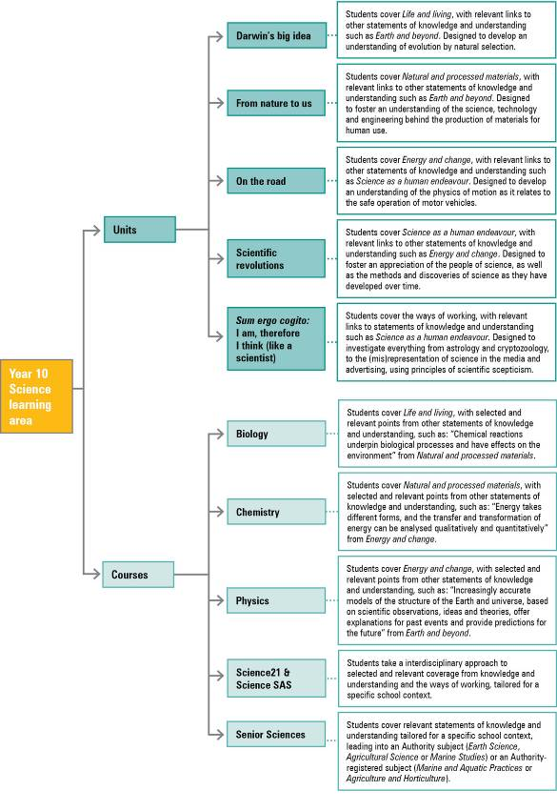

Adapted from Rennie, L 2006, “The community’s contribution to science learning: Making it count”, Proceedings of the Australian Council for Educational Research, Melbourne, p. 6.

