Mathematics
Learning area

This document has been generated from the PDF version to support teachers.
The PDF version is the official publication.
First edition released January 2009
Mathematics learning area extract from second edition June 2009
© The State of Queensland (Queensland Studies Authority) 2009
Ground floor, 295 Ann Street Brisbane
PO Box 307 Spring Hill Queensland 4004 Australia
Phone: +61 7 3864 0299
Fax: +61 7 3221 2553
Email: office@qsa.qld.edu.au
Website: www.qsa.qld.edu.au
NOTE: This publication contains images that may cause distress to Indigenous Australians.

Special notes on terminology:
• When The Arts is referred to as a subject or key learning area, both words are capitalised. However, when the arts are referred to in a generic way, this is presented in lower case.
• Standards, as part of the terminology of the Year 10 Guidelines and the Essential Learnings,
is presented with an initial capital letter. However, standards in the generic sense is always lower case.

Organisation of the Year 10 learning areas
Each learning area is organised in the same way and includes a rationale, learning statements, Standards, and advice about assessment and planning courses of study. The advice can be used by teachers to guide their planning to best meet the learning needs of their students, using contexts that are relevant.

Rationale
Each learning area begins with a rationale that describes:
the discipline or the field of study on which the learning area is based
the school subject or subjects that are drawn from the learning area
the nature of Year 10 learners and learning in the learning area.
The rationale also features a pathways diagram that shows how the Year 10 learning area transitions from the Years 1–9 Essential Learnings and is the foundation for the pathways available in the senior phase of learning.

Learning statements
The learning statements identify what is important for students to be taught and what is important for students to learn. The learning statements continue the use of the terms used in the Years 1–9 Essential Learnings and Standards.

Knowledge and understanding
Knowledge and understanding describes concepts, facts and procedures of the learning area. These are presented under organisers that relate to the broad conceptual categories that are the focus of the learning area. In some Year 10 learning areas these organisers are identical to the Years 1–9 key learning area (KLA) organisers, while others use organisers that have greater similarity to the senior syllabuses.

Ways of working
The ways of working identify the processes associated with the particular learning area. These processes emphasise the higher-order thinking skills that support the development of deep understandings in Years 1–9 and have close connections to the processes described in the KLAs. The Year 10 learning area ways of working are at the same time more specific to the Years 11–12 syllabuses. For example, the broad social and environmental inquiry processes of the Years 1–9 Studies of Society and Environment (SOSE) KLA develop into the historical inquiry process in Year 10 History.

Standards
The Standards for each Year 10 learning area describe the expected qualities of a collection of student work on an A–E scale. The Standards descriptors are linked to the learning statements.
The Standards in Year 10 draw on the standards frameworks from Years 1–9 and Years 11–12 and relate both to the assessable elements of the Essential Learnings and the dimensions of the Years 11–12 syllabuses. Schools should use the Standards to:
make judgments about a collection of student work
develop criteria sheets / guides to making judgments to suit their course structure and individual assessment techniques.

Assessment
Year 10 learning areas include advice about planning a school-based assessment program and information about important assessment techniques for each learning area.
The specific guidance about assessment in the particular learning area includes assessment techniques, and the formats and conditions appropriate for developing assessment instruments.
This advice will assist transition to the assessment demands of specific Years 11–12 syllabuses and the senior phase of learning generally.

Course advice
Information about planning courses of study is provided for each Year 10 learning area. Examples of ways to plan using the Year 10 learning statements are described as:
- units — referring to term- or semester-length units planned around a particular topic or theme (contexts)
- courses — referring to a series of units over a year planned around a particular school subject.

Using the Year 10 learning areas: planning courses of study
Curriculum planning is a school-based decision. Schools may choose to use all or part of the information contained in the Guidelines, or use all or part of individual Year 10 learning areas to construct units or courses of study.
The Guidelines include five broad options for planning courses of study using the Year 10 learning areas:
- units
- Year 10 courses
- Years 9–10 or Years 8–10 courses
- Years 10–12 courses
- integrated multidisciplinary or transdisciplinary courses.

Units
Term- or semester-length units can be planned from a selection of the learning statements. Units could serve as an introduction to a particular learning area or specific subject in Years 11–12. Schools may use units as a marketing tool to “sell” specific Years 11–12 subjects.

Year 10 courses
Stand-alone single-year courses in Year 10 can be developed around the learning statements of a single Year 10 learning area or across one or more learning areas. For example, Year 10 Geography would be planned from the Year 10 Geography learning statements, whereas Year 10 Home Economics would be planned from Year 10 Technology and Year 10 Health and Physical Education.

Years 9–10 or Years 8–10 courses
Two- and three-year courses across Years 9–10 or Years 8–10 can be developed from the learning statements of Year 10 learning areas and Years 1–9 Essential Learnings. For example, The Arts subjects in lower secondary could be developed from the specific organisers in the Years 1–9 Essential Learnings and the Year 10 learning area to create courses in Visual Art, Drama, Dance, Music and Media.
Structuring curriculum as Years 9–10 or Years 8–10 courses builds on the current practice of a large number of Queensland secondary schools. Many schools offer lower secondary courses of study using the key learning areas shaped as specific school subjects.
Traditionally, these courses have provided some degree of transition to senior subjects and have provided a “sampler” to help students make an informed decision when choosing senior subjects. Using the learning statements from the Year 10 Guidelines will further strengthen this approach.

Years 10–12 courses
Some schools have developed three-year courses across Years 10–12. These courses describe a coherent three-year senior phase of learning where Year 10 is a foundation year.
Years 10–12 courses can be developed using the Year 10 learning areas and the relevant senior syllabuses. For example, a three-year course in Physics would draw from the Year 10 Science learning area and the senior Physics syllabus. A three-year History course would draw from the Year 10 History learning area and either the senior Modern History or Ancient History syllabus.
Based on their learning experiences in the first year of the course, students should have options to decide to:
- continue the course in Years 11–12
- make an alternative decision within the learning area, for example, elect to do Chemistry rather than Physics or choose Ancient History rather than Modern History
- choose a different pathway, for example, choose not to participate in a senior science or history subject.

Integrated multidisciplinary or transdisciplinary courses
Integrated multidisciplinary or transdisciplinary courses are common in some school settings, particularly middle schools.
These courses can be planned from learning statements across learning areas. In many instances, an organiser that crosses the learning area is used to give coherence to the planning of these courses.

Using the Year 10 learning areas: assessment advice
Assessment is a fundamental and integral part of the teaching and learning process and must be planned and ongoing. Assessment is used to:
- promote, assist and improve learning
- substantially contribute to the construction of programs of teaching and learning
- provide information for students, teachers, parents and carers about the progress and achievements of individual students to help them achieve as well as they are able.
Assessment in Year 10 should be guided by the principles of assessment described in the QSA’s P–12 Assessment Policy. See Resources on page 8 for details.

School-based assessment
During Year 10, assessment should continue the approaches of school-based assessment begun in Years 1–9 and build towards the externally moderated system of Years 11–12. Assessment in Year 10 is:
- standards-based. The Guidelines set out content and achievement standards. The learning statements are the content standards for each Year 10 learning area. These are statements of what students are expected to know and do by the end of Year 10. The achievement standards are linked to each set of learning statements and are reference points that describe how well students have achieved the learning statements
- diagnostic. The Guidelines provide an opportunity to use assessment to determine the nature of students’ learning difficulties as a basis for providing feedback or intervention
- formative. The main focus of assessment in Year 10 is on improving student learning to assist their transition to the senior phase of learning
- summative. Assessment in Year 10 can indicate standards achieved at particular points for reporting purposes.
Year 10 assessment is an opportunity for schools and teachers to develop students’ assessment literacy or familiarity with the processes and practices used in the senior syllabuses.
To develop assessment literacy for Years 11–12, a Year 10 assessment program should introduce and apply important ideas about school-based assessment from the principles of exit assessment in the senior syllabuses. These principles are:
- continuous assessment, or gathering information on student achievement over a course of study, using assessment instruments administered at suitable intervals
- balance of assessment, or making judgments about students’ achievements using a variety of assessment techniques and a range of assessment conditions over the course of study
- fullest and latest information, or making judgments about student achievement based on information gathered from the range of learning statements and from the most recent assessment of achievement.
Each Year 10 learning area provides assessment advice about Standards and assessment techniques and instruments.

Standards
Each learning area has a set of broad standards expressed as descriptors of quality on an A–E scale. The Standards are linked to the learning statements.
Diagram 1 shows a typical Standards table.

Diagram 1: Sample Standards table (The Arts — Drama)
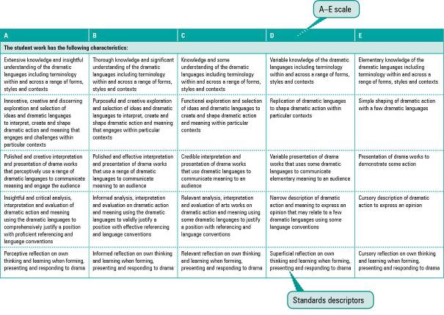

Assessment techniques and instruments
Each Year 10 learning area describes assessment techniques valued in the particular learning area and its related senior subjects.
The assessment advice is for guidance only, and is provided to assist teachers to develop an effective assessment program. It does not represent a required or mandatory approach.
The advice includes details about the typical formats of the assessment instruments and suggests conditions for implementing particular instruments in Year 10.
Teachers can use this information to develop assessment programs that:
- assist students to develop familiarity with the assessment in Years 11–12
- provide students with feedback on their learning
- provide evidence of student achievement.
Diagram 2 shows a typical assessment technique description.
Diagram 2: Sample assessment technique description
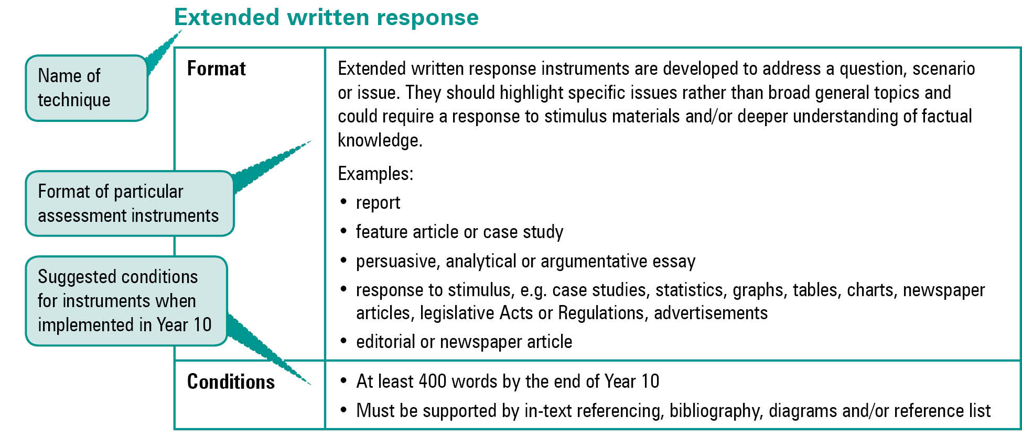
Quality assessment instruments have the following characteristics:
instrument descriptions
instrument-specific criteria sheets / guide to making judgments
instrument conditions.

Instrument descriptions
Instrument descriptions provide succinct and easily understood directions of what students must do.

Instrument-specific criteria sheets / guides to making judgments
Instrument-specific criteria sheets / guides to making judgments are developed from the Standards descriptors and provided to students before they respond to an assessment instrument, preferably at the beginning of a unit of work. These will help students understand the qualities the teacher will be looking for in their responses to the assessment instruments. Schools should note that not all aspects of knowledge and understanding and ways of working will be assessed in any one task. Aspects must be selected according to instrument demands.
Criteria sheets / guides to making judgments provide:
- descriptions of the qualities of student work in each of the selected aspects of knowledge and understanding and ways of working across A–E standards
- instrument-specific information on which teachers’ judgment will be based.

Instrument conditions
To develop assessment instruments that are realistic and achievable for students, teachers should give careful consideration to instrument conditions. All aspects of instrument conditions and demands need to be considered when making judgments about the student work.
Instrument conditions need to be stipulated on each instrument sheet, and detail:
- time and length requirements including:
- word length (written) or time length (spoken/signed)
- amount of time for the instrument (exam/test)
- notice of instrument (e.g. three weeks notice)
- amount of time for drafting or rehearsing
- access to resources, and any conditions which influence the access to material and human resources (e.g. seen or unseen question)
- drafting and/or rehearsing information
- details of scaffolding.

Assessment judgments and determining an overall result
Teachers make judgments about student work on individual assessment instruments, as well as making an overall judgment about a collection of student work (a folio).
The standard awarded for either an individual assessment instrument or a folio of work is an on-balance judgment about how the qualities of the student’s work match the typical Standards outlined in the learning area.
It is not necessary for a student to have met every descriptor for a particular standard in knowledge and understanding and ways of working to be awarded that standard.
Schools, in constructing their courses of study, decide which aspects of knowledge and understanding and ways of working will be covered and which ones may be reported on.
By using the Standards, schools will be able to report about student achievement in knowledge and understanding and ways of working. Schools will also be able to report on the overall standard for the course of study.
Recording student results for knowledge and understanding and ways of working for each assessment instrument on a student profile will help teachers in keeping records of student achievement.

Resources
Three useful references for developing quality assessment are:
- Learning P–12, QSA 2009, accessed 10 Jun 2009,
<www.qsa.qld.edu.au> (select Learning P–12 > Learning P–12).
Describes the relationships between the various syllabuses and guidelines produced by the QSA for the Preparatory Year through to Year 12.
- P–12 Assessment Policy, QSA 2009, accessed 10 Jun 2009, <www.qsa.qld.edu.au> (select Assessment > Overview > P–12 assessment policy).
Assessment in Year 10 should be guided by the principles of assessment described in this policy.
- Guidelines for Assessment Quality and Equity, Australian Curriculum, Assessment and Certification Authorities (ACACA) 1995, accessed10 Jun 2009, <http://acaca.bos.nsw.edu.au> (select ACACA documents > Guidelines for Assessment Quality and Equity.
Describes the characteristics of quality assessment instruments.

Mathematics learning area

Rationale
Mathematics is a unique and powerful way of viewing the world to investigate patterns, order, generality and uncertainty. Mathematics helps people make meaning of their life experiences through the use of universally true abstractions and, at the same time, to apply these abstract concepts to interpret new situations in the real world.
Mathematics is an integral part of a general education. It can enhance understanding of our world and the quality of our participation in a rapidly changing society. Mathematics pervades so many aspects of daily life that a sound knowledge is essential for informed citizenship. Through enhanced understanding of mathematics, people can become better informed economically, socially and politically in an increasingly mathematically oriented society.

Mathematics and numeracy
Mathematics across all years of schooling focuses on students’ development of knowledge and ways of working in a range of situations from real life to the purely mathematical. This has an important role in the development of young people’s numeracy.
Numeracy refers to the confident use of mathematical knowledge and problem-solving skills not only in the mathematics classroom, but across the school curriculum and in everyday life, work or further learning.
While numeracy is developed across the school curriculum, mathematics and numeracy are clearly interrelated and thus it is the responsibility of the mathematics curriculum to introduce and develop the mathematics which underpins numeracy. To make the most of the teaching and learning opportunities provided in Mathematics, students must be aware of this relationship between their learning Mathematics and their numeracy development, and also understand how one contributes to the other.

The nature of learning Mathematics in Year 10
In the Year 10 Mathematics learning area, the concepts described in knowledge and understanding, together with the ways of working, provide mathematical understandings and skills to help students identify and undertake pathways for their senior education and to engage with mathematical ideas in their everyday life, which is essential for active and critical citizenship.
The Year 10 Mathematics learning area leads directly into the study of Prevocational Mathematics, Mathematics A, Mathematics B and Mathematics C. The link between the Years 1–9 Mathematics KLA, the Year 10 Mathematics learning area and the
Years 11–12 mathematics subjects is shown in Diagram 3 on page 10.
Diagram 3: Mathematics pathways
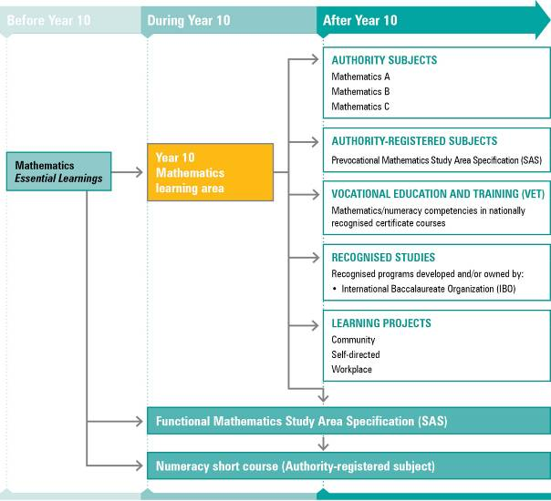
NOTE: For a full and current list of subjects, courses, and recognised studies visit the QSA website <www.qsa.qld.edu.au>.

Learning statements
The ways of working provide a unique and coherent framework of processes of mathematical analysis and justification, for explaining a myriad of physical and social phenomena. Thinking, reasoning and working mathematically are essential elements of learning about and through mathematics. The concise language of mathematics, verbal and symbolic, enables communication of shared mathematical understandings within and among communities.
Mathematical knowledge is dynamic because it is socially, culturally and historically constructed, responding to changing needs and expectations while also creating conditions for change. Mathematical understanding involves making connections among ideas, facts, concepts and procedures. Knowledge and understanding in Mathematics is organised by, and developed through, five interrelated organisers:
- number
- algebra
- measurement
- chance and data
- space.
Number is central to mathematics, as students will draw on numeration and their number sense when thinking, reasoning and working mathematically in the other areas. This focuses on number concepts, including the subsets of numbers within the set of real numbers, and the uses and purposes of money in our society; it also focuses on operations to support mental computation strategies and other computation methods.
Algebra focuses on the development of understandings of patterns and functions, using symbolic representations, and the methods associated with solving equations and maintaining equivalence.
Measurement develops understandings of estimation, measurement, units of measure, and the relationships between the units of length, mass, area, volume and time. This requires the use of measuring instruments and mathematical formulas.
Chance and data focuses on the collection, display, analysis and interpretation of data, and the use of experimental and theoretical probability to make judgments and decisions.
Space is about concepts related to the geometric terms and properties used to identify, visualise and create two-dimensional shapes and three-dimensional objects; and the construction and interpretation of maps, grids and plans, and their use in identifying and describing location, direction and movement.

Ways of working
Students are able to:
- interpret, clarify and analyse situations to identify the key mathematical features and conditions, strategies and procedures that may be relevant in the generation of a solution
- ask and refine questions to confirm or alter thinking and develop hypotheses and predictions
- plan and conduct simulations and investigations, using valid strategies and procedures to model and solve problems
- select and apply mathematical definitions and rules, mental and written computations, estimations, representations, and information and information and communication technologies (ICTs) to generate solutions
- analyse, interpret and synthesise solutions in the context of the problem to investigate the validity of mathematical arguments and models, and check reasonableness of the solution
- use mathematical interpretations and conclusions to generalise reasoning and make inferences
- communicate thinking, and justify and evaluate reasoning and generalisations, using mathematical language, representations and ICTs
- collect, organise, present and analyse data and information for different purposes and audiences, in a variety of representations, and translate information from one representation to another
- reflect upon, identify and appreciate the power, value and elegance of mathematics, and the contribution of mathematics to their own and other people’s lives and progress
- reflect upon their own thinking and reasoning, considering their application of mathematical ideas, the efficiency of their procedures and opportunities to apply new learning to future applications.

Knowledge and understanding
Students know and understand:

Number
Number properties and a range of strategies can be applied to a range of contexts to solve problems that involve real numbers, rates, ratios and direct and inverse proportions.
Real numbers (natural, whole, integer, rational and irrational) can be compared and ordered.
e.g. Distances in outer space, speed of light, mass of an electron.
Real numbers can be represented and described in different ways.
e.g. Index notation (integer indices), scientific notation (positive and negative powers of 10), logarithms, surds.
Real numbers can be used with the conventions of the laws of operations
(+, –, ~, ÷) to solve problems that involve rates, ratios and direct and inverse proportions.
e.g. Compound growth for various compounding periods, weather patterns, water usage in domestic and commercial situations, specific fuel consumption with variations in speed, calculating rates of change from graphs.
Financial decisions, budgeting and transactions are influenced by the analysis of short- and long-term benefits and consequences.
e.g. The advantages and disadvantages of over-commitment.
Financial decisions, budgeting and transactions are influenced by a range of factors, including income (gross and net), borrowing, consumer credit, investments and assets, savings, expenditure and methods of payment.
e.g. Personal loans (comparison of rates, fees and charges, repayments), appreciation and depreciation.
Financial decisions, budgeting and transactions are influenced by schedules of government and business charges.
e.g. Taxation, goods and services tax, rebates, levies.

Algebra
Variables, algebraic expressions and equations, relationships and functions can be described, represented and manipulated to solve problems from realistic situations.
Expressions and equations can be represented, interpreted and recorded using words, graphs or symbols using algebraic conventions.
e.g. Surface area of closed cone = RrC + Rrs where r is the radius in m, s is the slant height of the cone in m, and surface area is in mC.
Algebraic models of quantitative phenomena can be interpreted and evaluated using real number values of variables.
e.g. Trends in data, travel networks with distance covered versus time taken, the length of queues against the time taken to be served, fitness levels by monitoring heart rate before, during and after exercise.
Equations can be manipulated, rearranged and solved using property laws, four operations, expanding and factorising.
e.g. Binomial product, difference of two squares, perfect squares, common factor, grouping terms.
Properties of functions can be used to identify the form and shape of particular families of functions, such as linear, quadratic, reciprocal and exponential.
e.g. Gradient, intercepts, domain, range, distance and mid-point formula, maximum, minimum, turning point.
Linear equations related to real-life problems, including real numbers and inequations, can be interpreted and evaluated using a variety of methods.
e.g. Number of sausages that need to be sold for a fundraising project.
Nonlinear equations (quadratic and other polynomial expressions, exponential and logarithmic) related to real-life problems, including real numbers, can be modelled, interpreted and evaluated using a variety of methods.
e.g. Changes in crowd numbers at a rock concert as the starting time approaches, design of a skateboard bowl to optimise speed.
Simultaneous equations can be manipulated, rearranged and solved using graphing, substitution and elimination.
e.g. Optimise profit given constraints on income and expenditure.

Measurement
Units of measure, instruments, formulas and strategies can be used to estimate and calculate quantities and consider reasonable error in solving multistep problems.
Instruments, technologies, strategies and formulas are used to estimate, compare and calculate measures and derived measures, including circumference, area, volume, capacity, surface area, density and international time zone differences.
e.g. International travel itineraries, schedules for television coverage of live overseas events, measurements of compound shapes such as different sizes and shapes of tents, geological drill cores and ice-cream cones.
Relationships exist between units of equivalent measure and are used to make conversions of units to facilitate calculations.
e.g. Angles as D° M' S", nautical miles, knots, converting time into decimal notation.
Lengths and angles that cannot be measured directly can be determined using scale, similarity, Pythagoras’ theorem or trigonometry (tangent, sine and cosine ratios, including inverse functions).
e.g. Carpentry and construction projects requiring squareness, angle of trajectory (in sporting activities), steepness of roads and access pathways with reference to government safety guidelines.
- Judgments can be made about acceptable error of measurement and error can be compounded by repetition and calculation.
e.g. Reasoning behind repetition in a scientific fair test.

Chance and data
Probability and data can be displayed in various ways and analysed, and used to make comparisons, predictions, inferences, generalisations and judgments. Sample spaces can be specified for chance situations (single and compound) using lists, tables and tree diagrams, and comparing outcomes of events classified as complementary or mutually exclusive.
Probabilities, including conditional probabilities, can be determined using different methods, such as counting, measuring, symmetry and calculation (multiplication and addition principle).
e.g. Likelihood of inheriting genetic traits such as eye colour.
Data can be gathered from populations and samples using censuses, surveys, experiments, simulations, published data and databases, and used to estimate probabilities of events and to respond to claims and questions.
e.g. Writing a survey relevant to social questions of interest and collecting and analysing its data, considering responses to pairs of questions (bivariate data).
Data interpretation is simplified through the use of suitable representations and descriptive statistics.
e.g. Histogram, cumulative frequency histogram, polygon, ogive, bar, column, pie, segmented bar, line, scatterplots, frequency distribution tables, two-way tables, dot plot, stem-and-leaf plot, box-and-whiskers plot.
Measures of spread and centre, distribution of responses, and the effect of bias and outliers on the measures of location are used to make inferences.
e.g. Measures of central tendency (mode, median, mean), measures of spread (range, deviation, mean deviation, interquartile range), mean of grouped distributions.

Space
Geometric and mapping conventions can be used to describe, represent, construct and manipulate a range of shapes, objects, maps and plans. Geometric conventions are used to describe a variety of two-dimensional shapes and three-dimensional objects, including curved surfaces, and compound and embedded shapes.
Two-dimensional shapes and three-dimensional objects and their cross-sections can be analysed and represented as constructions, sketches, drawings or electronic images, using specifications and conventions to identify and show geometric properties.
e.g. Support structures for constructions, architectural designs for buildings or bridges.
Congruence, similarity, sequences of transformations, and symmetry are used to analyse geometric properties.
e.g. Similar triangles (AAA, SSS, SAS), congruent triangles (SSS, SAS, ASA, AAS, RHS).
Deductions about geometric properties can be supported by proofs related to angle properties associated with parallel, perpendicular and transverse lines and polygons (circles and quadrilaterals).
e.g. Supplementary, complementary, vertically opposite, alternate, corresponding,
co-interior, exterior angle, angles of a triangle, angles of a quadrilateral, opposite angles.
Maps and plans (using scale, coordinates, distance, bearing, angles, keys and annotations) can be constructed and used to specify location (coordinates, latitude, longitude) and represent spatial relationships, as well as distance and orientation between locations on the earth’s surface.
e.g. Interpreting and drawing house plans, calculating distance along great circles and along parallels of latitude, relationship between longitude and time.
Simple network diagrams can be interpreted, drawn and analysed to determine the number of routes, the shortest route and critical paths.
e.g. Networks can be analysed to see whether it is possible to traverse without repeating any edges.

Standards: Mathematics (table continues over the page)
A | B | C | D | E
The student work has the following characteristics:
Accurate identification of relevant and key mathematical features, conditions, strategies and procedures in simple non-routine through to complex routine situations | Accurate identification of relevant and key mathematical features, conditions, strategies and procedures in simple non-routine situations | Suitable identification of mathematical features, conditions, strategies and procedures in simple routine situations | Suitable identification of mathematical features, conditions, strategies and procedures in simple rehearsed situations | Attempted identification of mathematical features, conditions, strategies and procedures in simple rehearsed situations
Application of clear and logical questions, hypotheses and predictions in simple non-routine through to complex routine situations | Application of clear and logical questions, hypotheses and predictions in simple non-routine situations | Application of questions, hypotheses and predictions in simple routine situations | Use of given questions, hypotheses and predictions in simple rehearsed situations | Attempted use of given questions, hypotheses and predictions in simple rehearsed situations
Application of simple to complex strategies and procedures to model and solve problems in simple non-routine through to complex routine situations | Application of simple procedures and strategies to model and solve problems in simple non-routine situations | Application of procedures and strategies for problem solving in simple routine situations | Use of given procedures and strategies for problem solving in simple rehearsed situations | Attempted use of given procedures and strategies for problem solving in simple rehearsed situations
Accurate selection and application of rules, formulas, strategies and ICTs in simple non-routine through to complex routine situations | Accurate selection and use of rules, formulas, strategies and ICTs in simple non-routine situations | Relevant selection and use of rules, formulas, strategies and ICTs in simple routine situations | Selection and use of given rules, formulas, strategies and ICTs in simple rehearsed situations | Use of given rules, strategies and ICTs in simple rehearsed situations
Use of strategies to analyse, interpret, synthesise and justify the reasonableness of solutions, in simple non-routine through to complex routine situations | Use of strategies to analyse, interpret, synthesise and justify the reasonableness of solutions in simple non-routine situations | Use of strategies to analyse, interpret, synthesise and check for reasonableness of solutions in simple routine situations | Use of given strategies to interpret and check for reasonableness of solutions in simple rehearsed situations | Attempted use of given strategies to interpret and check for reasonableness of solutions in simple rehearsed situations
Use of mathematical interpretations and conclusions to generalise reasoning and make logical inferences and informed decisions in simple non-routine through to complex routine situations | Use of mathematical interpretations and conclusions to generalise reasoning and make logical inferences and informed decisions in simple non-routine situations | Use of mathematical interpretations and conclusions to generalise reasoning and make inferences and informed decisions in simple routine situations | Use of mathematical interpretations and conclusions to generalise reasoning and make inferences in simple rehearsed situations | Attempted use of mathematical interpretations and conclusions to generalise reasoning and make inferences in simple rehearsed situations

Standards: Mathematics (continued from previous page)
A | B | C | D | E
The student work has the following characteristics:
Accurate and concise use of mathematical language, representations and ICTs in simple non-routine through to complex routine situations to communicate thinking, and coherent and logical justification and evaluation of reasoning and generalisations | Accurate use of mathematical language, representations and ICTs in simple non-routine situations to communicate thinking, and clear and logical justification and evaluation of reasoning and generalisations | Suitable use of mathematical language, representations and ICTs in simple routine situations to communicate thinking, and the justification and evaluation of reasoning and generalisations | Suitable use of mathematical language, representations and ICTs in simple rehearsed situations to communicate thinking, and the evaluation of reasoning | Attempted use of mathematical terminology or conventions in simple rehearsed situations to communicate thinking and reasoning
Organisation, presentation and analysis of information in a wide variety of representations and translation of information from one representation to another, in simple non-routine through to complex routine situations | Organisation, presentation and analysis of information in a variety of representations and translation of information from one representation to another, in simple non-routine situations | Organisation, presentation and analysis of information in a variety of representations and translation of information from one representation to another, in simple routine situations | Organisation and presentation of information in a variety of representations and translation of information from one representation to another, in simple rehearsed situations | Organisation and presentation of information in a variety of representations in simple rehearsed situations
Perceptive reflection on thinking and reasoning processes to validate appropriateness of solutions and decisions relating to the contribution of mathematics to learning, in simple non-routine through to complex routine situations | Informed reflection on thinking and reasoning processes to validate appropriateness of solutions and decisions in simple non-routine situations | Relevant reflection on thinking and reasoning processes to validate solutions in simple routine situations | Superficial reflection on thinking and reasoning or solutions in simple rehearsed situations | Cursory reflection on solutions in simple rehearsed situations

Assessment

Planning an assessment program
Schools should refer to Using the Year 10 learning areas: assessment advice on page 5 when planning an assessment program. For Mathematics, an effective assessment program includes a range and balance of assessment techniques providing opportunities for students to demonstrate their learning across:
- the Standards
- types of assessment
- a range of assessment conditions.

Assessment techniques and instruments
The following advice has been designed to help schools use the Year 10 Mathematics learning area to build student learning towards assessment techniques that are valued in the senior phase of learning.
Extended modelling and problem-solving tasks
Format | Extended responses to a specific task or issue that highlights a real-life application of Mathematics.
Conditions | • Individually and/or in groups  • Prepared in class time and/or in the student’s own time  • Typically in written form, or a combination of written, oral and multimedia forms
Reports
Format | Extended responses, mathematical investigation/experiment, field activity, project, case study, scientific report, proposal to a company or organisation, feasibility study, posters.
Conditions | • Individually and/or in groups  • Prepared in class time and/or in the student’s own time  • Typically in written form, or a combination of written, oral and multimedia forms
Supervised tests
Format | Short- and extended-response items, multiple-choice, matching/true/false/classification, cloze passages and sentence completion, practical exercises, responses to seen or unseen stimulus materials.
Conditions | • Under supervised conditions  • Individual  • Perusal time may be required  • If stimulus materials are lengthy, they may need to be shared with students before the administration of the supervised test
Diaries, journals, learning logs, blogs
Format | A diary of relevant, significant tasks carried out by the student; documentation of planning, justifying, managing and evaluating; evidence of decision-making processes.
Conditions | • Does not need to be a single document  • May consist of documentation pertaining to major projects, diary events etc.
Oral presentations
Format | Group discussions, debates, interviews, reports, evaluation presentations, roleplays, demonstrations of practical skills.
Conditions | • Individually and/or in groups  • Prepared in class time and/or in the student’s own time  • Length and degree of complexity increases as students progress through a course of study (2–5 minutes)
Computer-generated presentations
Format | Websites, PowerPoint presentations, spreadsheets, blogs, wikis, podcasts.
Conditions | • Individually and/or in groups  • Prepared in class time and/or in the student’s own time
Peer- and self-reflections
Format | Feedback from small or large group discussions or responses to evaluation questions.
Conditions | • Individually and/or in groups  • Prepared in class time and/or in the student’s own time
Other nonwritten methods
Format | Simple diagrams, sketches, flowcharts, digital photographs or videos, making 2-D or 3-D models, virtual models using computer software.
Conditions | • Individually and/or in groups  • Prepared in class time and/or in the student’s own time

Course advice

Planning a course of study
The development of a course of study is a school-based decision. A school may decide to use all or part of the information contained in this learning area to construct a course of study. The Guidelines may be used to plan:
- the final year of a Years 8–10 Mathematics course
- part of a specialised Years 9–10 or Year 10 Mathematics course
- an integrated multidisciplinary or transdisciplinary course of study that combines learning statements from other learning areas
- term- or semester-length units of work
- the first year of a three-year senior course of study.

Examples of courses of study
Diagram 4 on page 20 describes examples of ways to plan and package courses of study using the Year 10 Mathematics learning statements. These examples do not preclude other ways of planning and packaging the learning statements. The examples are described as:
- units — referring to term- or semester-length units planned around a particular topic or theme (contexts)
- courses — referring to a series of units over a year planned around a particular school subject.
Diagram 4: Planning a Year 10 Mathematics course of study
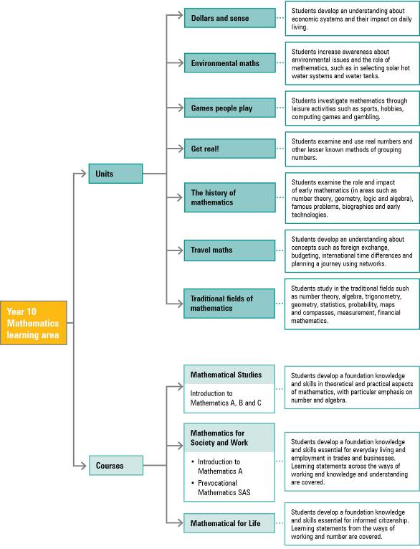

Principles of similar triangles: angle-angle-angle (AAA), side-side-side (SSS), side-angle-side (SAS)
Principles of congruent triangles: side-side-side (SSS), side-angle-side(SAS), angle-side-angle (ASA), angle-angle-side (AAS), right angle-hypotenuse-side (RHS)

