Languages
Learning area

This document has been generated from the PDF version to support teachers.
The PDF version is the official publication.
First edition released January 2009
Languages learning area extract from second edition June 2009
© The State of Queensland (Queensland Studies Authority) 2009
Ground floor, 295 Ann Street Brisbane
PO Box 307 Spring Hill Queensland 4004 Australia
Phone: +61 7 3864 0299
Fax: +61 7 3221 2553
Email: office@qsa.qld.edu.au
Website: www.qsa.qld.edu.au
NOTE: This publication contains images that may cause distress to Indigenous Australians.

Special notes on terminology:
• When The Arts is referred to as a subject or key learning area, both words are capitalised. However, when the arts are referred to in a generic way, this is presented in lower case.
• Standards, as part of the terminology of the Year 10 Guidelines and the Essential Learnings,
is presented with an initial capital letter. However, standards in the generic sense is always lower case.

Organisation of the Year 10 learning areas
Each learning area is organised in the same way and includes a rationale, learning statements, Standards, and advice about assessment and planning courses of study. The advice can be used by teachers to guide their planning to best meet the learning needs of their students, using contexts that are relevant.

Rationale
Each learning area begins with a rationale that describes:
the discipline or the field of study on which the learning area is based
the school subject or subjects that are drawn from the learning area
the nature of Year 10 learners and learning in the learning area.
The rationale also features a pathways diagram that shows how the Year 10 learning area transitions from the Years 1–9 Essential Learnings and is the foundation for the pathways available in the senior phase of learning.

Learning statements
The learning statements identify what is important for students to be taught and what is important for students to learn. The learning statements continue the use of the terms used in the Years 1–9 Essential Learnings and Standards.

Knowledge and understanding
Knowledge and understanding describes concepts, facts and procedures of the learning area. These are presented under organisers that relate to the broad conceptual categories that are the focus of the learning area. In some Year 10 learning areas these organisers are identical to the Years 1–9 key learning area (KLA) organisers, while others use organisers that have greater similarity to the senior syllabuses.

Ways of working
The ways of working identify the processes associated with the particular learning area. These processes emphasise the higher-order thinking skills that support the development of deep understandings in Years 1–9 and have close connections to the processes described in the KLAs. The Year 10 learning area ways of working are at the same time more specific to the Years 11–12 syllabuses. For example, the broad social and environmental inquiry processes of the Years 1–9 Studies of Society and Environment (SOSE) KLA develop into the historical inquiry process in Year 10 History.

Standards
The Standards for each Year 10 learning area describe the expected qualities of a collection of student work on an A–E scale. The Standards descriptors are linked to the learning statements.
The Standards in Year 10 draw on the standards frameworks from Years 1–9 and Years 11–12 and relate both to the assessable elements of the Essential Learnings and the dimensions of the Years 11–12 syllabuses. Schools should use the Standards to:
make judgments about a collection of student work
develop criteria sheets / guides to making judgments to suit their course structure and individual assessment techniques.

Assessment
Year 10 learning areas include advice about planning a school-based assessment program and information about important assessment techniques for each learning area.
The specific guidance about assessment in the particular learning area includes assessment techniques, and the formats and conditions appropriate for developing assessment instruments.
This advice will assist transition to the assessment demands of specific Years 11–12 syllabuses and the senior phase of learning generally.

Course advice
Information about planning courses of study is provided for each Year 10 learning area. Examples of ways to plan using the Year 10 learning statements are described as:
- units — referring to term- or semester-length units planned around a particular topic or theme (contexts)
- courses — referring to a series of units over a year planned around a particular school subject.

Using the Year 10 learning areas: planning courses of study
Curriculum planning is a school-based decision. Schools may choose to use all or part of the information contained in the Guidelines, or use all or part of individual Year 10 learning areas to construct units or courses of study.
The Guidelines include five broad options for planning courses of study using the Year 10 learning areas:
- units
- Year 10 courses
- Years 9–10 or Years 8–10 courses
- Years 10–12 courses
- integrated multidisciplinary or transdisciplinary courses.

Units
Term- or semester-length units can be planned from a selection of the learning statements. Units could serve as an introduction to a particular learning area or specific subject in Years 11–12. Schools may use units as a marketing tool to “sell” specific Years 11–12 subjects.

Year 10 courses
Stand-alone single-year courses in Year 10 can be developed around the learning statements of a single Year 10 learning area or across one or more learning areas. For example, Year 10 Geography would be planned from the Year 10 Geography learning statements, whereas Year 10 Home Economics would be planned from Year 10 Technology and Year 10 Health and Physical Education.

Years 9–10 or Years 8–10 courses
Two- and three-year courses across Years 9–10 or Years 8–10 can be developed from the learning statements of Year 10 learning areas and Years 1–9 Essential Learnings. For example, The Arts subjects in lower secondary could be developed from the specific organisers in the Years 1–9 Essential Learnings and the Year 10 learning area to create courses in Visual Art, Drama, Dance, Music and Media.
Structuring curriculum as Years 9–10 or Years 8–10 courses builds on the current practice of a large number of Queensland secondary schools. Many schools offer lower secondary courses of study using the key learning areas shaped as specific school subjects.
Traditionally, these courses have provided some degree of transition to senior subjects and have provided a “sampler” to help students make an informed decision when choosing senior subjects. Using the learning statements from the Year 10 Guidelines will further strengthen this approach.

Years 10–12 courses
Some schools have developed three-year courses across Years 10–12. These courses describe a coherent three-year senior phase of learning where Year 10 is a foundation year.
Years 10–12 courses can be developed using the Year 10 learning areas and the relevant senior syllabuses. For example, a three-year course in Physics would draw from the Year 10 Science learning area and the senior Physics syllabus. A three-year History course would draw from the Year 10 History learning area and either the senior Modern History or Ancient History syllabus.
Based on their learning experiences in the first year of the course, students should have options to decide to:
- continue the course in Years 11–12
- make an alternative decision within the learning area, for example, elect to do Chemistry rather than Physics or choose Ancient History rather than Modern History
- choose a different pathway, for example, choose not to participate in a senior science or history subject.

Integrated multidisciplinary or transdisciplinary courses
Integrated multidisciplinary or transdisciplinary courses are common in some school settings, particularly middle schools.
These courses can be planned from learning statements across learning areas. In many instances, an organiser that crosses the learning area is used to give coherence to the planning of these courses.

Using the Year 10 learning areas: assessment advice
Assessment is a fundamental and integral part of the teaching and learning process and must be planned and ongoing. Assessment is used to:
- promote, assist and improve learning
- substantially contribute to the construction of programs of teaching and learning
- provide information for students, teachers, parents and carers about the progress and achievements of individual students to help them achieve as well as they are able.
Assessment in Year 10 should be guided by the principles of assessment described in the QSA’s P–12 Assessment Policy. See Resources on page 8 for details.

School-based assessment
During Year 10, assessment should continue the approaches of school-based assessment begun in Years 1–9 and build towards the externally moderated system of Years 11–12. Assessment in Year 10 is:
- standards-based. The Guidelines set out content and achievement standards. The learning statements are the content standards for each Year 10 learning area. These are statements of what students are expected to know and do by the end of Year 10. The achievement standards are linked to each set of learning statements and are reference points that describe how well students have achieved the learning statements
- diagnostic. The Guidelines provide an opportunity to use assessment to determine the nature of students’ learning difficulties as a basis for providing feedback or intervention
- formative. The main focus of assessment in Year 10 is on improving student learning to assist their transition to the senior phase of learning
- summative. Assessment in Year 10 can indicate standards achieved at particular points for reporting purposes.
Year 10 assessment is an opportunity for schools and teachers to develop students’ assessment literacy or familiarity with the processes and practices used in the senior syllabuses.
To develop assessment literacy for Years 11–12, a Year 10 assessment program should introduce and apply important ideas about school-based assessment from the principles of exit assessment in the senior syllabuses. These principles are:
- continuous assessment, or gathering information on student achievement over a course of study, using assessment instruments administered at suitable intervals
- balance of assessment, or making judgments about students’ achievements using a variety of assessment techniques and a range of assessment conditions over the course of study
- fullest and latest information, or making judgments about student achievement based on information gathered from the range of learning statements and from the most recent assessment of achievement.
Each Year 10 learning area provides assessment advice about Standards and assessment techniques and instruments.

Standards
Each learning area has a set of broad standards expressed as descriptors of quality on an A–E scale. The Standards are linked to the learning statements.
Diagram 1 shows a typical Standards table.

Diagram 1: Sample Standards table (The Arts — Drama)
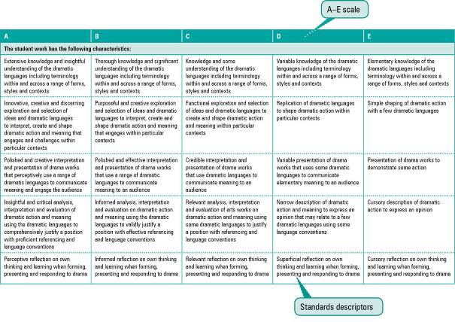

Assessment techniques and instruments
Each Year 10 learning area describes assessment techniques valued in the particular learning area and its related senior subjects.
The assessment advice is for guidance only, and is provided to assist teachers to develop an effective assessment program. It does not represent a required or mandatory approach.
The advice includes details about the typical formats of the assessment instruments and suggests conditions for implementing particular instruments in Year 10.
Teachers can use this information to develop assessment programs that:
- assist students to develop familiarity with the assessment in Years 11–12
- provide students with feedback on their learning
- provide evidence of student achievement.
Diagram 2 shows a typical assessment technique description.
Diagram 2: Sample assessment technique description
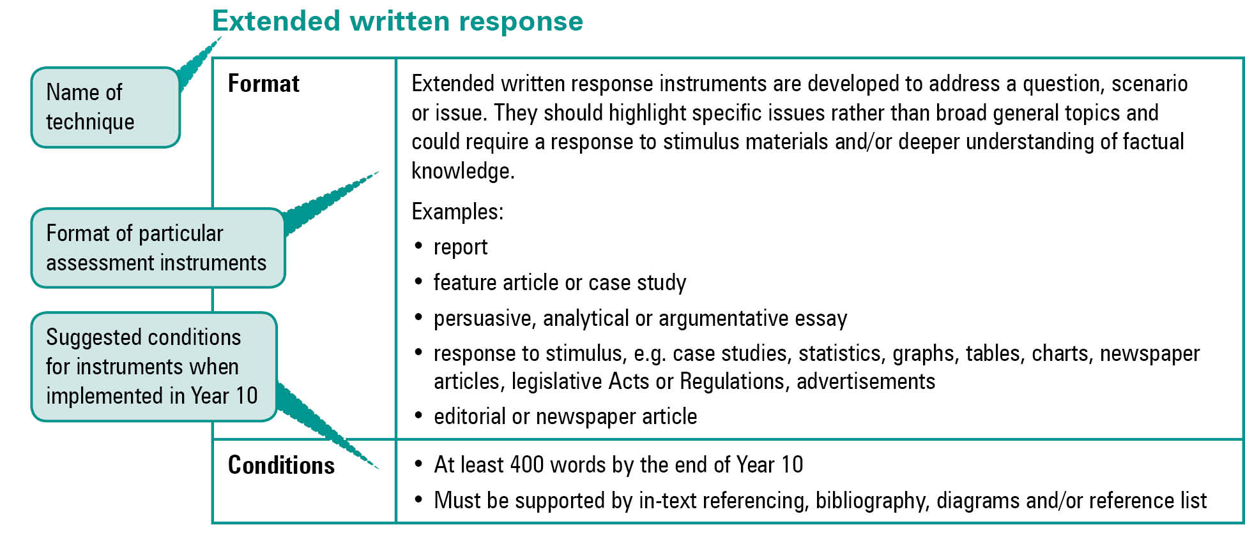
Quality assessment instruments have the following characteristics:
instrument descriptions
instrument-specific criteria sheets / guide to making judgments
instrument conditions.

Instrument descriptions
Instrument descriptions provide succinct and easily understood directions of what students must do.

Instrument-specific criteria sheets / guides to making judgments
Instrument-specific criteria sheets / guides to making judgments are developed from the Standards descriptors and provided to students before they respond to an assessment instrument, preferably at the beginning of a unit of work. These will help students understand the qualities the teacher will be looking for in their responses to the assessment instruments. Schools should note that not all aspects of knowledge and understanding and ways of working will be assessed in any one task. Aspects must be selected according to instrument demands.
Criteria sheets / guides to making judgments provide:
- descriptions of the qualities of student work in each of the selected aspects of knowledge and understanding and ways of working across A–E standards
- instrument-specific information on which teachers’ judgment will be based.

Instrument conditions
To develop assessment instruments that are realistic and achievable for students, teachers should give careful consideration to instrument conditions. All aspects of instrument conditions and demands need to be considered when making judgments about the student work.
Instrument conditions need to be stipulated on each instrument sheet, and detail:
- time and length requirements including:
- word length (written) or time length (spoken/signed)
- amount of time for the instrument (exam/test)
- notice of instrument (e.g. three weeks notice)
- amount of time for drafting or rehearsing
- access to resources, and any conditions which influence the access to material and human resources (e.g. seen or unseen question)
- drafting and/or rehearsing information
- details of scaffolding.

Assessment judgments and determining an overall result
Teachers make judgments about student work on individual assessment instruments, as well as making an overall judgment about a collection of student work (a folio).
The standard awarded for either an individual assessment instrument or a folio of work is an on-balance judgment about how the qualities of the student’s work match the typical Standards outlined in the learning area.
It is not necessary for a student to have met every descriptor for a particular standard in knowledge and understanding and ways of working to be awarded that standard.
Schools, in constructing their courses of study, decide which aspects of knowledge and understanding and ways of working will be covered and which ones may be reported on.
By using the Standards, schools will be able to report about student achievement in knowledge and understanding and ways of working. Schools will also be able to report on the overall standard for the course of study.
Recording student results for knowledge and understanding and ways of working for each assessment instrument on a student profile will help teachers in keeping records of student achievement.

Resources
Three useful references for developing quality assessment are:
- Learning P–12, QSA 2009, accessed 10 Jun 2009,
<www.qsa.qld.edu.au> (select Learning P–12 > Learning P–12).
Describes the relationships between the various syllabuses and guidelines produced by the QSA for the Preparatory Year through to Year 12.
- P–12 Assessment Policy, QSA 2009, accessed 10 Jun 2009, <www.qsa.qld.edu.au> (select Assessment > Overview > P–12 assessment policy).
Assessment in Year 10 should be guided by the principles of assessment described in this policy.
- Guidelines for Assessment Quality and Equity, Australian Curriculum, Assessment and Certification Authorities (ACACA) 1995, accessed10 Jun 2009, <http://acaca.bos.nsw.edu.au> (select ACACA documents > Guidelines for Assessment Quality and Equity.
Describes the characteristics of quality assessment instruments.

Languages learning area

Rationale
The ability to speak additional languages and to communicate across cultures is enriching in many ways. The world is becoming increasingly diverse, both in the immediate environment and on a more global level. This diversity involves many different ways of knowing and behaving, communicating and thinking. Learning a new language provides access to these different ways and opportunities to broaden understanding of self and others. It increases career and employment opportunities, and improves access to the systems of digital communication and representation which are increasingly a core component of students’ lives in and out of school.
Learning an additional language not only develops communicative competence and intercultural understanding but also develops skills which have broad educational applications. These skills increase cognitive flexibility and the interpersonal ability to respond positively to difference. They also have a positive and significant effect on the student’s first language, particularly in the areas of reading, vocabulary, grammar and communication skills.
The overarching goals for language learning in Year 10 are to:
- develop the language proficiency and communication skills required to use the target language intentionally and effectively in different contexts, for different purposes and through different language modes, including information and communication technologies (ICTs)
- build explicit and substantive knowledge of how the target language works as a language system and as social and cultural practice
- learn to comprehend and critically analyse a range of spoken and written texts in the target language, to convey meaning and solve problems in communicative encounters
- develop the orientation, attitudes and analytical skills needed to develop intercultural awareness and become confident in intercultural interactions
- explore the connection between language, culture and identity
- increase cognitive flexibility, divergent and critical thinking skills and the capacity to engage productively with difference and diversity
- reflect upon and evaluate individual learning strategies and experience, and the importance and application of proficiency in an additional language.
As a school subject, language learning involves knowing how to use a new language, knowing about the language, and knowing how to learn a new language.
Knowing how to use a new language involves:
- developing proficiency in listening, reading, speaking and writing skills; understanding and using nonverbal language and other meaning-making conventions accurately, appropriately and authentically; and using digital systems to experience real and virtual worlds through the target language
- comprehending and composing a variety of texts; understanding that texts differ according to contexts, situations and purposes; and developing an inquiry-based orientation to text
- developing the ability to “read between the lines” of the target language; to identify culture in language; to interact in culturally appropriate ways; and to acknowledge and explore the validity of different perspectives and systems of meaning-making.
Knowing about the language involves:
- understanding the interrelated systems of the language: writing conventions, sound systems, grammatical, lexical and rhetorical systems
- exploring the dynamic and arbitrary nature of language: how languages change, borrow from and impact on each other
- understanding the interrelationship of language, culture and identity.
Knowing how to learn the target language involves strategies and process skills such as noticing similarities and differences between languages, analysing why the target language works in the ways it does, and reflecting critically on learning.
Students’ proficiency in the target language is developed through listening and reading (comprehension) and speaking and writing (conveying meaning). Proficiency is further developed by reflection, not only on the spoken and written texts, but also on their own learning. This involves:
- interpreting and applying the language system
- interpreting and communicating ideas and information in spoken and written texts
- demonstrating intercultural knowledge and understanding
- analysing and critically reflecting on language and learning.
These ways of working foster the development of specific dispositions: the willingness to consider alternative perspectives, intellectual curiosity in response to difference and diversity, capacity for self-reflection, and the ability to challenge stereotypes and to communicate in new ways.
The study of languages in Year 10 should provide a challenging and engaging program that bridges the middle and senior phases of learning and sets the foundation for the next phase of learning. At this stage of their learning, students are developing pathways and beginning to explore the implications and possibilities of learning languages for further studies, career and citizenship. As more cognitively mature learners, students increasingly make explicit choices with longer term consequences for their future pathways of study, their likely or possible careers, and their engagement in a multicultural and multilingual society.
The Year 10 Languages learning statements link the Years 1–9 Languages Essential Learnings to the senior languages subjects, as well as consolidating languages education in the middle phase of learning, as shown in Diagram 3 on page 11.
Diagram 3: Languages pathways
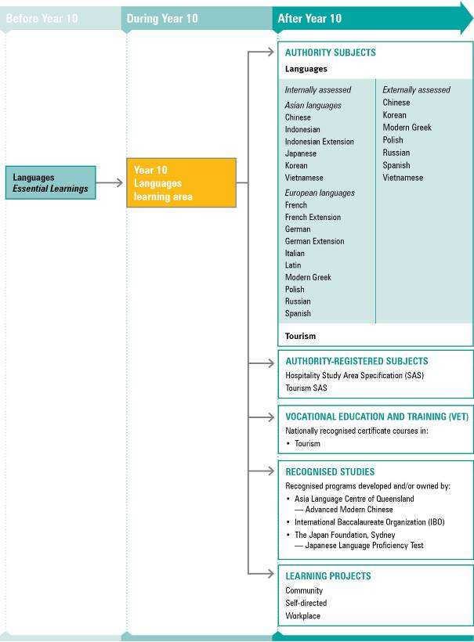
NOTE: For a full and current list of subjects, courses, and recognised studies visit the QSA website <www.qsa.qld.edu.au>.

Learning statements
Language learning focuses on use of the macroskills, comprehension and conveying meaning. These skills are developed independently (speaking is developed by speaking, reading by reading, etc.) and interdependently (one skill supports development in others). The greatest transfer of learning is from comprehension (receptive communication, involving listening and reading) to conveying meaning (productive communication, involving speaking and writing).
The ways of working are the essential thinking processes and skills inherent in the study of languages. Students use these processes and skills to demonstrate their ability to communicate in the target language. The ways of working and knowledge and understanding statements are described under the two broad communicative organisers:
- comprehension
- conveying meaning.
In turn, the descriptions under each of these organisers are structured under the key aspects of language learning applicable to the organisers.
These concepts are developed through the application of the ways of working in learning experiences and assessment opportunities throughout the course.

Ways of working

Comprehension (receptive communication — Listening and reading)
Students are able to:
- interpret the language system
- recognise lexical and grammatical features in a range of text types
- distinguish features of familiar and unfamiliar texts, including those involving short, dependent clauses clearly marked by high-frequency forms
- recognise aspects of authentic texts spoken at natural background-speaker speed where the content is realistic, rather than abstract
- interpret ideas and information
- work out meaning from lexical and grammatical features and contexts
- determine essential information where the language used is familiar
- differentiate gist and detail in a range of texts containing some complex sentences and unfamiliar language
- deduce the meaning of familiar and unfamiliar language using an understanding of context and grammatical features
- recognise obvious attitude, purpose or intention
- demonstrate intercultural understanding
- recognise, analyse and discuss embedded cultural references in texts
- compare similarities and differences in text formats, language and style between similar texts in the target language and English to strengthen intercultural communication
- interpret references to aspects of the target culture by comparing with their own culture/s
- reflect on language and learning
- analyse and evaluate ideas and information to draw conclusions and justify judgments
- identify and reflect on speakers’ and writers’ attitudes, purposes, intentions or cultural meanings
- evaluate the suitability of language choices and learning strategies.

Conveying meaning (productive communication — Speaking and writing)
Students are able to:
- apply the language system
- manipulate lexical and grammatical features in a range of text types
- use the conventions of a range of text types for creating texts, including formal letters and speeches, and internet postings
- use a range of language devices in familiar contexts (e.g. linking words, conjunctions, dependent clauses)
- communicate meaning in spoken and written texts
- use familiar language to communicate information and ideas on a range of topics and through a variety of text types
- select a range of vocabulary and cohesive devices
- construct original and coherent texts of varying lengths
- present information relevant to context, audience and purpose
- use acceptable pronunciation (rhythm, stress and intonation) and pause fillers
- use some common idiomatic and colloquial expressions
- respond to conversational cues
- demonstrate intercultural understanding
- comment on issues of significance to members of the target culture of a similar age and compare with their own culture/s
- demonstrate cultural awareness by making appropriate language choices, both verbal and nonverbal
- reflect on language and learning
- evaluate the suitability of language choices and learning strategies
- analyse and reflect on learning to identify new understandings and future applications.

Knowledge and understanding
Students know and understand:
Comprehension and conveying meaning in the target language requires knowledge and understanding of language concepts, structures and processes.
Verbal language and nonverbal language are adapted according to role, purpose, context, audience, setting and text type.
e.g. People speak and write more formally to strangers, elders, people in official roles or particular occupations such as doctors; nonverbal greetings (handshakes, kissing on cheek) vary according to cultures and relationships.
Language functions, features and structures provide clues to the purpose and meaning of texts.
e.g. In Asian languages the use of particles can vary the meaning of a sentence significantly; in European languages the imperative mood varies according to the audience.
High-frequency forms and identification of register and tone help when interpreting language involving dependent clauses.
e.g. Identifying the context and familiar forms, functions and elements when reading or listening to an authentic text.
Language can be manipulated to construct original and coherent texts appropriate to role, purpose, context, audience, setting and text type.
e.g. Writing a formal letter of introduction using socioculturally appropriate conventions; using abbreviations and emoticons in email/SMS messages.
Common idioms and colloquial expressions are often used in communication to convey meaning that is culturally significant.
e.g. In Japan, a term such as “sempai-koohai” indicates the importance of social relationships; in Germany “geil” is used predominantly by young people to mean “cool, awesome”; in China, proverbs are used to convey deeper meanings.
Ideas and information can be expressed through a variety of literary and non-literary text types, appropriate to formal and informal contexts.
e.g. In Japanese and Chinese, the use of two different characters for the same meaning, dependent upon text type and context.
Language and culture are inextricably linked; beliefs, values and attitudes are embedded in languages and cultures, and knowledge of these ensures effective communication and fosters intercultural understanding.
e.g. In Japanese, “uchi” (home) can have a number of different interpretations; in Spanish, “querer” and “amar” (to love) have different usage according to context and purpose.

Standards: Languages
A | B | C | D | E
The student work has the following characteristics:
Comprehensive knowledge and understanding of language concepts, structures and processes, including an extensive range of functions, features, idioms and colloquialisms | Substantial knowledge and understanding of language concepts, structures and processes, including a wide range of functions, features, idioms and colloquialisms | Knowledge and understanding of basic language concepts, structures and processes, including the most commonly used functions, features, idioms and colloquialisms | Variable knowledge and understanding of obvious language concepts, structures and processes, and some language functions or features | Knowledge of isolated language concepts, structures or processes
Perceptive interpretation of the language system and recognition of a wide range of textual features in authentic texts | Accurate interpretation of the language system and recognition of textual features in simple authentic texts | Broad interpretation of the language system and recognition of some aspects of authentic texts | Variable interpretation of the language system and recognition of some aspects of authentic texts | Recognition of isolated aspects of authentic texts
Comprehensive interpretation, analysis and evaluation of ideas and information in familiar and unfamiliar texts | Interpretation, analysis and evaluation of ideas and information in familiar and unfamiliar texts | Essential ideas and information in familiar texts presented, including some points which may not always be relevant | Presentation of some information from familiar texts | Presentation of fragmented information
Effective and consistent identification, analysis and interpretation of cultural references and discussion of implications | Identification and interpretation of cultural references and implications | Identification and some interpretation of obvious cultural references | Recognition of obvious cultural references | Recognition of some obvious cultural references
Well-supported and well-reasoned reflection on attitudes, purpose, intention and language choices | Informed reflection on purpose, intention and language choices | Recognition of general purpose and intention when obvious within a familiar context | Superficial identification of purpose | Minimal identification of purpose
Discerning application of the language system which effectively communicates ideas and information relevant to context, audience and purpose, with a high degree of accuracy | Efficient application of the language system to communicate ideas and information relevant to context, audience and purpose, with a reasonable degree of accuracy | Application of aspects of the language system to communicate information relevant to context and purpose, although errors are evident | Variable use of the language system with frequent inaccuracies in familiar vocabulary and grammar | Minimal use of the language system, with frequent errors in familiar vocabulary and grammar
Effective and sustained communication of meaning through competent use of a range of cohesive devices and a variety of idiomatic and colloquial expressions | Clear communication of meaning, with evidence of some appropriate idiomatic and colloquial expressions and selected cohesive devices | Communication of essential meaning, with the use of some common idiomatic and colloquial expressions and basic cohesive devices which connect simple ideas | Communication of obvious meaning, although it may be disjointed and hesitant | Communication of some simple meanings, although information is fragmented and generally unclear
Comprehensive knowledge and understanding of intercultural perspectives in communication | Informed knowledge and understanding of intercultural perspectives in communication | Awareness of some significant intercultural perspectives in communication | Variable acknowledgement of cultural context in communication | Minimal acknowledgement of cultural context in communication
Analysis and reflection on learning and language choices which contribute to future learning | Substantiated reflection on language choices and learning | Relevant reflection on language choices and learning | Superficial reflection on language choices and learning | Cursory reflection on language choices and learning

Assessment

Planning an assessment program
Schools should refer to Using the Year 10 learning areas: assessment advice on page 5 when planning an assessment program. For Languages, the assessment program should include a range and balance of assessment types providing opportunities for students to demonstrate their learning across:
- the Standards
- types of assessment
- a range of assessment conditions
- the four macroskills.

Assessment techniques and instruments
The following advice has been designed to help schools use the Year 10 Languages learning area to build student learning towards assessment techniques that are valued in senior languages subjects.
As language learning focuses on the use of the four macroskills, a concurrent approach to their teaching and assessing should be adopted. Equal emphasis should be given to all four macroskills. While this emphasis may vary during the course depending on the nature of the particular themes or topics, a broad balance should be maintained across the Year 10 course.
In all four macroskills, students should perform tasks set in communicative contexts. A task may involve more than one macroskill; for example, a conversation involves listening and speaking, answering a letter involves reading and writing. A variety of tasks, which include inquiry and/or problem-solving, promotes the progressive development of the four macroskills.
Listening
Format | Students listen to texts that are realistic in pace but still use familiar language. Texts may include both explicit and implicit sociocultural knowledge. Some texts are drawn from authentic sources on known topics. The language used is clearly articulated in the standard variety, and spoken in the slower range of normal background-speaker rate of utterance.  Suitable texts may include interviews, announcements, messages, advertisements, conversations, news bulletins, media commentaries and stories.  Responses could include short answers, writing or completing a summary, retelling a story, or re-presenting and reorganising information.
Conditions | • Conducted under supervised or unsupervised conditions  • Individually or in groups  • Formal or informal  • Length of listening texts is appropriate to the task and text type
Reading
Format | Students read a variety of authentic texts that differ in length, purpose and complexity.  Suitable texts may include magazine and newspaper articles, literary texts  (e.g. poem, short story), webpages and internet articles, travel brochures, advertisements, personal letters and emails, cartoons and sets of instructions.  Responses could include short answers, writing or completing summaries, retelling stories, or re-presenting and reorganising information.
Conditions | • Conducted under supervised or unsupervised conditions  • Individually or in groups  • Formal or informal  • Length of reading texts is appropriate to the task and text type
Speaking
Format | Students interact in exchanges that simulate realistic conversations between peers and others but may not be idiomatic or sustained. Presentations on known topics are appropriate to audience, logically sequenced and incorporate a few dependent clause structures.  Student dialogues demonstrate some spontaneity.  Oral presentations are for a range of audiences and purposes. Unprepared answers to questions at the end of a talk will influence the level of performance.  Contexts could include one-to-one interviews or conversations, small-group discussions, debates, class talks, responses to stimuli (e.g. pictures, maps, cartoons, brochures) and roleplays.
Conditions | • Conducted under supervised or unsupervised conditions  • Individually or in groups  • Formal or informal  • Length of speaking texts is appropriate to the task and text type  • Visual aids may be used (e.g. datashow presentation)
Writing
Format | Each written text type should be set in an authentic or realistic social context, with a specific audience nominated and a realistic purpose.  Suitable texts may include personal letters and emails, blogs, websites, invitations, personal journal entries, school magazine articles, brochures, postcards and imaginative responses to stimulus material.  For scripted languages students are expected to write in script.
Conditions | • Conducted under supervised or unsupervised conditions  • Individually or in groups  • Formal or informal  • Length of writing texts is appropriate to the task and text type but at least one should be an extended passage  • Dictionaries may be used

Course advice
The Year 10 Languages learning area links the Languages Essential Learnings to the senior languages subjects through curriculum content, processes and skills, with a direct relationship to the more specialised content and expectations of the senior languages syllabuses. The Guidelines help to consolidate languages studies in the middle phase of learning.
Students in Year 10 will have a range of prior experiences in the target language — as beginners, continuers or immersion students; there are some who have been learning an additional language since Year 4, and others who have been learning another language since Year 8. A number of students will be background or heritage speakers.
Languages courses in Year 10 may be structured in a number of ways, according to the level of students’ language proficiency.

Beginner
A beginner Languages course would help students with no prior experience in learning languages to pursue further studies in the target language. This course would involve students working on a selection of learning statements from the Years 1–9 Languages Essential Learnings and the Year 10 Guidelines.

Continuer
A continuer course would consolidate students’ learning in the middle phase and prepare them for senior languages studies. It would help students with prior languages experience pursue a senior languages course. The Year 10 course would involve students working across a variety of Year 10 learning statements.

Advanced
An advanced Languages course would provide students with the opportunity to accelerate their learning in the target language using the Year 10 learning statements. This course is for students with extensive experience or demonstrated ability in an additional language, for example, students who have studied an additional language since Year 4, those involved in an immersion program, and background and heritage speakers. The course would assist students to enrol in a senior Languages course at a continuer or extension level.
Students from immersion languages programs and others with advanced target language proficiency may have opportunities to commence the senior course in Year 10.

Organising principle
Contexts and themes, and their associated topics form the main organising principle for language study. They are selected and arranged to provide progressive and cumulative opportunities for students to develop language and cultural understandings. The sequencing of activities and language content allows students to acquire and develop new ways of working, new knowledge and understanding, and positive attitudes.
Most topics should be familiar to students, should relate to their interests, and provide opportunities for investigation of issues. Activities should be task-based and set in real-life contexts. Although tasks are still scaffolded, they should provide enough scope to lead students towards independent, self-directed learning. Both directed and independent learning are focused on the acquisition of new language, structures, communication conventions, ways of thinking about the topic/s and their expression, as well as comparisons between languages and societies.
Select topics that:
- are culturally, socially or linguistically distinctive to particular languages
- can extend, reinforce or complement topics already covered
- are relevant and of interest to the students
- integrate with themes, topics or key areas being covered in other learning areas.
Diagram 4 on page 20 shows how a Year 10 Languages course could be developed using a context- or theme-based approach. As language development depends primarily upon the level of language proficiency of students, the contexts and languages themes could suit any level of language proficiency; the learning statements could be embedded in any and all of the contexts and themes. For example, the Years 11–12 theme “Personal and community life” could be studied at a beginner, continuer or advanced level — students’ language proficiency will determine the level of ways of working and knowledge and understandings undertaken.
Diagram 4: Planning a Year 10 Languages course of study
