Health and Physical Education (HPE)
Learning area

This document has been generated from the PDF version to support teachers.
The PDF version is the official publication.
First edition released January 2009
Health and Physical Education (HPE) learning area extract from second edition June 2009
© The State of Queensland (Queensland Studies Authority) 2009
Ground floor, 295 Ann Street Brisbane
PO Box 307 Spring Hill Queensland 4004 Australia
Phone: +61 7 3864 0299
Fax: +61 7 3221 2553
Email: office@qsa.qld.edu.au
Website: www.qsa.qld.edu.au
NOTE: This publication contains images that may cause distress to Indigenous Australians.

Special notes on terminology:
• When The Arts is referred to as a subject or key learning area, both words are capitalised. However, when the arts are referred to in a generic way, this is presented in lower case.
• Standards, as part of the terminology of the Year 10 Guidelines and the Essential Learnings,
is presented with an initial capital letter. However, standards in the generic sense is always lower case.

Organisation of the Year 10 learning areas
Each learning area is organised in the same way and includes a rationale, learning statements, Standards, and advice about assessment and planning courses of study. The advice can be used by teachers to guide their planning to best meet the learning needs of their students, using contexts that are relevant.

Rationale
Each learning area begins with a rationale that describes:
the discipline or the field of study on which the learning area is based
the school subject or subjects that are drawn from the learning area
the nature of Year 10 learners and learning in the learning area.
The rationale also features a pathways diagram that shows how the Year 10 learning area transitions from the Years 1–9 Essential Learnings and is the foundation for the pathways available in the senior phase of learning.

Learning statements
The learning statements identify what is important for students to be taught and what is important for students to learn. The learning statements continue the use of the terms used in the Years 1–9 Essential Learnings and Standards.

Knowledge and understanding
Knowledge and understanding describes concepts, facts and procedures of the learning area. These are presented under organisers that relate to the broad conceptual categories that are the focus of the learning area. In some Year 10 learning areas these organisers are identical to the Years 1–9 key learning area (KLA) organisers, while others use organisers that have greater similarity to the senior syllabuses.

Ways of working
The ways of working identify the processes associated with the particular learning area. These processes emphasise the higher-order thinking skills that support the development of deep understandings in Years 1–9 and have close connections to the processes described in the KLAs. The Year 10 learning area ways of working are at the same time more specific to the Years 11–12 syllabuses. For example, the broad social and environmental inquiry processes of the Years 1–9 Studies of Society and Environment (SOSE) KLA develop into the historical inquiry process in Year 10 History.

Standards
The Standards for each Year 10 learning area describe the expected qualities of a collection of student work on an A–E scale. The Standards descriptors are linked to the learning statements.
The Standards in Year 10 draw on the standards frameworks from Years 1–9 and Years 11–12 and relate both to the assessable elements of the Essential Learnings and the dimensions of the Years 11–12 syllabuses. Schools should use the Standards to:
make judgments about a collection of student work
develop criteria sheets / guides to making judgments to suit their course structure and individual assessment techniques.

Assessment
Year 10 learning areas include advice about planning a school-based assessment program and information about important assessment techniques for each learning area.
The specific guidance about assessment in the particular learning area includes assessment techniques, and the formats and conditions appropriate for developing assessment instruments.
This advice will assist transition to the assessment demands of specific Years 11–12 syllabuses and the senior phase of learning generally.

Course advice
Information about planning courses of study is provided for each Year 10 learning area. Examples of ways to plan using the Year 10 learning statements are described as:
- units — referring to term- or semester-length units planned around a particular topic or theme (contexts)
- courses — referring to a series of units over a year planned around a particular school subject.

Using the Year 10 learning areas: planning courses of study
Curriculum planning is a school-based decision. Schools may choose to use all or part of the information contained in the Guidelines, or use all or part of individual Year 10 learning areas to construct units or courses of study.
The Guidelines include five broad options for planning courses of study using the Year 10 learning areas:
- units
- Year 10 courses
- Years 9–10 or Years 8–10 courses
- Years 10–12 courses
- integrated multidisciplinary or transdisciplinary courses.

Units
Term- or semester-length units can be planned from a selection of the learning statements. Units could serve as an introduction to a particular learning area or specific subject in Years 11–12. Schools may use units as a marketing tool to “sell” specific Years 11–12 subjects.

Year 10 courses
Stand-alone single-year courses in Year 10 can be developed around the learning statements of a single Year 10 learning area or across one or more learning areas. For example, Year 10 Geography would be planned from the Year 10 Geography learning statements, whereas Year 10 Home Economics would be planned from Year 10 Technology and Year 10 Health and Physical Education.

Years 9–10 or Years 8–10 courses
Two- and three-year courses across Years 9–10 or Years 8–10 can be developed from the learning statements of Year 10 learning areas and Years 1–9 Essential Learnings. For example, The Arts subjects in lower secondary could be developed from the specific organisers in the Years 1–9 Essential Learnings and the Year 10 learning area to create courses in Visual Art, Drama, Dance, Music and Media.
Structuring curriculum as Years 9–10 or Years 8–10 courses builds on the current practice of a large number of Queensland secondary schools. Many schools offer lower secondary courses of study using the key learning areas shaped as specific school subjects.
Traditionally, these courses have provided some degree of transition to senior subjects and have provided a “sampler” to help students make an informed decision when choosing senior subjects. Using the learning statements from the Year 10 Guidelines will further strengthen this approach.

Years 10–12 courses
Some schools have developed three-year courses across Years 10–12. These courses describe a coherent three-year senior phase of learning where Year 10 is a foundation year.
Years 10–12 courses can be developed using the Year 10 learning areas and the relevant senior syllabuses. For example, a three-year course in Physics would draw from the Year 10 Science learning area and the senior Physics syllabus. A three-year History course would draw from the Year 10 History learning area and either the senior Modern History or Ancient History syllabus.
Based on their learning experiences in the first year of the course, students should have options to decide to:
- continue the course in Years 11–12
- make an alternative decision within the learning area, for example, elect to do Chemistry rather than Physics or choose Ancient History rather than Modern History
- choose a different pathway, for example, choose not to participate in a senior science or history subject.

Integrated multidisciplinary or transdisciplinary courses
Integrated multidisciplinary or transdisciplinary courses are common in some school settings, particularly middle schools.
These courses can be planned from learning statements across learning areas. In many instances, an organiser that crosses the learning area is used to give coherence to the planning of these courses.

Using the Year 10 learning areas: assessment advice
Assessment is a fundamental and integral part of the teaching and learning process and must be planned and ongoing. Assessment is used to:
- promote, assist and improve learning
- substantially contribute to the construction of programs of teaching and learning
- provide information for students, teachers, parents and carers about the progress and achievements of individual students to help them achieve as well as they are able.
Assessment in Year 10 should be guided by the principles of assessment described in the QSA’s P–12 Assessment Policy. See Resources on page 8 for details.

School-based assessment
During Year 10, assessment should continue the approaches of school-based assessment begun in Years 1–9 and build towards the externally moderated system of Years 11–12. Assessment in Year 10 is:
- standards-based. The Guidelines set out content and achievement standards. The learning statements are the content standards for each Year 10 learning area. These are statements of what students are expected to know and do by the end of Year 10. The achievement standards are linked to each set of learning statements and are reference points that describe how well students have achieved the learning statements
- diagnostic. The Guidelines provide an opportunity to use assessment to determine the nature of students’ learning difficulties as a basis for providing feedback or intervention
- formative. The main focus of assessment in Year 10 is on improving student learning to assist their transition to the senior phase of learning
- summative. Assessment in Year 10 can indicate standards achieved at particular points for reporting purposes.
Year 10 assessment is an opportunity for schools and teachers to develop students’ assessment literacy or familiarity with the processes and practices used in the senior syllabuses.
To develop assessment literacy for Years 11–12, a Year 10 assessment program should introduce and apply important ideas about school-based assessment from the principles of exit assessment in the senior syllabuses. These principles are:
- continuous assessment, or gathering information on student achievement over a course of study, using assessment instruments administered at suitable intervals
- balance of assessment, or making judgments about students’ achievements using a variety of assessment techniques and a range of assessment conditions over the course of study
- fullest and latest information, or making judgments about student achievement based on information gathered from the range of learning statements and from the most recent assessment of achievement.
Each Year 10 learning area provides assessment advice about Standards and assessment techniques and instruments.

Standards
Each learning area has a set of broad standards expressed as descriptors of quality on an A–E scale. The Standards are linked to the learning statements.
Diagram 1 shows a typical Standards table.

Diagram 1: Sample Standards table (The Arts — Drama)
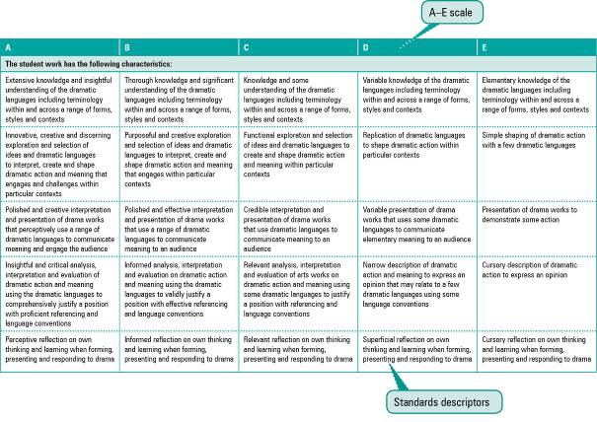

Assessment techniques and instruments
Each Year 10 learning area describes assessment techniques valued in the particular learning area and its related senior subjects.
The assessment advice is for guidance only, and is provided to assist teachers to develop an effective assessment program. It does not represent a required or mandatory approach.
The advice includes details about the typical formats of the assessment instruments and suggests conditions for implementing particular instruments in Year 10.
Teachers can use this information to develop assessment programs that:
- assist students to develop familiarity with the assessment in Years 11–12
- provide students with feedback on their learning
- provide evidence of student achievement.
Diagram 2 shows a typical assessment technique description.
Diagram 2: Sample assessment technique description
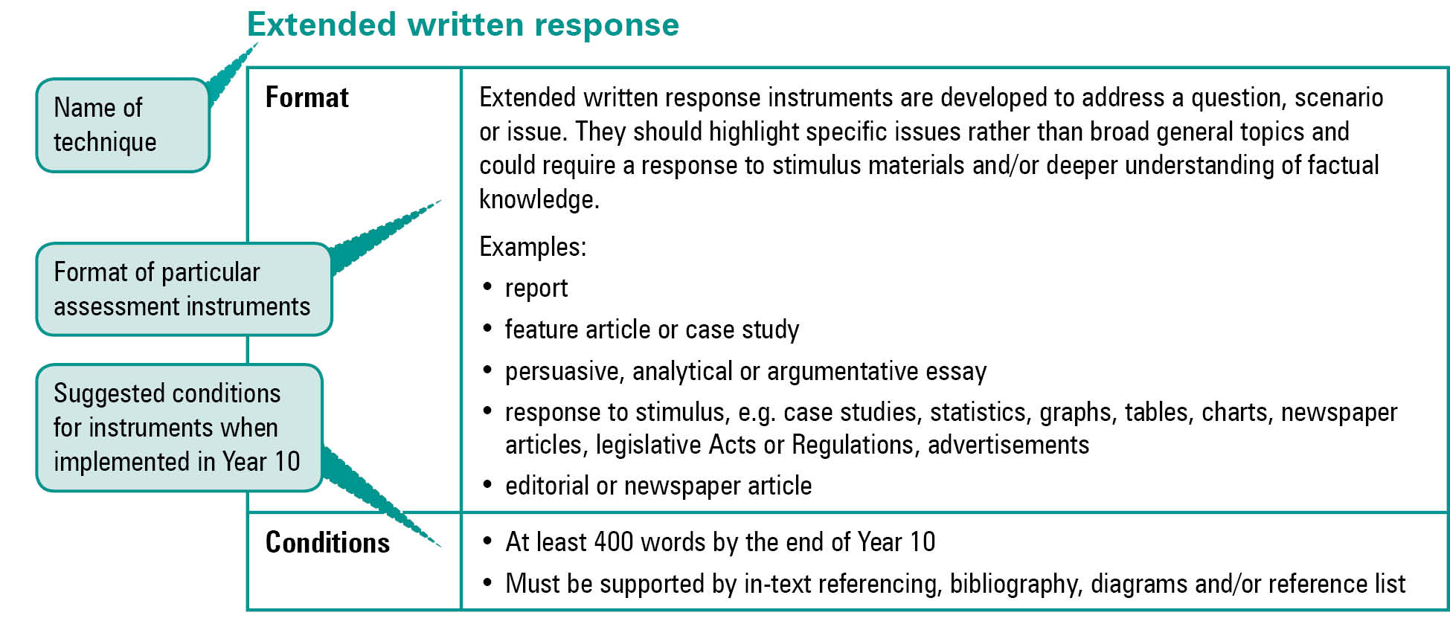
Quality assessment instruments have the following characteristics:
instrument descriptions
instrument-specific criteria sheets / guide to making judgments
instrument conditions.

Instrument descriptions
Instrument descriptions provide succinct and easily understood directions of what students must do.

Instrument-specific criteria sheets / guides to making judgments
Instrument-specific criteria sheets / guides to making judgments are developed from the Standards descriptors and provided to students before they respond to an assessment instrument, preferably at the beginning of a unit of work. These will help students understand the qualities the teacher will be looking for in their responses to the assessment instruments. Schools should note that not all aspects of knowledge and understanding and ways of working will be assessed in any one task. Aspects must be selected according to instrument demands.
Criteria sheets / guides to making judgments provide:
- descriptions of the qualities of student work in each of the selected aspects of knowledge and understanding and ways of working across A–E standards
- instrument-specific information on which teachers’ judgment will be based.

Instrument conditions
To develop assessment instruments that are realistic and achievable for students, teachers should give careful consideration to instrument conditions. All aspects of instrument conditions and demands need to be considered when making judgments about the student work.
Instrument conditions need to be stipulated on each instrument sheet, and detail:
- time and length requirements including:
- word length (written) or time length (spoken/signed)
- amount of time for the instrument (exam/test)
- notice of instrument (e.g. three weeks notice)
- amount of time for drafting or rehearsing
- access to resources, and any conditions which influence the access to material and human resources (e.g. seen or unseen question)
- drafting and/or rehearsing information
- details of scaffolding.

Assessment judgments and determining an overall result
Teachers make judgments about student work on individual assessment instruments, as well as making an overall judgment about a collection of student work (a folio).
The standard awarded for either an individual assessment instrument or a folio of work is an on-balance judgment about how the qualities of the student’s work match the typical Standards outlined in the learning area.
It is not necessary for a student to have met every descriptor for a particular standard in knowledge and understanding and ways of working to be awarded that standard.
Schools, in constructing their courses of study, decide which aspects of knowledge and understanding and ways of working will be covered and which ones may be reported on.
By using the Standards, schools will be able to report about student achievement in knowledge and understanding and ways of working. Schools will also be able to report on the overall standard for the course of study.
Recording student results for knowledge and understanding and ways of working for each assessment instrument on a student profile will help teachers in keeping records of student achievement.

Resources
Three useful references for developing quality assessment are:
- Learning P–12, QSA 2009, accessed 10 Jun 2009,
<www.qsa.qld.edu.au> (select Learning P–12 > Learning P–12).
Describes the relationships between the various syllabuses and guidelines produced by the QSA for the Preparatory Year through to Year 12.
- P–12 Assessment Policy, QSA 2009, accessed 10 Jun 2009, <www.qsa.qld.edu.au> (select Assessment > Overview > P–12 assessment policy).
Assessment in Year 10 should be guided by the principles of assessment described in this policy.
- Guidelines for Assessment Quality and Equity, Australian Curriculum, Assessment and Certification Authorities (ACACA) 1995, accessed10 Jun 2009, <http://acaca.bos.nsw.edu.au> (select ACACA documents > Guidelines for Assessment Quality and Equity.
Describes the characteristics of quality assessment instruments.

Health and Physical Education (HPE) learning area

Rationale
Health and Physical Education (HPE) is a school-based subject that draws on many disciplines and fields of study in the construction of its identity. HPE reflects the dynamic and multidimensional nature of health and recognises the significance of physical activity in the lives of individuals and groups in Australian society. It provides a foundation for developing active and informed members of society, capable of managing the interactions between themselves and their social, cultural and physical environments in the pursuit of good health.
The focus of HPE is the integration of students’ physical, personal, social, mental and emotional health and wellbeing. Through engagement in learning experiences and assessment opportunities, students are challenged to understand the effects that culture, society, socioeconomic status and education have on their own and others’ wellbeing. They will understand the contribution they can make to the improvement of individual, family and community health outcomes by exploring issues particular to themselves, their peer group and their family, and advocating for change.
The overarching goals for HPE in Year 10 are for students to:
- individually and collaboratively make decisions, apply skills and take action to promote and advocate their own and others’ health and safety
- enhance their own and others’ participation and performance in physical activity through acquiring, applying and evaluating movement skills, concepts and strategic awareness
- develop and refine personal and interpersonal skills and strategies to promote positive relationships
- reflect on how physical, social, cultural and environmental factors influence a person’s health, physical activity and personal development.
HPE has three organisers:
- health
- physical activity
- personal development.
The health organiser emphasises that health is multidimensional and is influenced by the interaction of personal, social, cultural and environmental factors that shape how individuals, groups and communities think about and act on health-related matters. Students will also understand that it is the interaction of these factors that determine their potential to take actions to improve their own and others’ health. The focuses in the Year 10 Guidelines are health issues that effect adolescents and families, including nutrition and eating behaviours.
Participation in physical activities is central to the physical activity organiser. The physical activities provide the medium for acquiring understandings about physical activity concepts, motor skills, and the strategic awareness required for participation. The physical activities chosen by schools should support the courses that the school offers in the next phase of schooling. Through evaluation and reflection, students learn to appraise their own and others’ performances and the factors that facilitate or inhibit performance and participation. The focuses in the Year 10 Guidelines are strategies for improving and modifying performance and the sociocultural influences that determine individual, group and community participation in physical activity.
The personal development organiser acknowledges that personal identity, relationships, and growth and development are key aspects of a person’s health. Assuming roles and responsibilities, experiencing success, respecting difference and working well with others develop students’ positive personal identity and the ability to adjust to life events and transitions.
In Year 10 HPE studies, personal development focus is on self-concept and self-esteem and the influence these have on relationships, and effective communication and conflict resolution. Effective communication skills are integral to personal development as they help establish and maintain relationships in family, school and community settings.
In Year 10 Geography, students develop the ability to analyse and explain increasingly complex spatial associations and interactions of systems and human activities in Australia and in other parts of the world. They further their awareness of the global links between environments and the impact of globalisation on their own and other people’s lives.
Diagram 3 on page 11 illustrates the pathways available to students from learning planned with the Year 10 Guidelines.
The HPE learning area leads directly to the study of senior Physical Education and Health Education (Authority subjects) and Recreation (Authority-registered subject), as well as supporting aspects of Food studies and Living environments from senior Home Economics.

Diagram 3: Health and Physical Education (HPE) pathways
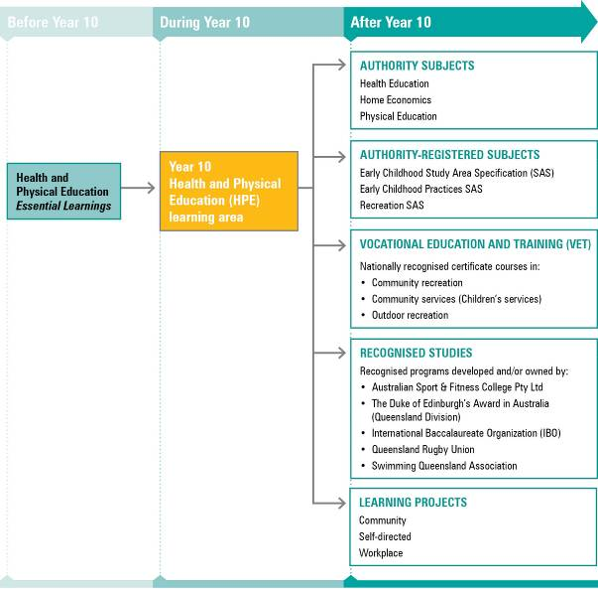
NOTE: For a full and current list of subjects, courses, and recognised studies visit the QSA website <www.qsa.qld.edu.au>.

Learning statements
The learning statements are structured around ways of working and knowledge and understanding.
Knowledge and understanding is developed through the application of the ways of working in learning experiences and assessment.
Knowledge and understanding is organised by the concepts of Health, Physical activity, and Personal development. These concepts represent common and valued aspects of HPE.

Ways of working
Students are able to work individually and in groups to:
- plan investigations, actions and activities
- collect, sort and analyse information and resources
- trial actions and strategies
- evaluate information, draw conclusions and make decisions
- examine risk, and decide upon and apply safe practices
- create and perform movement sequences through modifying and combining movement skills and applying movement concepts
- select and demonstrate personal development skills and strategies.

Knowledge and understanding
Students know and understand:

Health
Health is multidimensional and is influenced by the interaction of personal, social, cultural and environmental factors that shape how individuals, groups and communities think about and act on health-related matters.
Health outcomes are influenced by the interrelationships between health determinants.
e.g. While socioeconomic status is the single strongest indicator for health outcomes, education and environment are also interdependent indicators.
The health issues of adolescents impact on the health of families, and vice versa.
e.g. Adolescence is a time of emotional turmoil and emerging health issues (e.g. illicit drug use, sexual health) for many young people as they strive for individual identity and belonging with their peers and within the family.
Healthy eating improves performance in all areas of life.
e.g. Eating behaviours established in adolescence, where young people gain increased responsibility over what, how and when they eat, are often lifelong.

Physical activity
Application of physical activity theories, concepts and strategies improve performance and influence participation in physical activity.
Participation in physical activity is influenced by many factors.
e.g. Children with active parents are more likely to be physically active now and throughout life; the choice of recreation activities is often influenced by socioeconomic status.
Individual and group performance strategies in physical activities can improve performance.
e.g. Within a team, understanding an individual’s strengths can improve overall performance; applying and modifying psychological, training and skill acquisition strategies to the performances of self and others will improve performance.

Personal development
Assuming roles and responsibilities, experiencing success, respecting difference and working well with others develop positive identity and abilities to adjust to life events and transitions.
Self-concept and self-esteem are influenced by the interrelatedness of internal and external factors that affect a person’s behaviour, and in turn influence the relationships between individual persons, between individuals and the family, and between individuals and the community.
e.g. Many mental and emotional health issues that influence how a person relates to others stem from a lack of self-concept and self-esteem.
Effective communication and cooperation skills are required to implement decisions and to resolve conflict.
e.g. Being able to understand, discuss and empathise with another’s point of view is necessary to solve a conflict.

Standards: Health and Physical Education (HPE) (table continues over the page)
A | B | C | D | E
The student work has the following characteristics:
Thorough explanations of the significant and relevant interrelationships among the determinants for health | Explanations of the relevant interrelationships among the determinants for health | Descriptions of the relevant interrelationships among the determinants for health | Descriptions of the determinants for health | Listing of aspects of the determinants for health
Thorough explanation of the significant relevant differences and relationships between adolescent health and the health of families | Explanation of the relevant differences and relationships between adolescent health and the health of families | Description of relevant differences and relationships between adolescent health and the health of families | Descriptions of differences between adolescent health and the health of families | Listing of aspects of adolescent health or the health of families
Thorough explanations of links between healthy eating behaviours and performance | Explanations of links between healthy eating behaviours and performance | Descriptions of links between healthy eating behaviours and performance | Listing of facts about healthy eating behaviours and performance | Listing of aspects of healthy eating behaviours or performance
Thorough explanations of significant relevant individual and group performance strategies that improve physical performance | Explanations of relevant individual and group performance strategies that improve physical performance | Descriptions of relevant individual and group performance strategies that improve physical performance | Listing of individual and group performance strategies that improve physical performance | Listing of aspects of individual or group performance strategies
Thorough explanations of significant relevant factors that influence participation in physical activity | Explanations of relevant factors that influence participation in physical activity | Descriptions of relevant factors that influence participation in physical activity | Listing of factors that influence participation in physical activity | Listing of aspects of participation in physical activity
Thorough explanations of the beneficial relationships between complex self-concept and self-esteem strategies | Explanations of the beneficial relationships between complex self-concept and self-esteem strategies | Explanations of simple self-concept and self-esteem strategies | Descriptions of simple self-concept and self-esteem strategies | Mention of simple self-concept and self-esteem strategies
Effective significant communication and advanced cooperative skills | Effective communication and cooperative skills | Relevant communication and cooperative skills | Communication and cooperative skills | Aspects of communication or cooperative skills
Detailed and effectively planned investigations, actions and activities | Effectively planned investigations, actions and activities | Planned investigations, actions and activities | Aspects of investigations, actions and activities planned | Listing of some aspects of investigations or activities
Significant and relevant information and resources collected and insightfully analysed | Relevant information and resources collected and thoroughly analysed | Collection and analysis of information and resources | Collection of information and resources with some similarities and differences identified | Provided information and resources presented with some similarities and differences identified
Significant actions and complex relevant strategies thoroughly trialled | Significant actions and relevant strategies trialled | Relevant actions and strategies trialled | Aspects of actions and strategies trialled | Actions attempted

Standards: Health and Physical Education (HPE) (continued from previous page)
A | B | C | D | E
The student work has the following characteristics:
Insightful evaluation with significant and logical decisions proffered and convincing conclusions drawn | Thorough evaluation with logical decisions proffered and defensible conclusions drawn | Evaluations with decisions made and reasonable conclusions drawn | Information presented with conclusions drawn | Points of view expressed
Performance of complex movement sequences that modify and combine sophisticated movement skills, demonstrating advanced and successful application of movement concepts | Performance of movement sequences that modify and combine movement skills, demonstrating the successful application of movement concepts | Performance of simple movement sequences that combine rehearsed movement skills, demonstrating the application of movement concepts | Performance of simple movement sequences that combine rehearsed movement skills, demonstrating learnt movement concepts | Performance of rehearsed movement sequences
Insightful application of significant and relevant personal development skills and effective complex strategies in team and group situations | Application of personal development skills and effective strategies in team and group situations | Application of personal development skills and suitable strategies in team and group situations | Application of personal development skills and strategies in team and group situations | Application of personal development skills

Assessment

Planning an assessment program
Schools should refer to Using the Year 10 learning areas: assessment advice on page 5 when planning an assessment program. For HPE, an effective assessment program should provide opportunities for students to demonstrate their learning across:
- the Standards
- types of assessment, including written, spoken, multimodal and practical/physical modes
- a range of assessment conditions.

Assessment techniques and instruments
The following advice has been designed to help schools use the Year 10 HPE learning area to build student learning towards assessment techniques that are valued in the senior phase of learning. The suggested formats and conditions are modified from those in senior syllabuses to suit Year 10 learners.
When developing assessment programs and individual assessment instruments, consider that:
- assessment opportunities should encompass both knowledge and understanding and ways of working as integrated and interdependent entities
- students’ performance in ways of working is dependent on the depth of their understanding of the facts and concepts developed in knowledge and understanding
- assessment instruments, where possible, should be developed through an inquiry process.
Practical performances
Format | Ongoing observation of students involved in doing an activity/task/performance
Conditions | • Normally multiple opportunities to demonstrate through doing what they know and can do  • Performances based in a context as authentic as possible
Research assignments/reports
Format | Research assignments and reports may involve:  • an extended written response based on data collection, literature review or both  • a response to a question, problem, hypothesis, issue or stimulus.  Possible products:  • continuous piece of prose (e.g. essay)  • report with headings and other generic requirements depending on type of report, audience and purpose.  All products should have:  • justifications  • recommendations or conclusions.
Conditions | • Emphasis is on the research process  • Students should use research skills and demonstrate the literacy requirements of research task (e.g. referencing, interpretation of information from various sources)  • Students should demonstrate the numeracy skills applicable to research tasks  (e.g. statistical analysis, interpretation of graphic information)  • Class and own time required  • 600–800 words (excludes references, quotes, diagrams, graphs etc.)
Integrated tasks
Format | Integrated tasks may involve:  • an extended task that is process-driven, normally as the result of an investigation  • practical, written, spoken or multimodal components  • production of a number of pieces of student work that need to be considered together when making judgments.
Conditions | • Emphasis is on the investigation or action research processes  • Class and own time required  • Length, time or mode of presentation/action dependent on task
Essays under supervised conditions
Format | Extended written text in response to a question, issue or stimulus
Conditions | • Completed in a single, uninterrupted session  • Question/task unseen before the examination  • Perusal time may be allowed  • 60–90 minutes  • 500–600 words
Interactive oral tasks
Format | An oral task that has a significant component that is interactive with the audience (e.g. interview, panel presentation), and may be multimodal in delivery.
Conditions | • Class and own time required for development  • May be individual or small group  • Length, time or mode of presentation/action dependent on task  (e.g. 3–5 minutes)
Multimodal presentations
Format | Multimodal presentations are expository instruments that:  • use ICTs and a combination of text types (visual, written, spoken)  • incorporate research components  • may be in response to a question, problem, hypothesis, issue or stimulus.
Conditions | • Class and own time required for development  • May be individual or small group  • Length and time dependent on task (e.g. 3–5 minutes)

Course advice

Planning a course of study
The development of a course of study is a school-based decision. A school may decide to use all or part of the information contained in this learning area to construct a course of study. The Guidelines may be used to plan:
- the final year of a Years 8–10 HPE course
- part of a specialised Years 9–10 or Year 10 course (e.g. Home Economics, Health Education, Physical Education, Physical Recreation)
- an integrated multidisciplinary or transdisciplinary course of study that combines learning statements from other learning areas
- term- or semester-length units of work
- the first year of a three-year senior course of study.

Considerations for planning courses of study in Year 10 HPE
Schools constructing a year-long HPE course should consider the following:
- Unit length should allow for in-depth study (e.g. 4–6 units of work, each 6–10 weeks in duration).
- Learning experiences and assessment, where possible, should be integrated and personalised.
- Assessment instruments should be constructed to introduce aspects of the demands of senior courses of study.
- A balance and variety of assessment instruments should be included.
- When courses include physical activities:
- at least half of units should be based around a physical activity context
- at least half of the physical activities should have a strong recreational focus. These activities should be suitable for family participation (e.g. bushwalking) and should be used to facilitate learning in both health and personal development.

Examples of courses of study
Diagram 4 on page 19 describes examples of ways to plan and package courses of study using the Year 10 HPE learning statements. These examples do not preclude other ways of planning and packaging the learning statements. The examples are described as:
- units — referring to term- or semester-length units planned around a particular topic or theme (contexts)
- courses — referring to a series of units over a year planned around a particular school subject.
Diagram 4: Planning a Year 10 Health and Physical Education (HPE) course of study
