History
Learning area

This document has been generated from the PDF version to support teachers.
The PDF version is the official publication.
First edition released January 2009
History learning area extract from second edition June 2009
© The State of Queensland (Queensland Studies Authority) 2009
Ground floor, 295 Ann Street Brisbane
PO Box 307 Spring Hill Queensland 4004 Australia
Phone: +61 7 3864 0299
Fax: +61 7 3221 2553
Email: office@qsa.qld.edu.au
Website: www.qsa.qld.edu.au
NOTE: This publication contains images that may cause distress to Indigenous Australians.

Special notes on terminology:
• When The Arts is referred to as a subject or key learning area, both words are capitalised. However, when the arts are referred to in a generic way, this is presented in lower case.
• Standards, as part of the terminology of the Year 10 Guidelines and the Essential Learnings,
is presented with an initial capital letter. However, standards in the generic sense is always lower case.

Organisation of the Year 10 learning areas
Each learning area is organised in the same way and includes a rationale, learning statements, Standards, and advice about assessment and planning courses of study. The advice can be used by teachers to guide their planning to best meet the learning needs of their students, using contexts that are relevant.

Rationale
Each learning area begins with a rationale that describes:
the discipline or the field of study on which the learning area is based
the school subject or subjects that are drawn from the learning area
the nature of Year 10 learners and learning in the learning area.
The rationale also features a pathways diagram that shows how the Year 10 learning area transitions from the Years 1–9 Essential Learnings and is the foundation for the pathways available in the senior phase of learning.

Learning statements
The learning statements identify what is important for students to be taught and what is important for students to learn. The learning statements continue the use of the terms used in the Years 1–9 Essential Learnings and Standards.

Knowledge and understanding
Knowledge and understanding describes concepts, facts and procedures of the learning area. These are presented under organisers that relate to the broad conceptual categories that are the focus of the learning area. In some Year 10 learning areas these organisers are identical to the Years 1–9 key learning area (KLA) organisers, while others use organisers that have greater similarity to the senior syllabuses.

Ways of working
The ways of working identify the processes associated with the particular learning area. These processes emphasise the higher-order thinking skills that support the development of deep understandings in Years 1–9 and have close connections to the processes described in the KLAs. The Year 10 learning area ways of working are at the same time more specific to the Years 11–12 syllabuses. For example, the broad social and environmental inquiry processes of the Years 1–9 Studies of Society and Environment (SOSE) KLA develop into the historical inquiry process in Year 10 History.

Standards
The Standards for each Year 10 learning area describe the expected qualities of a collection of student work on an A–E scale. The Standards descriptors are linked to the learning statements.
The Standards in Year 10 draw on the standards frameworks from Years 1–9 and Years 11–12 and relate both to the assessable elements of the Essential Learnings and the dimensions of the Years 11–12 syllabuses. Schools should use the Standards to:
make judgments about a collection of student work
develop criteria sheets / guides to making judgments to suit their course structure and individual assessment techniques.

Assessment
Year 10 learning areas include advice about planning a school-based assessment program and information about important assessment techniques for each learning area.
The specific guidance about assessment in the particular learning area includes assessment techniques, and the formats and conditions appropriate for developing assessment instruments.
This advice will assist transition to the assessment demands of specific Years 11–12 syllabuses and the senior phase of learning generally.

Course advice
Information about planning courses of study is provided for each Year 10 learning area. Examples of ways to plan using the Year 10 learning statements are described as:
- units — referring to term- or semester-length units planned around a particular topic or theme (contexts)
- courses — referring to a series of units over a year planned around a particular school subject.

Using the Year 10 learning areas: planning courses of study
Curriculum planning is a school-based decision. Schools may choose to use all or part of the information contained in the Guidelines, or use all or part of individual Year 10 learning areas to construct units or courses of study.
The Guidelines include five broad options for planning courses of study using the Year 10 learning areas:
- units
- Year 10 courses
- Years 9–10 or Years 8–10 courses
- Years 10–12 courses
- integrated multidisciplinary or transdisciplinary courses.

Units
Term- or semester-length units can be planned from a selection of the learning statements. Units could serve as an introduction to a particular learning area or specific subject in Years 11–12. Schools may use units as a marketing tool to “sell” specific Years 11–12 subjects.

Year 10 courses
Stand-alone single-year courses in Year 10 can be developed around the learning statements of a single Year 10 learning area or across one or more learning areas. For example, Year 10 Geography would be planned from the Year 10 Geography learning statements, whereas Year 10 Home Economics would be planned from Year 10 Technology and Year 10 Health and Physical Education.

Years 9–10 or Years 8–10 courses
Two- and three-year courses across Years 9–10 or Years 8–10 can be developed from the learning statements of Year 10 learning areas and Years 1–9 Essential Learnings. For example, The Arts subjects in lower secondary could be developed from the specific organisers in the Years 1–9 Essential Learnings and the Year 10 learning area to create courses in Visual Art, Drama, Dance, Music and Media.
Structuring curriculum as Years 9–10 or Years 8–10 courses builds on the current practice of a large number of Queensland secondary schools. Many schools offer lower secondary courses of study using the key learning areas shaped as specific school subjects.
Traditionally, these courses have provided some degree of transition to senior subjects and have provided a “sampler” to help students make an informed decision when choosing senior subjects. Using the learning statements from the Year 10 Guidelines will further strengthen this approach.

Years 10–12 courses
Some schools have developed three-year courses across Years 10–12. These courses describe a coherent three-year senior phase of learning where Year 10 is a foundation year.
Years 10–12 courses can be developed using the Year 10 learning areas and the relevant senior syllabuses. For example, a three-year course in Physics would draw from the Year 10 Science learning area and the senior Physics syllabus. A three-year History course would draw from the Year 10 History learning area and either the senior Modern History or Ancient History syllabus.
Based on their learning experiences in the first year of the course, students should have options to decide to:
- continue the course in Years 11–12
- make an alternative decision within the learning area, for example, elect to do Chemistry rather than Physics or choose Ancient History rather than Modern History
- choose a different pathway, for example, choose not to participate in a senior science or history subject.

Integrated multidisciplinary or transdisciplinary courses
Integrated multidisciplinary or transdisciplinary courses are common in some school settings, particularly middle schools.
These courses can be planned from learning statements across learning areas. In many instances, an organiser that crosses the learning area is used to give coherence to the planning of these courses.

Using the Year 10 learning areas: assessment advice
Assessment is a fundamental and integral part of the teaching and learning process and must be planned and ongoing. Assessment is used to:
- promote, assist and improve learning
- substantially contribute to the construction of programs of teaching and learning
- provide information for students, teachers, parents and carers about the progress and achievements of individual students to help them achieve as well as they are able.
Assessment in Year 10 should be guided by the principles of assessment described in the QSA’s P–12 Assessment Policy. See Resources on page 8 for details.

School-based assessment
During Year 10, assessment should continue the approaches of school-based assessment begun in Years 1–9 and build towards the externally moderated system of Years 11–12. Assessment in Year 10 is:
- standards-based. The Guidelines set out content and achievement standards. The learning statements are the content standards for each Year 10 learning area. These are statements of what students are expected to know and do by the end of Year 10. The achievement standards are linked to each set of learning statements and are reference points that describe how well students have achieved the learning statements
- diagnostic. The Guidelines provide an opportunity to use assessment to determine the nature of students’ learning difficulties as a basis for providing feedback or intervention
- formative. The main focus of assessment in Year 10 is on improving student learning to assist their transition to the senior phase of learning
- summative. Assessment in Year 10 can indicate standards achieved at particular points for reporting purposes.
Year 10 assessment is an opportunity for schools and teachers to develop students’ assessment literacy or familiarity with the processes and practices used in the senior syllabuses.
To develop assessment literacy for Years 11–12, a Year 10 assessment program should introduce and apply important ideas about school-based assessment from the principles of exit assessment in the senior syllabuses. These principles are:
- continuous assessment, or gathering information on student achievement over a course of study, using assessment instruments administered at suitable intervals
- balance of assessment, or making judgments about students’ achievements using a variety of assessment techniques and a range of assessment conditions over the course of study
- fullest and latest information, or making judgments about student achievement based on information gathered from the range of learning statements and from the most recent assessment of achievement.
Each Year 10 learning area provides assessment advice about Standards and assessment techniques and instruments.

Standards
Each learning area has a set of broad standards expressed as descriptors of quality on an A–E scale. The Standards are linked to the learning statements.
Diagram 1 shows a typical Standards table.

Diagram 1: Sample Standards table (The Arts — Drama)
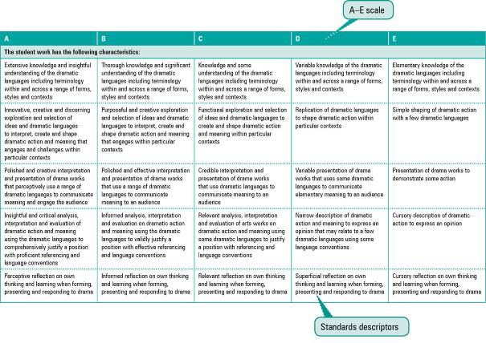

Assessment techniques and instruments
Each Year 10 learning area describes assessment techniques valued in the particular learning area and its related senior subjects.
The assessment advice is for guidance only, and is provided to assist teachers to develop an effective assessment program. It does not represent a required or mandatory approach.
The advice includes details about the typical formats of the assessment instruments and suggests conditions for implementing particular instruments in Year 10.
Teachers can use this information to develop assessment programs that:
- assist students to develop familiarity with the assessment in Years 11–12
- provide students with feedback on their learning
- provide evidence of student achievement.
Diagram 2 shows a typical assessment technique description.
Diagram 2: Sample assessment technique description
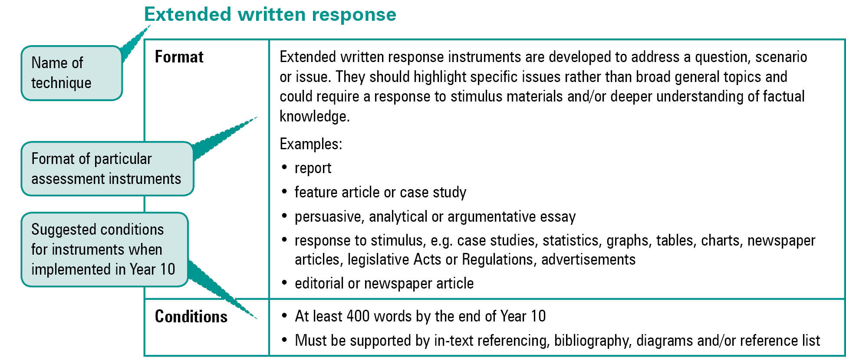
Quality assessment instruments have the following characteristics:
instrument descriptions
instrument-specific criteria sheets / guide to making judgments
instrument conditions.

Instrument descriptions
Instrument descriptions provide succinct and easily understood directions of what students must do.

Instrument-specific criteria sheets / guides to making judgments
Instrument-specific criteria sheets / guides to making judgments are developed from the Standards descriptors and provided to students before they respond to an assessment instrument, preferably at the beginning of a unit of work. These will help students understand the qualities the teacher will be looking for in their responses to the assessment instruments. Schools should note that not all aspects of knowledge and understanding and ways of working will be assessed in any one task. Aspects must be selected according to instrument demands.
Criteria sheets / guides to making judgments provide:
- descriptions of the qualities of student work in each of the selected aspects of knowledge and understanding and ways of working across A–E standards
- instrument-specific information on which teachers’ judgment will be based.

Instrument conditions
To develop assessment instruments that are realistic and achievable for students, teachers should give careful consideration to instrument conditions. All aspects of instrument conditions and demands need to be considered when making judgments about the student work.
Instrument conditions need to be stipulated on each instrument sheet, and detail:
- time and length requirements including:
- word length (written) or time length (spoken/signed)
- amount of time for the instrument (exam/test)
- notice of instrument (e.g. three weeks notice)
- amount of time for drafting or rehearsing
- access to resources, and any conditions which influence the access to material and human resources (e.g. seen or unseen question)
- drafting and/or rehearsing information
- details of scaffolding.

Assessment judgments and determining an overall result
Teachers make judgments about student work on individual assessment instruments, as well as making an overall judgment about a collection of student work (a folio).
The standard awarded for either an individual assessment instrument or a folio of work is an on-balance judgment about how the qualities of the student’s work match the typical Standards outlined in the learning area.
It is not necessary for a student to have met every descriptor for a particular standard in knowledge and understanding and ways of working to be awarded that standard.
Schools, in constructing their courses of study, decide which aspects of knowledge and understanding and ways of working will be covered and which ones may be reported on.
By using the Standards, schools will be able to report about student achievement in knowledge and understanding and ways of working. Schools will also be able to report on the overall standard for the course of study.
Recording student results for knowledge and understanding and ways of working for each assessment instrument on a student profile will help teachers in keeping records of student achievement.

Resources
Three useful references for developing quality assessment are:
- Learning P–12, QSA 2009, accessed 10 Jun 2009,
<www.qsa.qld.edu.au> (select Learning P–12 > Learning P–12).
Describes the relationships between the various syllabuses and guidelines produced by the QSA for the Preparatory Year through to Year 12.
- P–12 Assessment Policy, QSA 2009, accessed 10 Jun 2009, <www.qsa.qld.edu.au> (select Assessment > Overview > P–12 assessment policy).
Assessment in Year 10 should be guided by the principles of assessment described in this policy.
- Guidelines for Assessment Quality and Equity, Australian Curriculum, Assessment and Certification Authorities (ACACA) 1995, accessed10 Jun 2009, <http://acaca.bos.nsw.edu.au> (select ACACA documents > Guidelines for Assessment Quality and Equity.
Describes the characteristics of quality assessment instruments.

History learning area

Rationale
History is the study of the past. It is also a study of people, societies, cultures, events and ideas, and their interrelationships. History is:
- an academic discipline
- a community activity
- a key element of personal and cultural heritages
- a central component of societies’ collective memory, commemorations and representations of the past in popular culture
- a school subject.
As an academic discipline, it is a study through which historians investigate, interpret, explain and describe changes and consequences in human affairs over time. History is also a component of learning in other disciplines and fields of study, including literature, media and cultural studies, sociology, the sciences, the arts and languages. In this regard, history is positioned both in the social sciences and the humanities. Historical method is a process that is similar to other social science methodologies in that it uses sources to test hypotheses and develop interpretations. Additionally, the purpose of history is grounded firmly in the humanities, as it seeks to give people the tools to develop their understandings of humanity, and to make sense of cultures, identities and values.
History as a school subject exists as part of the curriculum in its own right and as part of the broader Studies of Society and Environment (SOSE) key learning area. The content of school history subjects is a publicly contested area and reflects the nature of history in democratic societies. However, while the important knowledge of the subject can be debatable, there is broad agreement that school History should involve students “doing history”, that is, employing elements of the historical method and developing the processes of “historical thinking”. School History develops an understanding of chronology and a broad narrative at various scales and in various settings. The value of this school subject lies in the cultural capital this learning gives to the learner, and the capabilities and skills that students can translate to future learning, employment and civic life. History in Australian schools obviously focuses on the significant topics from Australia’s past, but also includes topics that span eras from ancient to modern, and involve a wider global context.
The two broad purposes of history learning in Year 10 are to:
- prepare students for studying senior history subjects, other social and environmental studies, and the senior phase of learning generally
- provide students with a platform of socially valued knowledge, capabilities and dispositions regardless of students’ future pathways.
History learning in Year 10 allows students to enquire into more specialised historical topics based on the “big ideas” of history. It places student inquiry at the centre of the learning used to investigate these topics and makes students aware that they can create their own views and make their own decisions about people, societies, cultures, events and ideas. It also caters for adolescent learners who are gaining a greater depth in their understanding of different perspectives on past events, and who are developing an adult awareness of the complexities associated with issues of cultures, identity, values and social systems. To this end, studying History in Year 10 should contribute to:
- the development of critical citizenry, the key component of active and informed citizenship
- civic knowledge, including an understanding of the principles of governance, and the role of government and policy in topics for historical investigation
- an understanding and appreciation of relevant geographical locations, especially the Asia–Pacific region, its peoples, environments, cultures, belief systems and societies
- an understanding of Australia’s ethnic and cultural diversity.
Learners in Year 10 particularly look for relevance, engagement and future application in their studies. History, when structured around inquiry learning, can offer this to students beginning their senior phase of learning.
Diagram 3 illustrates the pathways available to students from learning planned with the Year 10 Guidelines.
Diagram 3: History pathways
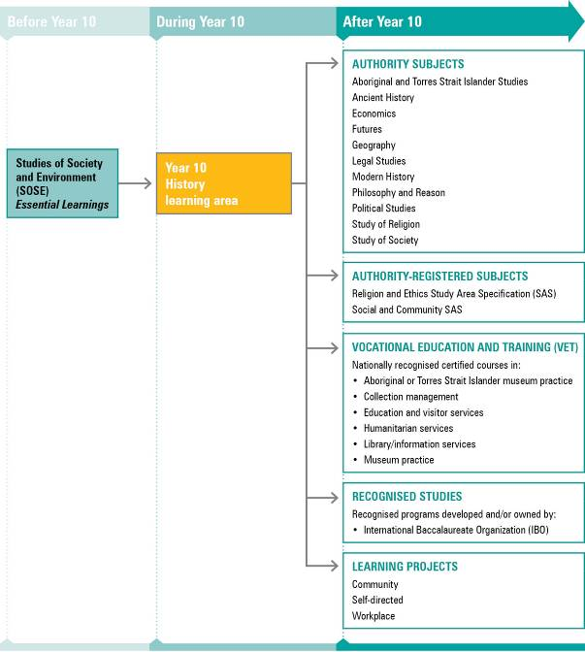
NOTE: For a full and current list of subjects, courses, and recognised studies visit the QSA website <www.qsa.qld.edu.au>.

Learning statements
The learning statements are structured around ways of working and knowledge and understanding.
Ways of working are developed from the processes of historical inquiry, which include the investigation of key historical ideas based on five major aspects:
- definitions
- sources
- backgrounds, changes and continuities: motives and causes
- effects, interests and arguments
- reflections and responses.
The organisers for knowledge and understanding are:
- time, continuity and change
- culture and identity
- systems.
These concepts represent the “big ideas” of historical learning and provide a framework to organise historical understandings.

Ways of working
Students are able to:
- identify issues or problems for investigation and design research questions
- plan investigations and use a historical inquiry process and its major aspects
- locate and use evidence from primary and secondary sources and maintain a record of research
- analyse and interpret explicit and implicit meanings in a range of historical sources
- evaluate sources of evidence for their worth, including their relevance, reliability, authenticity, purpose, bias and perspective
- draw conclusions and make decisions supported by interpretations of evidence
- communicate descriptions, interpretations and conclusions, using written and nonwritten text types specific to the study of history using the conventions of research-based texts
- reflect on the nature of historical sources, recognising inherent values and beliefs, and the tentative and interpretive qualities
- reflect on the research process and findings to revise and adapt the inquiry.

Knowledge and understanding
Students know and understand:

Time, continuity and change
Changes and continuities are connected to particular events, people and movements, understood through key historical ideas, definitions and concepts, and interpreted from different standpoints.
Past events are classified, organised and interpreted using descriptions of time and ideas which locate social, political, economic and cultural changes and continuities.
e.g. Eras (the Depression era), ages (the industrial age), periods (the interwar period), the swinging sixties, New Imperialism, the year of revolutions, post-9/11, the breakdown of the Roman republic.
Past events reveal values, beliefs and assumptions that have changed and continue to impact on present-day Australian public policy and community views.
e.g. Australian immigration policies and views on migrants have been shaped by national and international events, views on race and changes in the nature of Australian society. Events such as the Myall Creek massacre, the Eureka uprising, the female suffrage campaigns, the World War I conscription debate, the Wave Hill strike, the Whitlam dismissal of 1975 and the Tampa incident are controversial because of the underlying values, beliefs and assumptions.
Significant individuals and groups have influenced and contributed to historical changes in Australian and global contexts.
e.g. Eddie Mabo and his role in campaigning for land rights for Indigenous Australians, Germaine Greer and her influence on the movement for women’s rights, Mohandas Gandhi and his role in Indian independence, the Civil Rights movement in the United States and the changes in the citizenship rights of African Americans.
Changes and continuities in Australian and international settings reflect the dominant ideas and beliefs of particular historical eras.
e.g. Australian foreign policy has reflected ideas of empire, nationalism, anti-communism and internationalism; European expansion between the 16th and 19th centuries reflects the ideas of imperialism and colonialism.
Present-day societies have their origins in ancient and pre-modern civilisations and eras, and their development reflects a heritage of significant ideas from Eastern and Western cultures.
e.g. The development of ideas about religion, philosophy, science, the arts, law, politics and governance, and social structures can be traced to specific ancient civilisations — Rome, Greece, China, and historical periods such the Enlightenment, Renaissance, Reformation and age of revolutions.
Historians and public figures influence the points of view from which historical events are analysed, and how evidence of the past is interpreted.
e.g. The coming of Europeans to Australia — invasion or settlement?; the changing interpretations of Australians at war — the ANZAC myth, the significance of the Western Front, the “battle for Australia” and the status of Vietnam veterans; the view of the Holocaust in modern Germany; the treatment of Word War II in Japanese school textbooks.

Culture and identity
Cultures and identities are shaped by events, people and movements and their development reflects how the past can promote division, cohesion and diversity.
Aboriginal cultures and Torres Strait Islander cultures are shaped by contact with non-Indigenous cultures and this contact has had positive and negative impacts.
e.g. Government policies on Indigenous peoples, including protection, assimilation, integration and self-determination and the responses to these polices, such as the 1967 referendum, the reconciliation movement and the recognition of land rights and native title, have changed attitudes to the rights and freedoms of Aboriginal and Torres Strait Islander peoples and the value placed on Indigenous cultures.
Australian cultures and identities have been shaped by international events and connections to other nations.
e.g. The influences of Britain and the United States on Australian popular culture in the post-1945 period; the influences of Asia on Australian national identity since 1972.
Globalisation of culture has produced responses which seek to reject or moderate its homogenising effects.
e.g. The renewal of nationalism in the post-Cold War era in the Asia–Pacific region; the rejection of Western “cultural imperialism” by some groups.
Cultural research involves following protocols and acting sensitively.
e.g. Acknowledging the ownership of Indigenous sources of knowledge; accessing sacred sites or places of significance through traditional custodians.

Systems
Social, political and economic systems in Australia and globally have changed over time, and events, people and movements have impacted on their ideas, institutions, principles and values.
Australian political and economic systems have been changed by people and movements that have campaigned for civil and political rights for specific groups of Australians.
e.g. Indigenous Australians, women’s groups, trade unions, church groups, student movements, industry groups, communities such as farmers, and special interest groups such as Queensland’s Right to March campaign, free David Hicks campaign; the reform of the Queensland electoral system, police service and public service as a result of the Fitzgerald Inquiry.
Australian systems of law and government can trace their development to events in Britain, the United States and Europe.
e.g. The development of constitutional monarchy and parliamentary government of the Westminster system, French and American Revolutions, the Chartist movement, the development of the French and American written constitutions.
Ideas of global citizenship have developed from social, political and economic events, and the responses of individuals and groups.
e.g. Political crises and environmental catastrophes in the developing world; the emergence of global warming as an international issue; the establishment of global campaigns for labour rights, wildlife conservation and environmental protection; the global interconnections through free trade agreements and the development of transnational businesses.
Australian governments have been influenced by and have responded to regional and global movements and events through membership of international organisations and participation in global systems of law, diplomacy, human rights, trade and security.
e.g. The role of Australia in establishing the United Nations Organization in 1945, Australia’s membership of the ANZUS and SEATO treaty organisations in the Cold War era, the role of Australia in United Nations Transitional Administration in East Timor between 1999 and 2002, and Australia’s continuing membership of unilateral organisations such as the Asia–Pacific Economic Cooperation (APEC) group, the Commonwealth Heads of Government Meeting (CHOGM) and the International Whaling Commission.

Standards: History
A | B | C | D | E
The student work has the following characteristics:
Comprehensive knowledge of events, people and movements, and key historical ideas, definitions and concepts | Thorough knowledge of events, people and movements, and key historical ideas, definitions and concepts | Accurate knowledge of events, people and movements, and key historical ideas, definitions and concepts | Narrow knowledge of events, people and movements, and key historical ideas, definitions and concepts | Fragmented knowledge of events, people and movements, and key historical ideas, definitions and concepts
Comprehensive understanding of the concepts of time, continuity and change, culture and identity, and systems | Thorough understanding of the concepts of time, continuity and change, culture and identity, and systems | Broad understanding of the concepts of time, continuity and change, culture and identity, and systems | Uneven understanding of the concepts of time, continuity and change, culture and identity, and systems | Fragmented understanding of the concepts of time, continuity and change, culture and identity, and systems
Comprehensive understanding of key historical ideas, definitions and concepts | Thorough understanding of key historical ideas, definitions and concepts | Broad understanding of key historical ideas, definitions and concepts | Uneven understanding of key historical ideas, definitions and concepts | Fragmented understanding of key historical ideas, definitions and concepts
Complex issues for investigation identified and probing historical research questions and appropriate subquestions designed | Significant issues for investigation identified and appropriate historical research questions and appropriate subquestions designed | Straightforward historical research questions and subquestions involving simple issues and familiar concepts designed and applied | Factually based historical research questions used | Factually based questions used
Investigations using a well-developed historical research process planned and detailed; systematic, coherent records of research created and maintained | Investigations using a historical research process planned and detailed, and coherent records of research created and maintained | Investigations using a historical research process planned, and coherent records of research created and maintained | Investigations using a research process and records of research created and maintained | Investigations using a research process and records of research maintained
Primary and secondary sources of historical evidence offering a range of perspectives located and organised with initiative, with perceptive reflection on the nature of historical sources and the research process and findings | Primary and secondary sources of historical evidence offering different perspectives located and used effectively, with thoughtful reflection on the nature of historical sources and the research process and findings | Primary and secondary sources of historical evidence located and used, with reflection on the nature of historical sources and the research process and findings | Primary and secondary sources of historical evidence located, with superficial reflection on the nature of historical sources and the research process and findings | Historical evidence located, with cursory reflection on the nature of historical sources and the research process and findings
Discerning interpretation, analysis and evaluation of explicit and implicit meanings in a range of historical sources | Logical interpretation, analysis and evaluation of explicit and implicit meanings in a range of historical sources | Interpretation, analysis and evaluation of explicit meaning, purpose and viewpoint in a range of historical sources | Narrow interpretation, analysis and evaluation of historical sources | Disjointed interpretation, analysis and evaluation of historical sources
Insightful conclusions drawn and supported by evidence | Well-reasoned conclusions drawn and supported by evidence | Obvious conclusions drawn and supported by evidence | Conclusions drawn and supported by opinions with some reference to evidence | Conclusions drawn and opinions stated
Descriptions, interpretations and conclusions fluently and coherently communicated using written and nonwritten text types and recognised referencing conventions | Descriptions, interpretations and conclusions clearly and coherently communicated using written and nonwritten text types and appropriate referencing conventions | Descriptions, interpretations and conclusions coherently communicated using written and nonwritten text types and generally sound referencing conventions | Descriptions unevenly communicated using written and nonwritten text types with some use of research text conventions | Descriptions disjointedly communicated in written and nonwritten text types with limited use of research text conventions

Assessment

Planning an assessment program
Schools should refer to Using the Year 10 learning areas: assessment advice on page 5 when planning an assessment program. For History, an effective assessment program includes a range and balance of assessment techniques providing opportunities for students to demonstrate their learning across:
- the Standards
- types of assessment instruments
- a range of assessment instrument conditions.

Assessment techniques and instruments
The following advice has been designed to help schools use the Year 10 History learning area to build student learning towards assessment techniques that are valued in the senior phase of learning. Particular to the transition into senior Ancient History and Modern History are the extended written response to historical sources, and research tasks that assess the process of research and the final product. The formats and conditions described are suggested and modified from those in senior syllabuses to suit Year 10 learners.
Extended written responses to historical sources
Format | Essay under supervised conditions in which the student gives a response to a question or statement, mainly by reference to sources supplied.  Sources are primary and secondary, and include at least some visual sources (e.g. graph, cartoon, photograph, map, illustration).  All sources supplied are relevant, reliable and representative, and have a clear perspective on the topic.
Conditions | - The question or statement may be provided before the test.  - All sources may be provided before the test.  - Students may have assistance from teacher with comprehension and interpretation of sources.  - Length depends on the complexity of the response required  (e.g. 60–90 minutes; 700 words).
Written research assignments
Format | Written assignment, based on a given research question and the use of a range of historical sources.  Examples:  • reflective report on research experience (based on a field trip or practical experience) including a contents page, introduction, outline of research strategy, findings to date, tentative conclusions, solved and unsolved problems, strategy for completing research, bibliography or list of references, and research notes  • written assignment, in which a hypothesis is tested or research question answered and conclusions drawn, and including a statement and development of hypothesis (if used)  • a form of presentation in which results of research are presented in a genre such as an analytical, persuasive or argumentative essay, a formal report, a journal, a feature article, a dialogue, or an interview with contextualising essay
Conditions | - Class time and student time used  - Referencing appropriate to the genre  - Research notes/record of research  - Length depends on the complexity of the response required  (e.g. 600–1000 words)
Multimodal presentations
Format | Multimodal presentations are the outcome of research and may take a wide variety of forms. All presentations should be accompanied by research notes. Presentations should conform to the characteristics of the mode and medium selected.  Examples:  • nonwritten assignment: seminar, debate or formal speech with script including referencing appropriate to the genre  • dramatic presentation followed by an out-of-role account and rationale for the script with accompanying key items of evidence  • video presentation that is interpretive and interactive  • computer simulation that is interpretive and interactive
Conditions | - Class time and student time used  - Referencing appropriate to the genre  - Research notes/record of research  - Length depends on the complexity of the response required  (e.g. up to 10 minutes)
Tasks under supervised conditions
Format | Short-response test including items requiring 1–2 line responses and short paragraph responses.  Response to stimulus tests.  Essay tests.  Other written responses under test conditions such as editorials and news articles.
Conditions | - Supervised test conditions  - Sources used provided or seen before the test, or some sources unseen  - Students may have assistance from teacher with comprehension and interpretation of sources  - Length depends on the complexity of the response required  (e.g. 60–90 minutes; 400–500 words)

Course advice

Planning a course of study
The development of a course of study is a school-based decision. A school may decide to use all or part of the information contained in this learning area to construct a course of study. The Guidelines may be used to plan:
- the final year of a Years 8–10 SOSE course
- part of a specialised Years 9–10 or Year 10 History course
- an integrated multidisciplinary or transdisciplinary course of study that combines learning statements from other learning areas
- term- or semester-length units of work
- the first year of a three-year senior course of study.

Considerations for planning courses of study in Year 10 History
Courses in History should consider these factors, where appropriate:
- range and balance of scales of study: local, regional, national and global
- range of geographical contexts: Australia, Asia-Pacific, Europe, Africa and Americas
- range of time periods within broader ancient and modern settings including up to 500 AD, 500 to 1800, 1800 to 1945, and post-1945
- selection of themes: broad areas of study and a selection of inquiry topics — in-depth inquiry-based topics of study
- processes and aspects of historical inquiry
- development of chronology and historical narrative across the length of the course.

Examples of courses of study
Diagram 4 on page 18 describes examples of ways to plan and package courses of study using the Year 10 History learning statements. These examples do not preclude other ways of planning and packaging the learning statements. The examples are described as:
- units — referring to term- or semester-length units planned around a particular topic or theme (contexts)
- courses — referring to a series of units over a year planned around a particular school subject.
Diagram 4: Planning a Year 10 History course of study
