Geography
Learning area

This document has been generated from the PDF version to support teachers.
The PDF version is the official publication.
First edition released January 2009
Geography learning area extract from second edition June 2009
© The State of Queensland (Queensland Studies Authority) 2009
Ground floor, 295 Ann Street Brisbane
PO Box 307 Spring Hill Queensland 4004 Australia
Phone: +61 7 3864 0299
Fax: +61 7 3221 2553
Email: office@qsa.qld.edu.au
Website: www.qsa.qld.edu.au
NOTE: This publication contains images that may cause distress to Indigenous Australians.

Special notes on terminology:
• When The Arts is referred to as a subject or key learning area, both words are capitalised. However, when the arts are referred to in a generic way, this is presented in lower case.
• Standards, as part of the terminology of the Year 10 Guidelines and the Essential Learnings,
is presented with an initial capital letter. However, standards in the generic sense is always lower case.

Organisation of the Year 10 learning areas
Each learning area is organised in the same way and includes a rationale, learning statements, Standards, and advice about assessment and planning courses of study. The advice can be used by teachers to guide their planning to best meet the learning needs of their students, using contexts that are relevant.

Rationale
Each learning area begins with a rationale that describes:
the discipline or the field of study on which the learning area is based
the school subject or subjects that are drawn from the learning area
the nature of Year 10 learners and learning in the learning area.
The rationale also features a pathways diagram that shows how the Year 10 learning area transitions from the Years 1–9 Essential Learnings and is the foundation for the pathways available in the senior phase of learning.

Learning statements
The learning statements identify what is important for students to be taught and what is important for students to learn. The learning statements continue the use of the terms used in the Years 1–9 Essential Learnings and Standards.

Knowledge and understanding
Knowledge and understanding describes concepts, facts and procedures of the learning area. These are presented under organisers that relate to the broad conceptual categories that are the focus of the learning area. In some Year 10 learning areas these organisers are identical to the Years 1–9 key learning area (KLA) organisers, while others use organisers that have greater similarity to the senior syllabuses.

Ways of working
The ways of working identify the processes associated with the particular learning area. These processes emphasise the higher-order thinking skills that support the development of deep understandings in Years 1–9 and have close connections to the processes described in the KLAs. The Year 10 learning area ways of working are at the same time more specific to the Years 11–12 syllabuses. For example, the broad social and environmental inquiry processes of the Years 1–9 Studies of Society and Environment (SOSE) KLA develop into the historical inquiry process in Year 10 History.

Standards
The Standards for each Year 10 learning area describe the expected qualities of a collection of student work on an A–E scale. The Standards descriptors are linked to the learning statements.
The Standards in Year 10 draw on the standards frameworks from Years 1–9 and Years 11–12 and relate both to the assessable elements of the Essential Learnings and the dimensions of the Years 11–12 syllabuses. Schools should use the Standards to:
make judgments about a collection of student work
develop criteria sheets / guides to making judgments to suit their course structure and individual assessment techniques.

Assessment
Year 10 learning areas include advice about planning a school-based assessment program and information about important assessment techniques for each learning area.
The specific guidance about assessment in the particular learning area includes assessment techniques, and the formats and conditions appropriate for developing assessment instruments.
This advice will assist transition to the assessment demands of specific Years 11–12 syllabuses and the senior phase of learning generally.

Course advice
Information about planning courses of study is provided for each Year 10 learning area. Examples of ways to plan using the Year 10 learning statements are described as:
- units — referring to term- or semester-length units planned around a particular topic or theme (contexts)
- courses — referring to a series of units over a year planned around a particular school subject.

Using the Year 10 learning areas: planning courses of study
Curriculum planning is a school-based decision. Schools may choose to use all or part of the information contained in the Guidelines, or use all or part of individual Year 10 learning areas to construct units or courses of study.
The Guidelines include five broad options for planning courses of study using the Year 10 learning areas:
- units
- Year 10 courses
- Years 9–10 or Years 8–10 courses
- Years 10–12 courses
- integrated multidisciplinary or transdisciplinary courses.

Units
Term- or semester-length units can be planned from a selection of the learning statements. Units could serve as an introduction to a particular learning area or specific subject in Years 11–12. Schools may use units as a marketing tool to “sell” specific Years 11–12 subjects.

Year 10 courses
Stand-alone single-year courses in Year 10 can be developed around the learning statements of a single Year 10 learning area or across one or more learning areas. For example, Year 10 Geography would be planned from the Year 10 Geography learning statements, whereas Year 10 Home Economics would be planned from Year 10 Technology and Year 10 Health and Physical Education.

Years 9–10 or Years 8–10 courses
Two- and three-year courses across Years 9–10 or Years 8–10 can be developed from the learning statements of Year 10 learning areas and Years 1–9 Essential Learnings. For example, The Arts subjects in lower secondary could be developed from the specific organisers in the Years 1–9 Essential Learnings and the Year 10 learning area to create courses in Visual Art, Drama, Dance, Music and Media.
Structuring curriculum as Years 9–10 or Years 8–10 courses builds on the current practice of a large number of Queensland secondary schools. Many schools offer lower secondary courses of study using the key learning areas shaped as specific school subjects.
Traditionally, these courses have provided some degree of transition to senior subjects and have provided a “sampler” to help students make an informed decision when choosing senior subjects. Using the learning statements from the Year 10 Guidelines will further strengthen this approach.

Years 10–12 courses
Some schools have developed three-year courses across Years 10–12. These courses describe a coherent three-year senior phase of learning where Year 10 is a foundation year.
Years 10–12 courses can be developed using the Year 10 learning areas and the relevant senior syllabuses. For example, a three-year course in Physics would draw from the Year 10 Science learning area and the senior Physics syllabus. A three-year History course would draw from the Year 10 History learning area and either the senior Modern History or Ancient History syllabus.
Based on their learning experiences in the first year of the course, students should have options to decide to:
- continue the course in Years 11–12
- make an alternative decision within the learning area, for example, elect to do Chemistry rather than Physics or choose Ancient History rather than Modern History
- choose a different pathway, for example, choose not to participate in a senior science or history subject.

Integrated multidisciplinary or transdisciplinary courses
Integrated multidisciplinary or transdisciplinary courses are common in some school settings, particularly middle schools.
These courses can be planned from learning statements across learning areas. In many instances, an organiser that crosses the learning area is used to give coherence to the planning of these courses.

Using the Year 10 learning areas: assessment advice
Assessment is a fundamental and integral part of the teaching and learning process and must be planned and ongoing. Assessment is used to:
- promote, assist and improve learning
- substantially contribute to the construction of programs of teaching and learning
- provide information for students, teachers, parents and carers about the progress and achievements of individual students to help them achieve as well as they are able.
Assessment in Year 10 should be guided by the principles of assessment described in the QSA’s P–12 Assessment Policy. See Resources on page 8 for details.

School-based assessment
During Year 10, assessment should continue the approaches of school-based assessment begun in Years 1–9 and build towards the externally moderated system of Years 11–12. Assessment in Year 10 is:
- standards-based. The Guidelines set out content and achievement standards. The learning statements are the content standards for each Year 10 learning area. These are statements of what students are expected to know and do by the end of Year 10. The achievement standards are linked to each set of learning statements and are reference points that describe how well students have achieved the learning statements
- diagnostic. The Guidelines provide an opportunity to use assessment to determine the nature of students’ learning difficulties as a basis for providing feedback or intervention
- formative. The main focus of assessment in Year 10 is on improving student learning to assist their transition to the senior phase of learning
- summative. Assessment in Year 10 can indicate standards achieved at particular points for reporting purposes.
Year 10 assessment is an opportunity for schools and teachers to develop students’ assessment literacy or familiarity with the processes and practices used in the senior syllabuses.
To develop assessment literacy for Years 11–12, a Year 10 assessment program should introduce and apply important ideas about school-based assessment from the principles of exit assessment in the senior syllabuses. These principles are:
- continuous assessment, or gathering information on student achievement over a course of study, using assessment instruments administered at suitable intervals
- balance of assessment, or making judgments about students’ achievements using a variety of assessment techniques and a range of assessment conditions over the course of study
- fullest and latest information, or making judgments about student achievement based on information gathered from the range of learning statements and from the most recent assessment of achievement.
Each Year 10 learning area provides assessment advice about Standards and assessment techniques and instruments.

Standards
Each learning area has a set of broad standards expressed as descriptors of quality on an A–E scale. The Standards are linked to the learning statements.
Diagram 1 shows a typical Standards table.

Diagram 1: Sample Standards table (The Arts — Drama)
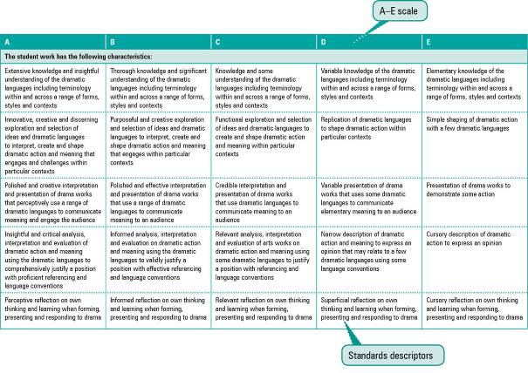

Assessment techniques and instruments
Each Year 10 learning area describes assessment techniques valued in the particular learning area and its related senior subjects.
The assessment advice is for guidance only, and is provided to assist teachers to develop an effective assessment program. It does not represent a required or mandatory approach.
The advice includes details about the typical formats of the assessment instruments and suggests conditions for implementing particular instruments in Year 10.
Teachers can use this information to develop assessment programs that:
- assist students to develop familiarity with the assessment in Years 11–12
- provide students with feedback on their learning
- provide evidence of student achievement.
Diagram 2 shows a typical assessment technique description.
Diagram 2: Sample assessment technique description
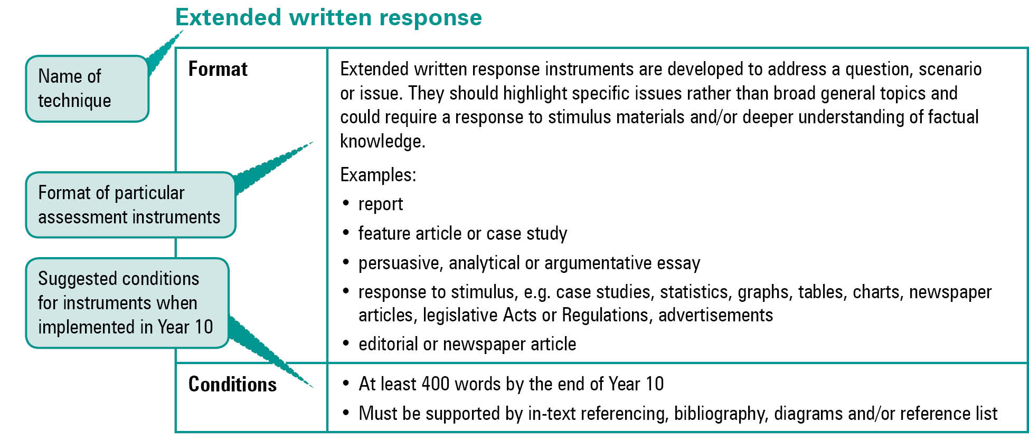
Quality assessment instruments have the following characteristics:
instrument descriptions
instrument-specific criteria sheets / guide to making judgments
instrument conditions.

Instrument descriptions
Instrument descriptions provide succinct and easily understood directions of what students must do.

Instrument-specific criteria sheets / guides to making judgments
Instrument-specific criteria sheets / guides to making judgments are developed from the Standards descriptors and provided to students before they respond to an assessment instrument, preferably at the beginning of a unit of work. These will help students understand the qualities the teacher will be looking for in their responses to the assessment instruments. Schools should note that not all aspects of knowledge and understanding and ways of working will be assessed in any one task. Aspects must be selected according to instrument demands.
Criteria sheets / guides to making judgments provide:
- descriptions of the qualities of student work in each of the selected aspects of knowledge and understanding and ways of working across A–E standards
- instrument-specific information on which teachers’ judgment will be based.

Instrument conditions
To develop assessment instruments that are realistic and achievable for students, teachers should give careful consideration to instrument conditions. All aspects of instrument conditions and demands need to be considered when making judgments about the student work.
Instrument conditions need to be stipulated on each instrument sheet, and detail:
- time and length requirements including:
- word length (written) or time length (spoken/signed)
- amount of time for the instrument (exam/test)
- notice of instrument (e.g. three weeks notice)
- amount of time for drafting or rehearsing
- access to resources, and any conditions which influence the access to material and human resources (e.g. seen or unseen question)
- drafting and/or rehearsing information
- details of scaffolding.

Assessment judgments and determining an overall result
Teachers make judgments about student work on individual assessment instruments, as well as making an overall judgment about a collection of student work (a folio).
The standard awarded for either an individual assessment instrument or a folio of work is an on-balance judgment about how the qualities of the student’s work match the typical Standards outlined in the learning area.
It is not necessary for a student to have met every descriptor for a particular standard in knowledge and understanding and ways of working to be awarded that standard.
Schools, in constructing their courses of study, decide which aspects of knowledge and understanding and ways of working will be covered and which ones may be reported on.
By using the Standards, schools will be able to report about student achievement in knowledge and understanding and ways of working. Schools will also be able to report on the overall standard for the course of study.
Recording student results for knowledge and understanding and ways of working for each assessment instrument on a student profile will help teachers in keeping records of student achievement.

Resources
Three useful references for developing quality assessment are:
- Learning P–12, QSA 2009, accessed 10 Jun 2009,
<www.qsa.qld.edu.au> (select Learning P–12 > Learning P–12).
Describes the relationships between the various syllabuses and guidelines produced by the QSA for the Preparatory Year through to Year 12.
- P–12 Assessment Policy, QSA 2009, accessed 10 Jun 2009, <www.qsa.qld.edu.au> (select Assessment > Overview > P–12 assessment policy).
Assessment in Year 10 should be guided by the principles of assessment described in this policy.
- Guidelines for Assessment Quality and Equity, Australian Curriculum, Assessment and Certification Authorities (ACACA) 1995, accessed10 Jun 2009, <http://acaca.bos.nsw.edu.au> (select ACACA documents > Guidelines for Assessment Quality and Equity.
Describes the characteristics of quality assessment instruments.

Geography learning area

Rationale
Geography is the study of the human and physical characteristics of places and the interactions between them. It is a rich and complex discipline, which includes two vital dimensions:
- the spatial dimension, which focuses on where things are and why they are there
- the ecological dimension, which considers how humans interact with environments.
Geography as a school subject brings together the natural and social sciences in a holistic approach to help students better understand the important challenges facing the world. Geographically informed citizens can observe, measure and describe places on the surface of the Earth, analyse and provide explanations for the complex interactions of human and physical phenomena, and make informed judgments to improve their community, region, nation and the world. Geographers develop and design plans that can enhance the spatial arrangements or management of places in socially just, democratic and peaceful ways.
The study of geography is a vital medium for education because students will:
- understand Australia’s geography
- gain a sense of Australia’s national identity, ethnic and cultural diversity and place in the world
- develop an understanding of the contribution of geography to understanding questions, issues and problems arising from human perceptions and use of the earth’s resources
- become proficient in the use of the key questions and concepts of geography and the way they guide the process of geographical investigation
- use geographical concepts to organise information about people and environments to achieve an understanding of questions, issues and problems
- become proficient in the use of a range of thinking, social, communication, practical and study skills, and be able to use each step in following through the stages of a geographical inquiry
- develop spatial literacy
- develop a concern for the sustainability of the environment and the quality of human life; through investigation, students should explore a range of attitudes and values related to ecologically sustainable development, peace, social justice, and democratic processes and institutions
- value the study of geography
- develop the knowledge, abilities and ethical commitment to participate as active citizens in shaping the future.
Students of geography investigate how different people interact with environments differently, in different places at different times. They explore the opportunities, challenges and constraints of different locations. It is the currency and relevance of the chosen case studies that are the key to a successful foundation course and to exciting students’ interest in lifelong learning. This practical aspect of Geography enables students to pursue multiple pathways.
Studying geography in Year 10 should contribute to:
- the development of critical citizenry — the key component of active and informed citizenship
- civic knowledge, including an understanding of the principles of governance, and the role of government and policy in topics for geographical investigation
- an understanding and appreciation of the Asia–Pacific region, its peoples, environments, cultures, belief systems and societies.
In Year 10 Geography, students develop the ability to analyse and explain increasingly complex spatial associations and interactions of systems and human activities in Australia and in other parts of the world. They further their awareness of the global links between environments and the impact of globalisation on their own and other people’s lives.
Diagram 3 illustrates the pathways available to students from learning planned with the Year 10 Guidelines.
Diagram 3: Geography pathways
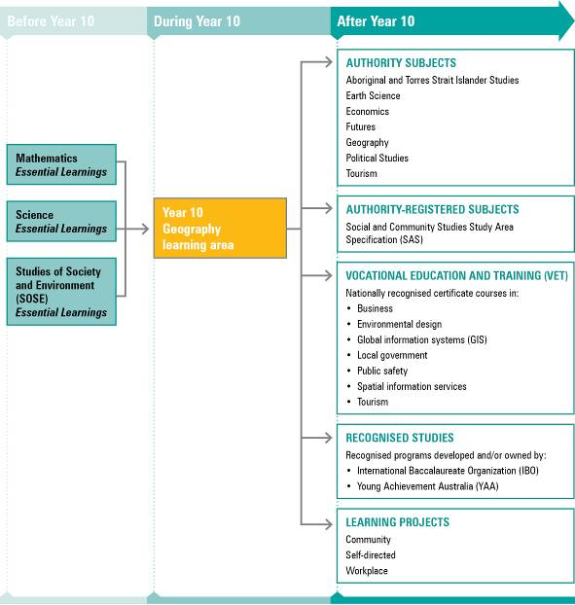
NOTE: For a full and current list of subjects, courses, and recognised studies visit the QSA website <www.qsa.qld.edu.au>.

Learning statements
The learning statements are structured around ways of working and knowledge and understanding.
Ways of working are developed from the geographical inquiry process and describe how students investigate. In the course of geographical inquiry, students consider:
- their role as global citizens and as lifelong learners in relation to the values of democratic processes, social justice, sustainability and peace
- the opportunities for planning and contributing to community action projects.
Students of Geography use a geographical inquiry process, which is framed around the following questions:
- What and where are these issues or patterns being studied?
- How and why do these issues and patterns develop?
- What are the impacts of these issues and patterns?
- What is being done or what could be done to devise creative and innovative plans to sustainably manage these impacts?
Knowledge and understanding has three organisers:
- place
- space
- systems.
Central to the understanding of these organisers is that they are shaped by cultural perceptions and link to social, political, economic and environmental contexts.

Ways of working
Students are able to:
- understand geographical facts, concepts and procedures
- make connections between spatial knowledge and geographical examples
- understand how systems influence the changes in places and the distribution and movement of people, resources and information
- interpret a variety of maps, images (aerial, oblique, ground photographs, satellite images), tables, graphs and diagrams
- identify and explain patterns, trends and relationships in geographical data and information
- analyse the characteristics of geographical features and processes
- use spatial information systems, including geographical information system (GIS) and global positioning system (GPS) techniques to record information and interpret patterns, geographical issues and problems
- respond to geographical investigations across a range of scales
- provide and evaluate alternatives in response to geographical investigations across a range of scales
- select appropriate intervals and modality considering the variables in the data when transforming data
- collect, select and organise primary data from field settings
- present geographical information and data in formats appropriate to audience and purpose
- use appropriate geographical and language conventions and terminology when manipulating data and creating maps and plans.

Knowledge and understanding
Students know and understand:

Place
Places have absolute and relative locations (site and situation). Complex human and physical factors cause variations in their features and uses over time that contribute to a place being what it is.
Place can be defined by physical, social, cultural, public and private characteristics and these characteristics cause variations in communities’ size and how they are perceived as places to live.
e.g. A refugee camp has an absolute and relative location that results from the political system (conflict) and the geographical features of the landscape. It has a physical structure (tents, latrines, fences and roads) and social and political features (refugees, ethnic groups, gender, non-government organisations etc.) that make it what it is. As places, refugee camps’ access to resources like water is different to other settlements. Traditional notions of public and private use of space and resources are challenged in a refugee camp.
Places are dynamic and the global pattern of settlements has changed significantly as the rate of urbanisation has raised issues of sustainability.
e.g. New York was chosen because of its location at the confluence of the East River and the Hudson River; now it is a technological, commercial and transport hub. It has grown from a small trading outpost to a megacity.
- Public and private places can be managed in creative and innovative ways according to the principles of stewardship and sustainability.
e.g. Initiatives such as smart housing; theories such as new urbanism; field work to monitor a development proposal’s impact on the character of a street or suburb; comparison of views on the care of places on that development.
Aboriginal and Torres Strait Islander peoples’ economic, social and spiritual life defines significant places and connections to country.
e.g. Local area study of significant Aboriginal and Torres Strait Islander places in consultation and agreement with local community elders; land and sea rights for Aboriginal and Torres Strait Islander peoples.
The Australian environment has impacted on the way people interact with place and space and this can be seen in the different relationships with the land.
e.g. Use and access to land and resources for Aboriginal and Torres Strait Islander peoples; contrasting rural, remote and urban communities.

Space
Space is about intervals, distances and association, and there are patterns in the arrangement of physical, political, social and cultural components within the built and natural environments. Perceptions of space vary between cultures.
Scales of study (local, regional, national, global) have different characteristics and they can define and differentiate a unit of space.
e.g. What characteristics define a region and how does it differ from other regions? Compare and contrast the Granite Belt wine tourism region with the Loire Valley region of France. What makes a scale of study regional?
Distribution and arrangement of human and physical elements can be observed and measured, and can reveal spatial associations, patterns and arrangements.
e.g. Processes (climate) that affect global distribution of rainforests and people; patterns of deforestation in Indonesia and Brazil; understanding and using scale, enlargement, reduction, vertical exaggeration, area and distance; constructing and interpreting profiles, cross-sections and transects to describe and explain the patterns of the distribution of a resource.
Maps, including topographic, political and thematic maps, are developed with particular features.
e.g. Choropleth mapping of the distribution and access to education, fair trading relationships, access to doctors; locating and using different types of maps (topographic, cadastral and thematic) and their features (latitude, longitude, grid reference, legend or key, direction and contours) to explain the arrangements and connectedness of geographical features of a specific environment.
Geographical information management tools are used.
e.g. Remote sensing (RS) / earth observation data — from Landsat to Ikonos; geographical information systems (GIS) software; global positioning systems (GPS).

Systems
Systems underpin the relationships, the connections, the human interactions and movement between places and within spaces.
The world’s physical environment is composed of systems — atmosphere (e.g. nitrogen, carbon cycles), biosphere, lithosphere, hydrosphere — that are not separate entities but interact upon each other and have a profound effect on human existence.
e.g. How land degradation exemplifies the sensitivity of the natural environments to human activity and the need for careful conservation and sustainable management; the Great Barrier Reef; salinity in the Murray Darling.
Varying social, economic and civic values within a society and changes to these values over time are challenges to the reform of systems.
e.g. The role of mining in Australia; water in south-eastern Australia.
The development of resources is essential to our social and economic wellbeing, but this needs to be balanced against harmful impacts on the natural environment and the potential impact on the quality of life of some peoples.
e.g. Factors that influenced the construction of the Three Gorges Dam and the relocation of citizens in that area.
The location of geographical elements on earth, including the relative location of significant natural and human features, is the result of geographical patterns and processes.
e.g. The processes that affect the location of major mountain ranges and glaciers.
A complexity of factors in physical, social, economic, cultural and political systems and decision making affect levels of access to resources and influence the movement of people, resources and information.
e.g. The distribution of water in south-eastern Australia; the systems that differentiate access to this water; war; famine; trade relationships and movements of goods, services and labour for multinationals such as Nike, Coca Cola Amatil; access to broadband communications.
Natural phenomena across a range of scales have an impact on geographical patterns, features and human activity.
e.g. The investigations of a meteorological phenomenon like severe weather patterns; Australia’s climate patterns and vegetation patterns.
Globalisation and increasing levels of technology in so-called developed or industrialised nations results in a process of systemic and ideological convergence; this process reveals itself in patterns of distribution and movement.
e.g. Patterns of the distribution and movement of labour, goods and information and their cultural and social impact in various communities.

Standards: Geography (table continues over the page)
A | B | C | D | E
The student work has the following characteristics:
Comprehensive understanding of geographical facts, conceptual knowledge and procedures in familiar and unfamiliar contexts | Thorough understanding of geographical facts, concepts and procedures in familiar and some unfamiliar contexts | Broad understanding of geographical facts, concepts and procedures in familiar contexts | Uneven understanding of geographical facts, concepts and procedures in routine contexts | Fragmented understanding of geographical facts, concepts and procedures in rehearsed contexts
Logical and insightful connections between spatial knowledge and geographical examples | Logical connections between spatial knowledge and geographical examples | Connections between spatial knowledge and geographical examples | Weak connections between spatial knowledge and geographical examples | Tenuous connections between basic spatial knowledge and examples
Explanation of systems using strong and detailed geographical examples | Explanation of systems using valid geographical examples | Explanation of systems using geographical examples | Explanation of systems | Explanation of basic systems
Interpretation of diverse geographical and spatial data and information | Interpretation of various geographical and spatial data and information | Interpretation of geographical and spatial data and information | Interpretation of some geographical and spatial data and information | Interpretation of basic geographical and spatial data and information
Identification and explanation of patterns, trends, anomalies, and simple and complex relationships | Identification and explanation of patterns, trends, and simple and complex relationships | Identification and explanation of patterns, trends and relationships | Identification and explanation of basic patterns and trends | Identification of basic patterns
In-depth analysis of characteristics of geographical features, patterns and processes | Detailed analysis of characteristics of geographical features, patterns and processes | Analysis of characteristics of geographical features, patterns and processes | Analysis of basic characteristics of geographical features, patterns and processes | Description of characteristics of geographical features, patterns and processes
Provision and evaluation of detailed, planned and creative alternatives in response to geographical investigations across a range of scales | Provision and evaluation of detailed and planned alternatives in response to geographical investigations across a range of scales | Provision and evaluation of alternatives in response to geographical investigations across a range of scales | Examination of alternatives in response to geographical investigations | Provision of alternatives with limited or no connection to geographical investigations
Collection, selection and organisation of relevant primary data from a wide variety of field settings | Collection, selection and organisation of relevant primary data from a variety of field settings | Collection, selection and organisation of relevant primary data from field settings | Collection and selection of primary data from field settings | Collection of primary data from field settings
Effective selection of intervals and mode, and detailed and discerning consideration of the variables in data | Effective selection of intervals and mode, and detailed consideration of variables in data | Appropriate selection of intervals and mode, and consideration of variables in data | Uneven selection of appropriate intervals and mode, and consideration of variables in data | Selection of intervals and modes that makes data difficult to understand

Standards: Geography (continued from previous page)
A | B | C | D | E
The student work has the following characteristics:
Logical and deliberate presentation of geographical information and data, in formats appropriate to audience and purpose | Logical presentation of geographical information and data, in formats appropriate to audience and purpose | Presentation of geographical information and data in formats appropriate to audience and purpose | Uneven presentation of geographical information and data | Unclear presentation of geographical information and data
Precise use of appropriate language and geographical conventions and terminology | Effective use of appropriate language and geographical conventions and terminology | Use of appropriate language and geographical conventions and terminology with lapses that do not detract from meaning | Use of appropriate language, geographical conventions and terminology with lapses that detract from meaning | Disjointed use of language and geographical conventions and terminology

Assessment

Planning an assessment program
Schools should refer to Using the Year 10 learning areas: assessment advice on page 5 when planning an assessment program. For Geography, an effective assessment program includes a range and balance of assessment techniques providing opportunities for students to demonstrate their learning across:
- the Standards
- types of assessment
- a range of assessment conditions
- a range of scales of study
- a variety of geographical contexts.

Assessment techniques and instruments
The following advice has been designed to help schools use the Year 10 Geography learning area to build student learning towards assessment techniques that are valued in senior Geography. For example, a practical exercise under test conditions is a mandatory task for the senior Geography verification folio.
Field data presentations
Format | Students undertake a fieldwork activity in which they apply the skills of geographical inquiry and interpretation, and present the data from this field activity. Field activity can be virtual.  The field data presentation can be part of building the student’s skill set for a community project or field report. This may depend on the length of the course of study offered.  Students observe, measure, map, graph, record, identify and present data gathered in the field.  Possible products:  - land use maps  - field sketches  - models  - annotated photographic montages  - videos  - GIS maps
Conditions | - Variable across Year 10 with increasing complexity and autonomy  - Recommended scale of study: local
Practical exercises
Format | Students manipulate and represent geographical data from primary or raw data sources in formats suitable for audience and purpose.  The practical exercise can be part of building the student’s skill set for a Geography project or field report, or integrated into the development of a field report or project. This may depend on the length of the course of study offered.  Practical exercise can use assistive technologies (ICTs, spatial technologies, GIS, GPS, RS) or be based on manual transformation.  Students demonstrate their graphicacy and mapping skills.  Possible products:  - choropleth maps  - cross-section diagrams  - tables  - graphs  - synoptic charts  - population pyramids  - thematic maps  - précis maps
Conditions | - Supervised examination conditions (e.g. less than 60 minutes)  - Can also be part of the development of the field report
Data responses
Format | Students interpret and analyse geographical information and data, and make decisions based on their analysis.  Data response can use data from primary and secondary sources, videos, photographs, maps, statistics, tables, graphs and spatial technologies.  The data response can be part of building the student’s skill set for a community project or field report. This may depend on the length of the course of study offered.  Possible products:  - short responses: locating and using grid references, longitude and latitude, scale, direction, interpretation of images (aerial, oblique, ground photographs, satellite images)  - extended paragraph responses describing patterns, trends and anomalies evident in data and making decisions based on data  - analysis, interpretation and use of a range of maps  - interpretation and analysis of tables, graphs and diagrams.
Conditions | - Supervised  - Spoken or written  - Limited time  - Length depends on the complexity of the response required  (e.g. paragraph format, 100 words)
Field report
Format | Students undertake an in-depth field investigation.  Field investigation can be virtual.  Students communicate their findings, conclusions and recommendations following the conventions of a report.  Possible products: a written or oral report, a website, linked documents, multimedia, a video.  At least one student-generated map should be included in the findings.
Conditions | Variable across Year 10 with increasing complexity and autonomy  (e.g. report of 600–750 words)
Integrated projects
Format | Students independently negotiate a geographical project that investigates a community-based issue, makes recommendations and takes action.  Students are agents of their own learning and demonstrate their mastery of geographical concepts, procedures and inquiry.  Students map their own project milestones.  Possible products: negotiated.
Conditions | - Negotiated  - Collaborative in nature  - Recommended scale: local

Course advice

Planning a course of study
The development of a course of study is a school-based decision. A school may decide to use all or part of the information contained in this learning area to construct a course of study. The Guidelines may be used to plan:
- part of a specialised Years 9–10 or Year 10 Geography course
- the final year of a Years 8–10 SOSE course
- an integrated multidisciplinary or transdisciplinary course of study that combines learning statements from other learning areas
- term- or semester-length units of work
- the first year of a three-year senior course of study.

Considerations for planning courses of study in Year 10 Geography
Courses in Geography should consider, where appropriate:
- a range and balance of scales of study: local, regional, national and global
- a range of geographical contexts: Australian, Asian, European, African, and North and South American
- a balance of human and physical geography
- geographical inquiry.

Examples of courses of study
Diagram 4 on page 19 describes examples of ways to plan and package courses of study using the Year 10 Geography learning area. These examples do not preclude other ways of planning and packaging the learning statements. The examples are described as:
- units — referring to term- or semester-length units planned around a particular topic or theme (contexts)
- courses — referring to a series of units over a year planned around a particular school subject.
Diagram 4: Planning a Year 10 Geography course of study
