English
Learning area

This document has been generated from the PDF version to support teachers.
The PDF version is the official publication.
First edition released January 2009
English learning area extract from second edition June 2009
© The State of Queensland (Queensland Studies Authority) 2009
Ground floor, 295 Ann Street Brisbane
PO Box 307 Spring Hill Queensland 4004 Australia
Phone: +61 7 3864 0299
Fax: +61 7 3221 2553
Email: office@qsa.qld.edu.au
Website: www.qsa.qld.edu.au
NOTE: This publication contains images that may cause distress to Indigenous Australians.

Special notes on terminology:
• When The Arts is referred to as a subject or key learning area, both words are capitalised. However, when the arts are referred to in a generic way, this is presented in lower case.
• Standards, as part of the terminology of the Year 10 Guidelines and the Essential Learnings,
is presented with an initial capital letter. However, standards in the generic sense is always lower case.

Organisation of the Year 10 learning areas
Each learning area is organised in the same way and includes a rationale, learning statements, Standards, and advice about assessment and planning courses of study. The advice can be used by teachers to guide their planning to best meet the learning needs of their students, using contexts that are relevant.

Rationale
Each learning area begins with a rationale that describes:
the discipline or the field of study on which the learning area is based
the school subject or subjects that are drawn from the learning area
the nature of Year 10 learners and learning in the learning area.
The rationale also features a pathways diagram that shows how the Year 10 learning area transitions from the Years 1–9 Essential Learnings and is the foundation for the pathways available in the senior phase of learning.

Learning statements
The learning statements identify what is important for students to be taught and what is important for students to learn. The learning statements continue the use of the terms used in the Years 1–9 Essential Learnings and Standards.

Knowledge and understanding
Knowledge and understanding describes concepts, facts and procedures of the learning area. These are presented under organisers that relate to the broad conceptual categories that are the focus of the learning area. In some Year 10 learning areas these organisers are identical to the Years 1–9 key learning area (KLA) organisers, while others use organisers that have greater similarity to the senior syllabuses.

Ways of working
The ways of working identify the processes associated with the particular learning area. These processes emphasise the higher-order thinking skills that support the development of deep understandings in Years 1–9 and have close connections to the processes described in the KLAs. The Year 10 learning area ways of working are at the same time more specific to the Years 11–12 syllabuses. For example, the broad social and environmental inquiry processes of the Years 1–9 Studies of Society and Environment (SOSE) KLA develop into the historical inquiry process in Year 10 History.

Standards
The Standards for each Year 10 learning area describe the expected qualities of a collection of student work on an A–E scale. The Standards descriptors are linked to the learning statements.
The Standards in Year 10 draw on the standards frameworks from Years 1–9 and Years 11–12 and relate both to the assessable elements of the Essential Learnings and the dimensions of the Years 11–12 syllabuses. Schools should use the Standards to:
make judgments about a collection of student work
develop criteria sheets / guides to making judgments to suit their course structure and individual assessment techniques.

Assessment
Year 10 learning areas include advice about planning a school-based assessment program and information about important assessment techniques for each learning area.
The specific guidance about assessment in the particular learning area includes assessment techniques, and the formats and conditions appropriate for developing assessment instruments.
This advice will assist transition to the assessment demands of specific Years 11–12 syllabuses and the senior phase of learning generally.

Course advice
Information about planning courses of study is provided for each Year 10 learning area. Examples of ways to plan using the Year 10 learning statements are described as:
- units — referring to term- or semester-length units planned around a particular topic or theme (contexts)
- courses — referring to a series of units over a year planned around a particular school subject.

Using the Year 10 learning areas: planning courses of study
Curriculum planning is a school-based decision. Schools may choose to use all or part of the information contained in the Guidelines, or use all or part of individual Year 10 learning areas to construct units or courses of study.
The Guidelines include five broad options for planning courses of study using the Year 10 learning areas:
- units
- Year 10 courses
- Years 9–10 or Years 8–10 courses
- Years 10–12 courses
- integrated multidisciplinary or transdisciplinary courses.

Units
Term- or semester-length units can be planned from a selection of the learning statements. Units could serve as an introduction to a particular learning area or specific subject in Years 11–12. Schools may use units as a marketing tool to “sell” specific Years 11–12 subjects.

Year 10 courses
Stand-alone single-year courses in Year 10 can be developed around the learning statements of a single Year 10 learning area or across one or more learning areas. For example, Year 10 Geography would be planned from the Year 10 Geography learning statements, whereas Year 10 Home Economics would be planned from Year 10 Technology and Year 10 Health and Physical Education.

Years 9–10 or Years 8–10 courses
Two- and three-year courses across Years 9–10 or Years 8–10 can be developed from the learning statements of Year 10 learning areas and Years 1–9 Essential Learnings. For example, The Arts subjects in lower secondary could be developed from the specific organisers in the Years 1–9 Essential Learnings and the Year 10 learning area to create courses in Visual Art, Drama, Dance, Music and Media.
Structuring curriculum as Years 9–10 or Years 8–10 courses builds on the current practice of a large number of Queensland secondary schools. Many schools offer lower secondary courses of study using the key learning areas shaped as specific school subjects.
Traditionally, these courses have provided some degree of transition to senior subjects and have provided a “sampler” to help students make an informed decision when choosing senior subjects. Using the learning statements from the Year 10 Guidelines will further strengthen this approach.

Years 10–12 courses
Some schools have developed three-year courses across Years 10–12. These courses describe a coherent three-year senior phase of learning where Year 10 is a foundation year.
Years 10–12 courses can be developed using the Year 10 learning areas and the relevant senior syllabuses. For example, a three-year course in Physics would draw from the Year 10 Science learning area and the senior Physics syllabus. A three-year History course would draw from the Year 10 History learning area and either the senior Modern History or Ancient History syllabus.
Based on their learning experiences in the first year of the course, students should have options to decide to:
- continue the course in Years 11–12
- make an alternative decision within the learning area, for example, elect to do Chemistry rather than Physics or choose Ancient History rather than Modern History
- choose a different pathway, for example, choose not to participate in a senior science or history subject.

Integrated multidisciplinary or transdisciplinary courses
Integrated multidisciplinary or transdisciplinary courses are common in some school settings, particularly middle schools.
These courses can be planned from learning statements across learning areas. In many instances, an organiser that crosses the learning area is used to give coherence to the planning of these courses.

Using the Year 10 learning areas: assessment advice
Assessment is a fundamental and integral part of the teaching and learning process and must be planned and ongoing. Assessment is used to:
- promote, assist and improve learning
- substantially contribute to the construction of programs of teaching and learning
- provide information for students, teachers, parents and carers about the progress and achievements of individual students to help them achieve as well as they are able.
Assessment in Year 10 should be guided by the principles of assessment described in the QSA’s P–12 Assessment Policy. See Resources on page 8 for details.

School-based assessment
During Year 10, assessment should continue the approaches of school-based assessment begun in Years 1–9 and build towards the externally moderated system of Years 11–12. Assessment in Year 10 is:
- standards-based. The Guidelines set out content and achievement standards. The learning statements are the content standards for each Year 10 learning area. These are statements of what students are expected to know and do by the end of Year 10. The achievement standards are linked to each set of learning statements and are reference points that describe how well students have achieved the learning statements
- diagnostic. The Guidelines provide an opportunity to use assessment to determine the nature of students’ learning difficulties as a basis for providing feedback or intervention
- formative. The main focus of assessment in Year 10 is on improving student learning to assist their transition to the senior phase of learning
- summative. Assessment in Year 10 can indicate standards achieved at particular points for reporting purposes.
Year 10 assessment is an opportunity for schools and teachers to develop students’ assessment literacy or familiarity with the processes and practices used in the senior syllabuses.
To develop assessment literacy for Years 11–12, a Year 10 assessment program should introduce and apply important ideas about school-based assessment from the principles of exit assessment in the senior syllabuses. These principles are:
- continuous assessment, or gathering information on student achievement over a course of study, using assessment instruments administered at suitable intervals
- balance of assessment, or making judgments about students’ achievements using a variety of assessment techniques and a range of assessment conditions over the course of study
- fullest and latest information, or making judgments about student achievement based on information gathered from the range of learning statements and from the most recent assessment of achievement.
Each Year 10 learning area provides assessment advice about Standards and assessment techniques and instruments.

Standards
Each learning area has a set of broad standards expressed as descriptors of quality on an A–E scale. The Standards are linked to the learning statements.
Diagram 1 shows a typical Standards table.

Diagram 1: Sample Standards table (The Arts — Drama)
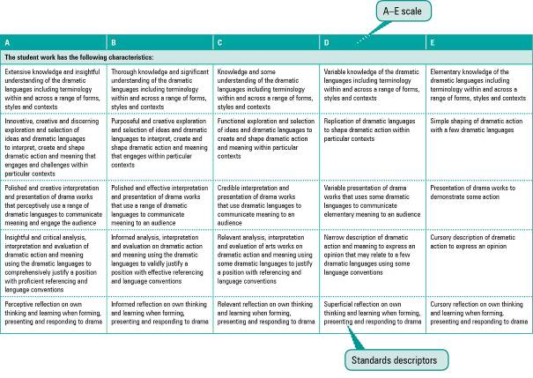

Assessment techniques and instruments
Each Year 10 learning area describes assessment techniques valued in the particular learning area and its related senior subjects.
The assessment advice is for guidance only, and is provided to assist teachers to develop an effective assessment program. It does not represent a required or mandatory approach.
The advice includes details about the typical formats of the assessment instruments and suggests conditions for implementing particular instruments in Year 10.
Teachers can use this information to develop assessment programs that:
- assist students to develop familiarity with the assessment in Years 11–12
- provide students with feedback on their learning
- provide evidence of student achievement.
Diagram 2 shows a typical assessment technique description.
Diagram 2: Sample assessment technique description
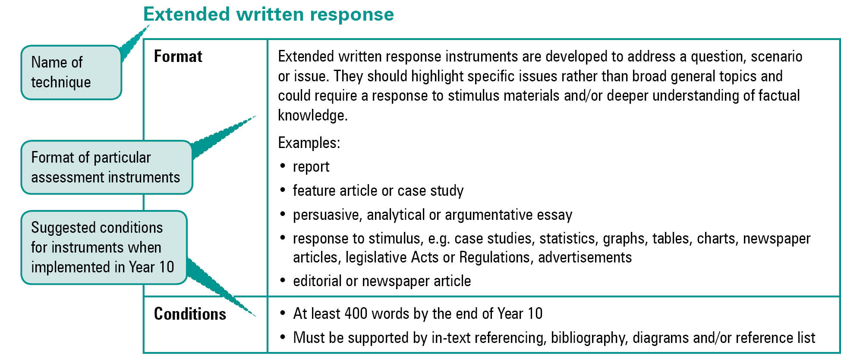
Quality assessment instruments have the following characteristics:
instrument descriptions
instrument-specific criteria sheets / guide to making judgments
instrument conditions.

Instrument descriptions
Instrument descriptions provide succinct and easily understood directions of what students must do.

Instrument-specific criteria sheets / guides to making judgments
Instrument-specific criteria sheets / guides to making judgments are developed from the Standards descriptors and provided to students before they respond to an assessment instrument, preferably at the beginning of a unit of work. These will help students understand the qualities the teacher will be looking for in their responses to the assessment instruments. Schools should note that not all aspects of knowledge and understanding and ways of working will be assessed in any one task. Aspects must be selected according to instrument demands.
Criteria sheets / guides to making judgments provide:
- descriptions of the qualities of student work in each of the selected aspects of knowledge and understanding and ways of working across A–E standards
- instrument-specific information on which teachers’ judgment will be based.

Instrument conditions
To develop assessment instruments that are realistic and achievable for students, teachers should give careful consideration to instrument conditions. All aspects of instrument conditions and demands need to be considered when making judgments about the student work.
Instrument conditions need to be stipulated on each instrument sheet, and detail:
- time and length requirements including:
- word length (written) or time length (spoken/signed)
- amount of time for the instrument (exam/test)
- notice of instrument (e.g. three weeks notice)
- amount of time for drafting or rehearsing
- access to resources, and any conditions which influence the access to material and human resources (e.g. seen or unseen question)
- drafting and/or rehearsing information
- details of scaffolding.

Assessment judgments and determining an overall result
Teachers make judgments about student work on individual assessment instruments, as well as making an overall judgment about a collection of student work (a folio).
The standard awarded for either an individual assessment instrument or a folio of work is an on-balance judgment about how the qualities of the student’s work match the typical Standards outlined in the learning area.
It is not necessary for a student to have met every descriptor for a particular standard in knowledge and understanding and ways of working to be awarded that standard.
Schools, in constructing their courses of study, decide which aspects of knowledge and understanding and ways of working will be covered and which ones may be reported on.
By using the Standards, schools will be able to report about student achievement in knowledge and understanding and ways of working. Schools will also be able to report on the overall standard for the course of study.
Recording student results for knowledge and understanding and ways of working for each assessment instrument on a student profile will help teachers in keeping records of student achievement.

Resources
Three useful references for developing quality assessment are:
- Learning P–12, QSA 2009, accessed 10 Jun 2009,
<www.qsa.qld.edu.au> (select Learning P–12 > Learning P–12).
Describes the relationships between the various syllabuses and guidelines produced by the QSA for the Preparatory Year through to Year 12.
- P–12 Assessment Policy, QSA 2009, accessed 10 Jun 2009, <www.qsa.qld.edu.au> (select Assessment > Overview > P–12 assessment policy).
Assessment in Year 10 should be guided by the principles of assessment described in this policy.
- Guidelines for Assessment Quality and Equity, Australian Curriculum, Assessment and Certification Authorities (ACACA) 1995, accessed10 Jun 2009, <http://acaca.bos.nsw.edu.au> (select ACACA documents > Guidelines for Assessment Quality and Equity.
Describes the characteristics of quality assessment instruments.

English learning area

Rationale
English is the study of the language and its texts. The English language is Australia’s national language and a language of international significance. While many other languages and dialects contribute to Australia’s linguistic richness and diversity, knowledge of and literacy in Standard Australian English are necessary for participation as an active citizen in local, national and global communities. While English should offer opportunities to use language and texts for enjoyment, English also asks students to use a wide range of approaches to analyse, evaluate and appreciate English language texts.
In the school subject English, students learn about the language and its texts through listening and speaking, reading and viewing, and writing and designing. Students use their knowledge of language and texts to effectively, creatively, reflectively and critically:
- interpret and analyse texts composed for a range of purposes and audiences in a variety of contexts through listening, reading and viewing
- compose texts for a range of purposes and audiences in a variety of contexts through speaking, writing and designing.
Texts are composed from language elements that are linguistic (e.g. words, sentences, paragraphs), spoken (e.g. volume, pausing for emphasis), nonverbal (e.g. gestures, stance), visual (e.g. images, diagrams) and aural (e.g. sound effects, music). In English, students learn to examine how these language elements are used in combination to interpret and convey meaning in texts.
In English, texts are categorised as literary or non-literary. The study of literary and non-literary texts provides opportunities for students to analyse, explore and experiment with the purpose, audience, subject matter, structure and language elements of a range of texts. Further information about text categories is given in the section Course advice on page 18.

English and literacy
Literacy refers to the capabilities that work together so individuals can effectively understand, use and make meaning in both traditional and new communications technologies across different contexts. While literacy and English are clearly not the same, literacy is underpinned by English. Students’ literacy capabilities are therefore developed through and alongside their learning in English.
This means that the knowledge students learn in English about language, texts, and how they are used is essential for the development of their literacy capabilities. To make the most of the teaching and learning opportunities provided in English, students must be aware of this relationship between their learning in English and their literacy development, and also understand how one contributes to the other. Literacy is therefore a key focus of English, even though all the learning areas have responsibility for developing students’ literacy capabilities.
Successful literacy development is important both for individuals and for society. Literate people are able to participate in and contribute to society throughout their lives. As Standard Australian English (SAE) is the language used and studied in Australia, students’ learning in English should build their literacy in SAE. However, many students with English as a second language (ESL), including Indigenous students, may be literate in their home language/s but not in SAE. English has an important responsibility to teach all students how to use SAE so they become literate citizens.

The nature of learning English in Year 10
As Year 10 is the foundation for the senior phase of learning, students are beginning to make choices about the pathways they will take through the senior years. These choices will also influence students’ pathways beyond school, which may include entering work and/or further education.
At this time in their schooling, students should have opportunities to learn through authentic or lifelike learning contexts connected to the future pathways they may choose. Schools should consider their students’ diverse backgrounds, learning needs, possible senior English subjects and pathways beyond school when:
- developing topics and investigation questions, or integrating devices for units of work
- selecting texts for study
- planning and implementing learning experiences
- planning and implementing assessment.
As students progress through Year 10, the suite of English senior syllabuses make a number of pathways available, as shown in Diagram 3 on page 11.
Diagram 3: English pathways
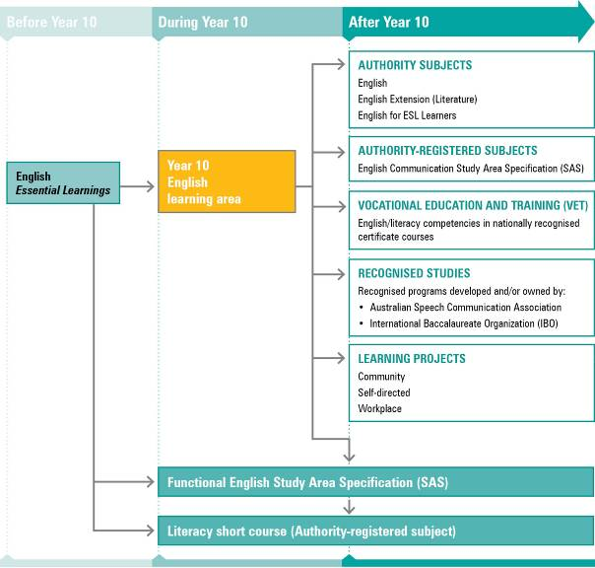
NOTE: For a full and current list of subjects, courses, and recognised studies visit the QSA website <www.qsa.qld.edu.au>.

Learning statements

Ways of working
The ways of working are the processes through which students engage with and demonstrate their learning about language and texts. Students experience language and texts as text users and text producers. Text users make meaning through listening, reading and viewing, and text producers convey meaning through speaking, writing and designing.
As text users students are able to:
- analyse opinions and perspectives
- analyse ideas, information and images in texts
- examine representations of identities (individuals and/or groups), issues, times and/or places in texts
- examine language used to express the ideas, knowledge, values and practices that underpin texts.
As text producers students are able to:
- communicate opinions and perspectives
- use ideas, information and images to influence audiences
- make representations of identities, issues, times and/or places
- use language to communicate the knowledge, ideas, values and practices that underpin texts.

Knowledge and understanding
The learning statements for knowledge and understanding describe the aspects of language and texts that work together to convey meaning. Students engage with and demonstrate their knowledge and understanding as text users and text producers.
Students know and understand:

Understanding and responding to contexts
Texts are composed for particular purposes and audiences in a variety of contexts.

> Genre patterns
Text users recognise genre patterns to make meaning from texts.
e.g. Students understand that while blogs and letters to the editor both set out to communicate opinions and to persuade, they use different genre patterns.
Text producers apply their knowledge of genre patterns to convey meaning in texts.
e.g. When preparing a formal speech, students consider the context, audience and purpose to make specific decisions about genre patterns.

> Subject matter
Text users understand how subject matter is selected and sequenced to organise ideas in texts.
e.g. By comparing two newspaper reports, students examine how subject matter has been organised to present information to readers in similar or different ways.
Text producers apply their knowledge to select and sequence subject matter to organise ideas in texts.
e.g. When writing a biography, students represent the subject in the desired way by including and omitting information about the subject, and revealing the selected information in a particular sequence.

> Roles and relationships
Text users understand how text producers use the roles and relationships that exist between themselves and their audience.
e.g. When listening to a radio program, students can identify the target audience from the program’s subject matter.
Text producers apply their knowledge of the roles and relationships that exist between themselves and their audience to convey meaning in texts.
e.g. When writing and designing a feature article, students make decisions about subject matter to reflect an understanding of audience, mode and medium.

Understanding and using textual features
Textual features are used for particular purposes and audiences in a variety of contexts

> Grammar (of Standard Australian English)
Text users apply their knowledge of grammar to make meaning from texts.
e.g. Students use their knowledge of verb tense to identify and interpret a flashback in a narrative.
Text producers use grammar, including well-formed clause and sentence structures, to convey meaning in texts.
e.g. Students use subject–verb agreement and verb tense to compose a coherent and cohesive news report.

> Cohesive devices
Text users apply their knowledge to understand how cohesive devices connect and develop ideas in texts.
e.g. Students examine how the repetition of key words, phrases and/or sentences develops an idea in a speech.
Text producers use cohesive devices to connect and develop ideas in texts.
e.g. Students use linking words to show sequence (“now” and “then”), cause and result (“consequently”, “therefore”), and to compare (“moreover”, “however”).

> Vocabulary
Text users apply their knowledge of vocabulary to make meaning from texts.
e.g. Students listen to, read and/or view news reports presenting different perspectives on the same issue. They examine how denotative and connotative vocabulary is used to construct these perspectives.
Text producers select and use vocabulary to convey meaning in texts.
e.g. When writing a persuasive essay, students use emotive language to connect with a particular audience.

> Spelling and punctuation
Text users apply their knowledge of spelling and punctuation to make meaning from texts.
e.g. Students examine texts where meaning has been hindered through errors in spelling and punctuation.
Text producers use spelling and punctuation to convey meaning in texts.
e.g. Students use punctuation appropriate to dialogue so readers can make meaning from their writing.

> Visual, auditory, verbal and/or nonverbal features
Text users apply their knowledge of spoken, nonverbal, visual and/or aural features to make meaning from texts.
e.g. Students examine how shot length, editing, sound effects and music are used to create the narrative of a feature film.
Text producers use spoken, nonverbal, visual and/or aural features to convey meaning in texts.
e.g. Students use spoken features (e.g. volume, pause for emphasis, pace) and nonverbal features (e.g. eye contact, proximity, facial expressions, gestures) to make meaning in a dramatic monologue.

Standards: English (table continues over the page)
A | B | C | D | E
The student work has the following characteristics:
Understanding of and sensitivity to a range of genre patterns appropriate to purposes, audiences and contexts | Understanding of a range of genre patterns appropriate to the purposes, audiences and contexts | Understanding of some genre patterns appropriate to the purpose and context | Recognition of genre patterns | Recognition of aspects of genre patterns
Understanding of how subject matter is selected and sequenced to emphasise ideas throughout texts | Understanding of how subject matter is selected and sequenced to develop ideas in texts | Understanding of how subject matter is selected and sequenced to identify ideas in texts | Recognition of obvious subject matter | Identification of simple subject matter
Interpretation and manipulation of a range of roles and relationships between text users and producers in a variety of contexts | Interpretation of a range of roles and relationships between text users and producers in a variety of contexts | Interpretation of roles and relationships between text users and producers in familiar contexts | Identification of obvious roles and relationships between text users and producers | Identification of the roles of text users and/or producers
Use of a range of cohesive devices, including paragraphing, that structure ideas and connect parts of texts | Use of cohesive devices, including paragraphing, that develop ideas and connect parts of texts | Use of cohesive devices, including paragraphing, that connect parts of texts | Use of connections between paragraphs and sentences | Use of functional connections between sentences
Use of a range of grammatically accurate complex clause and sentence structures | Use of a range of grammatically accurate clause and sentence structures | Use of clause and sentence structures that are mostly grammatically accurate | Use of basic sentence and simple clause structures that vary in grammatical accuracy | Use of basic sentence structures
Use of a wide range of sophisticated vocabulary, including figurative language, appropriate to purposes, audiences and contexts | Use of a range of vocabulary, including some figurative language, appropriate to purposes, audiences and contexts | Use of vocabulary appropriate to the context | Use of a basic vocabulary | Use of a narrow range of vocabulary
Sustained control of:  • a wide range of punctuation  • spelling of sophisticated vocabulary | Control of:  • appropriate punctuation  • spelling of some complex vocabulary | Control of:  • essential punctuation  • spelling of straightforward vocabulary | Frequent lapses in:  • punctuation  • spelling of functional vocabulary | Spelling and punctuation impeding communication

Standards: English (continued from previous page)
A | B | C | D | E
The student work has the following characteristics:
Use of a wide range of visual, aural, spoken and/or nonverbal features* appropriate to purposes, audiences and contexts | Use of a range of visual, aural, spoken and/or nonverbal features* appropriate to purposes, audiences and contexts | Use of visual, aural, spoken and/or nonverbal features* appropriate to the context | Use of basic visual, aural, spoken and/or nonverbal features* that convey meaning | Use of simple visual, aural, spoken and/or nonverbal features*
Analysis of a range of varying opinions and perspectives in texts, providing relevant supporting evidence  Sustained expression of opinions and perspectives to clearly influence the audience | Analysis of a range of stated opinions and perspectives in texts, providing some supporting evidence  Expression of opinions and perspectives to influence the audience | Analysis of openly stated opinions and perspectives in texts, including supporting comments  Expression of opinions and perspectives | Identification of opinions in texts  Establishment of an opinion or perspective | Identification of obvious opinions in texts  Statement of a personal opinion
Analysis of ideas, information, images and inferences in texts that influence audience  Maintained use of ideas, information, images and implications to clearly influence readers | Analysis of ideas, information and images in texts that influence audience  Use of ideas, information and images to influence readers | Analysis of ideas, information and images in texts  Use of ideas, information and images | Comprehension of simple ideas, information and images in texts  Use of simple ideas, information and images | Statement of simple ideas, information and images in texts  Basic use of simple ideas, information and images
Analysis of a variety of representations of identities, issues, times and/or places  Insightful composition of representations of identities, issues, times and/or places | Analysis of a variety of familiar representations of identities, issues, times and/or places  Composition of representations of identities, issues, times and/or places | Analysis of representations of known identities, issues, times and/or places  Description of representations of known identities, issues, times and/or places | Identification of familiar representations of known identities, times or places  Statement of simple obvious representations of known identities, times or places | Identification of obvious representations of learnt identities, times or places.  Restatement of simple learnt representations of known identities, times or places
Analysis of language used to express sophisticated ideas, knowledge, values and practices underpinning texts  Use of language to express various sophisticated ideas, knowledge, values and practices underpinning texts | Analysis of language used to express complex ideas, knowledge, values and practices underpinning texts  Use of language to express complex ideas, knowledge, values and practices underpinning texts | Analysis of language used to express the key ideas, knowledge, values and practices underpinning texts  Use of language to express key ideas, knowledge, values and practices underpinning texts | Identification of language used to express obvious ideas, knowledge values and/or practices underpinning texts  Use of language to communicate obvious simple ideas, knowledge, values and/or practices underpinning texts | Restatement of learnt ideas, knowledge, values and/or practices in texts
* Examples of: spoken features — pronunciation, phrasing and pausing, audibility and clarity, pace; nonverbal features — facial expressions, gestures, proximity, stance, movement; visual features — graphics, still and moving images, graphic design elements; aural features — music, silence, sound effects.

Assessment

Planning an assessment program
Schools should refer to Using the Year 10 learning areas: assessment advice on page 7 when planning an assessment program. For English, an effective assessment program includes assessment instruments across a range and balance of assessment techniques. These assessment instruments offer students opportunities to demonstrate their learning across:
- the Standards
- an appropriate number of assessment instruments (6–8 across the year)
- genres, modes (written and spoken) and mediums
- responses to literary texts (e.g. a novel, a play and a variety of poems) and non-literary texts (e.g. reports, essays, feature articles)
- instrument conditions (supervised and open assignment conditions, unseen and prepared questions, access to human and material resources, including drafting).

Assessment techniques and instruments
The following advice has been designed to help schools use the Year 10 English learning area to build student learning towards assessment techniques that are valued in senior English. For example, a mandatory task for the senior English verification folio is an analytical exposition in response to an unseen question about a single literary text, completed in one uninterrupted session. In Year 10 English, schools should plan instrument demands, including conditions that align with learning experiences. Planning and implementing an assessment program should support students in developing the assessment literacy they need for success in the senior phase of learning.
Schools should also consider offering students opportunities to demonstrate increasing independence throughout the assessment program. Increasing independence develops as students take responsibility for their own learning and assessment.
Schools can plan assessment programs encouraging increasing independence by considering assessment conditions such as:
- notice of task
- time allowed for students to prepare and submit responses
- access to conferencing and drafting time with the teacher.
Tables 1 to 3 provide information about assessment instrument formats. Table 4 details the conditions appropriate for Year 10 English assessment instruments.
Table 1: Expository texts
Format | Expository texts can be written, spoken/signed or multimodal. Expository texts are usually non-literary texts that:  • describe objects, events or processes in an objective manner  • explain, analyse and/or evaluate  • present or convey an argument.  Written texts include, for example:  • analytical expositions in response to a literary text (novel, play or poetry)  • comparative essays  • reports.  Spoken or multimodal texts include, for example:  • information speeches  • presentations  • analytical presentations.
Table 2: Persuasive/reflective texts
Format | Persuasive/reflective texts can be written, spoken/signed or multimodal, and may be literary or non-literary.  Persuasive texts seek to argue or persuade and are intended to convince readers to accept particular points of view.  Reflective texts seek to ponder, muse or reflect on events and experiences and may also be persuasive.  Written or multimodal texts include, for example:  • feature articles or columns  • editorials  • biographies or autobiographies  • travel writing  • reviews (e.g. film, novel).  Spoken texts include, for example:  • persuasive speeches or presentations  • panel discussions  • interviews  • speeches for special occasions or events (e.g. graduation, eulogy).
Table 3: Imaginative texts
Format | Imaginative texts can be written, spoken/signed or multimodal. Imaginative texts are usually literary texts that use language in aesthetic and engaging ways to entertain, move and/or reflect on.  Written examples include:  • narratives (e.g. short story, folk tale, original additional section for a novel)  • original poetry  • creative responses to a poem, story  • drama or TV scripts.  Spoken examples include:  • recitations of original poetry  • enacted original drama scripts  • monologues.
Table 4: Conditions
Conditions | A range of instrument conditions are available for the texts chosen. Schools may consider their students’ needs and the demands of their senior English courses to make decisions about instrument conditions that provide the best transition to Year 11.
Assignments | Open conditions may offer students:  • prior notice of task (e.g. an assignment with two weeks’ notice before the due date)  • access to resources: material and human  • opportunities for drafting and/or conferencing to scaffold learning and authenticate student work  • individual, pair or small-group work  • presentation live in class or submission as an audio/audiovisual recording.
Supervised conditions | Supervised conditions may offer students:  • prior notice of task (e.g. two school days)  • unseen question  • one uninterrupted session or a number of sessions.
Length of response | Suggestions for length of student responses:  • written or multimodal  open conditions: 500–600 words  supervised conditions: 400–500 words  • spoken or multimodal  long individual: 4–6 minutes  short individual or group: 2–3 minutes (per speaker).

Course advice

Planning a course of study
The development of a course of study is a school-based decision. A school may decide to use all or part of the information contained in this learning area to construct a course of study. The Guidelines may be used to plan:
- the final year of a Years 8–10 English course
- part of a specialised Years 9–10 or Year 10 English course
- an integrated multidisciplinary or transdisciplinary course of study that combines learning statements from other learning areas
- term- or semester-length units of work
- the first year of a three-year senior course of study.

Considerations for planning courses of study in Year 10 English
A course in English should include opportunities to engage with the learning statements and Standards through:
- the study of a range and balance of literary and non-literary texts
- a balance across modes and mediums.

Literary and non-literary texts
Table 5 on page 19 outlines features and examples of literary and non-literary texts. It is important to note that there is some overlap between these text categories. For example, literary texts can be persuasive and give opinions, and non-literary texts such as feature articles may seek to stimulate an emotional response from the reader.
Table 5: Literary and non-literary texts
Literary texts | Non-literary texts
Literary texts use language in aesthetic, imaginative and engaging ways to:  • entertain and move  • reflect and express emotions  • shape and explore cultural values and identity. | Non-literary texts use language to:  • transact and negotiate relationships, goods and services  • report on people, things, events and issues  • explain, analyse, argue, persuade and give opinions.
Examples:  • novels  • plays (scripts and performances)  • poetry  • short stories  • feature films | Examples:  • reports  • essays  • feature articles, editorials  • documentary films  • websites and other texts of new technologies  • texts of work, family and community life

Range of texts
In Year 10 English, students must read, listen to and view a range of texts to encourage their development as language learners and users. A Year 10 English course should include literary and non-literary texts, including Australian texts by Indigenous and non-Indigenous writers. Texts studied in Year 10 English should:
- include spoken, written, visual texts and texts of new technologies
- be selected with consideration for the backgrounds, abilities, interests, maturity levels and aspirations of the students, including Indigenous students.

Selection of texts
To provide a successful transition from the middle years, schools should consider the demands of their Year 9 English course when selecting texts for Year 10. Similarly, to support students during their transition into the senior phase of learning, the texts studied in Year 10 should build towards those studied in the school’s senior English courses. In Year 10 it is suggested that students have learning experiences developed through:
- literary texts, including:
- a novel
- a play, which may be a Shakespearean drama
- a range of poems across different poetic forms
- non-literary texts, including
- multimodal/multimedia and hypermedia texts (e.g. websites, CD-ROMs, documentary films, TV programs)
- expository texts (e.g. feature articles, essays, editorials).

Examples of courses of study
Diagram 4 on page 20 describes examples of ways to plan and package courses of study using the Year 10 English learning statements. These examples do not preclude other ways of planning and packaging the learning statements. The examples are described as:
- units — referring to term- or semester-length units planned around a particular topic or theme (contexts)
- courses — referring to a series of units over a year planned around a particular school subject.
Diagram 4: Planning a Year 10 English course of study
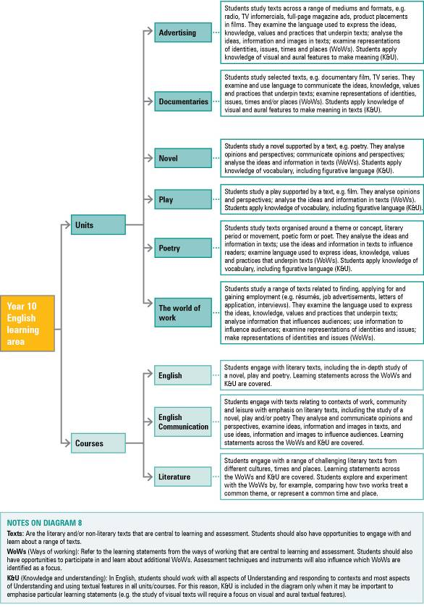

Texts are coherent, meaningful, written, visual, signed or multimodal communications. Examples of key texts are novels, plays, poems, films, speeches, media articles and hypermedia texts. Texts are broadly defined as written, spoken/signed, visual and multimodal works. They include works drawn from literature, mass media, electronic and everyday communications.
The form of Australian English which conforms to the perceived notion of appropriate usages for serious writing and speaking. (The Macquarie Dictionary, 4th edn, 2005, The Macquarie Library Pty Ltd, Macquarie University, NSW.) Reference texts, such as Pam Peters’s The Cambridge Australian English Style Guide and other publications from the Macquarie University Department of Linguistics, including The Macquarie Dictionary, are useful in establishing accepted Australian language conventions.
While the English Essential Learnings for Years 1–9 refer to language elements, in senior English students learn about textual features. Textual features are the components of texts that are chosen to suit context according to genre, purpose and audience. Examples of textual features are cohesion, clause and sentence structure, grammar, vocabulary, and aural, spoken, nonverbal and visual features.

