Business
Learning area

This document has been generated from the PDF version to support teachers.
The PDF version is the official publication.
First edition released January 2009
Business learning area extract from second edition June 2009
© The State of Queensland (Queensland Studies Authority) 2009
Ground floor, 295 Ann Street Brisbane
PO Box 307 Spring Hill Queensland 4004 Australia
Phone: +61 7 3864 0299
Fax: +61 7 3221 2553
Email: office@qsa.qld.edu.au
Website: www.qsa.qld.edu.au
NOTE: This publication contains images that may cause distress to Indigenous Australians.

Special notes on terminology:
• When The Arts is referred to as a subject or key learning area, both words are capitalised. However, when the arts are referred to in a generic way, this is presented in lower case.
• Standards, as part of the terminology of the Year 10 Guidelines and the Essential Learnings,
is presented with an initial capital letter. However, standards in the generic sense is always lower case.

Organisation of the Year 10 learning areas
Each learning area is organised in the same way and includes a rationale, learning statements, Standards, and advice about assessment and planning courses of study. The advice can be used by teachers to guide their planning to best meet the learning needs of their students, using contexts that are relevant.

Rationale
Each learning area begins with a rationale that describes:
the discipline or the field of study on which the learning area is based
the school subject or subjects that are drawn from the learning area
the nature of Year 10 learners and learning in the learning area.
The rationale also features a pathways diagram that shows how the Year 10 learning area transitions from the Years 1–9 Essential Learnings and is the foundation for the pathways available in the senior phase of learning.

Learning statements
The learning statements identify what is important for students to be taught and what is important for students to learn. The learning statements continue the use of the terms used in the Years 1–9 Essential Learnings and Standards.

Knowledge and understanding
Knowledge and understanding describes concepts, facts and procedures of the learning area. These are presented under organisers that relate to the broad conceptual categories that are the focus of the learning area. In some Year 10 learning areas these organisers are identical to the Years 1–9 key learning area (KLA) organisers, while others use organisers that have greater similarity to the senior syllabuses.

Ways of working
The ways of working identify the processes associated with the particular learning area. These processes emphasise the higher-order thinking skills that support the development of deep understandings in Years 1–9 and have close connections to the processes described in the KLAs. The Year 10 learning area ways of working are at the same time more specific to the Years 11–12 syllabuses. For example, the broad social and environmental inquiry processes of the Years 1–9 Studies of Society and Environment (SOSE) KLA develop into the historical inquiry process in Year 10 History.

Standards
The Standards for each Year 10 learning area describe the expected qualities of a collection of student work on an A–E scale. The Standards descriptors are linked to the learning statements.
The Standards in Year 10 draw on the standards frameworks from Years 1–9 and Years 11–12 and relate both to the assessable elements of the Essential Learnings and the dimensions of the Years 11–12 syllabuses. Schools should use the Standards to:
make judgments about a collection of student work
develop criteria sheets / guides to making judgments to suit their course structure and individual assessment techniques.

Assessment
Year 10 learning areas include advice about planning a school-based assessment program and information about important assessment techniques for each learning area.
The specific guidance about assessment in the particular learning area includes assessment techniques, and the formats and conditions appropriate for developing assessment instruments.
This advice will assist transition to the assessment demands of specific Years 11–12 syllabuses and the senior phase of learning generally.

Course advice
Information about planning courses of study is provided for each Year 10 learning area. Examples of ways to plan using the Year 10 learning statements are described as:
- units — referring to term- or semester-length units planned around a particular topic or theme (contexts)
- courses — referring to a series of units over a year planned around a particular school subject.

Using the Year 10 learning areas: planning courses of study
Curriculum planning is a school-based decision. Schools may choose to use all or part of the information contained in the Guidelines, or use all or part of individual Year 10 learning areas to construct units or courses of study.
The Guidelines include five broad options for planning courses of study using the Year 10 learning areas:
- units
- Year 10 courses
- Years 9–10 or Years 8–10 courses
- Years 10–12 courses
- integrated multidisciplinary or transdisciplinary courses.

Units
Term- or semester-length units can be planned from a selection of the learning statements. Units could serve as an introduction to a particular learning area or specific subject in Years 11–12. Schools may use units as a marketing tool to “sell” specific Years 11–12 subjects.

Year 10 courses
Stand-alone single-year courses in Year 10 can be developed around the learning statements of a single Year 10 learning area or across one or more learning areas. For example, Year 10 Geography would be planned from the Year 10 Geography learning statements, whereas Year 10 Home Economics would be planned from Year 10 Technology and Year 10 Health and Physical Education.

Years 9–10 or Years 8–10 courses
Two- and three-year courses across Years 9–10 or Years 8–10 can be developed from the learning statements of Year 10 learning areas and Years 1–9 Essential Learnings. For example, The Arts subjects in lower secondary could be developed from the specific organisers in the Years 1–9 Essential Learnings and the Year 10 learning area to create courses in Visual Art, Drama, Dance, Music and Media.
Structuring curriculum as Years 9–10 or Years 8–10 courses builds on the current practice of a large number of Queensland secondary schools. Many schools offer lower secondary courses of study using the key learning areas shaped as specific school subjects.
Traditionally, these courses have provided some degree of transition to senior subjects and have provided a “sampler” to help students make an informed decision when choosing senior subjects. Using the learning statements from the Year 10 Guidelines will further strengthen this approach.

Years 10–12 courses
Some schools have developed three-year courses across Years 10–12. These courses describe a coherent three-year senior phase of learning where Year 10 is a foundation year.
Years 10–12 courses can be developed using the Year 10 learning areas and the relevant senior syllabuses. For example, a three-year course in Physics would draw from the Year 10 Science learning area and the senior Physics syllabus. A three-year History course would draw from the Year 10 History learning area and either the senior Modern History or Ancient History syllabus.
Based on their learning experiences in the first year of the course, students should have options to decide to:
- continue the course in Years 11–12
- make an alternative decision within the learning area, for example, elect to do Chemistry rather than Physics or choose Ancient History rather than Modern History
- choose a different pathway, for example, choose not to participate in a senior science or history subject.

Integrated multidisciplinary or transdisciplinary courses
Integrated multidisciplinary or transdisciplinary courses are common in some school settings, particularly middle schools.
These courses can be planned from learning statements across learning areas. In many instances, an organiser that crosses the learning area is used to give coherence to the planning of these courses.

Using the Year 10 learning areas: assessment advice
Assessment is a fundamental and integral part of the teaching and learning process and must be planned and ongoing. Assessment is used to:
- promote, assist and improve learning
- substantially contribute to the construction of programs of teaching and learning
- provide information for students, teachers, parents and carers about the progress and achievements of individual students to help them achieve as well as they are able.
Assessment in Year 10 should be guided by the principles of assessment described in the QSA’s P–12 Assessment Policy. See Resources on page 8 for details.

School-based assessment
During Year 10, assessment should continue the approaches of school-based assessment begun in Years 1–9 and build towards the externally moderated system of Years 11–12. Assessment in Year 10 is:
- standards-based. The Guidelines set out content and achievement standards. The learning statements are the content standards for each Year 10 learning area. These are statements of what students are expected to know and do by the end of Year 10. The achievement standards are linked to each set of learning statements and are reference points that describe how well students have achieved the learning statements
- diagnostic. The Guidelines provide an opportunity to use assessment to determine the nature of students’ learning difficulties as a basis for providing feedback or intervention
- formative. The main focus of assessment in Year 10 is on improving student learning to assist their transition to the senior phase of learning
- summative. Assessment in Year 10 can indicate standards achieved at particular points for reporting purposes.
Year 10 assessment is an opportunity for schools and teachers to develop students’ assessment literacy or familiarity with the processes and practices used in the senior syllabuses.
To develop assessment literacy for Years 11–12, a Year 10 assessment program should introduce and apply important ideas about school-based assessment from the principles of exit assessment in the senior syllabuses. These principles are:
- continuous assessment, or gathering information on student achievement over a course of study, using assessment instruments administered at suitable intervals
- balance of assessment, or making judgments about students’ achievements using a variety of assessment techniques and a range of assessment conditions over the course of study
- fullest and latest information, or making judgments about student achievement based on information gathered from the range of learning statements and from the most recent assessment of achievement.
Each Year 10 learning area provides assessment advice about Standards and assessment techniques and instruments.

Standards
Each learning area has a set of broad standards expressed as descriptors of quality on an A–E scale. The Standards are linked to the learning statements.
Diagram 1 shows a typical Standards table.

Diagram 1: Sample Standards table (The Arts — Drama)
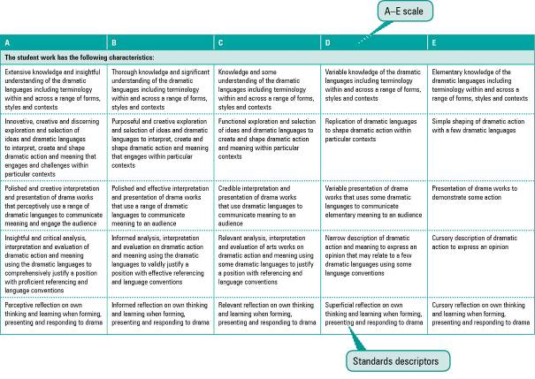

Assessment techniques and instruments
Each Year 10 learning area describes assessment techniques valued in the particular learning area and its related senior subjects.
The assessment advice is for guidance only, and is provided to assist teachers to develop an effective assessment program. It does not represent a required or mandatory approach.
The advice includes details about the typical formats of the assessment instruments and suggests conditions for implementing particular instruments in Year 10.
Teachers can use this information to develop assessment programs that:
- assist students to develop familiarity with the assessment in Years 11–12
- provide students with feedback on their learning
- provide evidence of student achievement.
Diagram 2 shows a typical assessment technique description.
Diagram 2: Sample assessment technique description
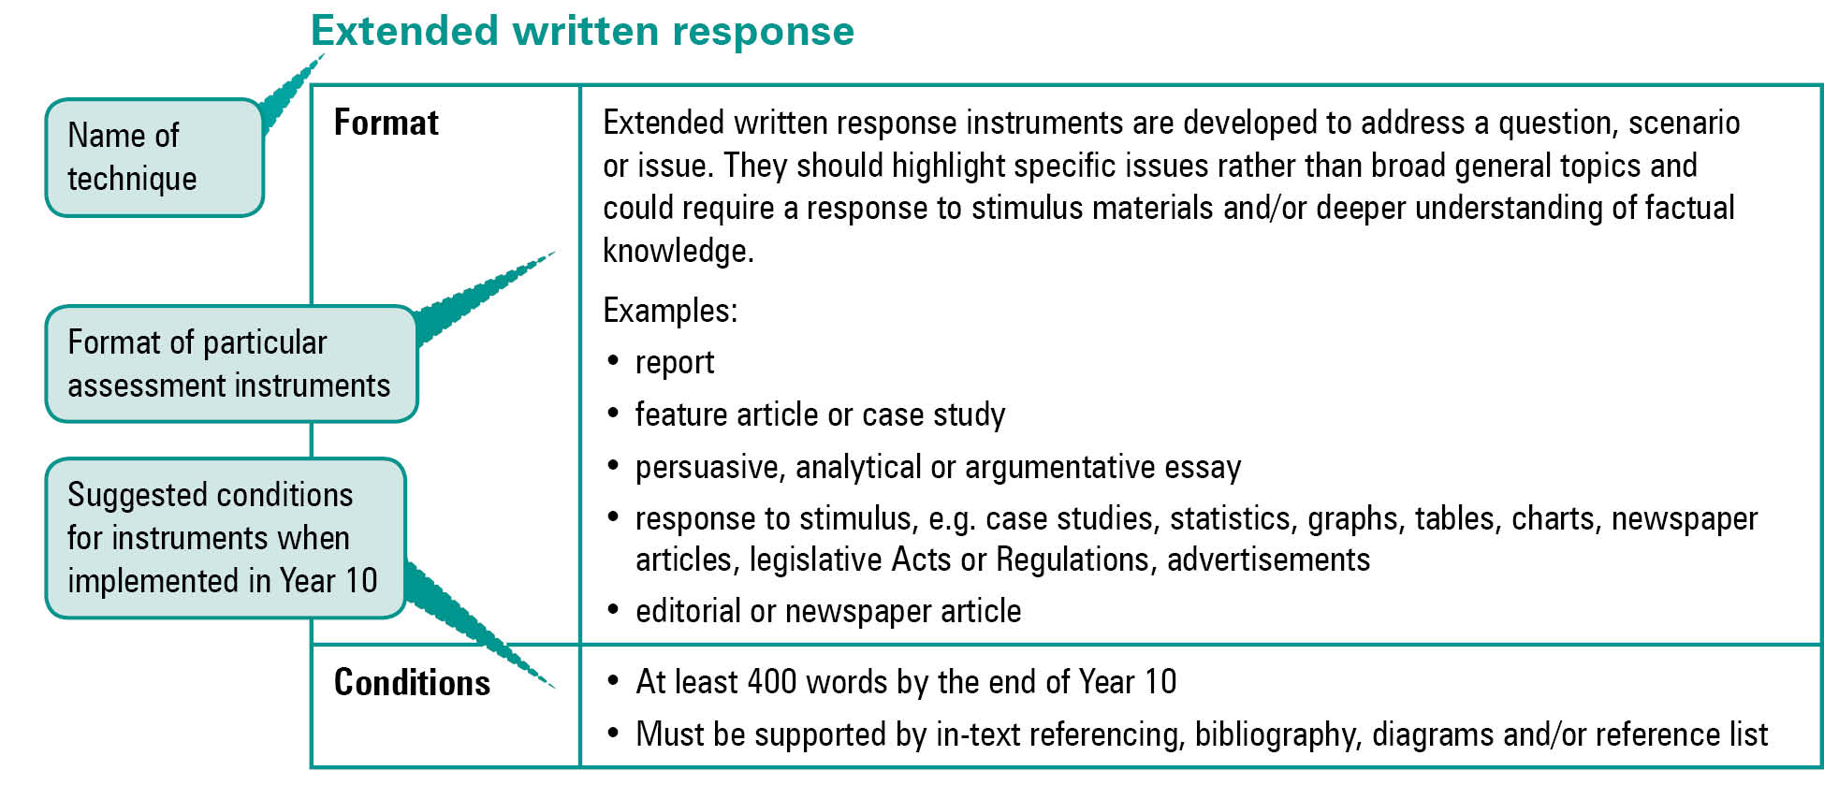
Quality assessment instruments have the following characteristics:
instrument descriptions
instrument-specific criteria sheets / guide to making judgments
instrument conditions.

Instrument descriptions
Instrument descriptions provide succinct and easily understood directions of what students must do.

Instrument-specific criteria sheets / guides to making judgments
Instrument-specific criteria sheets / guides to making judgments are developed from the Standards descriptors and provided to students before they respond to an assessment instrument, preferably at the beginning of a unit of work. These will help students understand the qualities the teacher will be looking for in their responses to the assessment instruments. Schools should note that not all aspects of knowledge and understanding and ways of working will be assessed in any one task. Aspects must be selected according to instrument demands.
Criteria sheets / guides to making judgments provide:
- descriptions of the qualities of student work in each of the selected aspects of knowledge and understanding and ways of working across A–E standards
- instrument-specific information on which teachers’ judgment will be based.

Instrument conditions
To develop assessment instruments that are realistic and achievable for students, teachers should give careful consideration to instrument conditions. All aspects of instrument conditions and demands need to be considered when making judgments about the student work.
Instrument conditions need to be stipulated on each instrument sheet, and detail:
- time and length requirements including:
- word length (written) or time length (spoken/signed)
- amount of time for the instrument (exam/test)
- notice of instrument (e.g. three weeks notice)
- amount of time for drafting or rehearsing
- access to resources, and any conditions which influence the access to material and human resources (e.g. seen or unseen question)
- drafting and/or rehearsing information
- details of scaffolding.

Assessment judgments and determining an overall result
Teachers make judgments about student work on individual assessment instruments, as well as making an overall judgment about a collection of student work (a folio).
The standard awarded for either an individual assessment instrument or a folio of work is an on-balance judgment about how the qualities of the student’s work match the typical Standards outlined in the learning area.
It is not necessary for a student to have met every descriptor for a particular standard in knowledge and understanding and ways of working to be awarded that standard.
Schools, in constructing their courses of study, decide which aspects of knowledge and understanding and ways of working will be covered and which ones may be reported on.
By using the Standards, schools will be able to report about student achievement in knowledge and understanding and ways of working. Schools will also be able to report on the overall standard for the course of study.
Recording student results for knowledge and understanding and ways of working for each assessment instrument on a student profile will help teachers in keeping records of student achievement.

Resources
Three useful references for developing quality assessment are:
- Learning P–12, QSA 2009, accessed 10 Jun 2009,
<www.qsa.qld.edu.au> (select Learning P–12 > Learning P–12).
Describes the relationships between the various syllabuses and guidelines produced by the QSA for the Preparatory Year through to Year 12.
- P–12 Assessment Policy, QSA 2009, accessed 10 Jun 2009, <www.qsa.qld.edu.au> (select Assessment > Overview > P–12 assessment policy).
Assessment in Year 10 should be guided by the principles of assessment described in this policy.
- Guidelines for Assessment Quality and Equity, Australian Curriculum, Assessment and Certification Authorities (ACACA) 1995, accessed10 Jun 2009, <http://acaca.bos.nsw.edu.au> (select ACACA documents > Guidelines for Assessment Quality and Equity.
Describes the characteristics of quality assessment instruments.

Business learning area

Rationale
Business activity affects the daily lives of all Australians as they work, spend, save, invest, travel and play. It influences jobs, incomes and opportunities for personal enterprise.
Business refers to enterprising endeavours undertaken to meet human needs and wants. Business, economic and legal activity impacts on and presents a range of challenges to individuals and members of groups and organisations in their roles as active and informed citizens, consumers, workers or entrepreneurs. These challenges may include:
- participating as an active and responsible citizen in business environments in response to individual, group, local, national and global needs
- making consumer decisions to meet the needs and wants of self and others
- managing scarcity of resources to meet the necessary business, economic and legal requirements for sustainability
- entering into contractual agreements and managing personal finances, investments and records
- owning or managing a business, enterprise or venture.
Business education in Year 10 has four organisers:
- business, economic and legal systems
- information procedures
- enterprise and ventures
- work environments.
Business education is important for students in the later years of schooling as it is at this time that they gain a degree of independence in accumulating and managing finances, make decisions about goods and services, and acquire legal rights and responsibilities as citizens. Students studying Business will develop effective decision-making skills related to consumer behaviour and the management and evaluation of personal financial matters, resulting in improved economic, consumer and financial literacy.
The ways in which wealth and income in a society are distributed depend on the types of business, economic and legal systems in place. The nature of an economic system affects basic decisions about what to produce, how to produce it and how to allocate the proceeds of production. Businesses are influenced and regulated by the economic system. Understandings of economics contribute to socially responsible and informed decision making within a dynamic economy.
Business practices continue to evolve. Information procedures and information and communication technologies (ICTs) impact upon the ways people do business — for example, the ways that people interact, communicate, trade and manage records. ICTs can be used to enhance business activities and produce high-quality outcomes.
Individuals, groups and organisations use business practices to achieve their goals. Business practices refer to the ways people work in business environments. Business practices involve the use of innovation, entrepreneurial creativity, strategic planning, management, marketing, communication and ICTs to create successful enterprises and ventures.
The changing nature of work will require individuals to work in new ways and in diverse work environments.
Ways of working and knowledge and understanding of Business are drawn from the fields of accounting, law, tourism, economics, marketing, management, communications, industrial relations, human resources, ICTs, and administration. The ways of working reflect the thinking processes and skills inherent in the study of business.
The Business learning area leads to multiple pathways. Diagram 5 shows the link between the Years 1–9 Essential Learnings, the Year 10 Business learning area and the
Years 11–12 subjects. It also demonstrates the multiple pathways for students to follow.

Diagram 5: Business pathways
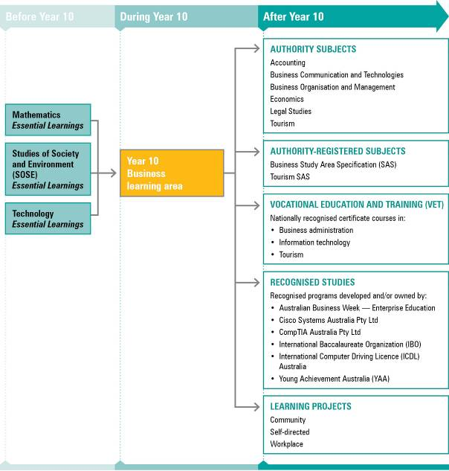
NOTE: For a full and current list of subjects, courses, and recognised studies visit the QSA website <www.qsa.qld.edu.au>.

Learning statements

Ways of working
Students are able to:
- develop a relevant hypothesis and research focus from broad business, economic and legal topics
- conduct investigations of past, present and future business, economic and legal activities, using valid business strategies, procedures and processes
- gather and validate evidence and data from a range of relevant sources using a planned approach
- analyse and interpret business data, financial information and evidence to solve problems
- develop arguments supported by interpretations of data, information and evidence
- apply concepts, processes and principles to unfamiliar business issues, problems and situations
- devise and justify recommendations and decisions to business issues and problems at local, national and global levels
- select and apply procedures, business technology and communication tools to present information to a business standard that suits the context and audience
- record, report, design and create business information, financial records and products for personal and professional purposes
- apply decision-making strategies in individual and team situations to develop business plans and products, and to take informed and responsible action to achieve specific business outcomes
- reflect on different perspectives and interactions within business, economic and legal environments, demonstrating consideration of social, ethical, environmental and economic responsibility.

Knowledge and understanding
Students know and understand:

Business, economic and legal systems
Business environments are shaped by stakeholder expectations, economic activity, regulatory systems, legal structures and different types of business organisations.
Businesses differ in size, location, type, purpose, structure and scope.
e.g. Types of businesses: manufacturing, retail, marketing, service; different size, location, scope: small and medium enterprises, multinational companies; business structures: public companies, private companies, partnerships, sole traders, cooperatives, government departments, government business enterprises.
Systems that influence and regulate business and economic activity assist with the allocation of scarce resources and protect parties who are directly and indirectly affected by this activity.
e.g. Types of activities: banking and finance, investment, communication, transport, hospitality, legal, accounting, travel; government policy: monetary policy, fiscal policy; laws and regulations; enforcement agencies; structure of systems and subsystems; components of the circular flow of income; external and internal controls: licensing, workplace health and safety; electronic accounting systems; human resources; resource allocation, scarcity, opportunity cost, global activity; organisation and governance of tourism industry.
Markets and prices are influenced by the relationship between supply and demand, buyers and sellers, and globalisation.
e.g. Decision making of buyers and sellers determines prices: consumer preferences, technology, trends; globalisation impacts on different individuals and groups in different ways.
Consumers and government expect businesses to act responsibly by making informed decisions and using business practices that are socially, ethically, economically and environmentally responsible and sustainable.
e.g. Consumer rights and responsibilities in obtaining goods and services; regulatory bodies (e.g. Reserve Bank of Australia, Australian Securities and Investment Commission (ASIC)) for resolving business and economic issues; values and ethics in business negotiation and decision making.
The principles and features of democracy in Australia include the common good, separation of powers, government accountability, Australian Constitution and parliamentary elections.
e.g. Role of the government in developing policy, establishing conditions for economic activity and formulating legislation; role of political parties, comparison of democracies; principles and features of democracy.

Information procedures
Information procedures and ICTs are used to ensure accountability and to manage records effectively for personal, workplace, community and business purposes.
Sources, forms and management of information impact upon the ways people do business and their ability to produce high-quality and professional outcomes.
e.g. Sources of information: bank accounts, reports, customer details; forms of information: internet sites, webpages, brochures, multimedia; information management methods: handwritten procedures, electronic systems; information procedures: accessing information from the internet, storing sites in folders, developing directories/folders.
Financial records management involves recording, reporting, analysing and interpreting financial information in personal, business and social contexts.
e.g. Nature of accounts, types of source documents; completion of business documents; accounting principles: accounting equation, methods, controls, double entry; record keeping, simple financial records and control procedures for specific audiences and purposes; analysis of financial reports for decision-making purposes; personal financial literacy skills (e.g. budgeting).
ICTs can be used to generate, manipulate, store, present, transform and transmit information in business contexts for different audiences to meet detailed specifications.
e.g. Transforming: PowerPoint presentations, webpages, multimedia, graphical images and diagrams, spreadsheets; transmitting: emails, attachments, memos, information statements, press releases, posters, faxes.

Enterprise and ventures
Successful enterprises and ventures are run by managers who are responsive to stakeholder needs and wants and are able to predict the possible and probable directions of the market.
Entrepreneurial behaviour, skills and activities can impact positively and negatively on a variety of stakeholders.
e.g. Nature of enterprising activity; skills and attributes needed to be a successful entrepreneur: record keeping, management, leadership, marketing, communication; impact on individuals: self-employment; impact on businesses: employment, profit, innovation, marketing; impact on communities: living standards, economic systems.
Management of an enterprise or venture is a complex process involving the generation of enterprising ideas, the development of business proposals and plans, the undertaking of ventures and the evaluation of the outcomes.
e.g. Simple business proposals and plans including sections on human resources, marketing, financial records, management, production.

Work environments
Australian workplaces are dynamic environments and operate through an interconnection of stakeholders, external forces and processes.
Work environments are influenced by the various roles and responsibilities of employees, employers, industrial organisations, state, territory and Commonwealth governments, and the community.
e.g. Safe work environment, payment of wages, leave and award entitlements; recruitment and selection procedures, discrimination practices, industrial action.
Effective communication and organisational skills are essential for quality staff and customer relations.
e.g. Teamwork skills, interpersonal skills, communication styles, listening skills, questioning techniques, nonverbal communication, written communication skills, time management; skills of active and informed citizens.
Different types of workforces are needed to meet the varied demands of local, national or global work environments.
e.g. Nature and location of paid, unpaid and voluntary work; types of work arrangements: full time, part time, permanent, contract, temporary; dynamic and changing work environments: complex, fast-changing and competitive.
Workplace practices and regulations are necessary to ensure safe, nondiscriminatory and fair conditions in the workplace.
e.g. State and Commonwealth legislation: Workplace Health and Safety Act 1995, Anti-Discrimination Act 1991, Human Rights and Equal Opportunity Commission Act 1986, Age Discrimination Act 2004, Freedom of Information Act 1982, Privacy Act 1998; enterprise bargaining; contractual work arrangements.
Past and present influences on workplace practices affect the changing nature of the work activity of employers, employees, unions and work-related groups.
e.g. Technological advances, rapid communication; influences on workplace practices; industrial revolution, growth and decline of trade unionism, Commonwealth Conciliation and Arbitration Act 1904; Australian Industrial Relations Commission, enterprise bargaining, outsourced labour in a global economy, technological change.

Standards: Business (table continues over the page)
A | B | C | D | E
The student work has the following characteristics:
Recall, definition and description of a comprehensive range of factual information, concepts and principles | Recall, definition and description of a substantial range of factual information, concepts and principles | Recall, definition and description of a range of factual information, concepts and principles | Recall and definition of factual information | Recall of some basic factual information
Thorough explanation of concepts, principles, processes and practices, supported by highly relevant examples | Significant explanation of concepts, principles, processes and practices, supported by relevant examples | General explanation of basic concepts, principles, processes and practices, supported by simple examples | Explanation of basic concepts, supported by some examples | Inclusion of some examples
Consistent selection and application of a range of relevant concepts, processes and principles to unfamiliar issues and problems | Effective selection and application of relevant concepts, processes and principles to most unfamiliar issues and problems | Selection and application of some relevant concepts, processes and principles to familiar and some unfamiliar issues and problems | Selection and application of some concepts, processes and principles to familiar issues | Occasional selection and application of some concepts to familiar issues
Consistent and critical interpretation, analysis and evaluation of data, information and evidence | Effective interpretation, analysis and evaluation of data, information and evidence | Credible interpretation, analysis and evaluation of data, information and evidence | Variable interpretation and analysis of data, information and evidence | Basic interpretation of information
Development of logically reasoned arguments and perceptive recommendations about an identified problem or issue | Development of reasoned arguments and valid recommendations about an identified problem or issue | Development of reasoned arguments and obvious recommendations about a given problem or issue | Development of arguments and recommendations based on opinion | Statement of decisions
Effective selection and application of a range of suitable procedures, business technology and communication skills to consistently produce accurate information:  • to a business standard  • for a variety of purposes and audiences | Selection and application of suitable procedures, business technology and communication skills to produce relatively accurate information:  • to a business standard  • for a variety of purposes and audiences | Selection and application of procedures, business technology and communication skills to produce information:  • to a business standard  • for identified purposes and/or audiences | Selection and application of some procedures, business technology and communication skills to produce information for a given purpose | Communication and presentation of some information using technology
Comprehensive preparation and accurate presentation of business information, financial records and products for personal and professional purposes | Effective preparation and mostly accurate presentation of business information, financial records and products for personal and some professional purposes | Preparation and presentation of business information, financial records and products for personal and some professional purposes, with varying degrees of accuracy | Preparation and presentation of business information, financial records and products for personal or some professional purposes | Preparation and presentation of business information, financial records and products for personal purposes

Standards: Business (continued from previous page)
A | B | C | D | E
The student work has the following characteristics:
Skilful use of strategies for making team decisions and for participating in informed and responsible action | Effective use of strategies for making team decisions and for participating in informed and responsible action | Appropriate use of strategies for making team decisions and for contributing to informed and/or responsible action | Variable use of strategies for making team decisions and for contributing to responsible action | Minimal use of strategies for making team decisions
Perceptive reflection on perspectives and interactions that demonstrates consideration of social, ethical, environmental and economic responsibility | Informed reflection on perspectives and interactions that demonstrates consideration of social, ethical, environmental and economic responsibility | Relevant reflection on perspectives and interactions when considering social, ethical, environmental and economic responsibility | Superficial reflection on perspectives and interactions | Cursory reflection on perspectives and interactions

Assessment

Planning an assessment program
Schools should refer to Using the Year 10 learning areas: assessment advice on page 5 when planning an assessment program. For the Business learning area, the assessment program should include a range and balance of assessment types providing opportunities for students to demonstrate their learning across:
- the Standards
- types of assessment
- a range of assessment conditions
- written and nonwritten modes.

Assessment techniques and instruments
The following advice has been designed to help schools use the Year 10 Business learning area to build student learning towards assessment techniques that are valued in senior business subjects. The suggested formats and conditions have been modified from those in senior syllabuses to suit Year 10 learners.
Short written response
Format | Short written response instruments may ask students to make one or a number of short responses. They are an effective method of assessing student knowledge and understanding.  Examples:  • multiple-choice questions  • definitions of terms  • one-word answers  • true/false questions  • matching/classification  • sentence or short paragraph responses
Extended written response
Format | Extended written response instruments are developed to address a question, scenario or issue. They should highlight specific issues rather than broad general topics and could require a response to stimulus materials and/or deeper understanding of factual knowledge.  Examples:  • report  • feature article or case study  • persuasive, analytical or argumentative essay  • response to stimulus (e.g. case studies, statistics, graphs, tables, charts, newspaper articles, legislative Acts or Regulations, advertisements)  • editorial or newspaper article
Conditions | • At least 400 words by the end of Year 10  • Must be supported by in-text referencing, bibliography, diagrams and/or reference list
Practical tasks
Format | Practical tasks are used to assess business records and procedures, either manually or electronically.  Examples:  • folio of work  • computer-generated documents  • financial documents  • diaries  • workplace health and safety audit
Nonwritten responses
Format | Nonwritten responses are spoken/signed (e.g. debate, seminar, lesson) and/or multimodal (e.g. webpage, board game). They must include an aspect of spoken/signed communication.  Examples:  • tour commentary  • seminar or lesson  • debate  • roleplay or interview  • development of video, website or computer software program  • photographic album of evidence  • song or poem  • radio or TV news report  • team discussion  • board game
Conditions | • Spoken/signed responses should be 3–5 minutes per student  • Must be supported by explanatory notes (which may include in-text referencing, bibliography, diagrams and/or reference list)
Project work
Format | Project work involves a variety of techniques completed in teams, individually or by a combination of individual and teamwork. Students may present their findings in a written or nonwritten format, or a combination of both. The integrated project should be undertaken over an extended period of time and involve the use of students’ own time and class time.  Examples:  • business plan  • seminar  • conference  • trade display
Conditions | Must be supported by explanatory notes (which may include in-text referencing, bibliography, diagrams and/or reference list).

Course advice

Planning a course of study
The development of a course of study is a school-based decision. A school may decide to use all or part of the information contained in this learning area to construct a course of study. The Guidelines may be used to plan:
- the final year of a Years 8–10 Business course
- part of a specialised Years 9–10 or Year 10 Business course
- an integrated multidisciplinary or transdisciplinary course of study that combines learning statements from other learning areas (e.g. enterprise education)
- term- or semester-length units of work
- the first year of a three-year senior course of study.

Considerations for planning courses of study in Year 10 Business
Courses in Business should consider, where appropriate:
- providing opportunities for students to understand and use business practices that involve innovation, entrepreneurial creativity, strategic planning, management, communication and ICTs
- links with business or industry people in the local community
- legal requirements
- the availability of school facilities and resources
- that all business learning statements can be contextualised (e.g. Queensland tourism).

Examples of courses of study
Multiple courses of study with different focuses can be developed from the Year 10 Business learning area. VET courses are complementary to Business education courses.
Diagram 6 on page 19 describes examples of ways to plan and package courses of study using the Year 10 Business learning statements. These examples do not preclude other ways of planning and packaging the learning statements. The examples are described as:
- units — referring to term- or semester-length units planned around a particular topic or theme (contexts)
- courses — referring to a series of units over a year planned around a particular school subject.
Diagram 6: Planning a Year 10 Business course of study
