Guideline for individual learning
  - Senior secondary students eligible for the Queensland Certificate of Individual Achievement (QCIA)
November 2023

Summary of amendments
November 2023
Section | Description of changes
Whole document | Minor edits for clarity and consistency.  Updated QCE and QCIA policy and procedures handbook and website references.

© State of Queensland (QCAA) 2023
Licence: https://creativecommons.org/licenses/by/4.0 | Copyright notice: www.qcaa.qld.edu.au/copyright —
lists the full terms and conditions, which specify certain exceptions to the licence. |
Attribution (include the link): © State of Queensland (QCAA) 2023 www.qcaa.qld.edu.au/copyright.

Queensland Curriculum & Assessment Authority
PO Box 307 Spring Hill QLD 4004 Australia
Phone: (07) 3864 0299
Email: office@qcaa.qld.edu.au
Website: www.qcaa.qld.edu.au

Contents
Introduction 1
Queensland Certificate of Individual Achievement 1
Using the Guideline for individual learning 1
1 Curriculum 3
1.1 Curriculum structure 3
1.1.1 Curriculum organisers 3
1.1.2 Learning focuses 3
1.1.3 Learning goals 3
1.2 Curriculum content 4
2 Planning for teaching, learning and assessment 6
2.1 Elements of effective planning 6
2.2 Planning using the Guideline for individual learning 6
3 Developing assessment 8
3.1 Assessment for individualised learning programs 8
3.1.1 Folio of student evidence of achievement 8
3.1.2 Evidence 9
4 Moderation 10
4.1 School-based moderation 10
4.2 QCIA quality assurance process 10
5 Certification 10
Appendix 1: Learning goals 11
Appendix 2: Planning with the guideline 37

Table of figures
Figure 1: Structure of the Guideline for individual learning 2
Figure 2: Curriculum structure 3
Figure 3: The five elements of effective curriculum and assessment planning 7

Introduction
The Guideline for individual learning provides a curriculum, assessment and reporting framework for schools when developing individualised curriculum plans for senior secondary students working toward the Queensland Certificate of Individual Achievement (QCIA).
Read this guideline in conjunction with the QCE and QCIA policy and procedures handbook, which provides detailed information on all aspects of the QCIA: www.qcaa.qld.edu.au/senior/certificates-and-qualifications/qce-qcia-handbook.

Queensland Certificate of Individual Achievement
The Queensland Certificate of Individual Achievement (QCIA) recognises and certifies the learning achievements of students whose learning is part of an individualised learning program.
The QCIA records educational achievements in two areas:
- Statement of Achievement
- Statement of Participation.
In the QCIA’s Statement of Achievement section, five curriculum organisers are defined to support teachers in recording student achievements:
- Communication and technologies
- Community, citizenship and the environment
- Leisure and recreation
- Personal and living dimensions
- Vocational and transition activities.

Using the Guideline for individual learning
The Guideline for individual learning is divided into five sections, which outline the processes for planning teaching, learning, assessment and certification (see Figure 1 overleaf):
- Section 1: Curriculum
- Section 2: Planning for teaching, learning and assessment
- Section 3: Developing assessment
- Section 4: Moderation
- Section 5: Certification.
Three appendixes provide valuable supporting information:
- Appendix 1: Learning goals
- Appendix 2: Planning with the guideline
- Appendix 3: Glossary.

Figure 1: Structure of the Guideline for individual learning
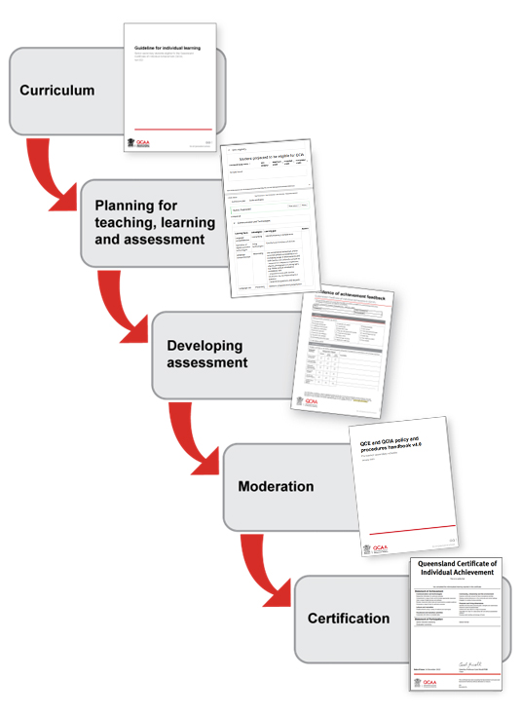
- Curriculum
  - Curriculum structure
The Guideline for individual learning provides a curriculum framework consisting of curriculum organisers, learning focuses and learning goals for developing individualised curriculum plans for senior secondary students working toward the QCIA.
The figure below shows how the elements of the QCIA curriculum fit together.
Figure 2: Curriculum structure
Curriculum organisers
Communication and technologies | Community, citizenship and the environment | Leisure and recreation | Personal and living dimensions | Vocational and transition activities
Learning focuses
Learning goals
    - Curriculum organisers
Learning for each of the five QCIA curriculum organisers is defined in the curriculum organiser descriptions, and learning focuses are developed directly from these (Section 1.2: Curriculum content).
    - Learning focuses
The learning focuses are identified and developed from the curriculum organisers and reflect the significant components of each curriculum organiser.
    - Learning goals
Learning goals for each learning focus are described in Appendix 1, and are accessible directly from the Curriculum content by clicking on the hyperlinks in the learning focuses column.
Learning focuses are described through learning goals. They are organised to reflect a range of learning. Learning goals are designed to build from awareness or recognition through to use and application of particular knowledge, understanding and skills, and are found on a student’s individualised curriculum plan.
  - Curriculum content
Curriculum organiser |  |  |  | Learning focuses | Code
 |  |  | Communication and technologies |  | CT
Curriculum organiser description:  Students gain knowledge, understanding and skills in literacy and digital and other technologies.  Communication involves the student learning to comprehend language in listening, reading and viewing. Students learn to use language to communicate with others through speaking, writing and creating.  Technologies involves the student learning to operate digital and other technologies, including those for listening, reading, viewing, speaking, writing and creating language and texts, and calculation. They learn technical and social protocols for appropriate use of digital technologies to interact with others. |  |  |  | - Language comprehension  - Listening  - Navigating, reading and viewing  - Interpreting  - Responding | CT1  CT1.1  CT1.2  CT1.3  CT1.4
 |  |  |  | - Language use  - Communicating behaviours  - Interacting and composing  - Presenting | CT2  CT2.1  CT2.2  CT2.3
 |  |  |  | - Operation of digital and other technologies  - Purpose of and audience for technologies  - Using technologies  - Troubleshooting | CT3  CT3.1  CT3.2  CT3.3
 |  |  |  | - Technical and social protocols for use of digital technologies | CT4
 |  |  | Community, citizenship and the environment |  | CCE
Curriculum organiser description:  Students develop knowledge, understanding and skills about communities, citizenship and the environment.  Students learn about active citizenship, and participate in and contribute to their local and wider communities.  They learn about changes over time and across locations.  They explore the world around them, and investigate the natural and constructed features of places and different environments and the relationship between people and places.  They learn about how scientific understandings can inform decision making about people, environments and their relationships. |  |  |  | - Active citizenship in the local and wider community  - Decision making in communities  - Participating in and contributing to communities | CCE1  CCE1.1  CCE1.2
 |  |  |  | - Similarities and differences between the past and present  - Changes in communities  - Important events over time in Australia and the world | CCE2  CCE2.1  CCE2.2
 |  |  |  | - Places, environments and people  - Location  - Natural features of places including climate and weather  - Constructed features of places  - Relationships between people and places | CCE3  CCE3.1  CCE3.2  CCE3.3  CCE3.4
 |  |  |  | - Making decisions using scientific understandings | CCE4
 |  |  | Leisure and recreation |  | LR
Curriculum organiser description:  Students gain knowledge, understanding and skills to participate in a variety of leisure, recreation, artistic and cultural activities.  They learn about different physical activities and the importance of lifelong physical activity.  They learn to identify, experience and participate in their own preferred leisure and recreation activities.  They learn to make, participate, perform, contribute to and express opinions for artistic and cultural activities. |  |  |  | - Physical activities for leisure and recreation  - Movement skills and challenges  - Group activities and fair play | LR1  LR1.1  LR1.2
 |  |  |  | - The importance of lifelong physical activity | LR2
 |  |  |  | - Preferred leisure and recreation activities  - Identifying preferences  - Participating in activities | LR3  LR3.1  LR3.2
 |  |  |  | - Performing Arts activities — dance, drama, music | LR4
 |  |  |  | - Visual and Media Arts activities | LR5
 |  | Personal and living dimensions |  |  | PLD
Curriculum organiser description:  Students develop knowledge, understanding and skills in relevant personal and living dimensions, including health, wellbeing and everyday numeracy.  Students learn about their own and others’ identity, health and wellbeing.  They explore and take actions to keep themselves and their peers healthy and safe through food and nutrition, safe use of medicines and ways to keep safe in the environment.  They learn about emotions, how to enhance their interactions and relationships with others, and the physical and social changes they go through as they get older.  They develop their ability to use numeracy skills in everyday situations. |  |  |  | - Identity  - Resilience  - Self-identity and others’ identities  - Values and ethics | PLD1  PLD1.1  PLD1.2  PLD1.3
 |  |  |  | - Health and wellbeing  - Health  - Physical and social development  - Understanding and managing emotions  - Safety  - Interacting with others  - Relationships | PLD2  PLD2.1  PLD2.2  PLD2.3  PLD2.4  PLD2.5  PLD2.6
 |  |  |  | - Everyday numeracy skills  - Understanding and using number values  - Applying patterns and relationships  - Using data  - Applying concepts of time  - Using money | PLD3  PLD3.1  PLD3.2  PLD3.3  PLD3.4  PLD3.5
 | Vocational and transition activities |  |  |  | VTA
Curriculum organiser description:  Students develop knowledge, understanding and skills by identifying and investigating their post-school pathways.  They learn how to set goals and make decisions to achieve them.  They learn about local and community resources for living independently and interdependently. They learn how to access resources to support their needs when they transition to life beyond school. |  |  |  | - Post-school pathways  - Options for living independently and interdependently  - Vocational and transition options  - Accessing local and community resources | VTA1  VTA1.1  VTA1.2  VTA1.3
 |  |  |  | - Skills for life beyond school  - Self-knowledge  - Skills for managing self and others  - Independence skills  - Goal setting and decision making | VTA2  VTA2.1  VTA2.2  VTA2.3  VTA2.4
- Planning for teaching, learning and assessment
Two principles underpin effective planning for teaching, learning and assessment across Prep to Year 12:
- high expectations for all students — built on differentiation of teaching and learning for all students in single and multiple year level contexts
- alignment of teaching and learning, and assessment and reporting — curriculum and assessment planning is thoughtful and ensures that all parts are connected; plans are reviewed regularly to inform future planning, teaching, learning and assessment.
  - Elements of effective planning
Planning for teaching, learning and assessment is guided by five independent elements of professional practice. These five elements can be used in any sequence but all should be considered:
- identify curriculum
- develop assessment
- sequence teaching and learning
- make judgments
- use feedback.
These planning elements are explored in the figure overleaf (Figure 3).
  - Planning using the Guideline for individual learning
When planning for individual students to meet the requirements of the QCIA, teachers use the Guideline for individual learning to:
- identify curriculum organisers
- for each relevant curriculum organiser:
  - select learning focuses suited to the student’s needs and interests
  - select learning goals associated with each selected learning focus
  - access resources that could support teaching, learning and assessment of learning goals.
Appendix 2 sets out a checklist teachers can use when using the guideline to plan for a QCIA.

Figure 3: The five elements of effective curriculum and assessment planning
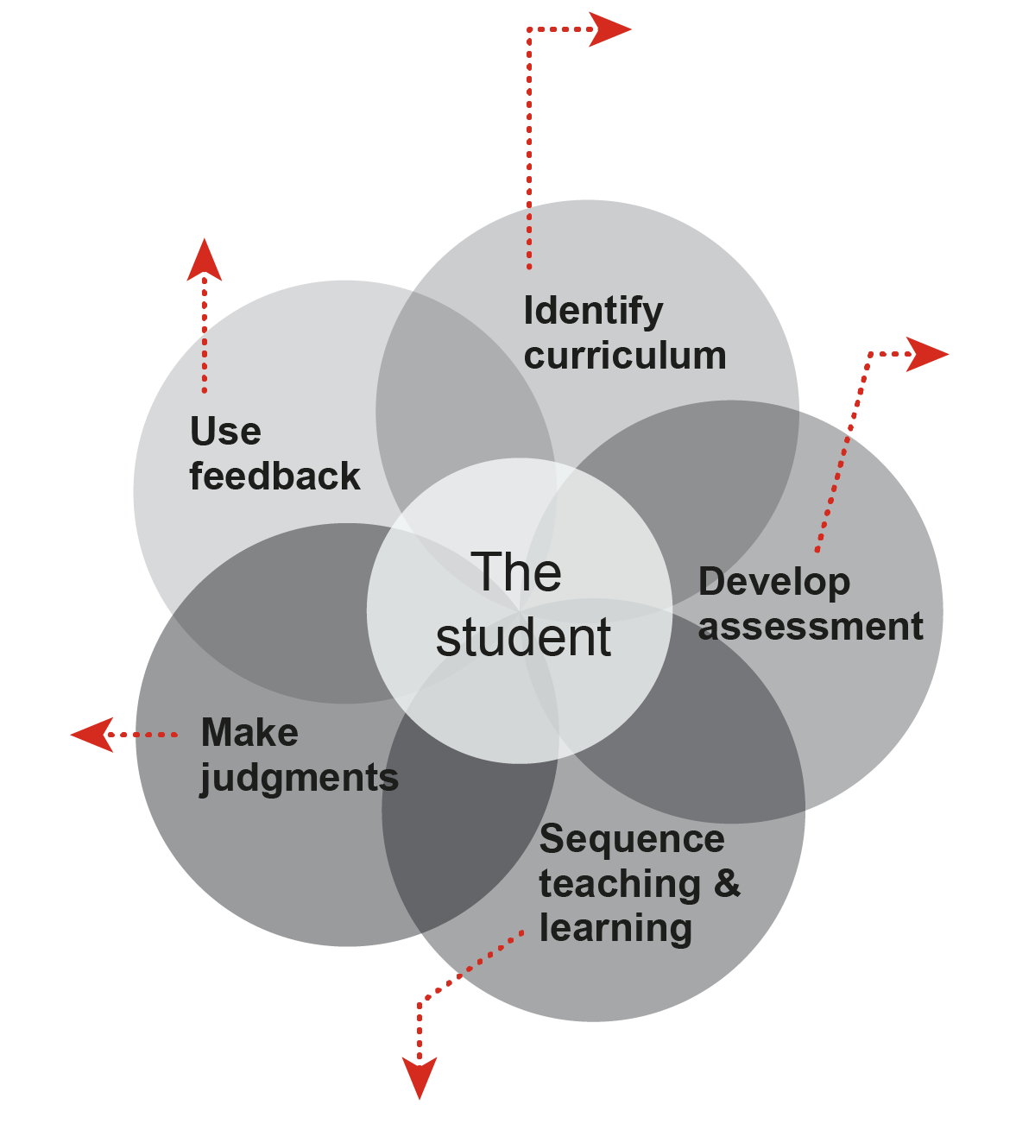
Use feedback
Students receive ongoing feedback throughout teaching and learning experiences.
Students and their parents/carers receive formal feedback at the time of reporting.
Teachers use feedback to inform their planning for teaching and learning.
Make judgments
Judgments are made about evidence of progress towards learning goals selected from the Guideline for individual learning.
Evidence should substantiate Statements of Achievement for each curriculum organiser that will be recorded on the QCIA.
Sequence teaching and learning
The selection and sequence of learning experiences and teaching strategies support student learning towards the selected learning goals and provide evidence of achievement through assessment.

Develop assessment
Assessment is an integral part of teaching and learning and provides evidence of progression towards the selected learning goals detailed in QCIA curriculum plans.
Identify curriculum
The Guideline for individual learning is the basis for planning teaching, learning and assessment.
Teachers select relevant curriculum organisers, learning focuses and learning goals provided in the guideline to develop teaching and learning experiences.

This planning tool is also available as a separate resource on the Curriculum: Planning with the GIL page: www.qcaa.qld.edu.au/senior/certificates-and-qualifications/qcia/curriculum-planning-gil.
- Developing assessment
Assessment is an integral part of teaching and learning. It is the purposeful collection of evidence about students’ achievements. An awareness of what learning is assessed and how it is assessed helps both students and parents/carers develop an understanding of what is valued and where to focus attention.
Assessment is used for a variety of purposes, but its most important use is in supporting student learning.
Sufficient and suitable evidence is collected to enable fair judgments to be made about student learning. Once the evidence is collected and analysed, it is summarised and presented in ways that are meaningful and useful to:
- help students achieve the highest outcomes they can
- promote, assist and improve teaching and learning
- build a shared understanding of the qualities of student work and communicate meaningful information about students’ progress and achievements to students, teachers, parents/carers and the system.
  - Assessment for individualised learning programs
Assessment is planned at the same time as the teaching and learning program. Assessment provides evidence of the learning goals developed from the selected learning focuses in the curriculum organisers.
A planned approach to assessment development and implementation will:
- guide and support targeted teaching and learning
- ensure students have opportunities to demonstrate their learning in all relevant aspects of selected curriculum organisers
- include opportunities for students to become familiar with the assessment techniques
- provide regular feedback to students about how they can improve their learning
- clarify future teaching and learning needs
- ensure teachers have sufficient evidence of, and progress towards, the learning goals outlined in the student’s curriculum plan.
    - Folio of student evidence of achievement
Teachers apply principles for and approaches to assessment when developing assessments and collecting evidence of student achievement.
The QCE and QCIA policy and procedures handbook provides guidelines for compiling folios of student evidence of achievement: www.qcaa.qld.edu.au/33044.htmlwww.qcaa.qld.edu.au/senior/certificates-and-qualifications/qce-qcia-handbook.
    - Evidence
Teachers collect evidence to support judgments about the student’s learning goals for each proposed Statement of Achievement linked to the curriculum organisers. Not all evidence collected needs to be submitted for verification, but all evidence submitted should match the Statements of Achievement and the Statements of Participation recorded on the draft certificate. Evidence must be recorded digitally, such as in a PowerPoint file, for upload by the date listed in the SEP calendar, which is updated annually.
Examples of how evidence can be gathered include:
- anecdotal records
- annotated photographs
- discussions with parents/carers, colleagues, employers
- interview with student
- learning logs
- observation notes
- peer and self-assessment checklist
- presentation
- progress chart
- sound/image recording (mp4 file)
- task responses and worksheets
- teacher and student journals
- visual folios
- work experience report.
- Moderation
The most effective way to build consistent and comparable on-balance teacher judgment is through planned activities when teachers — in a partnership or team situation — engage in focused professional dialogue to discuss and analyse the quality of student work, compare their judgments about student achievement and determine the match between the evidence in student work and learning goals. This process is known as moderation.
  - School-based moderation
Professional dialogue increases teachers’ awareness about the variety of ways in which students may respond to assessment and the types of evidence that may be available to support teacher judgments. In this way, teachers gain valuable insights about how the learning goals can be demonstrated in student work. They build a shared understanding about the match of evidence to learning goals, enhancing classroom practice and supporting the alignment of curriculum and assessment.
Moderation provides students and their parents/carers with confidence the judgments about student achievement are defensible and that the information provided by the school is meaningful, professional and consistent.
  - QCIA quality assurance process
Peer moderation is the key process that ensures the validity and reliability of certificate information. This occurs at the online verification meeting, which is facilitated by the QCAA.
The main focus is the review of the draft Statements of Achievement and evidence of achievement. Advisers review the evidence and QCIA curriculum plan to see if there is a match with the certificate information. The QCIA curriculum plan is used as an indication of the types of planned learning for the student.
The folio of evidence is reviewed to identify the link to the Statement of Achievement and Statement of Participation. Advisers make a judgment on whether the evidence substantiates the certificate information. Schools action feedback as provided by the advisers.
The QCE and QCIA policy and procedures handbook provides detailed information on quality assurance processes: www.qcaa.qld.edu.au/senior/certificates-and-qualifications/qce-qcia-handbook.
- Certification
Schools are required to provide twice-yearly plain language reports to parents/carers. Systems, sectors and individual schools determine approaches to and specific requirements for twice-yearly reporting. In most schools, this takes place at the end of each semester.
Schools record statements of achievement and participation for inclusion on each student’s QCIA at the end of Year 12. The QCAA provides resources to support schools in developing programs for students working toward the QCIA.

Appendix 1: Learning goals
This appendix provides learning goals for each of the curriculum organisers and learning focuses described in Section 1.2: Curriculum content.

Curriculum organisers
Communication and technologies 12
Community, citizenship and the environment 17
Leisure and recreation 22
Personal and living dimensions 26
Vocational and transition activities 33

Organiser coding
To support schools in the development of their curriculum and assessment plans, curriculum organisers have been coded as follows.
Curriculum organiser | Code | Icon
Communication and technologies | CT
Community, citizenship and the environment | CCE
Leisure and recreation | LR
Personal and living dimensions | PLD
Vocational and transition activities | VTA

- Learning focuses within each organiser are numbered.
i.e. Communication and technologies learning focuses are coded CT1 through CT4.
- When learning focuses are broken down further, the subcategories within the learning focuses are also numbered.
i.e. The first Communication and technologies learning focus is broken into four subcategories, which are coded CT1.1 through CT1.4.

Communication and technologies
The communication and technologies learning focuses are:
- Language comprehension CT1
  - Listening CT1.1
  - Navigating, reading and viewing CT1.2
  - Interpreting CT1.3
  - Responding CT1.4
- Language use CT2
  - Communicating behaviours CT2.1
  - Interacting and composing CT2.2
  - Presenting CT2.3
- Operation of digital and other technologies CT3
  - Purpose of and audience for technologies CT3.1
  - Using technologies CT3.2
  - Troubleshooting CT3.3
- Technical and social protocols for use of digital technologies CT4

Language comprehension CT1
Listening CT1.1
Learning goals:
- Listen and respond to questions and requests.
- Listen and respond to questions and statements.
- Listen to and identify key information in spoken and multimodal texts.
- Listen to and recall information about topics being learned in spoken texts.
- Listen to and recall information in simple spoken texts.
- Listen and respond to detailed spoken instructions for undertaking learning tasks.
- Listen and respond to one- and two-step instructions.
- Listen to and comprehend information presented in spoken texts and texts read aloud.
Navigation, reading and viewing CT1.2
Learning goals:
- Show awareness of and identify symbols and words.
- Identify high frequency words in texts.
- Understand that words can be organised into sentences.
- Navigate, read and view simple texts with:
  - familiar vocabulary and supportive illustrations
  - illustrations and simple graphics.
- Navigate, read and view:
  - different types of texts with illustrations and more detailed graphics
  - subject-specific texts with some challenging features and a range of graphic representations.
Interpreting CT1.3
Learning goals:
- Identify meaning in simple texts.
- Interpret simple texts using comprehension strategies such as activating and using prior knowledge and identifying literal information explicitly stated in the text.
- Use comprehension strategies such as interpreting literal information, making inferences and predicting to explore topics and gather information from texts.
- Use comprehension strategies such as interpreting literal information, making inferences and predicting to explore topics.
- Make some obvious inferences from texts.
- Summarise and organise information and ideas.
- Interpret implicit and explicit meaning of symbols, words and phrases.
- Compare texts on similar topics or themes.
Responding CT1.4
Learning goals:
- Use behaviours that are not intentionally directed at another person to attend to, respond to or show interest in familiar people, texts, events and activities.
- Use informal behaviours that show consistent anticipation of events in regular routines to:
  - attend consistently to familiar texts
  - respond consistently to social interactions with familiar people
  - demonstrate anticipation of predictable events
  - respond to questions and requests.
- Use conventional behaviours and/or concrete symbols consistently in an increasing range of environments and with familiar and unfamiliar people to:
  - respond to a sequence of gestures, objects, photographs or pictographs, e.g. follow a visual schedule to complete a task
  - respond to texts with familiar structures, e.g. by responding to a question
  - respond to requests.
- Use conventional behaviours and/or abstract symbols consistently in different contexts and with different people to:
  - work out the meaning of texts with familiar structures, such as illustrated books, printed words, braille texts and pictographs, using knowledge of context and vocabulary
  - respond to questions, sequence events and identify information from texts with familiar structures
  - use information in texts to explore a topic.

Language use CT2
Communicating behaviours CT2.1
Learning goals:
- Indicate a physical state, e.g. hot, cold, nauseous.
- Use behaviours that are not intentionally directed at another person to:
  - refuse or reject
  - reflect a preference or desire
  - reflect a state of wellbeing, e.g. contentment, joy, worry, pain.
- Use informal behaviours to intentionally communicate a single message consistently in familiar environments with familiar people, such as to:
  - refuse or reject
  - express a preference
  - request the continuation of an activity
  - request something new
  - request more
  - request attention.
- Use conventional behaviours and/or concrete symbols to intentionally communicate more than one idea at a time consistently across an increasing range of environments with familiar and unfamiliar people, such as to:
  - refuse or reject
  - request items, people or events present at the time
  - create texts, e.g. to comment on a recent event, story or shared experience.
- Use conventional behaviours and/or abstract symbols consistently in different contexts and with different people to communicate intentionally and consistently to:
  - create texts with familiar structures such as speech, simple print texts, keyboard texts, illustrations, pictographs
  - comment on people, events and objects in the past, present and future and to ask questions
  - convey knowledge about learning area topics.
Interacting and composing CT2.2
Learning goals:
- Use pair, group and class discussions and informal debates to:
  - explore topics
  - represent ideas and relationships
  - test possibilities
  - compare solutions.
- Compose texts to record and report events and ideas.
- Compose and edit texts to represent events and ideas.
Presenting CT2.3
Learning goals:
- Identify visual representations to communicate a response.
- Prepare visual representations for use in a short presentation.
- Deliver a prepared short presentation.
- Plan and deliver short presentations.
- Plan, rehearse and deliver short presentations, incorporating some visual and multimodal elements.
- Plan, research, rehearse and deliver presentations, selecting appropriate content and incorporating visual and multimodal elements.

Operation of digital and other technologies CT3
Purpose of and audience for technologies CT3.1
Learning goals:
- Engage with a number of different devices.
- Recognise that different devices have different purposes.
- Identify how digital and other technologies are used at home and at school.
- Identify the value and role of digital and other technologies used at home and school.
- Describe the different uses of digital and other technologies at school, home and in the local community.
- Identify and explore the benefits and risks of using digital and other technologies.
Using technologies CT3.2
Learning goals:
- Use augmentative and alternative communication (AAC) devices to communicate.
- Recognise that devices have tools and applications.
- Use the basic functions of devices.
- Identify and select digital and other technologies suited to completing simple specified tasks.
- Safely operate software, functions and commands when operating devices.
- Explore digital and other technologies as a tool to generate simple solutions for audiences and purposes.
- Create and modify simple technological solutions, outputs or data for purposes.
- Independently or collaboratively create or modify technological solutions for audiences and purposes.
- Follow conventions to modify simple technological solutions for audiences and purposes.
- Use digital technologies to:
  - identify where information is located
  - identify, record and classify information
  - plan an information search
  - generate information
  - identify and represent information.
Troubleshooting CT3.3
Learning goals:
- Recognise when a technology problem occurs.
- Understand processes and implement strategies for resolving technological problems by:
  - attempting to solve a problem before seeking help
  - seeking help when encountering a technological problem
  - seeking solutions when encountering a problem.
- Use basic troubleshooting procedures to resolve routine malfunctions.

Technical and social protocols for use of digital technologies CT4
Learning goals:
- Recognise social communication protocols when using digital technologies.
- Recognise intellectual property of digital work.
- Recognise that digital products can be used or misused.
- Follow instructions and protocols when sharing personal information.
- Follow instructions and protocols about applying standard guidelines and techniques to secure digital information.
- Acknowledge sources of digital information.
- Apply basic social protocols when using digital technologies to communicate with known audiences.
- Apply strategies for determining and protecting the security of digital information.
- Recognise and value individuals’ rights to identity, privacy and emotional safety for themselves and others when using digital technologies.
- Identify the risks to individuals’ identity, privacy and emotional safety when using digital technologies.
- Use digital technologies safely to:
  - view information shared by trusted adults
  - share and exchange information with known audiences.
- Select and use appropriate digital technologies and tools safely when sharing and exchanging information in online environments.
- Determine appropriate storage locations for different types of digital information.

Community, citizenship and the environment
The community, citizenship and the environment learning focuses are:
- Active citizenship in local and wider communities CCE1
  - Decision making in communities CCE1.1
  - Participating in and contributing to communities CCE1.2
- Similarities and differences between the past and present CCE2
  - Changes in communities CCE2.1
  - Important events over time in Australia and the world CCE2.2
- Places, environments and people CCE3
  - Location CCE3.1
  - Natural features of places including climate and weather CCE3.2
  - Constructed features of places CCE3.3
  - Relationships between people and places CCE3.4
- Making decisions using scientific understandings CCE4

Active citizenship in the local and wider community CCE1
Decision making in communities CCE1.1
Learning goals:
- Engage with the ideas of what makes a community, e.g. a common location, shared purposes, lifestyle choices, employment/industry.
- Identify home and school within the local community.
- Identify different types of communities, including Aboriginal communities and Torres Strait Islander communities.
- Show awareness of the role of the individual in different communities.
- Identify that there are rules and responsibilities when participating in communities.
- Understand the differences between ‘rules’ and ‘laws’, and how they impact on individuals and communities.
- Identify roles, rights and responsibilities that individuals have in different communities, e.g. at home, in the classroom, in community groups.
- Identify situations where individuals can take on different roles in communities.
- Identify needs and problems in communities.
- Describe the roles and responsibilities of different levels of government and their associated resources and services.
- Describe the qualities of ‘good’ rules or laws in communities, such as laws applying equally to everyone.
- Explain why people make rules for participation in communities.
- Explain how and why decisions are made in communities.
- Explain how communities provide support and care for their citizens.
- Compare the values, opinions and attitudes of individuals and groups in communities.
Participating in and contributing to communities CCE1.2
Learning goals:
- Follow instructions and rules of different communities including home, school and work.
- Identify the skills needed to engage with communities, including planning, organising, collaborating, negotiating and recordkeeping.
- Identify why people participate within communities and the different opportunities to actively participate and contribute.
- Describe how people work in groups to achieve their aims, express their shared beliefs and values and influence communities.
- Explain the contributions of individual and different groups to local communities and the wider Australian community.
- Plan and participate in school and community activities, using strategies to solve problems and build teams.
- Create ways to take action to address community needs and problems using skills to engage community members.
- Explain the obligations citizens may consider they have beyond their own national borders as active and informed global citizens.

Similarities and differences between the past and present CCE2
Changes in communities CCE2.1
Learning goals:
- Show awareness of people, events and objects in the past, present and future.
- Show awareness of different individuals and groups within communities including families, peer and friendship groupings, community organisations and service providers.
- Recognise how the present, past and future are signified by terms indicating time such as ‘a long time ago’, ‘then and now’, ‘now and then’, ‘old and new’, ‘tomorrow’; dates.
- Recognise that communities exist at different levels — local, state, national, regional and international, and change and develop over time.
- Identify different structures of families and family groups, and identify similarities and differences between them.
- Identify how different individuals and groups celebrate and commemorate events that are important to them.
- Identify how the stories of families and the past can be communicated, e.g. through photographs, artefacts, books, oral histories, digital media, museums.
- Describe differences in roles, such as gender, life stage (child, adolescent, teenager, adult), in families and in communities; and how these roles have changed or remained the same over time.
- Describe events that may have personal significance, such as birthdays, celebrations and seasons.
- Describe similarities and differences between young people’s daily lives today and life during their parents’ and grandparents’ childhoods, including family traditions, leisure time and communications.
- Describe the importance of a historical site of cultural or spiritual significance, e.g. a community building, a landmark, a war memorial.
- Explain how changes in technology have influenced people’s lives at home, at work, when travelling.
Important events over time in Australia and the world CCE2.2
Learning goals:
- Show awareness that the Aboriginal peoples and Torres Strait Islander peoples are the First Peoples of Australia.
- Identify the long history of Aboriginal peoples and Torres Strait Islander peoples in Australia.
- Identify important events in the local community, region or state/territory, e.g. in relation to the areas of transport, work, education, natural and built environments, entertainment, daily life.
- Participate in ceremonies and celebrations about past events with the local community, e.g. ANZAC Day, Sorry Day.
- Identify that Aboriginal peoples and Torres Strait Islander peoples are connected to Country and Place (land, sea, waterways and skies) and these connections shape their daily lives.
- Describe the stories of the different groups of Australians such as the First Australians and migrants.
- Describe the contribution of individuals and groups to Australian communities and other communities around the world.
- Explain why some events in the past are important to communities, nations and throughout the world.

Places, environments and people CCE3
Location CCE3.1
Learning goals:
- Show awareness of familiar places and locations within the local community.
- Identify places and locations around the world.
- Recognise elements of the wider world including natural surroundings, weather and constructed features.
- Recognise the location and nature of Australia as an island continent.
- Use the location and direction features of a map, including north orientation, symbols that represent natural and constructed features of places and a legend or key.
- Identify Australia and its states and territories represented in a simple map.
- Identify the location of places and their features on maps and a globe.
- Locate positions, show routes and interpret information on maps and diagrams.
- Explain directions using maps and diagrams of familiar locations and places.
- Create maps and models of familiar locations and places.
- Use public transport timetables and maps to access the local community.
Natural features of places including climate and weather CCE3.2
Learning goals:
- Show awareness of the natural features of the local environment, including weather and climate.
- Identify different types of weather and the effect it has on individuals and the environment.
- Identify the natural features of places including where they are located.
- Identify major natural features of Australia, Queensland and the local area.
- Identify the risks associated with natural features of places, e.g. being aware of dangers when swimming or bushwalking.
- Identify the main climate types in different parts of the world and identify similarities and differences between them.
- Describe the local weather and seasons.
- Describe different types of weather by presenting data in drawings or picture graphs.
- Locate, record and display data on a weather issue.
- Explore natural features of surroundings, e.g. nature trail, rock pool at the beach.
- Explain how different cultural groups, including Aboriginal peoples and Torres Strait Islander peoples, may describe weather and seasons in different ways.
- Explain the impact of weather events, such as bushfires, droughts, floods and cyclones, on environments and communities.
- Create strategies to show the value of and to protect the natural features of places.
Constructed features of places CCE3.3
Learning goals:
- Show awareness of the constructed features of the local community.
- Identify the constructed features of places including where they are located.
- Identify the ways that spaces within places, such as classrooms or backyards, can be rearranged to suit different activities or purposes.
- Identify major constructed features of Australia, Queensland and the local area, e.g. cities, landmarks.
- Identify and mitigate risks associated with constructed features of places, e.g. staying behind railings on a bridge.
- Explore constructed features of surroundings, e.g. sensory room, gardens.
- Plan a strategy for keeping a constructed environment healthy and safe.
Relationships between people and places CCE3.4
Learning goals:
- Recognise that people can have feelings about places that are significant to them.
- Identify why some places are special to people, and how these places can be cared for.
- Identify how people’s feelings about places can influence views about their protection.
- Identify how Aboriginal peoples and Torres Strait Islander peoples maintain special connections to particular Country/Place.
- Explain similarities and differences in individuals’ and groups’ feelings and perceptions about places, and how they influence views about the protection of these places.
- Explain reasons why people travel to particular places, e.g. work and tourism.
- Explain the importance of environments to animals and people.
- Explain what people do to protect environments and communities from natural hazards, e.g. bushfires, storms, floods.
- Create a plan to represent how individuals or groups can sustainably protect a place or an environment.

Making decisions using scientific understandings CCE4
Learning goals:
- Observe the local and wider environment using the senses.
- Recognise that science involves exploring and observing the local and wider environment using the senses.
- Recognise that science involves asking questions about, and describing changes in, objects and events.
- Identify how people use science in their daily lives, including when caring for their environment and living things.
- Identify how scientific understandings, discoveries and inventions are used to solve problems that directly affect people’s lives.
- Explain how science involves making predictions and describing patterns and relationships.
- Explain how science and technology contribute to finding solutions to issues.
- Explain how people use understanding and skills from across the disciplines of science in their occupations.
- Explain the importance of environments to animals and people, and identify different views on protecting them.
- Create a plan to use scientific evidence to solve a community problem.

Leisure and recreation
The leisure and recreation learning focuses are:
- Physical activities for leisure and recreation LR1
  - Movement skills and challenges LR1.1
  - Group activities and fair play LR1.2
- The importance of lifelong physical activity LR2
- Preferred leisure and recreation activities LR3
  - Identifying preferences LR3.1
  - Participating in activities LR3.2
- Performing Arts activities — dance, drama, music LR4
- Visual and Media Arts activities LR5

Physical activities for leisure and recreation LR1
Movement skills and challenges LR1.1
Learning goals:
- Position and move different parts of the body to maintain flexibility and health.
- Perform fundamental movement skills.
- Perform and practise fundamental movement skills:
  - using different parts of the body
  - in response to stimuli, such as equipment, rhythm, music and words.
- Demonstrate how the body can move in relation to other objects and people.
- Participate in gross motor activities.
- Participate in games with equipment.
- Participate in games without equipment.
- Identify movement challenges.
- Safely operate electric mobility devices.
- Test possible solutions to movement challenges through trial and error.
- Identify and describe how own body can move in relation to effort, space, time, objects and people.
- Perform fundamental movement skills to sequence and perform simple movement patterns.
- Perform simple movement sequences incorporating elements of effort, space, time, objects and people.
- Propose a range of alternatives and test their effectiveness when solving movement challenges.
- Apply innovative and creative thinking in solving movement challenges.
- Construct and perform imaginative and original movement sequences in response to stimuli.
- Practise and apply movement concepts and strategies.
Group activities and fair play LR1.2
Learning goals:
- Cooperate with others when participating in physical activities.
- Follow rules when participating in physical activities.
- Use strategies to work in group situations when participating in physical activities.
- Identify rules and play fairly when participating in physical activities.
- Adopt inclusive practices when participating in physical activities.
- Participate safely in simple games with and without equipment, such as moving safely in space, respecting others’ space and passing to other players.
- Apply basic rules and scoring systems.
- Demonstrate fair play when participating.
- Participate positively in groups and teams by encouraging others and negotiating roles and responsibilities.
- Demonstrate ethical behaviour and fair play when participating in physical activities.
- Understand the contribution of different roles and responsibilities, such as coach, official, manager, instructor and leader, in physical activities that promote enjoyment, safety and positive outcomes for participants.
- Adopt roles and responsibilities that support and enhance team cohesion and lead to successful movement outcomes.

The importance of lifelong physical activity LR2
Learning goals:
- Show awareness of participating in an activity, e.g. smiling.
- Describe feelings before, during and after participating in physical activities.
- Explore how regular physical activity keeps individuals healthy and well.
- Identify the body’s reactions to participating in physical activities.
- Examine the benefits of physical activity and physical fitness to health and wellbeing.
- Participate in physical activities designed to enhance fitness.
- Discuss the impact regular participation can have on health and wellbeing.
- Compare and contrast the effect of regular and non-regular participation in physical activities on own health and wellbeing.

Preferred leisure and recreation activities LR3
Identifying preferences LR3.1
Learning goals:
- Use behaviours that indicate preference for particular activities.
- Identify interests in particular physical, artistic and cultural activities.
- Make choices based on personal preferences for particular activities.
- Explain reasons for personal interest in particular physical, artistic and cultural activities.
- Identify and explain which physical, artistic and cultural activities meet own needs and interests.
- Describe the features that make different physical, artistic and cultural activities enjoyable.
- Identify what makes activities enjoyable and safe and how physical activity keeps you healthy and well, through participating in physical activities.
Participating in activities LR3.2
Learning goals:
- Participate as a spectator at a sports event.
- Explore ways spectators show their appreciation for games, matches or events.
- Explore how fans become involved with a particular sport, team or event.
- Participate as an audience member at a concert or show.
- Explore ways audience members show their appreciation for a concert or show.
- Identify and take up opportunities to access local community resources that support participation in physical and health-related activities.
- Identify and take up opportunities to access local community resources that support participation in artistic and cultural activities.
- Explore how participation in physical, artistic and cultural activities from their own and other cultures can create community connections and intercultural understanding.
- Participate in an organised sporting activity.

Performing Arts activities — dance, drama, music LR4
Learning goals:
- Show awareness of dramatic play or roleplay.
- Experience live and recorded music.
- Show awareness of sound and rhythm using voice, body percussion or movement.
- Recognise that dance, drama and music can convey emotions, ideas and stories.
- Use fundamental movement skills to engage in a dance, dramatic performance or music.
- Share dance, drama, or music with peers to communicate emotions, experiences, ideas and stories.
- Sing, play instruments and move to music, e.g. chants, songs, rhymes.
- Rehearse and perform to develop interpersonal and team skills.
- Describe how dance movements, dramatic stories or musical compositions communicate emotions, experiences, ideas and stories.
- Identify or imagine emotions, ideas or stories for a dance, drama or roleplay.
- Identify where and why people dance and engage in dramatic performances.
- Use voice, movement or facial expression to imagine or establish roles or situations.
- Share personal understanding of what happened in a performance.
- Explore how different cultures perform drama, dance and music.
- Describe the emotions, ideas or stories conveyed through music that has been listened to and played.
- Identify aspects of a dance, dramatic or musical performance enjoyed, or not enjoyed.
- Share personal opinions about a dance, dramatic performance or piece of music.
- Identify and describe personal music preferences.

Visual and Media Arts activities LR5
Learning goals:
- View their own and others’ artworks.
- Show awareness that artworks can convey emotions and stories.
- Show awareness of representations of self and others in images, sounds and text.
- Explore and experiment with different materials and processes to make artworks.
- Make representations of self and others using images, sounds and text.
- Use media technology to capture images, sounds and text and edit to convey experiences, emotions and ideas.
- Use safe practices when making artworks and using media technology.
- Identify and use different forms and styles of visual artwork, including 2D and 3D forms.
- Sequence events to create stories using images, sounds and text.
- Explore and experiment with techniques to enhance artworks.
- Share and explain own artworks to others.
- Explore and experiment with creating artworks that:
  - convey own feelings
  - use one’s own experiences, imagination and observations as inspiration
  - use others’ experiences, imagination and observations as inspiration.
- Describe the emotions and stories conveyed in artworks.
- Explain reasons for choosing to present and display artworks in particular ways.
- Describe the ideas, characters and settings of stories in images, sounds and text.
- Identify and share personal opinions about artworks.
- Give reasons for personal opinions about artworks.
- Identify and describe personal art preferences.

Personal and living dimensions
The personal and living dimensions learning focuses are:
- Identity PLD1
  - Resilience PLD1.1
  - Self-identity and others’ identities PLD1.2
  - Values and ethics PLD1.3
- Health and wellbeing PLD2
  - Health PLD2.1
  - Physical and social development PLD2.2
  - Understanding and managing emotions PLD2.3
  - Safety PLD2.4
  - Interacting with others PLD2.5
  - Relationships PLD2.6
- Everyday numeracy skills PLD3
  - Understanding and using number values PLD3.1
  - Applying patterns and relationships PLD3.2
  - Using data PLD3.3
  - Applying concepts of time PLD3.4
  - Using money PLD3.5

Identity PLD1
Resilience PLD1.1
Learning goals:
- Identify situations that feel safe or unsafe.
- Undertake and persist with short tasks within the limits of personal safety.
- Explore ways to approach and complete tasks while maintaining personal safety.
- Identify challenges and adapt approach to persist with tasks.
- Explore and practise strategies to use when feeling uncomfortable or unsafe, or needing help with a task, problem or situation.
- Practise and apply strategies to seek help for self or others.
- Assess and modify approaches to tasks to revisit them with renewed confidence when first attempts were not successful.
Self-identity and others’ identities PLD1.2
Learning goals:
- React to sensory stimulus to determine personal likes and dislikes.
- Identify self in images or reflections.
- Identify personal likes and dislikes, needs and wants.
- Identify personal strengths and achievements.
- Describe the influences on personal likes, dislikes, needs and wants.
- Share ideas about self with peers.
- Describe personal interests, skills and achievements.
- Describe own strengths and achievements and those of others.
- Describe how personal strengths contribute to individuals’ identities.
- Explain how personal interests, skills and achievements contribute to family and school life.
- Identify and describe personal skills that need further development.
- Examine how success, challenge and failure strengthen personal identities.
Values and ethics PLD1.3
Learning goals:
- Show awareness of values and ethics demonstrated in own and others’ behaviour.
- Identify values that are important to individuals.
- Explore everyday situations and interactions to identify ethical concepts.
- Identify and describe ethical concepts arising in familiar contexts, e.g. right and wrong, respect, honesty, fairness and justice, equality and equity.
- Compare personal values with others, and identify similarities and differences.
- Discuss some agreed values in familiar contexts.
- Identify and describe shared values in familiar and unfamiliar contexts.
- Explore how ethical concepts and ethical behaviour can contribute to achieving outcomes.
- Explore values that may be accepted or not accepted in communities.

Health and wellbeing PLD2
Health PLD2.1
Learning goals:
- Engage in mealtime routines.
- Explore healthy mealtime options.
- Engage in the preparation of healthy mealtime options.
- Show awareness of and identify health information and messages presented in the media, including online materials.
- Identify and express concerns about own health.
- Ask about and express interest in others’ health.
- Identify simple actions to support own and others’ health.
- Explore and practise daily habits that promote own and others’ health.
- Explore health information and messages presented in the media and how they relate to health decisions and behaviours.
- Practise preventive health strategies to support the health and wellbeing of individuals and the community.
- Recognise how media and well-known people in the community can influence personal attitudes, beliefs, decisions and behaviours about health.
- Explore and assess the usefulness and accuracy of health information presented in the media.
Physical and social development PLD2.2
Learning goals:
- Show awareness of and name parts of own body.
- Describe how their own body is growing and changing.
- Understand that there are physical and social changes as adolescents become adults.
- Understand and explain how family and community acknowledge physical and social changes.
- Explore strategies to manage physical, social and emotional change.
- Identify resources to support the transition from adolescence to adulthood.
- Identify and use resources and strategies that support the transition from adolescence to adulthood.
Understanding and managing emotions PLD2.3
Learning goals:
- Show awareness of and identify feelings and emotions in different situations.
- Show awareness that emotions influence the way individuals feel and act.
- Show awareness of and interest in others’ feelings and emotions.
- Show awareness of ways to identify, manage and moderate emotions and emotional responses.
- Identify and describe emotional responses people may experience in different situations.
- Describe situations that may evoke a range of emotions.
- Express emotions constructively in interactions with others.
- Identify and practise emotional responses that account for own and others feelings.
- Describe ways to express emotions to show awareness of the feelings and needs of others.
- Investigate how emotional responses vary in depth and strength.
- Describe the influence that people, situations and events have on own emotions.
- Identify strategies to manage and moderate emotions in increasingly familiar situations.
- Identify strategies to manage and moderate emotions in increasingly unfamiliar situations.
- Describe strategies to manage and moderate emotions in increasingly familiar and unfamiliar situations.
- Examine the influence of emotional responses on behaviour and relationships.
- Explain how the appropriateness of emotional responses influences behaviour.
- Explain the influence of emotions on behaviour, learning and relationships.
Safety PLD2.4
Learning goals:
- Identify situations and environments that feel safe or unsafe.
- Identify the people who are important and help keep them safe.
- Show awareness of and explore community resources to support their safety and wellbeing.
- Identify people, environments and situations that support self in feeling a sense of familiarity or safety.
- Understand and identify behaviours that can be used to support own safety.
- Identify, describe and practise strategies that promote wellbeing, safe practices and protective behaviours.
- Identify appropriate dress requirements for a range of activities and environments.
Interacting with others PLD2.5
Learning goals:
- Show awareness of and acceptance of others.
- Show awareness of group interactions.
- Identify positive ways to initiate, join and interrupt conversations with adults and peers.
- Contribute collaboratively to groups and teams.
- Practise personal and social skills to interact with and include others.
- Identify and propose ways to improve ways of working together.
- Discuss the use of verbal and nonverbal communication skills to respond appropriately to adults and peers.
- Identify communication skills that enhance relationships for particular groups and purposes.
- Describe characteristics of cooperative behaviour and identify evidence of these in group activities.
- Identify and explain factors that influence effective communication in a variety of situations.
- Contribute to groups and teams, suggesting improvement in methods used for group investigations and projects.
Relationships PLD2.6
Learning goals:
- Show an awareness of and identify different types of relationships within and beyond family.
- Show an awareness of and identify feelings related to intimate relationships.
- Explore relationships through group experiences.
- Identify ways to care for others, including ways of making and keeping friends.
- Practise behaviours and skills to establish and manage friendships and other relationships.
- Describe factors that contribute to positive relationships, including those with people at school and in the community.
- Identify the differences between positive and negative relationships and ways of managing these.
- Understand there are external factors that can influence relationships with others, e.g. use of drugs, alcohol and tobacco.
- Identify people with whom it is appropriate to initiate and engage in an intimate relationship.
- Understand, identify and use appropriate behaviours for initiating and engaging in intimate relationships.
- Understand the connections between intimate relationships and reproductive and sexual health.

Everyday numeracy skills PLD3
Understanding and using number values PLD3.1
Learning goals:
- Show awareness of numbers and the meanings they convey in own environment.
- Understand and demonstrate concepts of counting, quantity and measurement using everyday experiences, e.g. more and less, bigger and smaller, the same.
- Use language or actions to describe characteristics of length, temperature, mass, volume, capacity and area in familiar environments.
- Recognise the effect of adding to and taking away from a collection of objects.
- Understand and demonstrate concepts of division and multiplication.
- Recognise a ‘whole’ and ‘parts of a whole’ within everyday contexts.
- Measure size and mass of objects.
- Compare measurements of objects, e.g. size, mass.
- Connect and order number names, numerals and groups of objects using numbers.
- Solve everyday addition and share stories.
- Recognise that a whole object can be divided into equal parts.
- Model, represent, order and use numbers.
- Estimate the solution to a problem and then calculate the answer.
- Visualise and describe halves and quarters.
- Estimate the solution to a problem and then check the solution by recalling addition, subtraction, multiplication and division facts
- Check calculations using mental and written strategies.
- Understand and sequence:
  - tenths, hundredths, 1-place and 2-place decimals
  - fractions, decimals, simple percentages and rates.
- Solve problems using:
  - halves, quarters and equivalent fractions
  - tenths, hundredths, 1-place and 2-place decimals
  - simple percentages and rates.
Applying patterns and relationships PLD3.2
Learning goals:
- Recognise simple patterns in everyday situations.
- Sort and match objects according to their features.
- Sort, name and match simple 2D and 3D objects.
- Demonstrate an understanding of positional language, e.g. next to, in front of.
- Describe and continue patterns.
- Identify, describe and create simple patterns.
- Identify, sort and describe common 2D shapes and 3D objects.
- Identify and describe trends in everyday patterns.
- Identify and describe symmetry, shapes and simple angles in the environment.
Using data PLD3.3
Learning goals:
- Identify different types of data.
- Identify different ways of collecting and recording data.
- Display information using real objects or photographs.
- Respond to questions about displayed information.
- Ask and answer simple data questions.
- Select simple questions and gather responses.
- Interpret data in drawings or picture graphs.
- Display data as lists, tables or picture graphs.
- Collect record and display data as tables, diagrams, picture graphs and column graphs.
Applying concepts of time PLD3.4
Learning goals:
- Recognise that time is used to organise and describe daily events, e.g. ‘before’ and ‘after’; ‘earlier’ and ‘later’; ‘day’ and ‘night’; ‘yesterday’, ‘today’ and ‘tomorrow’.
- Recognise that time is measured in units, including hours, minutes, seconds, days, weeks, months, seasons and years.
- Recognise that instruments are used to show the time, e.g. clocks, watches, phones, tablets, calendars.
- Sequence familiar actions and events in a variety of ways.
- Sequence familiar actions and events using the everyday language of time.
- Identify digital and analogue displays.
- Use terminology for measuring time, e.g. ‘o’clock’, ‘half past’, ‘quarter to’, ‘am’ and ‘pm’.
- Read digital and analogue clocks to the hour, half-hour, quarter-hour and minute.
- Read calendars to identify month, day and date.
- Read calendars to locate events and compare their timing.
- Understand and estimate how much time is required for daily activities and special events.
- Describe the sequence of daily activities using suitable descriptions or units of time.
- Convert between hours and minutes, 12- and 24-hour systems.
- Interpret and use timetables to explain travel options.
Using money PLD3.5
Learning goals:
- Show awareness of money and its purpose.
- Identify situations when money is used.
- Identify the different values of coins and notes in the Australian monetary system.
- Identify and use combinations of coins and notes for simple purchases.
- Estimate value of purchases and change.
- Calculate value of purchases and change.
- Identify and give reasons for ‘best value for money’ decisions.
- Count and order small collections of Australian coins and notes according to their value.
- Understand that money is earned through employment and can be accessed by applying for support through government and community agencies.
- Understand that workers pay tax on earnings above the designated threshold.
- Understand where and how to access and secure money.
- Understand different ways to pay for purchases.
- Understand that money can be borrowed in different ways and borrowings must be repaid.
- Prioritise needs and wants and allocate money accordingly.
- Explore and assess the advantages and disadvantages of decisions about money.
- Create and follow simple budgets and savings plans.

Vocational and transition activities
The vocational and transition activities learning focuses are:
- Post-school pathways VTA1
  - Options for living independently and interdependently VTA1.1
  - Vocational and transition options VTA1.2
  - Accessing local and community resources VTA1.3
- Skills for life beyond school VTA2
  - Self-knowledge VTA2.1
  - Skills for managing self and others VTA2.2
  - Independence skills VTA2.3
  - Goal setting and decision making VTA2.4

Post-school pathways VTA1
Options for living independently and interdependently VTA1.1
Learning goals:
- Show awareness of life beyond school.
- Show awareness that everyone has housing needs.
- Identify, describe and explore own and others’ needs to maintain safe and stable accommodation, considering physical resources and facilities required; support available from family, friends and agencies; and associated costs.
- Compare own and others’ needs to maintain safe and stable accommodation.
- Plan for transitioning to life beyond school, with support from peers, family and familiar adults.
Vocational and transition options VTA1.2
Learning goals:
- Recognise personal skills, interests and preferences for vocational and transition options.
- Use information, products and services to investigate vocational pathways and training opportunities, including industry talks and visits.
- Identify vocational and transition options related to personal interests and needs.
- Participate in different vocational and transition options, such as volunteering, supported employment, community participation, and simulated work environments.
- Identify specific experience, knowledge and skills needed to gain necessary experience in preferred post-school pathways.
- Engage in and reflect on supported work and community placements.
- Prepare a resume and application letter for identified jobs.
- Complete application forms related to employment and participation in community services.
- Prepare for job interviews.
Accessing local and community resources VTA1.3
Learning goals:
- Show awareness of local and community resources.
- Identify and access agencies that provide information, products and services that support transition to life beyond school.
- Identify specific products and services to support participation in life beyond school, e.g. enrolling to vote, applying for a bank account, applying for a Medicare card, accessing disability pension, applying for a tax file number and 18+ card.
- Research and access products and services to support participation in life beyond school.
- Contribute to and participate in local and community resources.

Skills for life beyond school VTA2
Self-knowledge VTA2.1
Learning goals:
- Identify abilities, talents and interests as a learner.
- Reflect on feelings as a learner and how efforts affect skills and achievements.
- Describe strengths and weaknesses as a learner.
- Describe how abilities, talents and interests influence post-school pathway options.
- Identify learning strategies to assist with strengths and weaknesses.
- Identify and describe factors and strategies that assist learning.
- Identify own preferred learning styles and work habits.
- Identify and choose a range of learning strategies appropriate to specific tasks and describe work practices that assist own learning.
Skills for managing self and others VTA2.2
Learning goals:
- Show awareness of personal boundaries and appropriate degrees of intimacy.
- Greet others and introduce oneself.
- Engage in conversation with others and maintain comfortable eye contact.
- Respond to requests and instructions.
- Identify that people use different languages to communicate.
- Identify how words and actions can help or hurt others.
- Identify ways to take responsibility for familiar tasks.
- Encourage others, negotiate roles and relationships, and manage time and tasks.
- Listen to others’ ideas, and recognise that others may see things differently from oneself.
- Express perspective and opinions and listen to the opinions of others.
- Identify and describe shared perspectives within and across groups.
- Identify there are similarities and differences in the ways people communicate, including within and across cultural groups.
- Describe a range of conflict resolution strategies to negotiate positive outcomes to problems.
- Describe how the use of words and body language in interactions may have different meanings for various cultural groups.
- Demonstrate steps in a conflict resolution process, such as listen, express feelings, discuss solutions, make amends.
- Compare others’ ideas to reach an independent or shared decision.
- Practise solving interpersonal problems and seek support from peers or familiar adults when dealing with conflict.
Independence skills VTA2.3
Learning goals:
- Show awareness of routines in different environments, e.g. home, school, local community, work.
- Follow set routines for learning, work and life.
- Work safely in different environments, such as home, school, local community, work.
- Attempt tasks with support or assistance.
- Prioritise steps or stages for completing tasks.
- Identify and practise strategies to complete tasks.
- Work independently on routine tasks.
- Consider, select and adopt strategies when working independently.
- Assess the value of working independently.
- Identify opportunities to take initiative.
Goal setting and decision making VTA2.4
Learning goals:
- Understand and explain the importance of goal setting and self-management.
- Set goals for learning and personal organisation to complete tasks in a given time.
- Manage oneself and relationships with others to achieve goals.
- Identify and analyse factors that affect ability to manage self and relationships when working towards goals.
- Identify options when making decisions to meet own needs and needs of others.
- Practise individual and group decision making in real-world situations.
- Make decisions as an individual and a member of a group when working towards and achieving goals.
- Identify factors that influence decision making when working towards and achieving goals.
- Devise and apply strategies to set realistic goals and monitor own behaviour and progress.
- Predict the consequences of decisions and make adjustments to achieve goals.
- Assess the effectiveness of decisions made by individuals and groups.

Appendix 2: Planning with the guideline

Start with the individual student
- What is the student’s current level of learning, strengths, goals and interests?
- How will planning support the student’s continuity of learning and development into the senior phase?
- What goals and pathways are identified from the student’s SET plan and individual planning?
Identify curriculum  - What are the identified curriculum organisers?  - What are the selected learning focuses?  - What learning goals suit the student’s needs and interests? | 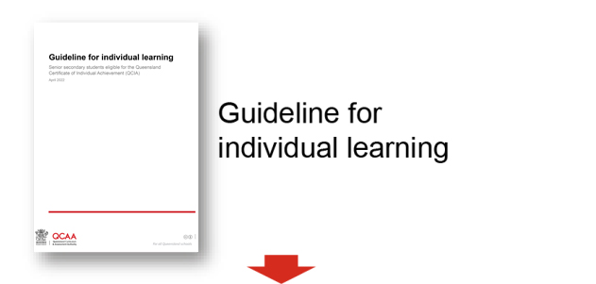
Sequence teaching and learning  - Which learning focuses and learning goals will be identified in the QCIA curriculum plan?  - What individualised age-appropriate teaching and learning activities will be planned, e.g. lesson plans, units of work?  - What resources are available to support teaching and learning? | 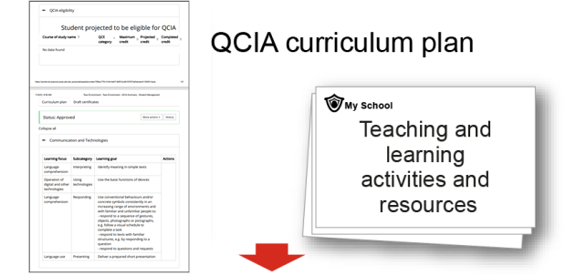
Develop assessment and make judgments  - What assessment is planned to provide evidence of achievement of learning goals?  - How will regular feedback be provided to students? | 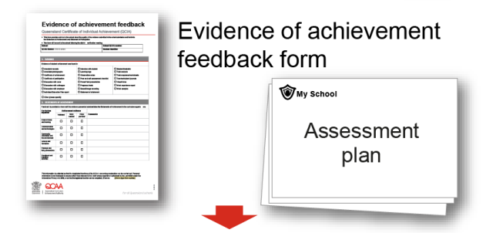
Moderation  - How will student work be moderated within the school?  - What evidence of student learning will you provide at the QCIA verification meeting? | 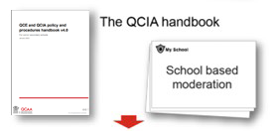
Record achievement  - What Statements of Achievement and Statements of Participation will be included under the curriculum organisers to demonstrate the achievement of the student? | 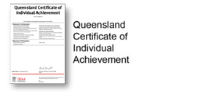

This checklist is also available as a separate resource from the Curriculum: Planning with the GIL page: www.qcaa.qld.edu.au/senior/certificates-and-qualifications/qcia/curriculum-planning-gil.

To support schools in the development of their curriculum and assessment plans, curriculum organisers have been coded. See Organiser coding.

