Access Management Kindergarten Administrator request

Online application
This document has been converted to an online form* and is submitted via the QCAA website at:
- Access Management Kindergarten Administrator request form

When to use this form
This form is used to assign users to the role of Access Management Kindergarten Administrator in the Kindergarten Transition Statement application within the QCAA Portal.
The role of Access Management Kindergarten Administrator is one of high responsibility. It should be undertaken by a director or other educational leader where possible.
The role is assigned to users who will:
- allocate teacher and director access to the QCAA Portal
- manage permissions for teachers and directors within the Kindergarten Transition Statement application
- upload the kindergarten logo to appear on transition statements.
It is recommended that, where possible, each kindergarten has two Access Management Kindergarten Administrators, though in small kindergartens, a single Access Management Kindergarten Administrator may be assigned.
As Access Management Kindergarten Administrators cannot edit their own roles in the Kindergarten Transition Statement application, they must also be assigned by the QCAA. Selecting the role required for the Kindergarten Transition Statement application ensures you have the access needed, according to the diagram below.

Kindergarten Transition Statement application roles
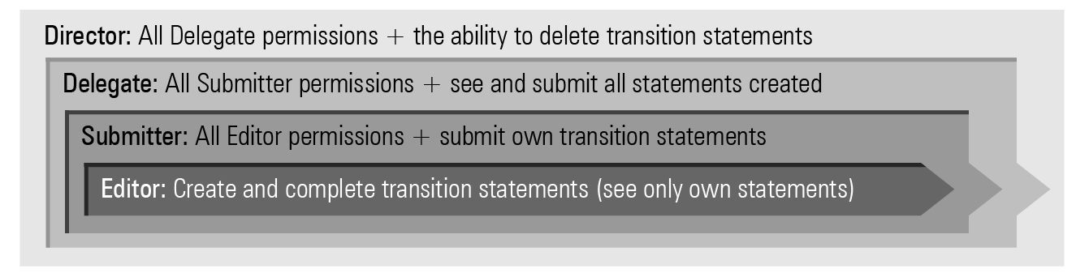

Kindergarten director authorisation
This request must be authorised by the kindergarten director. This includes a request to assign the kindergarten director to the role.

Finding out more
If you need more information, please contact QCAA Client Services by phoning (07) 3864 0278 or emailing ClientServices@qcaa.qld.edu.au.

*
* Published July 2021

