 | Queensland kindergarten learning guideline  Professional development | Resources | 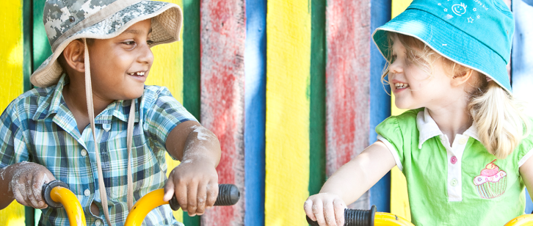
 | Reflecting on Wellbeing

The purpose of this professional learning is for teachers and staff to view intentional teaching examples in the Learning and development area: Wellbeing.
These resources provide the opportunity to reflect on how these examples relate to the Queensland kindergarten learning guideline (QKLG).
They support teachers to meet elements of Standards 2, 3 and 4 of the Australian Professional Standards for Teachers (www.aitsl.edu.au/australian-professional-standards-for-teachers).
Recommended time: 45 minutes

Reflection
View the suite of videos available on the Queensland and Curriculum Assessment Authority (QCAA) website at www.qcaa.qld.edu.au/kindergarten/qklg/learning-development-areas/intentional-teaching/wellbeing:
- Wellbeing: Promoting safety
- Wellbeing: Exploring movement.
Use the table provided to record examples of the Significant learnings you observe in the videos.

More information
To access further resources that explore supporting kindergarten children’s learning and development, visit the QCAA website (www.qcaa.qld.edu.au/28187).

Wellbeing  Related EYLF learning outcome:  Children have a strong sense of wellbeing | Key focus | Significant learnings | Observations from videos
 | - Building a sense of autonomy and wellbeing | - Delight in making decisions and choices (agency)  - Courage and resilience to manage change and challenges  - Ways to understand and regulate emotions
 | - Exploring ways to show care and concern and interact positively with others | - Interest in and desire to interact with others  - Considering and empathising with others
 | - Exploring ways to promote own and others’ health and safety | - Ways to manage personal hygiene and self-care  - Ways to stay healthy and safe
 | - Exploring ways to promote physical wellbeing | - Control and strength for manipulating objects, tools and equipment  - Large movement skills, movement control, coordination and strength  - Confidence to engage in movement challenges

Queensland kindergarten learning guideline (QKLG) p.32

