|  |  |  |
| --- | --- | --- |
|  |  |  |
|  | Queensland kindergarten learning guideline  Professional development | Resources |  |
|  | Exploring and engaging with numeracy in personally meaningful ways | |

In the Queensland kindergarten learning guideline (QKLG) children’s numeracy learning is described on page 62 within the Communicating learning and development area. During the Kindergarten Year, teachers focus on building concepts and language that will provide a foundation for children’s ongoing mathematical learning.

This document can be used to plan a variety of ways to intentionally develop the significant numeracy learnings within play, real-life situations, routines and transitions. It is important that teachers intentionally engage children in exploring mathematical ideas, relationships and language in emergent and planned learning experiences on a daily basis. The following examples highlight the importance of purposefully planning indoor and outdoor environments and adult interaction to build numeracy skills.



The indoor environment is purposefully designed and changed so that children have opportunities to explore mathematical language and concepts such as numbers, time sequences, repetition and patterns.

 

Rich outdoor environments are created that allow children to explore mathematical language and concepts as they measure, count, change position and direction, and explore shapes.

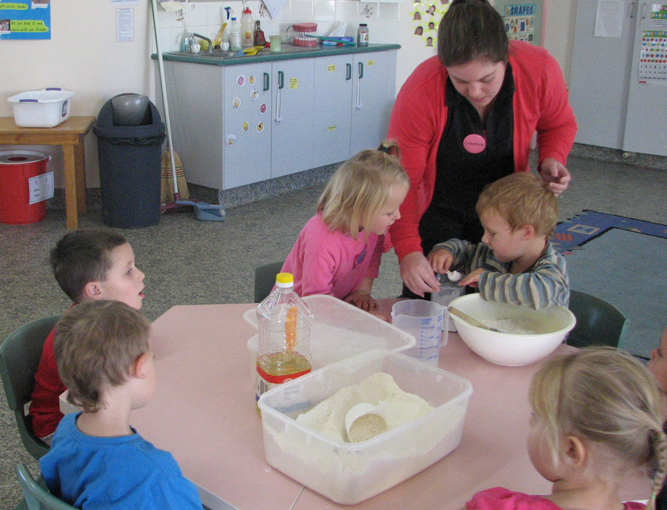

Adults play a vital role in introducing and making connections between mathematical language and concepts in a variety of learning contexts.

## Planning for early numeracy learning

The following table can be used by teachers to plan ways to promote the significant early numeracy learnings listed on page 62 of the *QKLG*. Some general examples are provided. Teachers are encouraged to list more specific ideas and resources.

#### Significant learning: Exploring number symbols and their purposes

|  |  |
| --- | --- |
| Learning focus | Ideas and resources |
| Explore and talk about how/when children use numbers in their family, community and kindergarten settings. | e.g. identifying and referring to numbers on a clock, remote control, measuring cup, price tag, cash register, calculator |
| Distinguish written numbers from other symbols, e.g. letters. | e.g. identifying and using the word ‘number’ when discussing numbers on signs, book pages or telephones, and explaining when a symbol is a number, not a picture or letter |
| Explore ways to represent numbers | e.g. writing numbers for/with children to record a  score in a target game, making a pretend cash  register and/or money, remembering how many  books have been taken outside |

#### Significant learning: Confidence and interest in counting and exploring patterns and relationships

|  |  |
| --- | --- |
| Learning focus | Ideas and resources |
| Understand the purpose of counting, e.g. to find out how many or which group  has more. | e.g. playing transition counting games, counting while cooking, counting to see if each player has the same number of cards |
| Recognise without counting the number in a small collection, e.g. ‘two pieces of fruit’. | e.g. knowing if/when they have ‘two’ without counting (one in each hand), knowing when ‘one’ person is left in a game |
| Listen to and join in counting, using number names in sequence. | e.g. counting to see if there are enough chairs at a table, learning counting rhymes |
| Recognise repetition, and copy or continue the repetition to create patterns. | e.g. exploring repetition when threading, using pattern boards/cards and peg boards, painting and arranging collage pieces |

#### Significant learning: Exploring mathematical thinking, concepts and language

| Learning focus | Ideas and resources |
| --- | --- |
| Identify same and different. | e.g. sorting blocks as they are put away, identifying what is similar/different about children (clothes, eyes, height, etc.), sorting shells in different ways |
| Share objects to create equal groups or  amounts. | e.g. dealing cards, sharing counters in a game, sharing fruit |
| Identify and talk about shapes and their  properties. | e.g. printing shapes, exploring shapes in everyday objects and artworks, using a range  of vocabulary to talk about shapes made while manipulating dough, making food for a pretend bakery shop, exploring shapes in the natural environment |
| Explore ways to represent the obvious spatial features of things. | e.g. drawing a treasure map or arranging photos to plan an obstacle course, using lines/shapes to draw a picture of the farm they built with blocks, taking photographs from different angles |
| Understand and use simple everyday words for position and direction. | e.g. engaging in movement songs and games, planning and using obstacle courses, reading stories about using a map, or playing hide-and-seek in various positions |
| Understand the purpose of measuring, e.g. to find which is longer/holds more. | e.g. counting to see how many steps it takes  to get across the sandpit/to the fort, filling one container from another to see which holds more, laying blocks to cover a space and counting to see how many cover the area, talking about ways to measure how tall a block building is |
| Explore and compare and talk about length, weight and capacity. | e.g. investigating the capacity and weight of containers during sand or water play or with balance scales |
| Explore and talk about the size of things. | e.g. comparing the length/width of dough snakes or collage pieces, sorting seed pods objects by size, discussing which dress-up clothes are bigger/smaller or longer/shorter |
| Talk about time and the order of daily events. | e.g. arranging images to show events in the day/a special day; referring to the clock to see if it is lunchtime, discussing what they will do before  or after/later or now |
| Talk about money and money exchange. | e.g. playing make-believe shops or banks, sharing stories about shopping |
| Talk about the idea of a whole and its parts. | e.g. completing a puzzle, cutting dough, using blocks and manipulative equipment |