 | Queensland kindergarten learning guideline  Professional development | Resources | 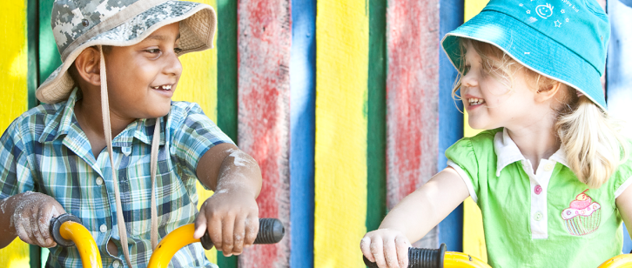
 | Reflecting on transition statements: Building partnerships

Record of professional learning
Date | Name and signature of teacher
Date | Name and signature of director
The purpose of this professional learning is to create an opportunity for teachers and staff to view and discuss information provided on building partnerships and how this relates to the Queensland kindergarten learning guideline (QKLG).
It is recommended that you allocate approximately 30 minutes to view and reflect on each audiovisual segment and respond to questions.

Reflection
- Read the information provided on building partnerships in the QKLG, pages 22 and 23.
- View the audiovisual segment, ‘Transition statements: Building partnerships’.
- Use the questions below to reflect on your practice in relation to the audiovisual segment
and the QKLG content.
How do you share information with parents/carers across the kindergarten year to support children’s continuity of learning and their smooth transition to Prep?
What strategies do you use for building partnerships with local feeder schools?
How do you collaborate to write transition statements that include the child, parents/carers and other educators and support staff?

