 | Queensland kindergarten learning guideline  Professional development | Resources | 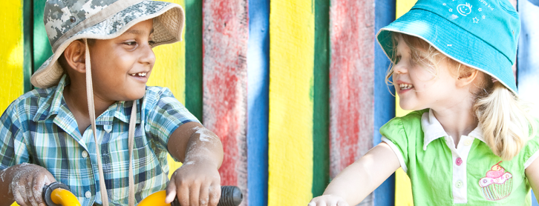
 | Intentional teaching

Reflecting on practices
This resource is intended for use with the Intentional teaching videos, available at http://www.qcaa.qld.edu.au/28213.html.
Use the grid below to note each of the intentional teaching practices evident in the video.
These resources help teachers meet elements of Standards 3 and 6 of the Australian Professional Standards for Teachers.
Please record your continuing professional development on the learning log available at http://www.qcaa.qld.edu.au/28187.html.

More information
Intentional teaching is explored on pages 63–64 of the Queensland kindergarten learning guideline (QKLG), available at http://www.qcaa.qld.edu.au/10192.html
Resources about intentional teaching are available on the QCAA website at http://www.qcaa.qld.edu.au/28205.html.

Intentional teaching practice | Definition | Examples of practice
Challenging | Offering children opportunities to extend their skills and ideas in the context of secure relationships. Teachers gauge when to offer challenges and opportunities that will extend children’s thinking through provocation and reflection.
Collaborating | Enabling children to take the lead in an investigation or an idea while working alongside them to contribute to, rather than dominate, the direction of the experience. This can also include involving others, such as family members and members of the community, who may have particular expertise or knowledge that can inform the learning.
Encouraging | Supporting, particularly when children are making an effort, through making comments that motivate and encourage them to persist.
Explaining | Making ideas and requests clear for children. This is useful at times when children want or need to understand a concept or idea, often about their own and others’ safety or rights.
Identifying | Drawing children’s attention to new ideas and topics. Pointing out things of interest may generate areas for exploration and investigation.
Imagining | Creating an environment where children are encouraged to use imagination and creativity to investigate, hypothesise and express themselves. Teachers plan for children to have opportunities where there is freedom to engage in experiences with no set expectations for outcomes, and where children can explore their own possibilities.
Instructing | Using techniques that engage children and are respectful of children’s ideas. Teachers use direct instruction when other strategies might not be appropriate. For example, teaching children about road safety on an outing requires teachers to be clear about their expectations for children, and to identify the safe practices needed in these types of situations.
Listening | Encouraging children to lead conversations through listening deeply and thoughtfully to what they are saying. Through actively responding to children’s contributions, teachers create opportunities for authentic and sustained conversational exchanges.
Making connections | Assisting children to see relationships and incongruities. Teachers contribute to children’s thinking by comparing and contrasting experiences and ideas.
Modelling | Demonstrating a skill or how a task is done. Modelling should always be supported with opportunities for children to have a go at practising the skill themselves.
Negotiating | Enabling children to have a go at solving problems and addressing complex issues. Teachers provide ‘scaffolding’ to allow children to see multiple sides to an argument or issue, and encourage children to find reasonable solutions that can address their own and others’ perspectives.
Providing for choice | Offering opportunities for children to make choices. This involves recognising children’s capacities to make safe choices and experience the consequences of their actions. Provisions for choice need to be well considered in the context of the relationships, and should not place children at risk or in danger. Supporting children to make choices is valuable when autonomy and independence are encouraged.
Questioning | Engaging children in a sensitive way in thinking and problem solving. Questions should be genuine and respectful, and not used to gather responses already known by teachers. Teachers should encourage children to ask questions of them and their own peers.
Researching | Working with children to find out and investigate. This can involve asking others, using the internet and local library or telephoning relevant agencies. Researching helps children learn about the many ways of finding solutions and gathering information.
Revisiting and revising | Taking the opportunity to revisit experiences and engage in thinking that enables children to reflect on and build on prior learning.
Scaffolding | Using knowledge of children’s abilities. Teachers can break down tasks and ideas, and provide children with a supportive framework for taking the next steps or moving onto a higher level of thinking.

