 | Queensland kindergarten learning guideline  Professional development | Resources | 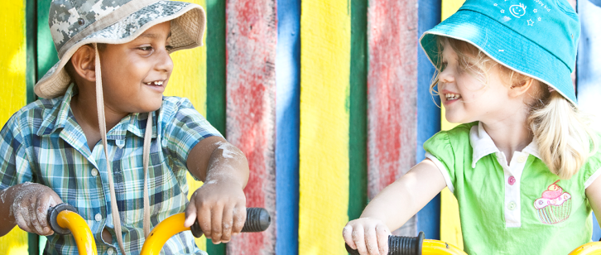
 | Intentional teaching in action: Camping at kindergarten

Record of professional learning
Date | Name and signature of teacher
Click here to enter  a date. | Click here to enter text.
Date | Name and signature of director
Click here to enter  a date. | Click here to enter text.
The purpose of this professional learning is to create an opportunity for teachers and staff to view and discuss examples of intentional teaching in action and how these relate to the Queensland kindergarten learning guideline (QKLG).
We are now going to complete a task designed to identify intentional teaching strategies in action. There is a transcript of the instructions and voices in the audiovisual segment available below the screen.
- First, take a moment to view and enjoy the audiovisual segment ‘Intentional teaching in action: Camping at kindergarten’ (4 minutes 2 seconds).
- Now that you have viewed the short audiovisual segment, read the intentional teaching strategies listed on pages 63 and 64 of your Queensland kindergarten learning guideline (QKLG).
- Watch the audiovisual segment a second time. Using the list in Table 1, identify the intentional teaching strategies the teacher, Lisa, uses to support children’s play.
- Finally, answer the set of five reflective questions in Table 2, which are based on the audiovisual segment. Share your answers, listen to others and discuss your observations and learning.

Table 1: Intentional teaching strategies
Challenging | Making connections
Collaborating | Modelling
Encouraging | Negotiating
Explaining | Providing for choice
Identifying | Questioning
Imagining | Researching
Instructing | Revisiting and revising
Listening | Scaffolding
For further detail, see Queensland kindergarten learning guideline, pages 63–64.

Table 2: Reflective questions
 | Reflective questions | Your responses
1 | How did the teacher extend on the children’s ideas? | Click here to enter text.
2 | How did the teacher respond to the children’s ideas and interests ‘in the moment’? | Click here to enter text.
3 | How could the teacher continue  to build on the children’s interests? | Click here to enter text.
4 | What kind of learning does this audiovisual segment capture? | Click here to enter text.
5 | What links can you see between the intentional teaching strategies used  to support the camping play and the QKLG learning and development areas? | Click here to enter text.
 | Note: Learning and development areas are listed on pages 32 and 33 of the QKLG.

