 | Queensland kindergarten learning guideline  Professional development | Resources | 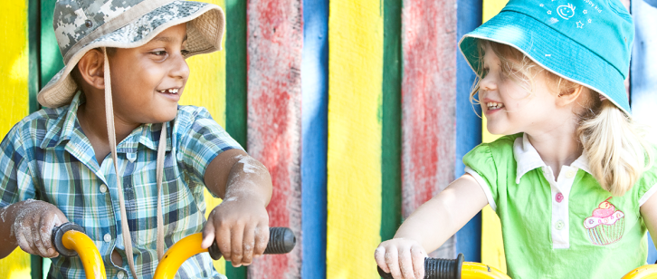
 | Reflecting on Identity

The purpose of this professional learning is for teachers and staff to view intentional teaching examples in the Learning and development area: Identity.
These resources provide the opportunity to reflect on how these examples relate to the Queensland kindergarten learning guideline (QKLG).
They support teachers to meet elements of Standards 2, 3 and 4 of the Australian Professional Standards for Teachers (www.aitsl.edu.au/australian-professional-standards-for-teachers).
Recommended time: 45 minutes

Reflection
View the Identity: Building self-identity video available on the Queensland and Curriculum Assessment Authority (QCAA) website www.qcaa.qld.edu.au/kindergarten/qklg/learning-development-areas/intentional-teaching/identity.
Use the table provided to record examples of the Significant learnings you observe in the videos.

More information
To access further resources that explore supporting kindergarten children’s learning and development, visit the QCAA website (www.qcaa.qld.edu.au/28187.html).

Identity  Related EYLF learning outcome:  Children have a strong sense of identity | Key focus | Significant learnings | Observations from videos
 | - Building a sense of security and trust | - A sense of being safe, accepted and supported  - A sense of belonging and confidence in others
 | - Acting with increasing independence and perseverance | - Organising self and belongings and managing routines  - Making choices  - Willingness to keep trying
 | - Building a confident self-identity | - Pride and confidence in who they are, their family and culture  - Pride and confidence in their strengths and abilities  - Confidence in themselves as learners

Queensland kindergarten learning guideline (QKLG) p.32

