 | Queensland kindergarten learning guideline  Professional development | Resources | 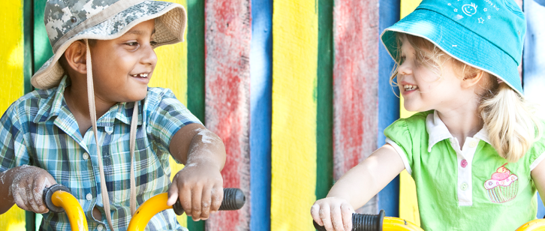
 | Cultural and linguistic diversity: Part 2 — Building positive relationships

This resource is part 2 in a series of three which provide information about strategies to support cultural and linguistic diversity in kindergarten. It was developed in collaboration with a community kindergarten using the Queensland kindergarten learning guideline (QKLG).
It is recommended that you allocate approximately 30 minutes per resource to read, reflect and respond to questions. The resources focus on:
- Part 1: Transition to kindergarten
- Part 2: Building positive relationships
- Part 3: Respecting diversity.

Building positive relationships
In all cultures there are protocols to follow which are specific to the community. The scenario below is an example of one kindergarten teacher’s experiences in supporting a family by promoting positive relationships with all partners involved in the kindergarten service.
For more information on building positive relationships see the QKLG, page 44.
Gun-Hae started kindergarten mid-year. His English was limited: he could say ‘hello’, ‘no’ and ‘yes’. He spoke to the teacher and other children in Korean, and assumed he was understood. The teacher or the assistant stayed with him much of the time, guiding him through the day’s routine.  The children were keen to help him and show him what to do and how things worked. He had never seen easel painting or playdough and the other children loved being with him as experienced these for the first time.  Gestures and vocal tone were key tools used to communicate with  Gun-Hae. It was important to change our communication style to match those he was more familiar with in his family and cultural context. Gun-Hae was used to clear, direct instructions. Requests such as, ‘Children, can you sit down now, please?’ were not easily understood. Gun-Hae was more comfortable with a short direction such as, ‘Sit down’, accompanied by a clear gesture. In Western cultures, this directness may seem impolite, but it is normal in Korean and Chinese cultures.  In addition, the teacher also used a set of flash cards (with Korean and English words) to communicate simple phrases and instructions such as ‘good morning’, ‘morning tea’, ‘wash hands’,’ toilet’, ‘dancing’ and ‘playing’ to help promote  two-way communication. Gun-Hae was also paired up with other children who spoke Korean and English and his partners would spontaneously translate  for him and teach him English vocabulary. | 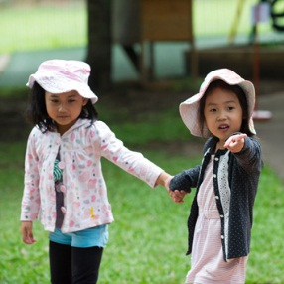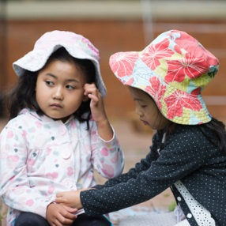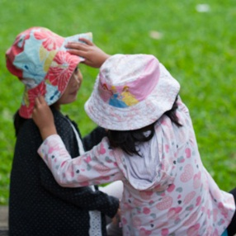

Learn new ways to communicate
It is important to find out about the interaction styles that the child is familiar with. Adjusting your communication to incorporate aspects of the child’s culture of origin can help them feel successful and that they belong. For example, in Korean and Chinese cultures short, direct instructions are more familiar than longer, ‘polite forms’ of requests that children from Western cultures may respond to.
Intentional teaching ideas:
- Practice correct pronunciation of children’s names.
- Learn a few words in the children’s first language and allow the child to bring a favorite object from home; it can often be reassuring.
- Ensure the routine remains the same until all children are settled.
- Provide positive feedback about children’s attempts to communicate, e.g. ‘Yes, that does say your name’.
- Ensure the child/children are kept close to teachers to help identify gestures, to reassure and to build acceptance and trust.
- Observe children’s physical movements, e.g. standing close to something they want.
- Use movement, music, and visual representation, and provide hands-on, manipulative experiences to explore ways to convey meaning.
- Have objects available for children to hold and explore, e.g. silkworms when engaged in an inquiry about silkworms.
- Teach skills for communicating or making ideas clearer, e.g. have children point to picture symbols to express their needs.
- Invite children to participate by pointing to familiar objects in shared reading texts. Respond with English names for these objects.
- Model appropriate language patterns, e.g. demonstrate a counting strategy or point to words in text while reading.
- Think aloud, e.g. ‘I’m going to start the reading here’, while using a pointer to show where the reading starts.
- Use gestures, e.g. clearly point to the block on the bottom while saying, ‘You put the block on the bottom’.
- Identify the child’s actions, e.g. ‘You painted a picture, you jumped, and you were counting the animals’.
- Introduce new vocabulary and extend the communication, e.g. if the child says, ‘I making cake’, reply, ‘You are making cake. Is it chocolate cake?’
For more information on communication see the QKLG, pages 59–62.

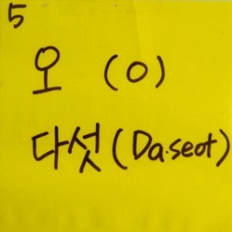
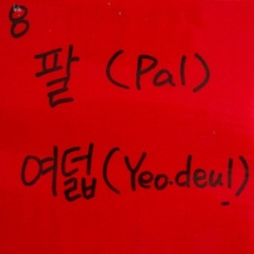
Draw on resources
- Include flash cards in both languages, e.g. colours translated or simple phrases and instructions such as ‘good morning’, ‘morning tea’, ‘wash hands’, ‘toilet’, ‘dancing’ and ‘playing’ to help communicate.
- Add to home area to include familiar objects from children’s diverse cultures — invite parents/carers and children to contribute suitable items.
- In collaboration with children and families display posters, pictures, music and artefacts from children’s cultures in the room. Pictures can be made with own photos, sourced from the internet (selecting images with appropriate copyright permissions).
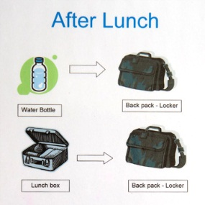
- Use Picture Exchange Communication System (PECS), a form of augmentative and alternative communication.
- Label bins, containers and shelves. Wherever possible, the label should include the word, a visual representation, and a translation in a child’s first language.
- Develop visual cues for routines, e.g. washing hands for morning tea time, collecting lunch box, sitting at a table.
Consider these questions as you reflect on ways to explore diversity with children and build respect for differences:
- How can you communicate with someone who has limited English?

- What resources (community members, children, materials, information) are available to help you to communicate and learn about diverse cultural groups in your community?

Whoever you are, wherever you are, our blood is the same.
Whoever you are, wherever you are.
Whoever you are, Mem Fox 1997, Voyager, San Diego.

More information
The QKLG is available at: www.qcaa.qld.edu.au/10192.html
Additional information and resources are available to support:
- cultural and linguistic diversity: www.qcaa.qld.edu.au/12974.html
- awareness of and respect for Australia’s first peoples, including:
- Building relationships with local communities, which presents a flowchart of how
to engage with local community and access information on consultation protocols: www.qcaa.qld.edu.au/3035.html
- The Aboriginal, Torres Strait Islander and other Australian flags are available for free
from your local member’s office. These can be displayed and may present a starting
point for discussions with children about our cultural heritage.

