 | Queensland kindergarten learning guideline  Professional development | Resources | 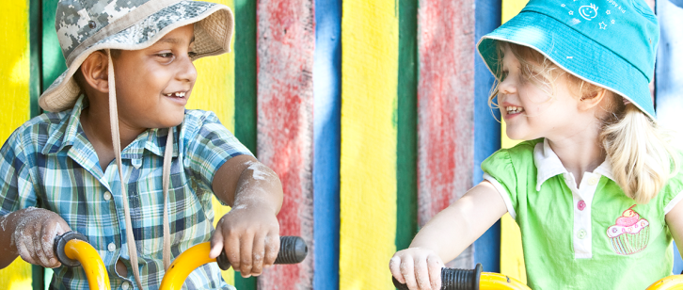
 | Reflecting on Communicating

The purpose of this professional learning is for teachers and staff to view intentional teaching examples in the Learning and development area: Communicating.
These resources provide the opportunity to reflect on how these examples relate to the Queensland kindergarten learning guideline (QKLG).
They support teachers to meet elements of Standards 2, 3 and 4 of the Australian Professional Standards for Teachers (www.aitsl.edu.au/australian-professional-standards-for-teachers).
Recommended time: 45 minutes

Reflection

View the suite of videos, Story time in kindergarten (www.qcaa.qld.edu.au/32542.html).
- Communicating: Selecting stories
- Communicating: Example of a read story
- Communicating: Extending on a read story
- Communicating: Example of a told story
- Communicating: Extending on a told story

Use the table provided to record examples of the Significant learnings you observe in the videos.

More information
To access further resources that explore supporting kindergarten children’s learning and development, visit the QCAA website (www.qcaa.qld.edu.au/28187.html).

Communicating  Related EYLF learning outcome:  Children are effective communicators | Key focus | Significant learnings | Observations from videos
 | - Exploring and expanding ways to use language* | - Spoken and nonverbal communication  - Age-appropriate speech patterns, vocabulary and sentence structures  - Using language for a range of purposes  - Skills for listening and taking turns in conversations
 | - Exploring and engaging with literacy in personally meaningful ways | - Positive engagement with a variety of print and multimedia texts and the arts  - Exploring symbols and patterns in language  - Exploring text purpose and meanings  - Confidence and interest in exploring reading and writing behaviours
 | - Exploring and engaging with numeracy in personally meaningful ways | - Exploring number symbols and their purposes  - Confidence and interest in counting and exploring patterns and relationships  - Exploring mathematical thinking, concepts and language

* Note: Children communicate using first language, signed (alternative) or alternative augmentative communication (AAC) and Standard Australian English (SAE) as or when appropriate. Nonverbal children may substitute alternative or AAC for words.
Queensland kindergarten learning guideline (QKLG) p. 59

