 | Queensland kindergarten learning guideline  Professional development | Resources | 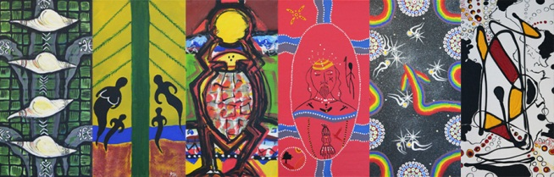
 | Reflecting on community and connectedness

Record of professional learning

Date | Name and signature of teacher
Date | Name and signature of director
The purpose of this professional learning is to create an opportunity for teachers and staff to view and discuss information provided on community and connectedness and how this relates to the Queensland kindergarten learning guideline (QKLG).
It is recommended that you allocate approximately 30 minutes to view and reflect on this audiovisual segment and respond to questions.

Reflection
- View the audiovisual segment, ‘Supporting Aboriginal and Torres Strait Islander children’s learning: Community and connectedness’.
- Read the learning and development area overview on pages 32 and 33 of the QKLG.
- Watch the audiovisual segment a second time.
- Use the questions below to reflect on the segment.
Where can I go to get information about local protocols?
What is the name of the language group in the local area? What other language/s are spoken
in the area?
How can I access local language resources and oral stories?
Who does the child live with and which is the preferred language in the home? Who uses Standard Australian English in the home?

