Anecdote booklet
  - Queensland kindergarten learning guideline: Observation template

This observation template can be printed and used as a booklet accessible to all staff in the kindergarten program. Multiple copies of the observation page can be made and the pages bound, then as each observation is completed it can be removed and placed in the child’s folio or file.
An overview of the learning and development areas and significant learnings in each area is provided for reference when recording observations. To make the booklet durable, you may choose to laminate the cover.

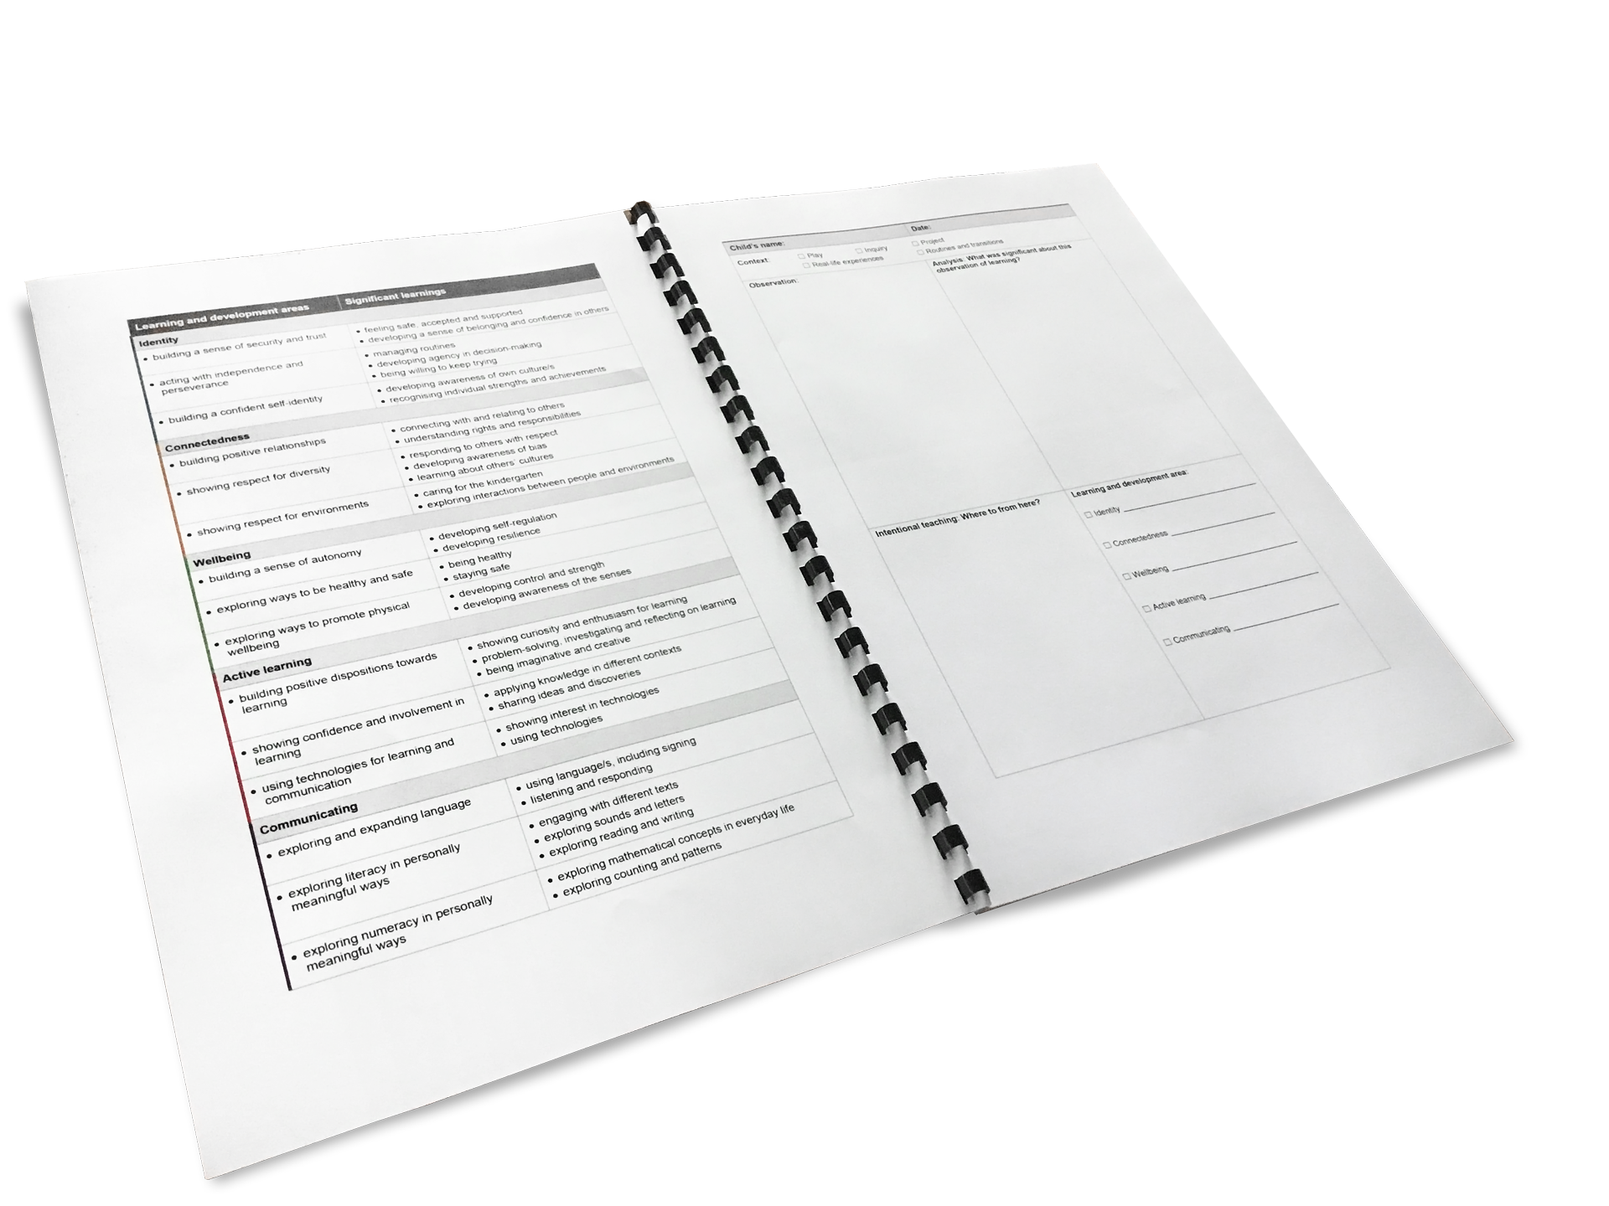
Child’s name: | Date:
Context: ☐ Play ☐ Inquiry ☐ Project
☐ Real-life experiences ☐ Routines and transitions
Observation: | Analysis: What was significant about this observation of learning?
Intentional teaching: Where to from here? | Learning and development areas:
 | ☐ Identity ________________________________
 | ☐ Connectedness _________________________
 | ☐ Wellbeing ______________________________
 | ☐ Active learning __________________________
 | ☐ Communicating _________________________

Learning and development areas | Significant learnings
Identity
- building a sense of security and trust | - feeling safe, accepted and supported  - developing a sense of belonging and confidence in others
- acting with independence and perseverance | - managing routines  - developing agency in decision-making  - being willing to keep trying
- building a confident self-identity | - developing awareness of own culture/s  - recognising individual strengths and achievements
Connectedness
- building positive relationships | - connecting with and relating to others  - understanding rights and responsibilities
- showing respect for diversity | - responding to others with respect  - developing awareness of bias  - learning about others’ cultures
- showing respect for environments | - caring for the kindergarten  - exploring interactions between people and environments
Wellbeing
- building a sense of autonomy | - developing self-regulation  - developing resilience
- exploring ways to be healthy and safe | - being healthy  - staying safe
- exploring ways to promote physical wellbeing | - developing control and strength  - developing awareness of the senses
Active learning
- building positive dispositions towards learning | - showing curiosity and enthusiasm for learning  - problem-solving, investigating and reflecting on learning  - being imaginative and creative
- showing confidence and involvement in learning | - applying knowledge in different contexts  - sharing ideas and discoveries
- using technologies for learning and communication | - showing interest in technologies  - using technologies
Communicating
- exploring and expanding language | - using language/s, including signing  - listening and responding
- exploring literacy in personally meaningful ways | - engaging with different texts  - exploring sounds and letters  - exploring reading and writing
- exploring numeracy in personally meaningful ways | - exploring mathematical concepts in everyday life  - exploring counting and patterns

