Home Economics Lower Secondary Subject Area Guidelines
June 2014

Contents
Rationale 1
Planning using these guidelines 2
Mapping of Essential Learnings and Year 10 Guidelines 3
Essential Learnings by the end of Year 9 — Health and Physical Education (HPE) 3
Essential Learnings by the end of Year 9 — Technology 6
Year 10 Guidelines — Health and Physical Education (HPE) 8
Year 10 Guidelines — Technology 10
Assessment 12
Planning an assessment program 12
Standards 12
Assessment techniques and instruments 12
Courses of study 14
Examples of term- or semester-length units of study 14

Rationale
The central focus of home economics is the wellbeing of people within their personal, family, community and work roles. Home economics encourages personal independence and effective living within wider society, and promotes preferred futures for self and others. Home economics is an interdisciplinary study drawing on the fields of nutrition, textiles and fashion, the built environment, human development, relationships and behaviour.
In home economics education, students become increasingly aware of the processes of growth and development and take increasing responsibility for their own growth and development. They make decisions and take actions to promote healthy eating and develop a sensitive approach to interpersonal relationships. They contribute to environments that are supportive of human growth and development, and develop a respect for the lifestyle choices of other people.
Informed people who think critically and creatively make socially and ethically responsible actions that enhance wellbeing. People who promote wellbeing and design their futures understand that the decisions and actions taken by them and others have consequences.
The ways of working and knowledge and understanding in these guidelines are drawn from the Essential Learnings (ELs) for Technology and Health and Physical Education (HPE), and the Year 10 Guidelines for the Technology and the Health and Physical Education learning areas.Figure 1 shows the relationship between the ELs and the Year 10 Guidelines and shows how they can be used to construct a course of study using the Home Economics Lower Secondary Subject Area Guidelines (Home Economics LSSAG).
Figure 1: Essential Learnings, Year 10 Guidelines and Home Economics Lower Secondary Subject Area Guidelines
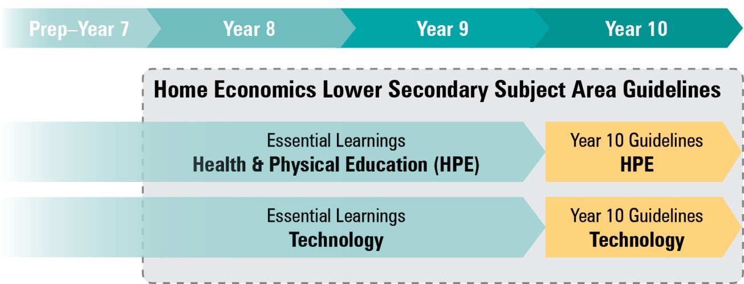

Planning using these guidelines
The development of a course of study is a school-based decision. A school may decide to use all or part of the information contained in these guidelines to construct a course of study.
The Home Economics LSSAG allows teachers to develop a variety of courses of study that meet the specific needs and interests of students and can be used to plan:
- part of a specialised Year 8, Year 9 or Year 10 Home Economics course
- part of a combined Year 8/9 or Year 9/10 Home Economics course
- term- or semester-length units of work
- an integrated multidisciplinary or transdisciplinary course of study that combines learning statements from other learning areas (e.g. enterprise education).

Figure 2: Five processes for planning

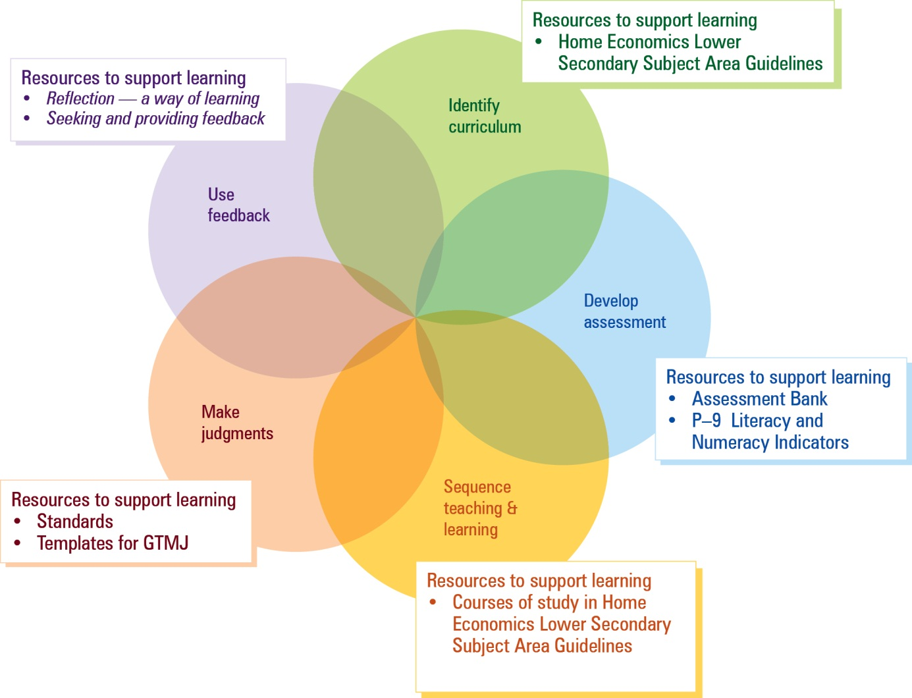
(see p. 14)

Mapping of Essential Learnings and Year 10 Guidelines
The following section includes the ways of working from the ELs and Year 10 Guidelines that link to Home Economics. Also included are tables that map the ELs and Year 10 Guidelines to Home Economics knowledge and understanding (K&U) examples. These lists of examples are not exhaustive.

Essential Learnings by the end of Year 9 — Health and Physical Education (HPE)

Relevant ways of working
Students are able to:
- identify issues and inequities and plan investigations and activities
- research, analyse and evaluate data, information and evidence
- draw conclusions and make decisions to construct arguments
- propose, justify, implement and monitor plans or actions to achieve goals, address inequities and promote health and wellbeing, movement capacities and personal development
- identify risks and devise and apply safe practices
- select and apply positive, respectful and inclusive personal development skills and strategies
- reflect on health inequities, and identify the impact of diverse influences on health and wellbeing, movement capacities and personal development, and the best use of positive influences
- reflect on learning, apply new understandings and justify future applications.

Knowledge and understanding (K&U)
ELs (end of Year 9) — HPE |  | Home Economics LSSAG K&U examples
Health  Health is multidimensional and dynamic, and influenced by actions and environments | Health has physical, social, emotional, cognitive and spiritual dimensions, which are dynamic, interrelated and interdependent | Examples may include:  - Factors influencing physical, social and emotional growth, development and wellbeing e.g. challenges with nutritional needs, catering for physical activities, peer relationships, intellectual and creative challenges  - Influences of significant transitions in life on growth, development and wellbeing e.g. puberty, changes in family structure  - Role of food as a socialiser that enhances social and emotional health  - Factors influencing intellectual wellbeing e.g. omega-3
 | The interaction between personal, social, cultural and environmental factors influences health behaviours, including nutrition and physical activity choices | Examples may include:  - Influences of the media, marketing and social trends on consumer choices  - Influences of food on individual, family and community wellbeing  - Trends in eating behaviours and planned healthy food choices  - The nutritional components of food, including the use of food selection models or tools, are required when assessing and planning for dietary patterns  - Food and nutrition needs of individuals, families and communities  - Food selection is influenced by:  - access to food / food availability  - education  - socioeconomic status  - individual food choice  - stage of the life cycle and special dietary needs  - marketing  - social and cultural factors  - practical skills and techniques  - resources
 | Individual, group and community action that enables people to adopt health promotion strategies, can address inequities and promote health and wellbeing, including safety | Examples may include:  - Importance of food for the different dimensions of health e.g. physical, social, emotional, intellectual  - Personal factors e.g. lifestyle, physical activity levels, specific health conditions  - Cost and limited access to healthy food, including shopping centres, rural and remote areas and disadvantaged socioeconomic groups  - Health promotion strategies and actioning of strategies such as:  - identify improvements needed  - identify factors that influence own and others’ food intake  - develop and implement strategies for personal behaviour change e.g. preparing healthy foods  - develop and implement strategies for creating a supportive environment for self and others e.g. teaching others to prepare foods to support their goals, promoting wise consumer decisions  - suggest and implement strategies that prevent or minimise negative impacts e.g. advocate for improved food choices within current trends, such as healthy takeaway or fast foods
 | Adolescents can meet their specific nutritional needs through eating foods that reflect the dietary guidelines | Examples may include:  - Healthy eating behaviours  - Strategies for optimising healthy food choices based on identified nutritional needs for growth, energy and health  - Information from Dietary Guidelines for Children and Adolescents in Australia  - Information from Australian Guide to Healthy Eating  - Physical, social and emotional factors that influence dietary behaviours e.g. importance of food for the different dimensions of health, personal factors, social factors, cultural background  - Label interpretation to enable healthy choices of processed foods
Personal development  Diverse social, cultural and environmental factors, values, beliefs and behaviours influence relationships and self-management, and shape personal development | Identity, health and wellbeing are interdependent and influenced by social and cultural factors | Examples may include:  - Competing influences: peer influences conflicting with traditional values, personal and community values impacting on the importance given to different concepts, media-constructed images and scientific data  - Actions and behaviours of different groups can impact on stakeholders e.g. marketing companies  - Social issues in home economics contexts: issues resulting from the actions and behaviours of individuals, groups, communities, governments  - Influence of changes associated with significant transitions in physical, social and emotional growth and development  - Influence of own and others’ behaviours on self-concept and self-esteem
 | Effective communication skills, including reflective listening, considering alternative views, respecting cultural protocols and expressing ideas in a way that is sensitive to others, help people establish and maintain relationships | Examples may include:  - Verbal and nonverbal communication skills  - Cultural protocols  - Cooperation and assertiveness  - Types of relationships e.g. child–parent, sibling  - Behaviours appropriate to different types of relationships  - Influence of relationships on wellbeing  - Roles, rights and responsibilities of relationships  - Factors influencing relationships e.g. sociocultural influences (community expectations, stereotypes, media images), stages of life cycle, stages of the family life cycle

Essential Learnings by the end of Year 9 — Technology

Ways of working
Students are able to:
- investigate and analyse specifications, standards and constraints in the development of design ideas
- consult, negotiate and apply ethical principles and cultural protocols to investigate, design and make products
- generate and evaluate design ideas and communicate research, design options, budget and timelines in design proposals
- select resources, techniques and tools to make products that meet detailed specifications
- plan, manage and refine production procedures for efficiency
- make products to meet detailed specifications by manipulating or processing resources
- identify, apply and justify workplace health and safety practices
- evaluate the suitability of products and processes against criteria and recommend improvements
- reflect on and analyse the impacts of products and processes on people, their communities and environments
- reflect on learning, apply new understandings and justify future applications.

Knowledge and understanding (K&U)
ELs (end of Year 9) — Technology |  | Home Economics LSSAG K&U examples
Technology as a human endeavour  Technology influences and impacts on people, their communities and environments in local and global contexts | New products and technologies are designed and developed to meet changing needs and wants of intended audiences, and include artefacts, systems, environments, services and processes | Examples may include:  - Consultative methods to gather knowledge, ideas and data when researching alternatives within design challenges e.g. interviews, surveys, discussions  - Development of products to meet new or emerging needs  - Formulation of detailed plans for gathering knowledge, ideas and data  - Validation of choices of information, sources and methods used to gather information  - Consumer behaviours: the impact on physical, social, emotional, financial and environmental wellbeing  - Influences on, and impacts of, consumer decision making
 | Product design and production decisions are influenced by aspects of appropriateness and by detailed specifications, constraints and standards of production | Examples may include:  - Factors influencing the production of selected options e.g. human and physical resources, economic factors  - Reasons and ways to negotiate and refine production procedures e.g. minimisation of waste, meeting timelines and budget requirements  - Methods for evaluating processes and products e.g. product tests and trials
 | People can influence decisions made about the design, development and use of technology to change the impact on people, their communities and environments at local and global levels | Examples may include:  - Influences on, and impacts of, consumer decision making  - Strategies to promote effective change, including advocacy  - Influence of textiles, food and relationships on individual, family and community wellbeing
Information, materials and systems (resources)  Resources originate from different sources, exist in various forms and are manipulated to meet specifications and standards to make products | Characteristics of resources are compared, contrasted and selected to meet detailed specifications and predetermined standards of production to best suit the user | Examples may include:  - Characteristics of materials  - Suitability of materials for specific purposes  - Comparing and contrasting materials in relation to standards  - Selection of materials to meet standards e.g. recycling, impact of materials on the environment; low-fat, high-fibre and low-salt ingredients are health promoting  - Manipulation of materials considering characteristics, techniques and purpose
 | Techniques and tools are selected, controlled and managed to manipulate or process resources to meet detailed specifications and predetermined standards of production | Examples may include:  - Considerations when selecting equipment to manipulate materials e.g. knowledge of equipment, access and ease of use of equipment  - Suitability of different equipment and techniques to meet predetermined standards  - Safe work practices when operating equipment and applying techniques  - Specialised equipment to make quality products to detailed specifications e.g. sushi mats, food processors  - Effects that can be achieved by refined techniques e.g. food styling and presentation, clothing embellishment  - Selection and management of resources to prepare foods that meet physical, social or emotional needs e.g. foods that meet growth and energy needs  - Food preparation techniques: methods and procedures to ensure quality food products; equipment that matches food preparation technique  - Principles of techniques to complete food preparation e.g. stir-frying, low-fat cookery  - Techniques to manipulate textiles  - Techniques to care for textiles

Year 10 Guidelines — Health and Physical Education (HPE)

Relevant ways of working
Students are able to:
- plan investigations, actions and activities
- collect, sort and analyse information and resources
- trial actions and strategies
- evaluate information, draw conclusions and make decisions
- examine risk, and decide upon and apply safe practices
- select and demonstrate personal development skills and strategies.

Knowledge and understanding (K&U)
Year 10 Guidelines — HPE |  | Home Economics LSSAG K&U examples
Health  Health is multidimensional and is influenced by the interaction of personal, social, cultural and environmental factors that shape how individuals, groups and communities think about and act on health-related matters | Health outcomes are influenced by the interrelationships between health determinants | Examples may include:  - Influence of socioeconomic disadvantage on health  - Impact of low levels of food literacy on food choices and health outcomes  - Obesity rates of disadvantaged groups affect lifestyle disease rates  - Access to healthy food in disadvantaged areas
 | The health issues of adolescents impact on the health of families, and vice versa | Examples may include:  - Forming and maintaining positive relationships  - Interdependence of individuals, families and communities  - Wellbeing of individuals, their families and communities are interdependent and can be supported or challenged by social structures and change  - Community and government organisations perform a variety of roles in providing support for individuals and families  - Food as a valuable socialiser for positive family relationships and social interaction
 | Healthy eating improves performance in all areas of life | Examples may include:  - Eating behaviours established in adolescence, where young people gain increased responsibility over what, how and when they eat, are often lifelong  - Current trends in eating behaviours e.g. takeaway foods, cultural foods  - Current trends in healthy eating e.g. vegetarian diets, celebrity diets, organic foods  - Knowledge of nutrition related to the interpretation of food labels, recipes and discernment of advertising required to enable healthy food choices  - Healthy eating is required for maximum performance of body and mind
Personal development  Assuming roles and responsibilities, experiencing success, respecting difference and working well with others develop positive identity and abilities to adjust to life events and transitions | Self-concept and self-esteem are influenced by the interrelatedness of internal and external factors that affect a person’s behaviour, and in turn influence the relationships between individual persons, between individuals and the family, and between individuals and the community | Examples may include:  - Many mental and emotional health issues that influence how a person relates to others stem from a lack of self-concept and self-esteem  - Influencing factors and positions: a range of factors influence the actions and behaviours of individuals, groups, community and governments e.g. profit motive, ethics and valuing wellbeing  - Influence of personal behaviours and social and physical environments on growth and development  - Actions that enhance growth and development of self and others  - Influence of sociocultural factors on own and others’ self-concept and self-esteem  - Influence of sociocultural factors on relationships between individuals and between individuals and the family at different stages of life
 | Effective communication and cooperation skills are required to implement decisions and to resolve conflict | Examples may include:  - Communication, cooperation and decision-making skills  - Relationships are enhanced through effective communication and other social processes  - Decision making is required to solve issues or design challenges  - Being able to understand, discuss and empathise with another’s point of view is necessary to solve a conflict

Year 10 Guidelines — Technology

Ways of working
Students are able to:
- investigate and analyse products, processes or services in response to design challenges or problems
- design solutions to challenges or problems, considering appropriateness, purpose and constraints, including budgets and timelines
- develop and use production plans to manage and refine procedures, using suitable techniques and tools, to make quality-controlled products, processes or services
- use safe and ethical practices relevant to specific contexts
- create products, processes or services to meet challenges or problems by manipulating or processing resources (information, materials and systems)
- communicate design solutions in response to challenges or problems using suitable modes and genres for presenting technical ideas and design concepts for a given audience and purpose
- use evaluation throughout the design and production process to validate and refine the effectiveness of solutions to challenges or problems
- analyse and evaluate the ethics and impacts of products, processes and services on local and global communities and environments
- reflect on learning, applying new understandings of technological processes to wider contexts.

Knowledge and understanding (K&U)
Year 10 Guidelines — Technology |  | Home Economics LSSAG K&U examples
Products, processes and services  Individual characteristics of different technological resources (information, materials or systems) will decide how they are applied in products, processes or services that have been designed to meet a challenge | Information takes different forms that can be collected, analysed and organised | Examples may include:  - Numerical and graphical data  - Client surveys analysed to identify needs and then used to develop the design solutions  - Impact of changes in consumer behaviour trends  - Impact of changes in national and global marketing strategies e.g. online shopping, reward schemes, price cuts
 | Materials have characteristics which are compared, contrasted and selected to meet detailed specifications and production standards | Examples may include:  - Decision making relating to the selection and production of products required to solve issues or design challenges  - Ingredients can be selected to develop menus to address nutritional requirements  - Fabrics or resistant materials can be selected based on the demands of specific applications
 | Systems incorporate multiple processes that work together to meet challenges and can be managed with tools | Examples may include:  - Flowcharts, models, networks, manufacturing processes, project plans or digital control systems
Techniques and tools  Techniques and tools are selected to manipulate resources to meet detailed specifications and predetermined standards, and their characteristics inform the selection for specific tasks | Practical experiences with techniques and tools provide opportunities to develop skills | Examples may include:  - Techniques and tools in areas such as food and textiles  - Specialised techniques to present and prepare solutions to design challenges
 | Safe practices are part of the control and management process | Examples may include:  - Strategies to control risks and hazards, policies and procedures in workrooms such as kitchens or textile rooms
 | Design ideas are represented by specialist forms of technical communication | Examples may include:  - Appropriate terminology, language, formats, graphical representation, techniques and conventions
Impacts and consequences  Decisions made about the design, development and use of technology are based on that technology’s probable impact on people, their communities and environments at local and global levels | New products and technologies are designed and developed to meet changing needs | Examples may include:  - Sustainable energy solutions, inductive cooking  - Innovations and emerging textile technologies  - Change management in our contemporary society  - Low-fat, low-salt, low-sugar and high-fibre alternatives  - Preservatives and additives  - Genetically modified foods  - Food technology
 | Impacts and consequences of products, processes and services include aesthetic, cultural, economic, environmental, ethical, functional and social factors | Examples may include:  - Energy-efficient systems  - Genetically modified products  - Recycled and reused materials  - Use of outworkers  - Group identity e.g. police, bikies

Assessment

Planning an assessment program
The assessment program for a course of study using the Home Economics LSSAG should include a range and balance of assessment types that provide opportunities for students to demonstrate their learning across:
- the standards
- assessment techniques and instruments that include:
- a range of assessment conditions
- written and nonwritten modes.

Standards
In a lower secondary context, the standards applied to the course may be drawn from the standards linked to the ELs and/or the Year 10 Guidelines for the relevant learning areas. Both sets of standards align to the curriculum content used in the Home Economics LSSAG.
The assessable elements identify the valued features of each key learning area and indicate what evidence of student learning is collected and assessed. The assessable elements The assessable elements for the HPE and Technology ELs are shown in Figure 3. Schools should decide how to use these assessable elements when designing a home economics course of study and assessment program.
Figure 3: Assessable elements of HPE and Technology ELs
 |  | ASSESSABLE ELEMENTS
 |  | HPE | Technology
DIMENSION | Knowledge and understanding | Knowledge and understanding | Knowledge and understanding
 | Ways of working | Investigating | Investigating and designing
 |  | Planning | Producing
 |  | Implementing and applying | Evaluating
 |  | Reflecting | Reflecting

Assessment techniques and instruments
The following advice is provided to help schools use the Home Economics LSSAG to build student learning towards assessment techniques that are valued in the Year 10 Guidelines for the HPE and Technology learning areas and in senior technology subjects.
Assessment of home economics involves students working on authentic, problem-solving situations, so assessment techniques focus on generating evidence by documenting these processes. Assessment should provide opportunities for students to demonstrate the relevant knowledge and understanding as well as the ways of working. All assessment pieces should include appropriate and relevant assessment conditions.

Supervised written assessments
Student responses are produced independently, under supervision and in a set timeframe. A supervised assessment may include one or more items. These could be in response to stimulus materials, which may be seen or unseen, or questions, which should be unseen.
Types of items could include:
- extended written responses
- short responses.

Research assessments
This technique is based on research practices, which include locating and using information that goes beyond the data that students have been given and the knowledge they currently have.
It may include the generation of primary data and/or the use of secondary data.
A research assessment may be presented in a variety of modes. Spoken and multimodal responses may include:
- interviews
- speeches
- PowerPoint presentations
- video evidence
- debates
- seminars.
Types of items could include:
- analytical expositions e.g. essays, magazine articles, papers, research assignments
- reports e.g. research reports, experimental investigations, projects
- folios (a purposeful collection of work that helps to define the student’s efforts and achievements in a specified area).

Performance and products
A product is based on the application of skills, theory and conceptual understandings. Students are required to analyse, synthesise and evaluate data and/or information in the development of a product. The assessment will often involve the creative input of students and the application of technical skill in solving a problem or providing a solution.
Product development should be supported by documentation and may include these items:
- a diary or journal of relevant, significant tasks carried out by the student; documentation of planning, justifying, managing and evaluating; evidence of decision-making processes, group consultations, interactions with clients
- design briefs, design ideas, concept maps, management plans, working notes and sketches, procedures, data collection and analyses, test or survey results
- product development, construction, models and prototypes, trade displays, software development
- peer and self-reflection, including feedback from small or large group discussions or responses to evaluation questions.

Courses of study
Multiple courses of study with different focuses can be developed from these guidelines. The table below provides examples of how the ELs and Year 10 Guidelines can be used to plan and develop units of study which target Years 8–10 students. This does not preclude other ways of planning and packaging the learning statements. Please note that these examples are not full units of work, and need to be further developed with assessment and learning experiences to complete a course of study.

Examples of term- or semester-length units of study
Example 1: How do I become a healthy adolescent?
ELs (end of Year 9) — HPE  Knowledge and understanding  Health  Health is multidimensional and dynamic, and influenced by actions and environments  - The interaction between personal, social, cultural and environmental factors influences health behaviours, including nutrition and physical activity choices  - Individual, group and community action that enables people to adopt health promotion strategies can address inequities and promote health and wellbeing, including safety  - Adolescents can meet their specific nutritional needs through eating foods that reflect the dietary guidelines  Include ways of working that clearly link to the developed assessment in the course of study | Year 8 focus  - Identify and explain the significant changes that occur during adolescence: puberty, emotional, social, intellectual, physical  - Discuss the different models of healthy eating  - Explain the characteristics of healthy adolescents  - Investigate and analyse my food intake over a period of time  - Use terminology associated with healthy eating  - Investigate why and how my food intake changes when my resources are changed  - Identification of improvements needed in my healthy eating plan  - Development and implementation of strategies to improve my own healthy eating plan  - Reflect on learning, apply new understandings and justify future applications of healthy food choices
Year 9 focus
- Identify and explain how social, emotional and physical factors affect dietary behaviours
- Determine how data gathering techniques could be used to determine food consumption of healthy adolescents
- Review how different types of food (e.g. GI food, energy balanced food) affect a healthy adolescent
- Select, analyse and justify appropriate healthy ingredients for a healthy eating plan
- Recommend a day’s menu for a healthy adolescent and give reasons for the choices made
- Reflect on learning, apply new understandings and justify future applications of healthy food choices
Year 10 Guidelines — HPE  Knowledge and understanding  Health  Health is multidimensional and is influenced by the interaction of personal, social, cultural and environmental factors that shape how individuals, groups and communities think about and act on health-related matters  - The health issues of adolescents impact on the health of families, and vice versa  - Healthy eating improves performance in all areas of life  Include ways of working that clearly link to the developed assessment in the course of study | Year 10 focus  - Investigate how health issues of unhealthy and healthy adolescent affect their families  - Investigate today’s food trends and habits  - Determine the data gathering techniques that could be used to determine the factors that affect healthy adolescent food choices  - Investigate and explain how the food choices of adolescents and the food choices of parents/carers differ  - Investigate and explain how the food choices of adolescents and the food choices of parents/carers are similar  - Evaluate strategies for optimising personal eating plans e.g. reduce intake of fat, sugar and salt
Example 2: How can recycled materials be used to create fashion accessories?
ELs (end of Year 9) — Technology  Knowledge and understanding  Technology as a human endeavour  Technology influences and impacts on people, their communities and environments in local and global contexts  - New products and technologies are designed and developed to meet changing needs and wants of intended audiences, and include artefacts, systems, environments, services and processes  - Product design and production decisions are influenced by aspects of appropriateness and by detailed specifications, constraints and standards of production  Information, materials and systems (resources)  Resources originate from different sources, exist in various forms and are manipulated to meet specifications and standards to make products  - Characteristics of resources are compared, contrasted and selected to meet detailed specifications and predetermined standards of production to best suit the user  - Techniques and tools are selected, controlled and managed to manipulate or process resources to meet detailed specifications and predetermined standards of production  Include ways of working that clearly link to the developed assessment in the course of study | Year 8 focus  - Explain why recycling is necessary  - Compare and contrast the positive and negatives of recycling  - Explain what responsible decision making means  - Determine some suitable embellishment techniques  - Select necessary equipment for the creation of the product  - Determine suitable fabric, embellishment and construction methods based upon investigation  - Practise embellishment techniques that are suitable for the creation of the product  - Investigate how accessories could be used  - Determine and plan the design requirements for the product (accessory)  - Investigate current fashion trends  - Draft and communicate a design brief  - Test and seek feedback on the design brief  - Select and practise a construction method  - Draft and communicate a construction plan
Year 9 focus
- Investigate how recycling impacts on the environment
- Compare new and recycled resources
- Investigate and determine different methods for assuring quality and evaluating products
- Consider design requirements and prepare a design brief considering current fashion trends and skills
- Sketch possible design ideas
- Generate a production plan and produce product based on investigation
- Manage time, resources and constraints
- Evaluate design ideas, production and the product based on predetermined criteria
Year 10 Guidelines — Technology  Knowledge and understanding  Products, processes and services  Individual characteristics of different technological resources (information, materials or systems) will decide how they are applied in products, processes or services that have been designed to meet a challenge  - Materials have characteristics which are compared, contrasted and selected to meet detailed specifications and production standards  Techniques and tools  Techniques and tools are selected to manipulate resources to meet detailed specifications and predetermined standards, and their characteristics inform the selection for specific tasks  - Practical experiences with techniques and tools provide opportunities to develop skills  Impacts and consequences  Decisions made about the design, development and use of technology are based on that technology’s probable impact on people, their communities and environments at local and global levels  - New products and technologies are designed and developed to meet changing needs.  Include ways of working that clearly link to the developed assessment in the course of study | Year 10 focus  - Investigate the current consumer trends in the textile industry  - Design and communicate a process journal  - Investigate and evaluate current recycled products  - Investigate fibre and fabric properties and determine which are suitable for a design brief or project  - Investigate methods for assuring quality and evaluating products  - Analyse the opportunities which exist for creating a new and improved textile product  - Evaluate how I would modify or improve processes and products in the future

Queensland Studies Authority
154 Melbourne Street South Brisbane
PO Box 307 Spring Hill
QLD 4004 Australia
T +61 7 3864 0299
F +61 7 3221 2553
www.qsa.qld.edu.au

See the QSA website to download the Essential Learnings <www.qsa.qld.edu.au/574.html> and Year 10 Guidelines <www.qsa.qld.edu.au/10954.html>.

