Design and Technology
Lower Secondary Subject Area Guidelines
November 2011

Contents
Rationale 3
Planning using these guidelines 4
Mapping Essential Learnings and Year 10 Guidelines 5
Technology Essential Learnings by the end of Year 9 5
Ways of working 5
Knowledge and understanding 5
Year 10 Guidelines: Technology 7
Ways of working 7
Knowledge and understanding 7
Assessment 10
Planning an assessment program 10
Standards 10
Assessment techniques and instruments 10
Courses of study 12
Using inquiry 12
Examples of term- or semester-length units of study 12
Example 1: Design a product to solve a storage problem 13
Example 2: Design a child’s toy and produce a virtual 3-D model 16

Rationale
Design and Technology involves the design and manufacture of products.
People engage in product design as commercial, industrial or personal activities to solve real-world problems, satisfy human needs and wants, and capitalise on opportunities.
The communication of designs and products through sketches, annotations, documentation and graphical representations are an integral aspect of the design process.
Technological developments continually expand the range of materials, tools, equipment, processes and techniques that can be used in the manufacture of products.
Students in Design and Technology use an iterative, cyclical and recursive design process involving investigation, ideation, production and evaluation when they design products.
Designers, manufacturers and consumers evaluate the appropriateness of products by considering social, ethical and environmental/sustainability issues pertaining to materials, production techniques, disposal, safety and product use.
Figure 1 shows the relationship between the Essential Learnings (ELs) and the Year 10 Guidelines, and how they can be used to construct a course of study using the Design and Technology Lower Secondary Subject Area Guidelines (D&T LSSAG).
Figure 1: Essential Learnings, Year 10 Guidelines, and D&T LSSAG
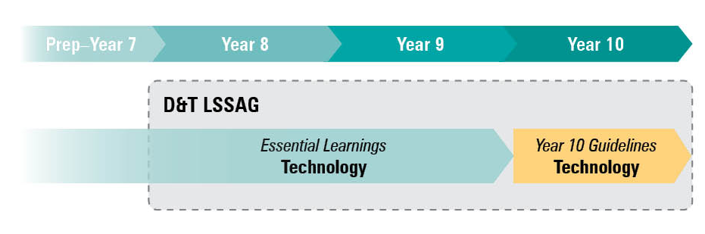

Planning using these guidelines
The development of a course of study is a school-based decision. A school may decide to use all or part of the information contained in these guidelines to construct a course of study.
The D&T LSSAG allows teachers to develop a variety of courses of study to meet the specific needs and interests of students, and may be used to plan:
- part of a specialised Year 8, Year 9 or Year 10 Design and Technology course
- part of a combined Years 8 and 9 or Years 9 and 10 Design and Technology course
- term- or semester-length units of work
- an integrated, multidisciplinary or transdisciplinary course of study that combines learning statements from other learning areas, e.g. Enterprise education.
Figure 2: Five processes for planning
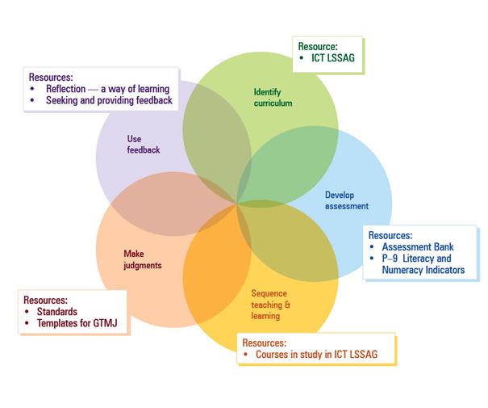

Mapping Essential Learnings and Year 10 Guidelines
The following sections include the Ways of working from the ELs and Year 10 Guidelines for the Technology learning area that link to Design and Technology. They also include tables that map the ELs and Year 10 Guidelines to Design and Technology knowledge and understanding examples. These lists of examples are not exhaustive.

Technology Essential Learnings by the end of Year 9

Ways of working
Students are able to:
- investigate and analyse specifications, standards and constraints in the development of design ideas
- consult, negotiate and apply ethical principles and cultural protocols to investigate, design and make products
- generate and evaluate design ideas and communicate research, design options, budget and timelines in design proposals
- select resources, techniques and tools to make products that meet detailed specifications
- plan, manage and refine production procedures for efficiency
- make products to meet detailed specifications by manipulating or processing resources
- identify, apply and justify workplace health and safety practices
- evaluate the suitability of products and processes against criteria and recommend improvements
- reflect on and analyse the impacts of products and processes on people, their communities and environments
- reflect on learning, apply new understandings and justify future applications.

Knowledge and understanding
Technology ELs by the end of Year 9 |  | Examples
Technology as a human endeavour  Technology influences and impacts on people, their communities and environments in local and global contexts. | New products and technologies are designed and developed to meet changing needs and wants of intended audiences, and include artefacts, systems, environments, services and processes. | Examples may include:  - nature of products and attributes of existing products  - human needs, wants and opportunities  - purpose of designing.
 | Product design and production decisions are influenced by aspects of appropriateness and by detailed specifications, constraints and standards of production. | Examples may include:  - product design, e.g. design brief, design situation, design criteria, purpose, user requirements, safety requirements, audience, function, constraints, financial considerations  - influence of manufacturing techniques on product design decisions  - factors influencing production decisions, e.g. operating environments, workplace health and safety issues.
 | People can influence decisions made about the design, development and use of technology to change the impact on people, their communities and environments at local and global levels. | Examples may include:  - past, present and future perspectives on technology  - impacts of technology on people, communities and the environment, e.g. impact of graphical communication, advertising, media and sustainability on decision making.
Information, materials and systems (resources)  Resources originate from different sources, exist in various forms and are manipulated to meet specifications and standards to make products. | Characteristics of resources are compared, contrasted and selected to meet detailed specifications and predetermined standards of production to best suit the user. | Examples may include:  - nature, characteristics and properties of typical resources, e.g. woods, metals, plastics, natural and synthetic materials  - suitability of materials for specific purposes  - design requirements  - influences on material selection, e.g. function, form and/or shape, economics, complexity of construction, aesthetics  - elements of design, e.g. points, lines, shapes, colours, textures, size, tone  - principles of design, e.g. balance, harmony, contrast, repetition, proportion, variety, emphasis.
 | Techniques and tools are selected, controlled and managed to manipulate or process resources to meet detailed specifications and predetermined standards of production. | Examples may include:  - risk assessment and management  - identifying and minimising potential hazards and risks  - ensuring safe work procedures and sequences  - disposing of waste safely  - using energy sources safely  - basic techniques for manipulating industrial materials, e.g. forming, separating, combining, conditioning, finishing  - graphical communication/drawings techniques, e.g. sketching and CAD Modelling, 2-D and 3-D representations  - use of graphical communication technologies, e.g. sketching and drawing equipment, computer-aided design and drafting software and techniques.

Year 10 Guidelines: Technology

Ways of working
Students are able to:
- investigate and analyse products, processes or services in response to design challenges or problems
- design solutions to challenges or problems, considering appropriateness, purpose and constraints, including budgets and timelines
- develop and use production plans to manage and refine procedures, using suitable techniques and tools, to make quality-controlled products, processes or services
- use safe and ethical practices relevant to specific contexts
- create products, processes or services to meet challenges or problems by manipulating or processing resources (information, materials and systems)
- communicate design solutions in response to challenges or problems using suitable modes and genres for presenting technical ideas and design concepts for a given audience and purpose
- use evaluation throughout the design and production process to validate and refine the effectiveness of solutions to challenges or problems
- analyse and evaluate the ethics and impacts of products, processes and services on local and global communities and environments
- reflect on learning, applying new understandings of technological processes to wider contexts.

Knowledge and understanding
Year 10 Guidelines: Technology |  | Examples
Products, processes and services  Individual characteristics of different technological resources (information, materials or systems) will decide how they are applied in products, processes or services that have been designed to meet a challenge. | Information takes different forms that can be collected, analysed and organised. | Examples may include:  - different sources of information that are used to match and develop design challenges, e.g. design briefs, references  - issues related to ownership and control of information in society, e.g. copyright, intellectual property, patents  - presentation of information to meet detailed specifications  - client needs that are used to develop the design solutions.
 | Materials have characteristics which are compared, contrasted and selected to meet detailed specifications and production standards. | Examples may include:  - nature of industrial materials, e.g. current trends in material development and use, potential uses of current materials, natural and synthetic materials  - characteristics of materials, e.g. chemical and physical characteristics of materials, relationship of characteristics to performance, testing of materials to determine characteristics, composites, heat treatment as a result of cutting and joining processes, glues  - suitability of materials for specific purposes and impacts and consequences of materials used  - aspects of appropriateness, e.g. cultural, functional, aesthetics, economic  - factors influencing production decisions, e.g. operating environments, workplace health and safety issues.
 | Systems incorporate multiple processes that work together to meet challenges and can be managed with tools. | Examples may include:  - structure, control and management of systems and subsystems  - industrial systems and subsystems, e.g. energy sources used as inputs in industrial systems, reliability, inputs, processes and outputs, role of components in a system, relationship between components of systems and control elements  - factors underlying complex systems, e.g. structure of input, processes and outputs, multiple controls, feedback, troubleshooting, problem solving, economic requirements, legislation, regulations or conventions  - factors influencing the development of industrial systems, e.g. commercialisation and enterprise, industrial standards and conventions.
Techniques and tools  Techniques and tools are selected to manipulate resources to meet detailed specifications and predetermined standards, and their characteristics inform the selection for specific tasks. | Practical experiences with techniques and tools provide opportunities to develop skills. | Examples may include:  - techniques for controlling industrial systems  - practical techniques, e.g. assembling and dismantling, testing and trialling, monitoring and diagnosing, programming, managing and controlling, modifying and refining  - specialised equipment and refined techniques to make quality products to detailed specifications  - techniques of graphical communication and/or drawings, e.g. sequencing, modelling, analysing, transforming, critiquing graphics, constructing, modifying, intersecting, projecting, transferring, rotating, presenting, arranging, sketching.
 | Safe practices are part of the control and management process. | Examples may include:  - strategies, policies and procedures to control risks and hazards  - safe practices in workshop environments  - potential hazards and demonstration of risk-control measures to manage safe work practices.
 | Design ideas are represented by specialist forms of technical communication. | Examples may include:  - appropriate terminology, language, formats, graphical representation, techniques and conventions  - design proposals, sketches, rendered pictorial drawings, formal working drawings  - animations, 3-D CAD models, 3-D printed prototypes.
Impacts and consequences  Decisions made about the design, development and use of technology are based on that technology’s probable impact on people, their communities and environments at local and global levels. | New products and technologies are designed and developed to meet changing needs. | Examples may include:  - sustainable energy solutions  - innovations and emerging technologies  - human needs, wants and opportunities in order to initiate new product development.
 | Impacts and consequences of products, processes and services include aesthetic, cultural, economic, environmental, ethical, functional and social factors. | Examples may include:  - impacts of industrial systems on the environment, industries, economies, individuals and communities  - global trends  - social change as a consequence of new technology  - influence and impact of changes in legislation and regulations on technology, e.g. workplace health and safety legislation, Australian standards, building codes  - new and emerging technology.

Assessment

Planning an assessment program
The assessment program for a course of study using the D&T LSSAG should include a range and balance of assessment types that provide opportunities for students to demonstrate their learning across:
- the standards
- assessment techniques and instruments that include:
  - a range of assessment conditions
  - written and nonwritten modes.

Standards
In a lower secondary context, the standards applied to the course may be drawn from the standards linked to the ELs and/or the Year 10 Guidelines. All sets of standards (for the Technology ELs by the end of Year 9 and the Year 10 Guidelines: Technology) align to the curriculum content used in the D&T LSSAG.
The assessable elements identify the valued features of each key learning area and indicate what evidence of student learning is to be collected and assessed. The assessable elements for the Technology ELs by the end of Year 9 are shown below in Figure 3. Schools should decide how to use these assessable elements when developing a Design and Technology course of study and assessment program.
Figure 3: Assessable elements of Technology ELs
Dimension | Assessable elements
Knowledge and understanding | Knowledge and understanding
Ways of working | Investigating and designing
 | Producing
 | Evaluating
 | Reflecting

Assessment techniques and instruments
The following advice has been designed to help schools use the D&T LSSAG to build student learning towards assessment techniques that are valued in the Year 10 Guidelines: Technology, and senior design and technology subjects. The suggested formats have been modified from those in the senior syllabuses to suit Years 8–10 students. Teachers should use their judgment to determine assessment conditions appropriate to the targeted year level.
Design project
Design projects involve designing a solution to a design challenge. They may include:
- identification of client need, want or opportunity
- development of design brief, design situation, design specification
- investigation and research, data collation, test and/or survey results
- use of design concepts, sketches, annotations, notes, workings, drawings
- development of proposed production materials, method, procedures, materials list
- photos of key production stages
- reflection on the production process
- evaluation and recommendations for improvement.

Research assignments
Research assignments, reports or system evaluations that:
- use information to establish cause and effect, compare or contrast, indicate consequences or relationships
- modify or transform information from one form to another
- draw a conclusion based on information or data
- make and support a recommendation or propose action based on information or data
- analyse sustainable practice, ethical principles and their impacts on society, culture, the economy, and the environment
- consider appropriateness based on purpose and constraints.

Product
Product involves the realisation of a product, system or process. This technique incorporates:
- development of knowledge and skills involved with working with materials and tools
- safe work practices
- management of production processes (tools, equipment, housekeeping)
- waste minimisation, sustainable practice
- managing resources
- production quality (precision, surface, fit, tolerances)
- working to timelines
- evaluation and recommendations for improvements.
Note: evidence may include photos of key production stages, design logs and annotated teacher observations.

Courses of study

Using inquiry
As knowledge is constantly expanding and changing, programs should be designed to nurture skills that develop an inquiring mind. To ensure an inquiry approach underpins teaching and learning in Design and Technology, the skills of inquiry require explicit teaching.
Technology practice involves developing practical, purposeful and innovative products that meet human needs and wants. Technology practice involves:
- investigation — gathering knowledge, ideas and data to meet design challenges
- ideation — generating and communicating ideas that meet design challenges, and justifying the selection of these ideas
- production — identifying, describing and managing procedures when making products that meet design challenges
- evaluation — making judgments about the appropriateness of design ideas, processes and products when meeting design challenges.
Figure 4: Inquiry model
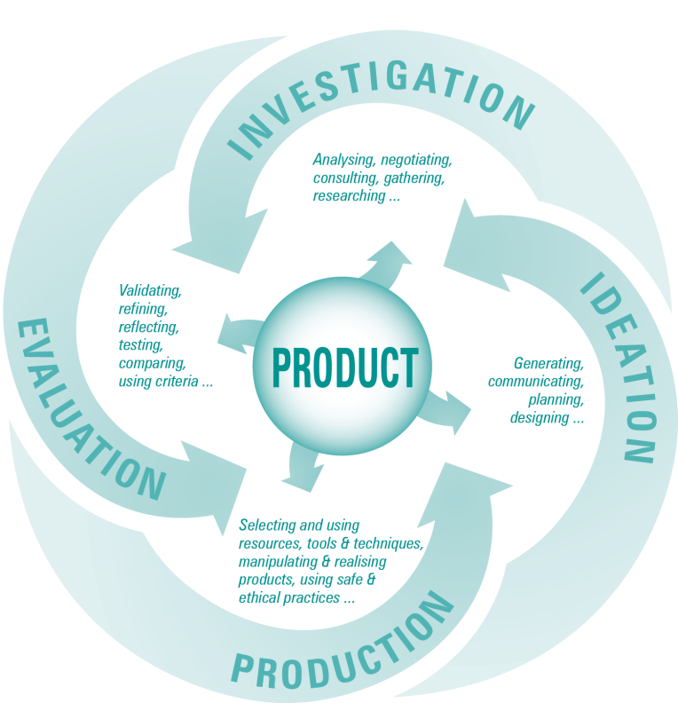

Examples of term- or semester-length units of study
Multiple courses of study with different focuses can be developed from this LSSAG. The unit examples below outline how the ELs and Year 10 Guidelines can be used to plan and develop units of study for Years 8–10 students. Teachers will need to devise risk assessments based on the materials, processes and techniques, aspects of safety being used and the skill level of specific student groups.
Please note that these examples do not preclude other ways of planning and packaging the learning statements. They are not full units of work, and need to be further developed with assessment and learning experiences to complete a course of study.

Example 1: Design a product to solve a storage problem
Technology ELs by the end of Year 9
Knowledge and understanding | Ways of working
Technology as a human endeavour  Technology influences and impacts on people, their communities and environments in local and global contexts.  - Product design and production decisions are influenced by aspects of appropriateness and by detailed specifications, constraints and standards of production.  Information, materials and systems (resources)  Resources originate from different sources, exist in various forms, and are manipulated to meet specifications and standards to make products.  - Characteristics of resources are compared, contrasted and selected to meet detailed specifications and predetermined standards of production to best suit the user.  - Techniques and tools are selected, controlled and managed to manipulate or process resources to meet detailed specifications and predetermined standards of production. | Students are able to:  - investigate and analyse specifications, standards and constraints in the development of design ideas  - consult, negotiate and apply ethical principles and cultural protocols to investigate, design and make products  - generate and evaluate design ideas and communicate research, design options, budget and timelines in design proposals  - select resources, techniques and tools to make products that meet detailed specifications  - plan, manage and refine production procedures for efficiency  - make products to meet detailed specifications by manipulating or processing resources  - identify, apply and justify workplace health and safety practices  - evaluate the suitability of products and processes against criteria and recommend improvements  - reflect on and analyse the impacts of products and processes on people, their communities and environments  - reflect on learning, apply new understandings and justify future applications.

Year 10 Guidelines: Technology
Knowledge and understanding | Ways of working
Products, processes and services  Individual characteristics of different technological resources (information, materials or systems) will decide how they are applied in products, processes or services that have been designed to meet a challenge.  - Materials have characteristics which are compared, contrasted and selected to meet detailed specifications and production standards.  Techniques and tools  Techniques and tools are selected to manipulate resources to meet detailed specifications and predetermined standards, and their characteristics inform the selection for specific tasks.  - Practical experiences with techniques and tools provide opportunities to develop skills. | Students are able to:  - investigate and analyse products, processes or services in response to design challenges or problems  - design solutions to challenges or problems, considering appropriateness, purpose and constraints, including budgets and timelines  - develop and use production plans to manage and refine procedures, using suitable techniques and tools, to make quality-controlled products, processes or services  - use safe and ethical practices relevant to specific contexts  - create products, processes or services to meet challenges or problems by manipulating or processing resources (information, materials and systems)  - communicate design solutions in response to challenges or problems using suitable modes and genres for presenting technical ideas and design concepts for a given audience and purpose  - use evaluation throughout the design and production process to validate and refine the effectiveness of solutions to challenges or problems  - analyse and evaluate the ethics and impacts of products, processes and services on local and global communities and environments  - reflect on learning, applying new understandings of technological processes to wider contexts.

 | Year 8 | Year 9 | Year 10
Task focus | Desk storage system | Home organiser | Secure storage device
Design brief | Design a storage system for a student desk at home. The design must hold a range of items that you would typically find on a student desk, such as pens, pencils, and paperclips.  The design is constrained by supplied materials and manufacturing processes suitable to the age and ability of students. | Identify a situation in the home that requires organisation or reorganisation, e.g. storage of shoes, mobile phone, keys, chargers, or remote controls.  The design is constrained by material costs and manufacturing processes suitable to the age and ability of students. | Design a secure storage device to suit personal needs, e.g. media storage box, jewellery box.  The design is constrained by limits on overall dimensions, material costs and manufacturing processes suitable to the age and ability of students.
Student focus | Students measure and mark out, work safely, cut, join and finish. Students design the individual components of a desk storage system. This design should incorporate the use of processes and techniques listed below.  The design folio is scaffolded by outlining key aspects, e.g. interpretation of design brief, areas requiring research, how to generate ideas, sketching with annotations, justification of choices, working sketches, production plan, evaluation. | Students measure and mark out, work safely, cut, join and finish. They design the product based on defined constraints or components.  The pre-production process should involve negotiated planning of the steps and processes to ensure successful production. | Students negotiate and problem solve the development of their idea with their teacher.  The pre-production process should involve negotiated planning of the steps and processes to ensure successful production.
Aspects of Safety | - General workshop safety  - Hand tool safety  - Battery drill safety  - Machinery safety, e.g. disc sander, strip heater, pedestal drill, buffing machine, scroll saw  - Personal protective equipment | - General workshop safety  - Hand tool safety  - Battery drill safety  - Machinery safety, e.g. disc sander, strip heater, pedestal drill, buffing machine, scroll saw, linisher, pyrographer  - Personal protective equipment | - General workshop safety  - Hand tool safety  - Battery drill safety  - Machinery safety, e.g. disc sander, strip heater, pedestal drill, buffing machine, scroll saw, linisher, pyrographer, bandsaw, pan brake, guillotine, metal lathe, soldering iron, welding equipment  - Personal protective equipment
Process and techniques | - Butt joint  - Fixings (wood screws, pop rivets)  - Adhesives  - Edge finishing (acrylic, timber, sheet metal)  - Drilling  - Clamping  - Manipulating materials with hand tools and/or machinery | - Must include specified joint type  - Fixings (wood screws, pop rivets)  - Adhesives  - Edge finishing (acrylic, timber, sheet metal)  - Drilling  - Clamping  - Manipulating materials with hand tools and/or machinery | - Fixings (wood screws, pop rivets)  - Adhesives  - Edge finishing (acrylic, timber, sheet metal)  - Drilling  - Clamping  - Folding sheet metal  - Cutting sheet metal  - Hinging  - Locks  - Manipulating materials with hand tools and/or machinery
Materials | Students are not required to calculate material costs.  Timber, plastics and metals are provided. | Students are required to calculate materials costs and must work within a specified budget.  Timber, plastics and metals are provided. Additional materials may be provided by the student. | Students are required to calculate materials costs and must work in a specified budget.  Timber, plastics and metals are provided. Additional materials may be provided by the student.
Student evaluation | Evaluate the suitability of the product against the design brief. Reflect on the impact of the product on improved storage practices at home. | Evaluate the suitability of the product against the design brief and suggest improvements. Reflect on the impact of the product on people, their communities and the environment. | Evaluate the suitability of the product against the design brief and the usability of the product by the targeted client. Reflect on the ethics and impacts of the product on local communities and environments.

Example 2: Design a child’s toy and produce a virtual 3-D model
Technology ELs by the end of Year 9
Knowledge and understanding | Ways of working
Technology as a human endeavour  Technology influences and impact on people, their communities and environments in local and global contexts.  - New products and technologies are designed and developed to meet changing needs and wants of intended audiences, and include artefacts, systems, environments, services and processes.  - Product design and production decisions are influenced by aspects of appropriateness and by detailed specifications, constraints and standards of production.  Information, materials and systems (resources)  Resources originate from different sources, exist in various forms and are manipulated to meet specifications and standards to make products.  - Techniques and tools are selected, controlled and managed to manipulate or process resources to meet detailed specifications and predetermined standards of production. | Students are able to:  - investigate and analyse specifications, standards and constraints in the development of design ideas  - consult, negotiate and apply ethical principles and cultural protocols to investigate, design and make products  - generate and evaluate design ideas and communicate research, design options, budget and timelines in design proposals  - select resources, techniques and tools to make products that meet detailed specifications  - plan, manage and refine production procedures for efficiency  - make products to meet detailed specifications by manipulating or processing resources  - identify, apply and justify workplace health and safety practices  - evaluate the suitability of products and processes against criteria and recommend improvements  - reflect on and analyse the impacts of products and processes on people, their communities and environments  - reflect on learning, apply new understandings and justify future applications.

Year 10 Guidelines: Technology
Knowledge and understanding | Ways of working
Products, processes and services  Individual characteristics of different technological resources (information, materials or systems) will decide how they are applied in products, processes or services that have been designed to meet a challenge.  - Information takes different forms that can be collected, analysed and organised.  Techniques and tools  Techniques and tools are selected to manipulate resources to meet detailed specifications and predetermined standards, and their characteristics inform the selection for specific tasks.  - Design ideas are represented by specialist forms of technical communication.  Impacts and consequences  Decisions made about the design, development and use of technology are based on that technology’s probable impact on people, their communities and environments at local and global levels.  - New products and technologies are designed and developed to meet changing needs. | Students are able to:  - investigate and analyse products, processes or services in response to design challenges or problems  - design solutions to challenges or problems, considering appropriateness, purpose and constraints, including budgets and timelines  - develop and use production plans to manage and refine procedures, using suitable techniques and tools, to make quality-controlled products, processes or services  - use safe and ethical practices relevant to specific contexts  - create products, processes or services to meet challenges or problems by manipulating or processing resources (information, materials and systems)  - communicate design solutions in response to challenges or problems using suitable modes and genres for presenting technical ideas and design concepts for a given audience and purpose  - use evaluation throughout the design and production process to validate and refine the effectiveness of solutions to challenges or problems  - analyse and evaluate the ethics and impacts of products, processes and services on local and global communities and environments  - reflect on learning, applying new understandings of technological processes to wider contexts.

 | Year 8 | Year 9 | Year 10
Task focus | Use computer-aided design software to design and represent a child’s wheeled toy (graphical product) in 3-D. | Use computer-aided design software to design and represent a child’s wheeled toy with moving parts (graphical product) in 3-D. | Use computer-aided design software to design and represent a child’s wheeled toy with moving parts (graphical product) in 3-D that is suitable for use in an early learning education centre.
Design brief | Design a wheeled toy suitable for use by a child. Represent the design solution as a 3-D,rendered graphical product suitable for use in advertising to your target audience. | Design a toy that includes multiple moving parts, suitable for use by a child. Represent the design solution as a 3-D, rendered graphical product suitable for use in advertising to your target audience. | Design a toy suitable for use by children aged 3–5 years at an early learning education centre.  Represent the design solution as a 3-D, rendered graphical product suitable for use in advertising to your target audience.
Student focus | Students investigate elements of good design to develop sketches and annotations of a child’s wheeled toy. They design and develop a 3-D digital image that incorporates the use of processes and techniques listed below.  The project is scaffolded by the teacher. | Students investigate elements of design, with particular focus on the safety of toys which have moving parts.  They design and develop a 3-D digital image that incorporates the use of processes and techniques listed below. | Students identify client needs and wants through an interview with an appropriate adult. They should negotiate and problem solve the development of their idea with their teacher.  Students design and develop a 3-D digital image that incorporates the use of processes and techniques listed below.
Process and techniques | - Investigate design situation requirements, considering concepts such as ergonomics, safety, sustainability and production.  - Sketch and annotate possible toys. Use shading, render and colour to enhance sketches.  - Develop a refined sketch from ideation sketches.  - Create a digital 3-D image of the toy. | - Investigate design situation requirements, considering concepts such as ergonomics, safety, sustainability and production.  - Sketch and annotate possible toys. Use shading, render and colour to enhance sketches.  - Develop a refined sketch from ideation sketches.  - Create a digital 3-D image of the toy.  - Produce an animation of the assembly of the parts of the toy. | - Interview the client to determine audience, design requirements, safety standards, functionality, etc.  - Develop a refined sketch from ideation sketches.  - Create a digital 3-D image of the toy.  - Produce a design, album and orthographic view of the toy.  - Produce an animation of the assembly of the parts of the toy.  - Prepare a presentation of the 3-D image for the client.
Evaluation focus | Evaluate the suitability of the product against the design brief. Reflect on the impact of the product on child enjoyment. | Evaluate the suitability of the product against the design brief and suggest improvements. Reflect on the impact of the product on people, their communities and the environment. | Evaluate the suitability of the product against the design brief and the usability of the product by the targeted client. Reflect on the ethics and impacts of the product on local communities and environments.

Queensland Studies Authority
154 Melbourne Street, South Brisbane
PO Box 307 Spring Hill
QLD 4004 Australia
T +61 7 3864 0299
F +61 7 3221 2553
www.qsa.qld.edu.au

