Business Lower Secondary Subject Area Guidelines
June 2014

Contents
Rationale 1
Planning using these guidelines 2
Mapping of Essential Learnings and Year 10 Guidelines 3
Essential Learnings by the end of Year 9 — Mathematics 3
Essential Learnings by the end of Year 9 — Studies of Society & Environment (SOSE) 4
Essential Learnings by the end of Year 9 — Technology 6
Year 10 Guidelines — Business 8
Assessment 11
Planning an assessment program 11
Standards 11
Assessment techniques and instruments 11
Courses of study 13
Examples of term- or semester-length units of study 13

Rationale
Business activity affects the daily lives of all Australians as they work, spend, save, invest, travel and play. It influences jobs, incomes and opportunities for personal enterprise.
“Business” refers to enterprising endeavours undertaken to meet human needs and wants. Business, economic and legal activities impact on and present a range of challenges to individuals and members of groups and organisations in their roles as active and informed citizens, consumers, workers or entrepreneurs. These challenges may include:
- participating as an active and responsible citizen in business environments in response to individual, group, local, national and global needs
- making consumer decisions to meet the needs and wants of self and others
- managing scarce resources to meet the necessary business, economic and legal requirements for sustainability
- entering into contractual agreements and managing personal finances, investments and records
- owning or managing a business, enterprise or venture.
Business education is important for students in their secondary schooling. In this phase of schooling, they gain a degree of independence in accumulating and managing finances, making decisions about goods and services, and acquiring legal rights and responsibilities as citizens. Students studying business will develop effective decision-making skills related to consumer behaviour and the management and evaluation of personal financial matters. The skills will result in improved economic, consumer and financial literacy.
The ways of working and the knowledge and understanding outlined in these guidelines are drawn from the Essential Learnings (ELs) for Mathematics, Technology, and Studies of Society and Environment (SOSE) and the Year 10 Guidelines for the Business learning area.
Figure 1 shows the relationship between the ELs and the Year 10 Guidelines and how they can be used to construct a course of study using the Business Lower Secondary Subject Area Guidelines (Business LSSAG).
Figure 1: Essential Learnings, Year 10 Guidelines and Business Lower Secondary Subject Area Guidelines
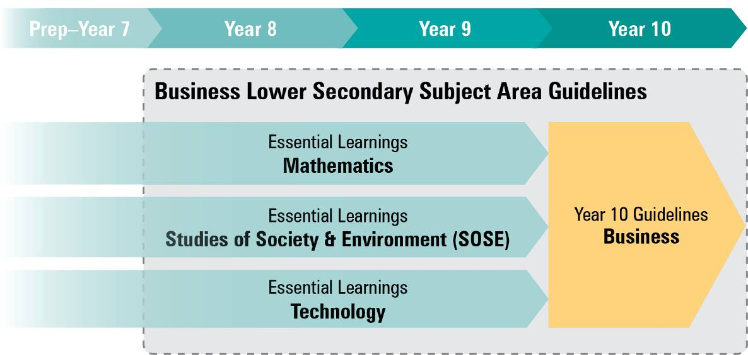

Planning using these guidelines
The development of a course of study is a school-based decision. A school may decide to use all or part of the information contained in these guidelines to construct a course of study.
The Business LSSAG allows teachers to develop a variety of courses of study to meet the specific needs and interests of students, and may be used to plan:
- part of a specialised Year 8, Year 9 or Year 10 business course
- part of a combined Year 8/9 or Year 9/10 business course
- term- or semester-length units of work
- an integrated multidisciplinary or transdisciplinary course of study that combines learning statements from other learning areas (e.g. enterprise education).

Figure 2: Five processes for planning
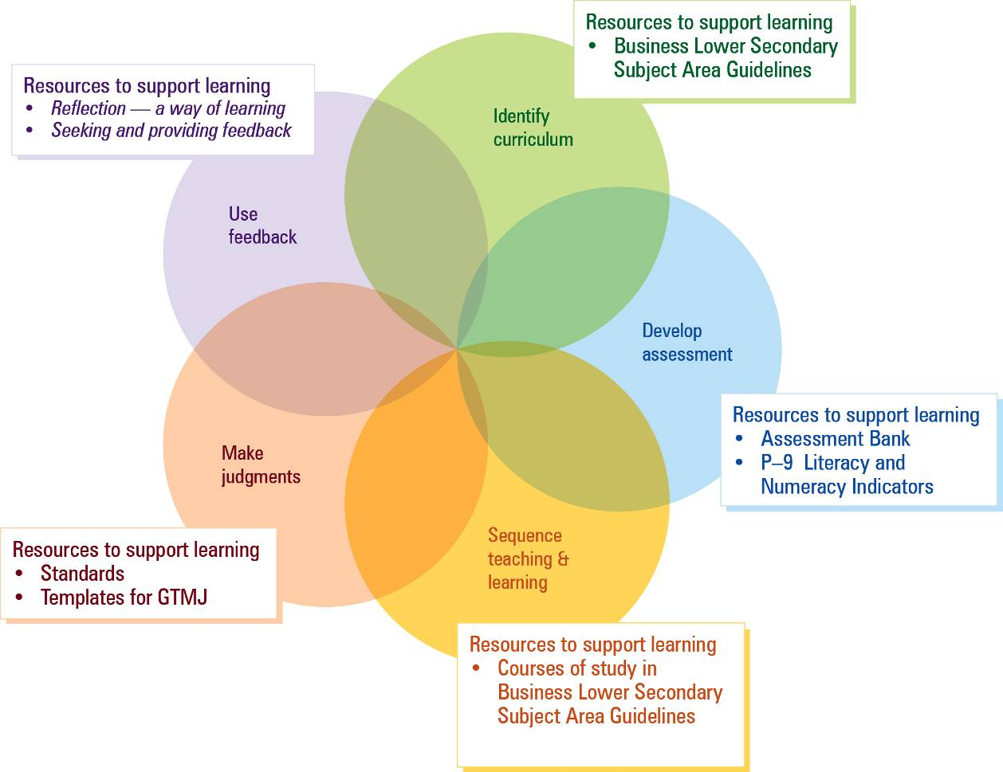
(see p. 13)

Mapping of Essential Learnings and Year 10 Guidelines
The following sections includes the ways of working from the ELs and Year 10 Guidelines for specific learning areas that link to Business. Also included are tables that map the ELs and Year 10 Guidelines to Business knowledge and understanding (K&U) examples. These lists of examples are not exhaustive.

Essential Learnings by the end of Year 9 — Mathematics

Ways of working
Students are able to:
- analyse situations to identify the key mathematical features and conditions, strategies and procedures that may be relevant in the generation of a solution
- pose and refine questions to confirm or alter thinking and develop hypotheses and predictions
- plan and conduct activities and investigations, using valid strategies and procedures to solve problems
- select and use mental and written computations, estimations, representations and technologies to generate solutions and to check for reasonableness of the solution
- use mathematical interpretations and conclusions to generalise reasoning and make inferences
- evaluate their own thinking and reasoning, considering their application of mathematical ideas, the efficiency of their procedures and opportunities to transfer results into new learning
- communicate thinking, and justify and evaluate reasoning and generalisations, using mathematical language, representations and technologies
- reflect and identify the contribution of mathematics to their own and other people’s lives
- reflect on learning, apply new understandings and justify future applications.

Knowledge and understanding (K&U)
ELs (end of Year 9) — Mathematics |  | Business LSSAG K&U examples
Number  Number properties and operations and a range of strategies can be applied when working with integers and rational numbers | Financial decisions can be made based on the analysis of short- and long-term benefits and consequences of cash, credit and debit transactions | Examples may include:  - Use of source documents  - Simple financial reports for specific audiences and purposes e.g. budgets, cash receipts, payrolls  - Cost-benefit financial analysis  - Personal finances and budgeting  - Interest received and interest paid calculations
 | Financial transactions for the provision of goods and services may incur additional costs determined by government and organisations | Examples may include:  - Components of various documents e.g. payments procedures, GST, discount details  - Simple financial reports for specific audiences and purposes e.g. profit-and-loss statements, balance sheets, bank statements  - Simple business activity statement (BAS) with GST received, GST paid and net result  - Financial factors influencing business decisions e.g. pricing levels, interest rates, share markets

Essential Learnings by the end of Year 9 — Studies of Society & Environment (SOSE)

Ways of working
Students are able to:
- identify a research focus from broad topics and design focus questions and sub-questions
- plan investigations, using discipline-specific inquiry models and processes
- research and analyse data, information and evidence from primary and secondary sources
- evaluate sources of data, information and evidence for relevance, reliability, authenticity, purpose, bias and perspective
- draw conclusions and make decisions supported by interpretations of data, information and evidence
- communicate descriptions, decisions and conclusions, using text types specific to the context and purpose and the conventions of research-based texts
- respond to local and global issues by taking action in planned and enterprising ways
- apply strategies for making group decisions and for taking informed social and environmental action
- reflect on different perspectives, and recognise and evaluate the influence of values and beliefs in relation to social justice, the democratic process, sustainability and peace
- reflect on learning, apply new understandings and justify future applications.

Knowledge and understanding (K&U)
ELs (end of Year 9) — SOSE |  | Business LSSAG K&U examples
Political and economic systems  Societies consist of interconnected decision-making systems, institutions and processes based on principles and values | Australia’s legal and justice systems are based on principles, including an independent judiciary, perform functions, including the protection of rights, and use different types of law and courts | Examples may include:  - Laws and regulations e.g. workplace health and safety, unfair dismissal  - Consumer rights and responsibilities  - Consumer support services e.g. legal aid, offices of fair trading, Australian Competition and Consumer Commission  - Informed and responsible ways to obtain products and services  - Regulatory bodies e.g. courts, tribunals, offices of fair trading  - Employer and employee rights and responsibilities  - Workplace practices and regulations for safe and equitable environments e.g. state and Commonwealth legislation — Workplace Health and Safety Act 1995, Anti-discrimination Act 1991, Freedom of Information Act 1982
 | Australia’s relationships with other nations involve membership of international organisations and participation in global systems of law, diplomacy, human rights, trade and security | Examples may include:  - Consumers buy and producers sell goods from domestic and international markets — trade  - Globalisation impacts on different individuals and groups in different ways  - Present influences on workplace practices e.g. outsourced labour in a global economy, social justice issues  - International relations with other countries e.g. agreements  - Trade relationships  - International trade laws, diplomatic relations and human rights
 | Australia’s economic system is shaped by a range of economic activities, including production and consumption, and government regulation | Examples may include:  - Types of business and economic activities e.g. banking and finance, investment, transport, hospitality, legal, accounting  - Need for systems to regulate activities  - Resource allocation — scarcity, unlimited needs, limited wants  - Allocation of scarce resources by individuals, groups and societies  - Government policy e.g. monetary policy, fiscal policy  - Laws and regulations e.g. workplace health and safety, unfair dismissal  - Enforcement agencies e.g. Australian Competition and Consumer Commission, environmental protection agencies, offices of fair trading  - Regulatory bodies e.g. Australian Taxation Office, Department of the Treasury  - Present influences on workplace practices e.g. enterprise bargaining  - Systems in business and economic contexts e.g. management, operations, financial, legal, transport, government, insurance, marketing  - Logic of systems and subsystems e.g. inputs, outputs, processes, components  - System structures, controls and management
Time, continuity and change  Social, political, economic and cultural changes and continuities are connected to particular events, ideas and contributions, and can be interpreted from different perspectives | Important ideas of democracy, government and law, citizenship rights and public decision making, and the concepts of power, dissent and civic duty, developed from ancient to modern times and from Eastern and Western cultures | Examples may include:  - Past influences on workplace practices e.g. industrial revolution, growth and decline of trade unionism, Commonwealth Court of Conciliation and Arbitration  - Current influences on workplace practices e.g. Australian Industrial Relations Commission, enterprise bargaining  - Cultural changes affecting business today e.g. increasing use of social networking sites (Twitter, Facebook) by businesses for marketing purposes  - Concept of a move from an industrial age to a “conceptual age” e.g. economy of knowledge  - Development of legal and regulatory requirements of business over time e.g. government intervention in markets, regulation of ownership

Essential Learnings by the end of Year 9 — Technology

Ways of working
Students are able to:
- investigate and analyse specifications, standards and constraints in the development of design ideas
- consult, negotiate and apply ethical principles and cultural protocols to investigate, design and make products
- generate and evaluate design ideas and communicate research, design options, budget and timelines in design proposals
- select resources, techniques and tools to make products that meet detailed specifications
- plan, manage and refine production procedures for efficiency
- make products to meet detailed specifications by manipulating or processing resources
- identify, apply and justify workplace health and safety practices
- evaluate the suitability of products and processes against criteria and recommend improvements
- reflect on and analyse the impacts of products and processes on people, their communities and environments
- reflect on learning, apply new understandings and justify future applications.

Knowledge and understanding (K&U)
ELs (end of Year 9) — Technology |  | Business LSSAG K&U examples
Technology as a human endeavour  Technology influences and impacts on people, their communities and environments in local and global contexts | New products and technologies are designed and developed to meet changing needs and wants of intended audiences, and include artefacts, systems, environments, services and processes | Examples may include:  - Links between information gathered and the design and development of products  - Ways of developing products to meet new or emerging consumer needs  - Ways to analyse links between information gathered and the development of products e.g. SWOT analysis, PMI analysis  - Detailed plans for gathering knowledge, ideas and data
 | Product design and production decisions are influenced by aspects of appropriateness and by detailed specifications, constraints and standards of production | Examples may include:  - Factors influencing the production of selected options include human and physical resources, appropriateness, economic factors  - Strategies to manage resources  - Predetermined standards e.g. design briefs, client specifications, government standards, industrial or commercial standards  - Reasons and ways to negotiate and refine production procedures  - Gathering feedback on design ideas and processes e.g. questionnaires, peer review, observations, testing  - Methods for evaluating commercial or industrial products and processes e.g. product tests and trials, interviews, market research, consultations with experts  - Changes to sources, forms and management of information affect design and production decisions e.g. technological developments, privacy issues, digital forms, e-commerce, email
 | People can influence decisions made about the design, development and use of technology to change the impact on people, their communities and environments at local and global levels | Examples may include:  - Changes to sources, forms and management of information affect design and production decisions e.g. technological developments, privacy issues, digital forms, e-commerce, email

Year 10 Guidelines — Business

Ways of working
Students are able to:
- develop a relevant hypothesis and research focus from broad business, economic and legal topics
- conduct investigations of past, present and future business, economic and legal activities, using valid business strategies, procedures and processes
- gather and validate evidence and data from a range of relevant sources using a planned approach
- analyse and interpret business data, financial information and evidence to solve problems
- develop arguments supported by interpretations of data, information and evidence
- apply concepts, processes and principles to unfamiliar business issues, problems and situations
- devise and justify recommendations and decisions to business issues and problems at local, national and global levels
- select and apply procedures, business technology and communication tools to present information to a business standard that suits the context and audience
- record, report, design and create business information, financial records and products for personal and professional purposes
- apply decision-making strategies in individual and team situations to develop business plans and products, and to take informed and responsible action to achieve specific business outcomes
- reflect on different perspectives and interactions within business, economic and legal environments, demonstrating consideration of social, ethical, environmental and economic responsibility.

Knowledge and understanding (K&U)
Year 10 Guidelines — Business |  | Business LSSAG K&U examples
Business, economic and legal systems  Business environments are shaped by stakeholder expectations, economic activity, regulatory systems, legal structures and different types of business organisations | Businesses differ in size, location, type, purpose, structure and scope | Examples may include:  - Types of businesses: manufacturing, retail, marketing, service  - Different size, location, scope: small and medium enterprises, multinational companies  - Business structures: public companies, private companies, partnerships, sole traders, cooperatives, government departments, government business enterprises
 | Systems that influence and regulate business and economic activity assist with the allocation of scarce resources and protect parties who are directly and indirectly affected by this activity | Examples may include:  - Types of activities: banking and finance, investment, communication, transport, hospitality, legal, accounting, travel  - Government policy: monetary policy, fiscal policy; laws and regulations; enforcement agencies  - Structure of systems and subsystems; components of the circular flow of income  - External and internal controls: licensing, workplace health and safety  - Electronic accounting systems, human resources  - Resource allocation, scarcity, opportunity cost, global activity  - Organisation and governance of tourism industry
 | Markets and prices are influenced by the relationship between supply and demand, buyers and sellers, and globalisation | Examples may include:  - Decision making of buyers and sellers determines prices: consumer preferences, technology, trends  - Globalisation impacts on different individuals and groups in different ways
 | Consumers and government expect businesses to act responsibly by making informed decisions and using business practices that are socially, ethically, economically and environmentally responsible and sustainable | Examples may include:  - Consumer rights and responsibilities in obtaining goods and services  - Regulatory bodies for resolving business and economic issues e.g. Reserve Bank of Australia, Australian Securities and Investment Commission  - Values and ethics in business negotiation and decision making
 | The principles and features of democracy in Australia include the common good, separation of powers, government accountability, Australian Constitution and parliamentary elections | Examples may include:  - Role of government in developing policy, establishing conditions for economic activity and formulating legislation  - Role of political parties, comparison of democracies  - Principles and features of democracy
Information procedures  Information procedures and ICTs are used to ensure accountability and to manage records effectively for personal, workplace, community and business purposes | Sources, forms and management of information impact upon the ways people do business and their ability to produce high-quality and professional outcomes | Examples may include:  - Sources of information: bank accounts, reports, customer details  - Forms of information: internet sites, webpages, brochures, multimedia  - Information management methods: handwritten procedures, electronic systems  - Information procedures: accessing information from the internet, storing sites in folders, developing directories/folders
 | Financial records management involves recording, reporting, analysing and interpreting financial information in personal, business and social contexts | Examples may include:  - Nature of accounts, types of source documents, completion of business documents  - Accounting principles: accounting equation, methods, controls, double entry  - Record keeping, simple financial records and control procedures for specific audiences and purposes  - Analysis of financial reports for decision-making purposes  - Personal financial literacy skills e.g. budgeting
 | ICTs can be used to generate, manipulate, store, present, transform and transmit information in business contexts for different audiences to meet detailed specifications | Examples may include:  - Transforming: PowerPoint presentations, webpages, multimedia, graphical images and diagrams, spreadsheets  - Transmitting: emails, attachments, memos, information statements, press releases, posters, faxes, letters  - Collaborative construction — knowledge building using ICTs to bring about a community of practice: wikis, forums, web 2.0 technologies (cloud computing)
Enterprise and ventures  Successful enterprises and ventures are run by managers who are responsive to stakeholder needs and wants and are able to predict the possible and probable directions of the market | Entrepreneurial behaviour, skills and activities can impact positively and negatively on a variety of stakeholders | Examples may include:  - Nature of enterprising activity  - Skills and attributes needed to be a successful entrepreneur: record keeping, management, leadership, marketing, communication  - Impact on individuals: self-employment; impact on businesses: employment, profit, innovation, marketing; impact on communities: living standards, economic systems
 | Management of an enterprise or venture is a complex process involving the generation of enterprising ideas, the development of business proposals and plans, the undertaking of ventures and the evaluation of the outcomes | Examples may include:  - Simple business proposals and plans, including sections on human resources, marketing, financial records, management, production
Work environments  Australian workplaces are dynamic environments and operate through an interconnection of stakeholders, external forces and processes | Work environments are influenced by the various roles and responsibilities of employees, employers, industrial organisations, state, territory and Commonwealth governments, and the community | Examples may include:  - Safe work environment, payment of wages, leave and award entitlement  - Recruitment and selection procedures, discrimination practices, industrial action
 | Effective communication and organisational skills are essential for quality staff and customer relations | Examples may include:  - Teamwork skills, interpersonal skills, communication styles, listening skills, questioning techniques, nonverbal communication, time management  - Skills of active and informed citizens  - Written communications skills — letters, emails, reports etc. for a specific purpose
 | Different types of workforces are needed to meet the varied demands of local, national or global work environments | Examples may include:  - Nature and location of paid, unpaid and voluntary work  - Types of work arrangements: full-time, part-time, permanent, contract, temporary  - Dynamic and changing work environments: complex, fast-changing and competitive
 | Workplace practices and regulations are necessary to ensure safe, non-discriminatory and fair conditions in the workplace | Examples may include:  - State and Commonwealth legislation: Workplace Health and Safety Act 1995, Anti-discrimination Act 1991, Human Rights and Equal Opportunity Commission Act 1986, Age Discrimination Act 2004, Freedom of Information Act 1982, Privacy Act 1988  - Enterprise bargaining, contractual work arrangements
 | Past and present influences on workplace practices affect the changing nature of the work activity of employers, employees, unions and work-related groups | Examples may include:  - Technological advances, rapid communication, influences on workplace practices  - Industrial revolution, growth and decline of trade unionism, Commonwealth Conciliation and Arbitration Act 1904  - Australian Industrial Relations Commission, enterprise bargaining, outsourced labour in a global economy, technological change

Assessment

Planning an assessment program
The assessment program for a course of study using the Business LSSAG should include a range and balance of assessment types that provide opportunities for students to demonstrate their learning across:
- the standards
- assessment techniques and instruments that include:
- a range of assessment conditions
- written and nonwritten modes.

Standards
In a lower secondary context, the standards applied to the course may be drawn from the standards linked to the Essential Learnings and/or the Year 10 Guidelines. All sets of standards (for the Year 9 ELs in Mathematics, SOSE and Technology and the Year 10 Guidelines: Business) align to the curriculum content used in the Business LSSAG.
The assessable elements identify the valued features of each key learning area and indicate what evidence of student learning is collected and assessed. The assessable elements for the Mathematics, SOSE and Technology ELs are shown in Figure 3. Schools should decide how to use these assessable elements when designing a business course of study and assessment program.
Figure 3: Assessable elements of Mathematics, SOSE and Technology ELs
 |  | ASSESSABLE ELEMENTS
 |  | Mathematics | SOSE | Technology
DIMENSION | Knowledge and understanding | Knowledge and understanding | Knowledge and understanding | Knowledge and understanding
 | Ways of working | Thinking and reasoning | Investigating | Investigating and designing
 |  | Communicating | Communicating | Producing
 |  |  | Participating | Evaluating
 |  | Reflecting | Reflecting | Reflecting

Assessment techniques and instruments
The following advice has been designed to help schools use the Business LSSAG to build student learning towards assessment techniques that are valued in the Year 10 Guidelines for Business and senior business subjects. The suggested formats have been modified from those in senior syllabuses to suit Years 8–10 students. Teacher judgment should be used to determine assessment conditions appropriate to the targeted year level.

Short written responses
Short written response instruments may ask students to make one or a number of short responses. They are an effective method of assessing student knowledge and understanding.
Examples include:
- multiple-choice questions
- definitions of terms
- one-word answers
- true/false questions
- matching/classification
- sentence or short paragraph responses.

Extended written responses
Extended written response instruments are developed to address a question, scenario or issue. They should highlight specific issues rather than broad general topics and could require a response to stimulus materials and/or deeper understanding of factual knowledge.
Examples include:
- reports
- feature articles or case studies
- persuasive, analytical or argumentative essays
- response to stimulus (e.g. case studies, statistics, graphs, tables, charts, newspaper articles, legislation, advertisements)
- editorial or newspaper articles.

Practical tasks
Practical tasks are used to assess business records and procedures, either manually or electronically.
Examples include:
- folios of work
- computer-generated documents
- record keeping
- diaries
- concept maps.

Nonwritten responses
Nonwritten responses are spoken/signed (e.g. debates, seminars, lessons) and/or multimodal (e.g. webpages, board games).
Examples include:
- debates
- roleplays or interviews
- development of videos, websites or computer software programs
- songs or poems
- radio or TV news reports
- team discussions
- board games
- trade displays.

Project work
Project work involves a variety of techniques completed in teams, individually or by a combination of individual and team work. Students may present their findings in a written or nonwritten format, or a combination of both. The integrated project should be undertaken over an extended period of time and involve the use of students’ own time and class time.
Examples include:
- business plans
- seminars
- conferences
- design briefs.

Courses of study
Multiple courses of study with different focuses can be developed from these guidelines. The table below provides examples of how the ELs and Year 10 Guidelines can be used to plan and develop units of study which target Years 8–10 students. This does not preclude other ways of planning and packaging the learning statements. Please note that these examples are not full units of work, and need to be further developed with assessment and learning experiences to complete a course of study.

Examples of term- or semester-length units of study

Example 1: Where do our resources go?
ELs (end of Year 9) — SOSE  Knowledge and understanding  Political and economic systems  Societies consist of interconnected decision-making systems, institutions and processes based on principles and values  - Australia’s economic system is shaped by a range of economic activities, including production and consumption, and government regulation  Include ways of working that clearly link to the developed assessment in the course of study | Year 8 focus  - Explain the concepts of needs and wants  - Investigate the concept of scarcity  - Determine what resources are limited and how this leads to scarcity  - Investigate how individuals, groups and societies meet needs and wants  - Explain how individuals and groups use decision-making processes to make choices and allocate resources  - Communicate my understanding in an appropriate business document
Year 9 focus
- Explain the term “opportunity cost”
- Investigate how opportunity cost affects individuals and businesses
- Use examples to explain opportunity cost
- Examine how governments and societies make decisions within an economic framework
- Investigate and communicate why and how the government needs to regulate consumer and business behaviour
Year 10 Guidelines — Business  Knowledge and understanding  Business, economic and legal systems  Business environments are shaped by stakeholder expectations, economic activity, regulatory systems, legal structures and different types of business organisations  - Systems that influence and regulate business and economic activity assist with the allocation of scarce resources and protect parties who are directly and indirectly affected by this activity  - Markets and prices are influenced by the relationship between supply and demand, buyers and sellers, and globalisation  Include ways of working that clearly link to the developed assessment in the course of study | Year 10 focus  - Explain the components of the circular flow of income  - Diagrammatically represent the circular flow of income  - Examine how each of the components of the circular flow of income impact upon each other  - Investigate how the decision making of buyers and sellers determines the price of products and services  - Investigate why the buyer–seller relationship is important for determining prices in the global market

Example 2: How do I make my money grow?
ELs (end of Year 9) — Mathematics  Knowledge and understanding  Number  Number properties and operations and a range of strategies can be applied when working with integers and rational numbers  - Financial decision can be made based on the analysis of short- and long-term benefits and consequences of cash, credit and debit transactions  - Financial transactions for the provision of goods and services may incur additional costs determined by government and organisations  Include ways of working that clearly link to the developed assessment in the course of study | Year 8 focus  - Determine the different forms of money  - Explain where and when the different forms of money are best used  - Compare and contrast the relationships between personal values and financial goals  - Explain how to best use a budget  - Explain how a budget is used to make financial decisions  - Prepare a budget using relevant ICTs  - Communicate what decisions can be made using a budget  - Examine the short-term benefits of cash, credit and debit transactions
Year 9 focus
- Explain the concept of financial planning
- Explain the opportunity cost of my financial decisions
- Examine the role of savings in a budget
- Investigate how to use ICTs to keep appropriate records
- Prepare appropriate financial planning records
- Explain the concept and implications of debt
- Explain GST
- Investigate the effect GST has on personal finances
- Determine how I should monitor my financial transactions
Year 10 Guidelines — Business  Knowledge and understanding  Information procedures  Information procedures and ICTs are used to ensure accountability and to manage records effectively for personal, workplace, community and business purposes  - Financial records management involves recording, reporting, analysing and interpreting financial information in personal, business and social contexts  Include ways of working that clearly link to the developed assessment in the course of study | Year 10 focus  - Explain the role savings play in achieving financial independence  - Investigate how to modify my budget to make independent financial decisions  - Investigate and prepare a personal investment strategy  - Investigate how to match financial management with personal capabilities and living patterns  - Examine some alternative forms of income

Example 3: What does it take to be a successful entrepreneur?
ELs (end of Year 9) — Technology  Knowledge and understanding  Technology as a human endeavour  Technology influences and impact on people, their communities and environments in local and global contexts  - New products and technologies are designed and developed to meet changing needs and wants of intended audiences, and include artefacts, systems, environments, services and processes  - Product design and production decisions are influenced by aspects of appropriateness and by detailed specifications, constraints and standards of production  Include ways of working that clearly link to the developed assessment in the course of study | Year 8 focus  - Explain what characteristics are needed to be an entrepreneur  - Investigate some ways of developing products to meet new or emerging consumer needs  - Examine how SWOT analysis and PMI analysis are used to analyse links between information gathered and the development of products  - Explain the factors that influence the production of selected options
Year 9 focus
- Investigate how changes to sources, forms and management of information affect design and production decisions e.g. technological developments, privacy issues, digital forms, e-commerce, email
- Explain how feedback on design ideas and processes can be gathered
Year 10 Guidelines — Business  Knowledge and understanding  Enterprise and ventures  Successful enterprises and ventures are run by managers who are responsive to stakeholder needs and wants and are able to predict the possible and probable directions of the market  - Entrepreneurial behaviour, skills and activities can impact positively and negatively on a variety of stakeholders  - Management of an enterprise or venture is a complex process involving the generation of enterprising ideas, the development of business proposals and plans, the undertaking of ventures and the evaluation of the outcomes  Include ways of working that clearly link to the developed assessment in the course of study | Year 10 focus  - Explain why a business proposal or plan is needed when starting a business  - Prepare a business proposal or plan for a new business idea  - Examine what needs to be included in a business plan  - Examine how an individual decides if a business will be successful

Queensland Studies Authority
154 Melbourne Street, South Brisbane
PO Box 307 Spring Hill QLD 4004 Australia
T +61 7 3864 0299
F +61 7 3221 2553
www.qsa.qld.edu.au

See the QSA website to download the Essential Learnings <www.qsa.qld.edu.au/574.html> and Year 10 Guidelines <www.qsa.qld.edu.au/10954.html>.

