Studies of Society and Environment Years 1 to 10 Syllabus

(SOSE)

Nature of the Studies of Society and Environment key learning area
The Years 1 to 10 Studies of Society and Environment key learning area centres on human fascination with the way people interact with each other and with environments. Studies of Society and Environment involve investigations of controversial and challenging issues and promote critical thinking in the development of optimistic future visions. This key learning area encourages young people to be active participants in their world. Students bring to Studies of Society and Environment their understandings about what it means to be young at this time. They appreciate and apply different perspectives to deepen their understandings. Students develop abilities to reflect on the values of democratic process, social justice, economic and ecological sustainability and peace to make decisions about issues related to societies and environments.
A range of interrelated concepts associated with particular key values and processes underpins the Studies of Society and Environment key learning area. These are drawn from disciplines including history, geography, economics, politics, sociology, anthropology, law, psychology and ethics; and studies, such as Aboriginal, Torres Strait Islander, Asian, Australian, civics and citizenship, enterprise, environmental, futures, gender, global, media, rural, peace, and others.

Key values  The key values of Studies of Society and Environment are:  - democratic process;  - social justice;  - ecological and economic sustainability;  - peace.  Processes  Social and environmental inquiry processes are the essence of Studies of Society and Environment. These processes of Social and environmental Inquiries, derived from various disciplines and studies, are expressed as:  - investigating;  - creating;  - participating;  - communicating;  - reflecting.  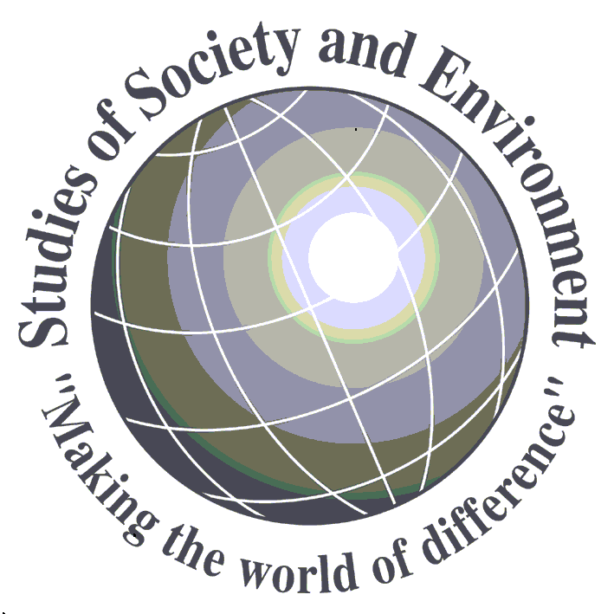  These processes and their utility for planning and assessing using outcomes are explained under the heading ‘Social and environmental inquiries’ in the Outcomes section. | Concepts  The learning outcomes for the Studies of Society and Environment key learning area are organised into strands. Each of these strands makes an equivalent contribution to this key learning area. There are four strands. Each strand develops five key concepts:  Time, Continuity and Change  1. evidence over time  2. changes and continuities  3. people and contributions  4. causes and effects  5. heritages  Place and Space  1. human–environment relationships  2. processes and environments  3. stewardship  4. spatial patterns  5. significance of place  Culture and Identity  1. cultural diversity  2. cultural perceptions  3. belonging  4. cultural change  5. constructions of identity  Systems, Resources and Power  1. interactions between ecological and other systems  2. economy and business  3. participation in decision making  4. citizenship and government  5. access to power

