The Years 1 to 10 Mathematics Syllabus is designed to help teachers provide students with opportunities to develop Mathematical knowledge, procedures and strategies that will inform the way they approach relevant problems now and in the future. Mathematical knowledge includes knowing about mathematics, knowing how to do mathematics, and knowing when and where to use mathematics.
The elements of mathematical knowledge have been organised into strands in the syllabus. The topics within the strands are interconnected. The Strands and Topics are described below.

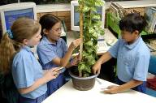

Number Strand
Number concepts — develops numeration and number sense, including the subsets of numbers within the set of rational numbers, the base ten system and the uses and purposes of money in our society.
Addition and subtraction — promotes the connections between these concepts, and develops understandings of number that support mental computation strategies and other computation methods.
Multiplication and division — promotes the connections between these concepts, and develops understandings of number that support mental computation strategies, fractional and proportional thinking and other computation methods.
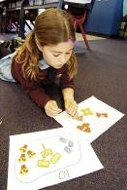
Patterns and Algebra Strand
Patterns and functions — develops understandings of consistent change and relationships.
Equivalence and equations — develops understandings of methods, symbol systems and language associated with balancing and solving equations.

Measurement Strand
Length, mass, area and volume — develops estimation and measurement strategies of these attributes and understandings of units of measurement and relationships between them.
Time — develops understandings of units and conventions associated with measuring and recording the passage and duration of time.
Chance and Data Strand
Chance — develops understandings of likelihood and the use of experimental and theoretical approaches to estimate or determine numerical probability to make judgments and decisions.
Data — develops understandings related to collecting and handling data, exploring and displaying data, and identifying and interpreting variation.

Space Strand
Shape and line — promotes understandings of the geometric terms and properties used to identify, visualise and create representations of 3D shapes and objects and 2D shapes.
Location, direction and movement — promotes understandings of the construction and interpretation of maps, grids and plans, and the identification and description of locations, directions and movements through familiar and other environments.

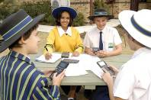

Thinking, reasoning and working mathematically
As students work within and across these strands and topics they develop the skills to think, reason and work mathematically.
Students think, reason and work mathematically when they:
- see the mathematics in situations encountered
- plan, investigate, conjecture, justify, think critically, generalise, communicate and reflect on mathematical understandings and procedures
- select and use relevant mathematical knowledge, procedures, strategies and technologies to analyse information.

