Writing music like a master
Year 4 | The Arts — Music
Students use the theme and third variation of the second movement of Haydn’s “Surprise” Symphony No. 94 as inspiration to create their own theme and variation and perform it for their peers.
Time allocation | Approximately 4 hours
Context for assessment
Theme and variations are composition techniques used by many master composers. Simple concepts can provide students with the opportunity to extend their understanding of musical form and composition and inspire creativity.
This assessment gathers evidence of learning for the following Essential Learnings:
The Arts Essential Learnings by the end of Year 5
Ways of working  Students are able to:  - select and develop ideas for arts works, considering different audiences and different purposes, using arts elements and languages  - rehearse and rework arts works, using interpretive and technical skills  - present arts works to informal and formal audiences, using arts techniques, skills and processes. | Knowledge and understanding  Music  Music involves singing, playing instruments, listening, moving, improvising and composing by selecting the music elements to express ideas, considering different audiences and different purposes, through sound.  - Duration, beat, time values and metre are used to create rhythmic patterns.  - Pitch and intervals are used to create the melodic arrangement of sound.  - Musical forms are used to structure music.  - Relative softness and loudness and articulation of sounds are used to change dynamic levels and expression of music.

Assessable elements
- Knowledge and understanding
- Creating
- Presenting
Source: Queensland Studies Authority 2007, The Arts Essential Learnings by the end of Year 5, QSA, Brisbane.

Listed here are suggested learning experiences for students before attempting this assessment.
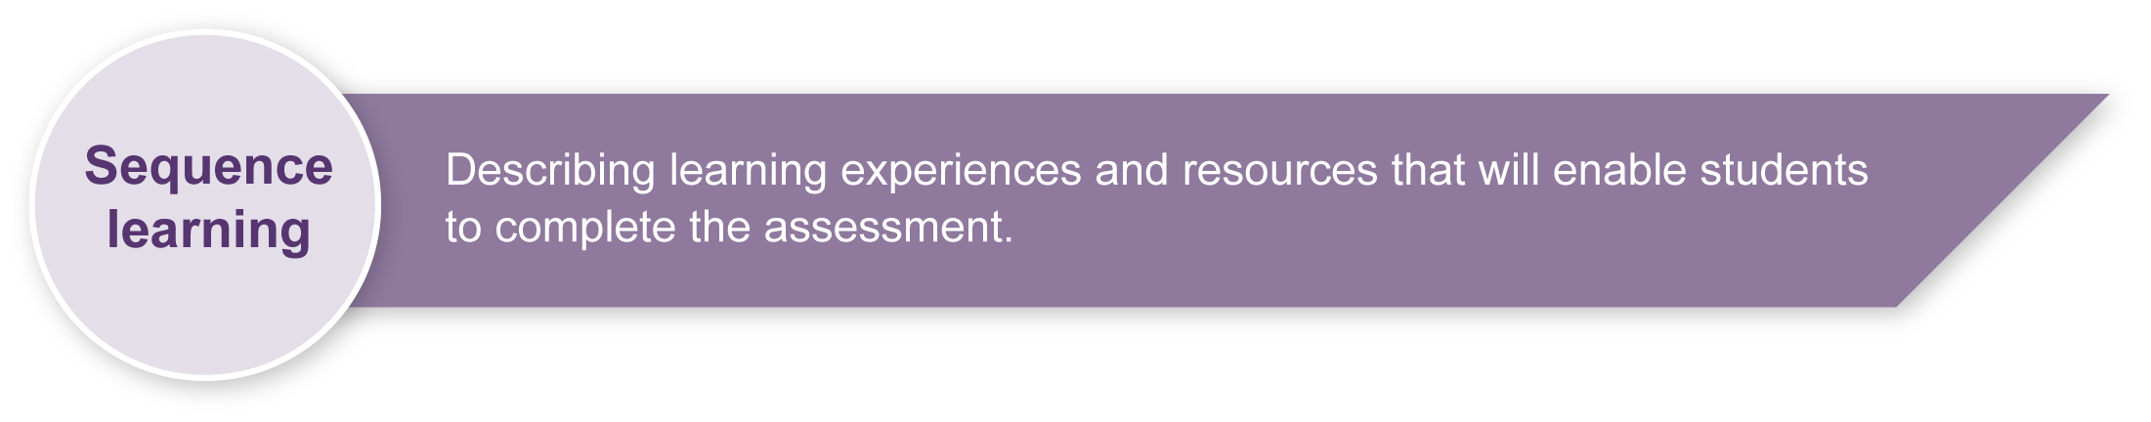
- Learn and practise using and writing rhythmic patterns appropriate for the student cohort.
- Practise identifying and writing simple rhythmic patterns in many contexts.
- Learn about rhythmic and melodic form.
- Look at and listen to other examples of theme and variations.
- Practise identifying the rhythmic and melodic form of many songs.
- Learn about theme and variations form.
- Practise using Haydn’s variation technique with known songs.
- Practise singing, playing and writing the do pentatonic scale.
- Practise reading, writing and performing rhythmic and melodic scores.
- Practise reading, writing and playing dynamics.
- Practise using tuned classroom instruments for melodic performance (e.g. xylophone; glockenspiel, recorder).

Teacher resources
Piano sheet music of Haydn’s theme: <http://gardenofpraise.com/key21bj.htm>.
Classics for kids: <www.classicsforkids.com/teachers/lessonplans/haydn/haydnK1.asp>.
This website includes:
- a pictorial listening map for Haydn’s “Surprise” theme
- a listening map with rhythms
- a map with dynamics
- information about Haydn
- an excellent recording of the second movement. For this assessment, students need to listen to the first half of the theme, which on this recording is from 00:00 – 00:34 seconds, and the third variation, which can be heard from 03:11 – 03:27.

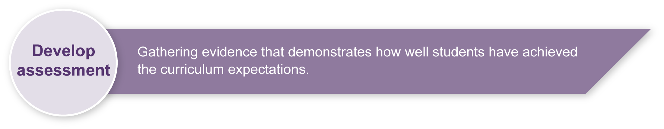
Preparing
Consider these points before implementing the assessment.
- Decide how students will perform their theme and variation.
- Make sure that your students are very familiar with the instruments you plan to use.

Implementation
Consider these points when implementing the assessment.
- It is suggested that this assessment be undertaken in small sections over a number of weeks.
- Some students may find performing solo particularly confronting. It may be appropriate to allow some students to perform in pairs or to allow students to perform in front of a small group of close friends, or for the teacher alone. It is important for the performance to be a positive experience that builds confidence.

Sample implementation plan
This table shows one way that this assessment can be implemented. It is a guide only — you may choose to use all, part, or none of the table. You may customise the table to suit your students and their school environment.
Suggested time |  | Student activity | Teacher role | Resources
Section 1. A master’s “surprise”
Haydn’s theme
10 minutes |  | Listen to the first part of Haydn’s “Surprise” theme.  Students identify how many phrases there are, how many times the same melody is repeated, and what is different on the repeat of the melody.  Students clap and move to the rhythm and hum the melody. | Guide student listening.  Encourage students to move to the rhythms of the theme and variation to help them feel how the rhythm changes. | Recording of the second movement of Haydn’s “Surprise” Symphony No.94 (see Teacher resources).
10 minutes |  | Students write the rhythm of the first 16 beats of the theme into the beat boxes provided. | Have the students first point to the beat boxes as they hum the rhythm, so they can decide how many sounds are heard on each beat.
5 minutes |  | Students identify the melodic form. | Guide student listening.
Haydn’s variation
5 minutes |  | Listen to the 3rd variation of Haydn’s theme.  Students clap and move to the new rhythm and hum the melody. | Guide student listening. | Recording of the second movement of Haydn’s “Surprise” Symphony No.94. (see Teacher resources).
10 minutes |  | Students write the rhythm of the first 16 beats of the variation into the beat boxes provided.  Students identify whether the melody has changed separately from the rhythmic change. | Have the students first point to the beat boxes as they hum the rhythm, so they can decide how many sounds are heard on each beat.
Section 2. My theme
5 minutes |  | Students write their own rhythmic theme using ta’s, ti-ti’s and za’s. | Guide student writing.
10 minutes |  | Students write their own melody using the do pentatonic scale. | Have the students sing the do pentatonic scale.  Remind students to use the same form as Haydn.
Section 3. My variation
10 minutes |  | Students write their own rhythmic variation using known rhythms. | Guide student writing.
5 minutes |  | Students add their melody to their varied rhythm. | Remind students that their melody should remain the same as the one they used for their theme (altered by rhythm only).
Section 4. Write your music like a master
30 minutes |  | As a class, write the first 2 bars of Haydn’s theme on the manuscript.  Students write their theme and variation on the manuscript provided. | Help the students to decide what time signature is required, and how many beats they will need to write per bar.
Section 5. Perform your theme and variation
30 minutes |  | Let students rehearse their theme and variation.  Have students practice for each other and provide constructive feedback. | Guide student rehearsal. | Instruments or voices.  Appendix A, Music word bank.
Dependant on class size |  | Students perform their theme and variation for their peers. | Teacher guides the performance order and ensure appropriate audience behaviour. | Instruments or voices.
 | Resources for the assessment
Appendix A Music word bank — This is a bank of safe words that students can use when giving peer feedback.
Appendix B Melody for Haydn’s “Surprise” theme and 3rd variation from Symphony No. 94, Movement 2.
During the learning process, you and your students should have developed a shared understanding of the curriculum expectations identified as part of the planning process.
After students have completed the assessment, identify, gather and interpret the information provided in student responses. Use only the evidence in student responses to make your judgment about the quality of the student learning. Refer to the following documents to assist you in making standards-referenced judgments:
- Guide to making judgments
- Indicative A response
- Sample responses (where available).

Making judgments about this assessment
This assessment assesses students through three task-specific assessable elements. Teachers may wish to judge these areas separately making an on balance judgment.
For further information, refer to the resource Using a Guide to making judgments, available in the Resources section of the Assessment Bank website.
Evaluate the information gathered from the assessment to inform teaching and learning strategies.
Involve students in the feedback process. Give students opportunities to ask follow-up questions and share their learning observations or experiences.
Focus feedback on the student’s personal progress. Emphasise continuous progress relative to their previous achievement and to the learning expectations — avoid comparing a student with their classmates.

Giving feedback about this assessment
- Have students listen to each others performances during the rehearsal phase and give each other feedback. Guide students on how to give positive and constructive feedback. See Appendix A, Music word bank, for safe word suggestions.
- Give students regular feedback about how they can enhance their performance.
For further information, refer to the resource Using feedback, available in the Resources section of the Assessment Bank website.

Music word bank
Teachers should be sensitive to issues that may arise as students respond to their own work and that of other students. It may be useful to develop a list of appropriate and safe words that can be used to describe peer performances. This will help increase students’ Arts vocabulary and allow them to show empathy toward others.
Brainstorm ideas with students and add to this list.
Safe words to help discuss music
Words for performance
fluent
interesting
exciting
clear
in time
rhythmic
in tune
accurate
musical
contrasting variation
uses dynamics
catchy
melodic

Melody for Haydn’s “Surprise” theme and 3rd variation from Symphony No. 94, Movement 2.

