The world game
Year 6 | Health & Physical Education (HPE)
Students will set personal skill development and activity goals, choosing and applying strategies to reach these goals. They help set, and carry out steps to achieve, class activity goals.
Time allocation | 6–8 weeks
Context for assessment
This assessment was written for football but can be used for any team game. The emphasis is on students taking control of their own improvement and level of activity. Improving individual skills and increasing their level of activity can enhance the participation experience for students and help individual students and the class reach activity goals. The movement concepts, skills and fitness required to play football and most recreational activities, sports and games can be used to attain and maintain health. This assessment highlights how improvement in skill can encourage active participation in team games and enhance a student’s capacity to achieve individual goals and contribute to achieving team goals.

Note: Throughout this assessment, “football” refers to “soccer”.
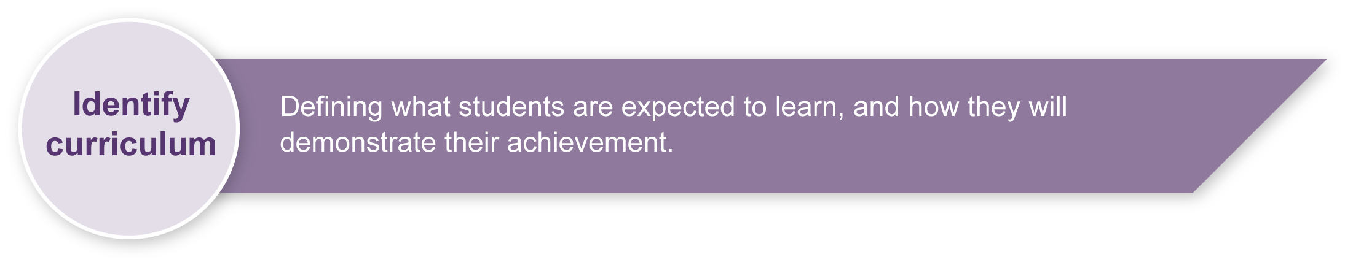
This assessment gathers evidence of learning for the following Essential Learnings:
HPE Essential Learnings by the end of Year 7
Ways of working  Students are able to:  - propose, justify, implement and monitor plans or actions to promote health and wellbeing, movement capacities and personal development  - apply movement concepts and make purposeful refinements to movement skills  - create and perform movement sequences through modifying and combining movement skills and applying movement concepts  - identify risks and justify and apply safe practices  - select and demonstrate appropriate personal development skills and strategies in team and group situations  - reflect on learning, apply new understandings and identify future applications. | Knowledge and understanding  Physical activity  Fundamental and specialised movement skills, movement concepts, tactics and strategies are elements of physical activity.  - Modifying techniques and selectively applying movement concepts can enhance physical performance and increase enjoyment in physical activities.  - Refining teamwork, tactics and strategies in a variety of contexts improves movement capacities, and physical performance, and enhances participation in physical activity.

Assessable elements
- Planning
- Implementing and applying
- Reflecting
Source: Queensland Studies Authority 2007, HPE Essential Learnings by the end of Year 7, QSA, Brisbane.

Listed here are suggested learning experiences for students before attempting this assessment.
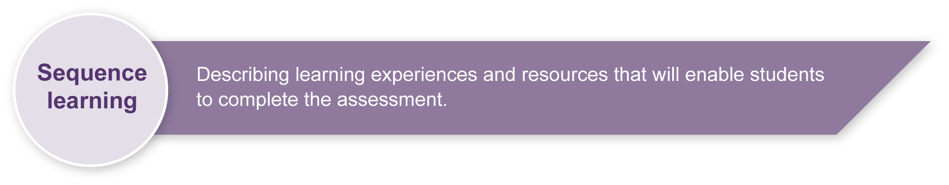
- Learn the skills and movement concepts involved in football.
- Research skill acquisition and development methods, including practice, visualisation and feedback.
- Learn how to set achievable and realistic activity goals for individuals and groups.
- Learn how skill and fitness levels have an impact on how actively one can be involved in and enjoy physical activities.
- Demonstrate and discuss how movement sequences can be created and performed through modifying and combining movement skills and applying movement concepts.
- Discuss risks and set rules for safe working practices (e.g. effective warm ups, wearing hats and sunscreen).
- Discuss specific safety issues (e.g. keeping tackles appropriate).
- Research actions and activities that can help improve fitness.
- Explore how individuals and groups can achieve activity goals.

Teacher resources
- Australian FourFourTwo: The ultimate football website is the online version of the football magazine with breaking news, interviews and features: <au.fourfourtwo.com/index.aspx>.
- Better Soccer Coaching offers coaching and fitness advice as well as free access to archived activities and drills: <www.bettersoccercoaching.com>.
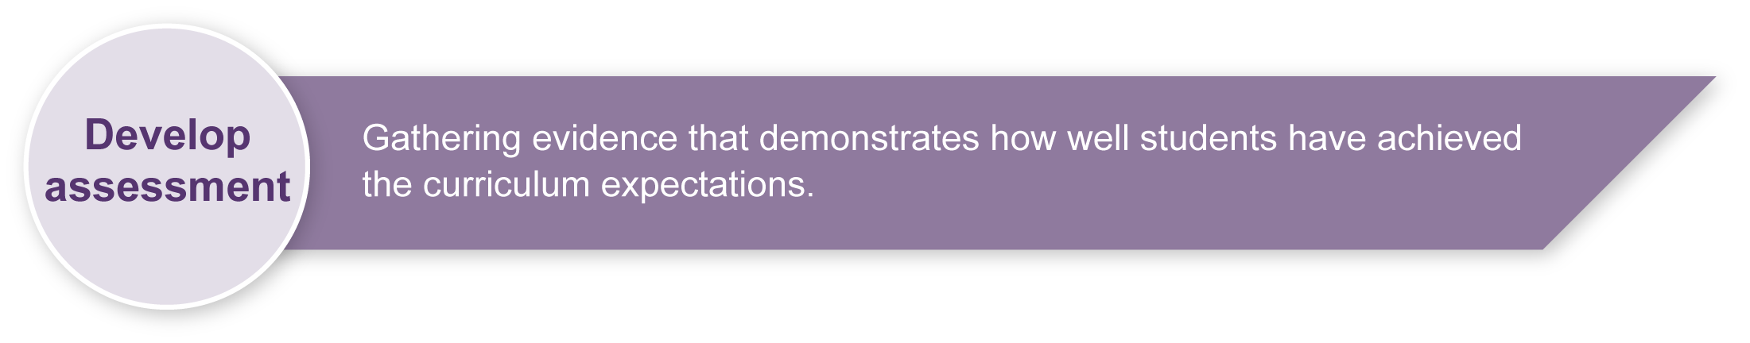

Preparing
Consider these points before implementing the assessment.
- This assessment puts knowledge into practice so that each student can gain the maximum health benefits from playing football.
- Students will need to have two or three football lessons before they can select a skill to improve. They then need to decide on strategies to improve their skills and increase active participation in games.
- Watch the students perform the skills during warm-ups and games.
- Write anecdotal notes on students’ progress in the lead-up to this assessment.
- Students who start the unit with highly developed skills should be encouraged to tutor those with less developed skills, to help everyone become more actively involved.

Resources for the assessment
Appendix A Skill development continuum
Appendix B Physical activity continuum
Appendix C Definitions for skill development continuum

Sample implementation plan
This table shows one way that this assessment can be implemented. It is a guide only — you may choose to use all, part or none of the table. You may customise the table to suit your students and their school environment.
Suggested time | Student activity | Teacher role
Section 1. Skill log
Week 1 | Select a skill to improve and set the goal for the level of improvement.  Design strategies to encourage more active involvement in games and to reach desired levels of improvement.  Rate current skill level on their personal continuum for the selected skill. | Guide students while they set goals and rate themselves.  Using Appendix A: Skill development continuum and Appendix C: Definitions for skill development continuum, rate students on the skill being improved.  Using Appendix B: Physical activity continuum, rate how actively students involve themselves in game play.  Help with strategy development.
Section 2. Physical activity log
Week 1 | Set the goal for active participation.  Design strategies to encourage more active involvement in games and to reach desired levels of improvement.  Students rate themselves on a personal continuum for level of active participation in football games. | Guide students while they set goals and rate themselves.  Help with strategy development.
Section 3. Group activity strategies
Every lesson | Set and apply strategies that foster more active involvement of the whole group.  Contribute to achieving class activity goals. | Help with skill development and physical activity strategies.  Guide the class while they pursue physical activity goals.
Section 4. Practical participation
Every lesson | Practise the skill to be improved in class and demonstrate how this enables more active participation in games of football.  Participate actively in games to achieve individual and group activity goals. | Guide the class while they pursue physical activity goals.
Section 5. Reflection
Last week of unit | Present a short written or oral reflection on what has been learnt. | Listen to oral responses.  Guide continuum plotting.

During the learning process, you and your students should have developed a shared understanding of the curriculum expectations identified as part of the planning process.
After students have completed the assessment, identify, gather and interpret the information provided in student responses. Use only the evidence in student responses to make your judgment about the quality of the student learning. Refer to the following documents to assist you in making standards-referenced judgments:
- Guide to making judgments
- Indicative A response
- Sample responses (where available).
For further information, refer to Using a Guide to making judgments, available in the Resources section of the Assessment Bank website.
Evaluate the information gathered from the assessment to guide teaching and learning strategies.
Involve students in the feedback process. Give students opportunities to ask follow-up questions and share their learning observations or experiences.
Focus feedback on the student’s personal progress. Emphasise continuous progress relative to their previous achievement and to the learning expectations — avoid comparing a student with their classmates.
For further information, refer to Using feedback, available in the Resources section of the Assessment Bank website.

Skill development continuum | Class

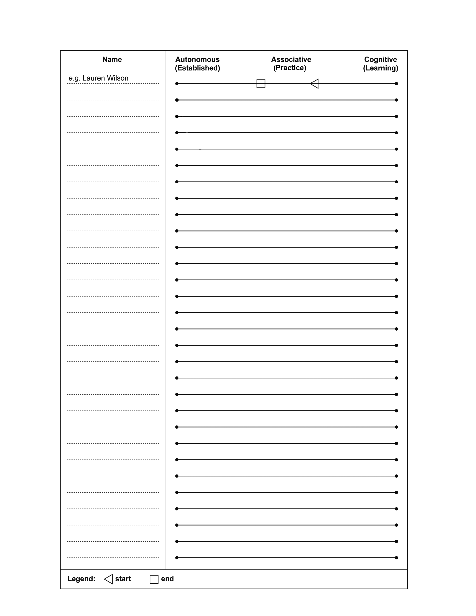

Physical activity continuum | Class

Definitions for skill development continuum
Cognitive (learning) stage
The cognitive stage involves the novice performer, who generally makes many errors that produce highly variable results. The athlete or performer needs to know what equipment is needed and forms a rough mental picture of the movement patterns required. They should be shown the correct technique for the motor skill so that they can recognise the individual actions required to complete the skill. This should be done by way of repeated demonstration by the coach, an experienced player or even by showing a video. Correct sequencing and timing of the actions will not happen immediately. Many errors will be made throughout this stage as learners become aware that they are making errors but cannot isolate the specific problems; feedback and simple instruction are required to help them make appropriate changes. However, the coach or teacher should provide only a limited amount of information and encourage clear thinking, preventing information overload and frustration.
The learner will spend a relatively short period of time in this stage of learning. Improvement is usually rapid, as all the learner is really trying to achieve is an understanding of the basic skill itself. Hours of practice will follow this understanding to refine the skill so that it can be effectively used within the competitive situation.
Associative (practice) stage
Once a performer grasps the mechanics of the skill and can execute that skill with few frequent errors, he or she has entered the associative stage of learning. Characteristics of this stage include minor errors and an emphasis on refining the skill rather than establishing new movement sequences.
The athlete or performer has a “feel” for the desirable actions and can make minor adjustments to their movement from their own feedback. The coach should continue to use demonstrations to help modify the skill and can use increasingly more specific feedback to achieve improvement. They should “open the skill up” during this stage of learning so that the skills are practised in a more game-like setting. In this way, the player can learn to modify the basic skill to fit differing match requirements. Improvement during this stage is gradual, but practising of the correct movement patterns is essential for performers at this stage in order to advance to the third and final stage.
Autonomous (established) stage
An athlete or performer at the autonomous stage consistently achieves the desired result without consciously thinking about the separate subroutines of skill production. Their movement responses are automatic and they pay more attention to improving specific components of the actions, as well as thinking about when to use a particular skill within the game situation.
Skill improvement is still important, but the focus is also on factors such as shot selection, tactics and responses to competitive situations. It is practice in the competitive situation that is crucial in this stage of learning. The individual performer is able to identify problems and adjust appropriately, whether during practice or in a competitive situation. Athletes who reach this stage usually remain in it, although they never stop learning. As new tactics and styles of play are devised, the autonomic performer must continuously refine his or her motor program to match the new conditions of play.

