Volleyball
Year 9 | Health & Physical Education (HPE)
Students participate in volleyball, applying specialised movements, tactics and teamwork. They write a reflective report evaluating their own performance.
Time allocation | 140–280 minutes over a number of sessions.
Student roles | Students work:  - cooperatively in game play  - individually on their reflective report.
Context for assessment
Volleyball allows students to develop specialised movements, tactical thinking and teamwork which they can use to support their participation in a range of court games. This assessment is designed to fit into a unit where students are provided with multiple opportunities to work collaboratively to develop and demonstrate their skills, and individually, to reflect on their performance. The assessment can be easily modified to accompany other games units.
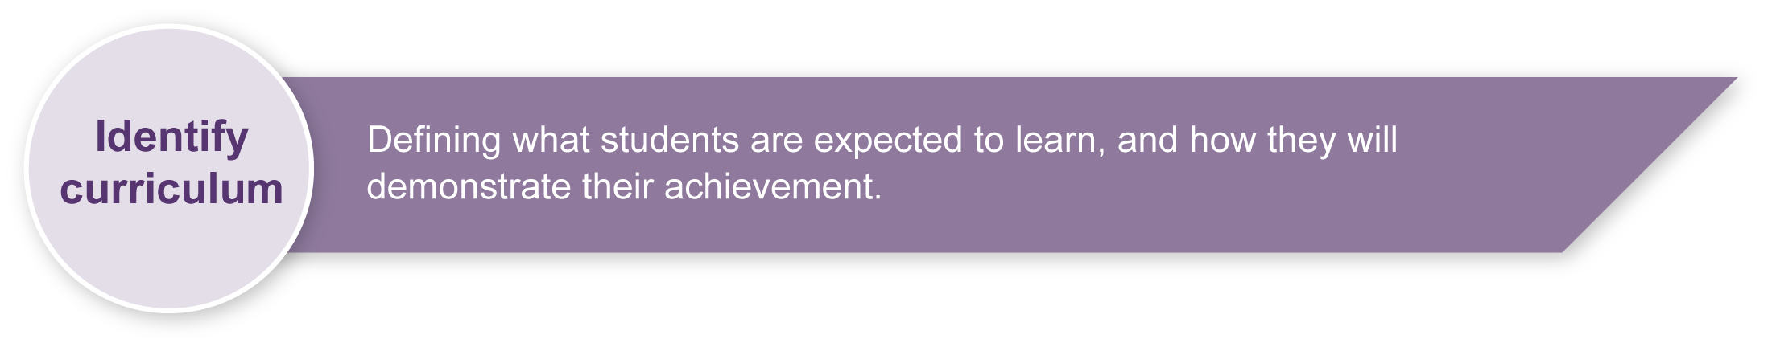
This assessment gathers evidence of learning for the following Essential Learnings:
HPE Essential Learnings by the end of Year 9
Ways of working  Students are able to:  - refine movement skills and apply movement concepts, and the principles of training  - create and perform movement sequences by manipulating and combining movement skills and applying movement concepts  - identify risks and devise and apply safe practices  - select and apply positive, respectful and inclusive personal development skills and strategies  - reflect on learning, apply new understandings and justify future applications. | Knowledge and understanding  Physical activity  Regular active and purposeful participation in physical activity promotes health and wellbeing, and supports the achievement of goals.  - Developing and refining specialised movements skills through applying movement concepts supports improved physical performance and participation in physical activities.  - Developing teamwork, tactical knowledge and strategic thinking supports and enhances physical performance and participation in physical activities.

Assessable elements
- Knowledge and understanding
- Implementing and applying
- Reflecting
Source: Queensland Studies Authority 2007, HPE Essential Learnings by the end of Year 9, QSA, Brisbane.

Listed here are suggested learning experiences for students before attempting this assessment.
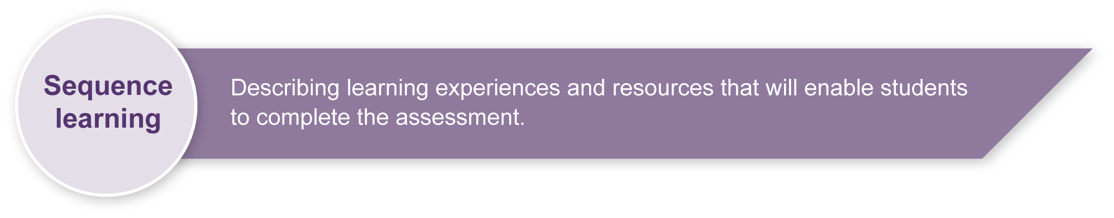
- View demonstrations of advanced game play and practices to identify the specialised skills, tactics and teamwork used in volleyball.
- In groups, discuss actions that individuals can take to support their own and others’ participation in volleyball.
- Practise the specialised movement skills and tactics of volleyball in small-group drills and modified games (2v2, 3v3) using preferred balls (soft, foam or practice).
- Demonstrate and discuss how movement sequences can be created and performed through modifying and combining movement skills and applying movement concepts.
- Discuss risks and set rules for safe working practices such as effective warm ups and wearing hats and sunscreen.
- Discuss specific safety issues (e.g. not kicking the ball near others).
- Allow volleyball game play with modifications (e.g. lower net, serving from within court, use of practice ball).
- Listen to or read volleyball rules and etiquette.
- Reflect on and analyse own participation and performance, making use of a physical activity reflective learning journal, or game analysis software and criteria (or both).
- Create a reflective report (written, oral).

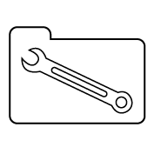 | Teacher resources
- Volleyball World Wide has information on playing volleyball and mastering volleyball skills: <volleyball.org/playing/index.html>.
- Federation Internationale De Volleyball has information on teaching basic individual techniques: <www.fivb.org/EN/Programmes/educational/moves.asp>.
- Federation Internationale De Volleyball has information on how to dig, set and spike: <www.fivb.org/TheGame/TheGame_Volleyballl.htm>.
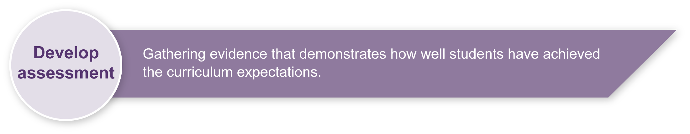
Preparing
Consider these points before implementing the assessment.
- Inform students that practical assessment will be conducted over a number of sessions.
- Discuss with students the value of reflecting on their performance and of keeping a physical activity reflective learning journal. See Appendix A, Physical activity reflective learning journal, for guidelines.
- At the end of each lesson, students will reflect on their learning in their journal. Students will need to have their journals at hand during each lesson.
- Decide how much class time you will allocate to games skill acquisition, reflective learning journal writing and ongoing assessment of practical performance.
- Set a due date for the reflective report.

Implementation
Consider these points when implementing the assessment.

Section 1. Practical performance
- All students should be provided with the opportunity to experience success and enjoy participation in physical activity sessions. Modifications, such as lowering the net, use of practice balls rather than match balls, and the option of serving the ball from within the court will help support participation.
- For judgments to be valid, it is essential that students be provided with multiple opportunities to demonstrate their skill. An ongoing record of judgments in the form of a skills checklist is an excellent way to track individual performances. See Appendix B, Volleyball skills checklist.
- While it may be advantageous for students to prepare for tactical play by working in ability groups, care needs to be taken to ensure no student is disadvantaged by the skill level of their peers. It may be necessary to make changes to teams so that all students have the opportunity to demonstrate what they can do.
- Remind students and give them time to complete their reflective journal entries.

Section 2. Reflective report
- The reflective report provides an opportunity to collect further information about student understanding of the specialised skills, tactics and teamwork of volleyball, and of the actions that they can take to support their own and others’ participation in physical activity.
- Before writing their report, encourage students to review entries in their reflective learning journal.
- If available, video material or game analysis software could be used to assist students to reflect on their performance.

Resources for the assessment

Documents
Appendix A Physical activity reflective learning journal
Appendix B Volleyball skills checklist

Physical resources
volleyball court area — indoor or outdoor
volleyball net and posts — adjustable
volleyball — soft, foam or practice
video footage of game play (optional)

During the learning process, you and your students should have developed a shared understanding of the curriculum expectations identified as part of the planning process.
After students have completed the assessment, identify, gather and interpret the information provided in student responses. Use only the evidence in student responses to make your judgment about the quality of the student learning. Refer to the following documents to assist you in making standards-referenced judgments:
- Guide to making judgments
- Indicative A response
- Sample responses (where available).

Making judgments about this assessment
Base judgments about student practical performance on information collected across multiple sessions.
For further information, refer to the resource Using a Guide to making judgments, available in the Resources section of the Assessment Bank website.
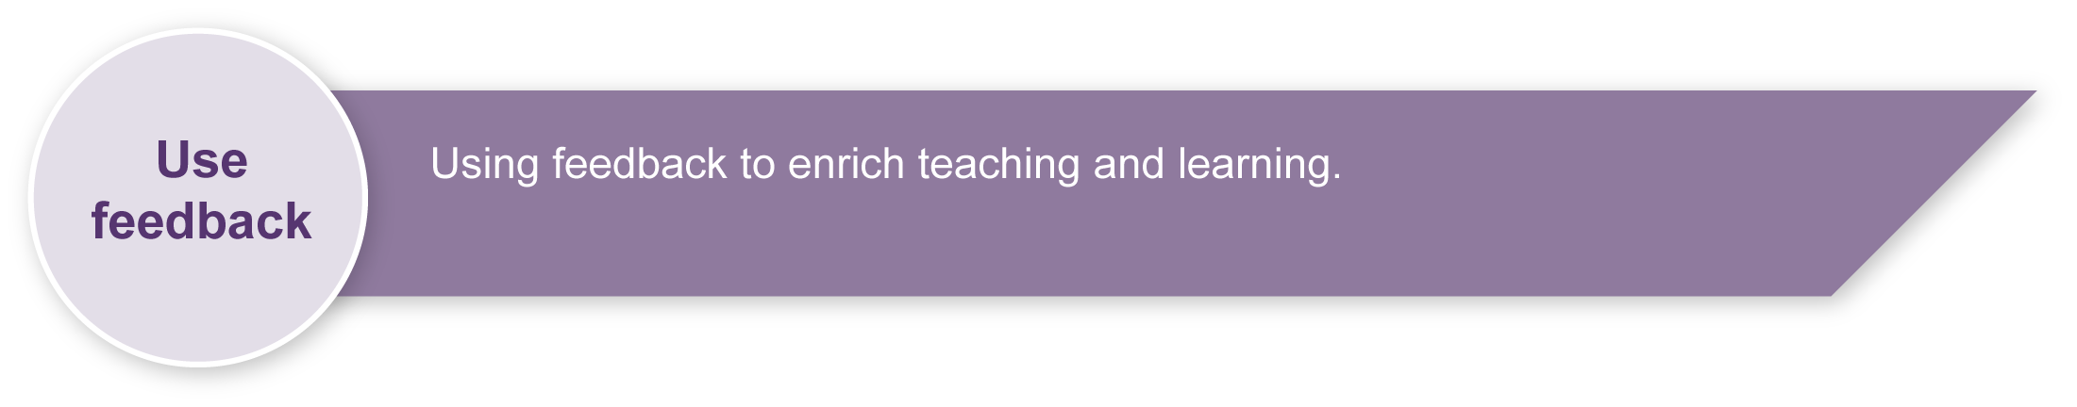
Evaluate the information gathered from the assessment to inform teaching and learning strategies.
Involve students in the feedback process. Give students opportunities to ask follow-up questions and share their learning observations or experiences.
Focus feedback on the student’s personal progress. Emphasise continuous progress relative to their previous achievement and to the learning expectations — avoid comparing a student with their classmates.
For further information, refer to the resource Using feedback, available in the Resources section of the Assessment Bank website.

Physical activity reflective learning journal

What is reflective learning?
Reflection is an approach to thinking. Reflective learning is the purposeful thinking about what has been learned with a view to further improving learning.

What is a reflective learning journal?
A reflective learning journal is an individual’s record of their reflective thoughts, including the meanings they make from engaging in learning experiences. Journals are unique to the individual.

What is a physical activity reflective learning journal?
A physical activity reflective learning journal is an individual’s record of their reflective thoughts, including the meanings they made from engaging in games, sports and other physical activity-related learning experiences.

How will keeping a physical activity reflective learning journal help you?
A physical activity reflective learning journal will help you develop the reflective thinking and learning skills required to improve your performance and participation in physical activity. It will help you think introspectively, be more aware of your strengths and weaknesses, more self-critical and open to feedback, and will motivate you to improve your performance.

How often should you write in the journal?
Reflect on what you have learned in each physical activity lesson.
It is best to record your reflections while they are fresh in your mind. If possible, write your reflections on the day of the lesson so that your thoughts do not become lost or distorted. You may be provided with some class time to do this or you may be expected to do it in your own time.

What does a reflective learning record contain?
Each record in your reflective learning journal should contain your thinking in two parts:
- an objective part — statements of fact about what you actually did and what you learned
- a subjective part — statements about what you think, feel and conclude about aspects of your performance, and what you need to do to improve aspects of your performance.
Use the questions in the table overleaf to help you think reflectively and write journal records.

Guide to thinking reflectively
Reflective thinking | Probing deeper | Sentence starters
Reflect objectively (i.e. record the facts)
Focus question: What was the focus of learning and what did you do to apply this learning?
What was the focus of learning in the lesson? | What specific movement skills, tactics or teamwork were of major and minor focus? | Today the lesson focused mostly on how to …
What concepts or facts did you learn? | What specific technique tips, tactics or rules did you learn? | One thing I learned about performing the … was …  I also learned that …
How did you try to apply what you learned?  What were your personal learning goals for this lesson? | What specific movement skills, tactics and teamwork did you focus on in order to improve your performance and participation? | My aim today in game play was to …  In relation to teamwork, I tried to …
Reflect subjectively (i.e. record your opinion)
Focus question: How do you think you went? What do you need to do to improve?
How well did you apply your learning and achieve your learning goals? | How well did you apply the selected movement skills, tactics and teamwork in drills and games? | I think that I was quite successful at … because …
 | What do you think you did well? Not so well? Badly? | I had difficulty with …
 | Why did something go well, not so well or badly? | I say this because …
 | What do you believe helped or hindered your learning and performance today? (e.g. Feedback from your teacher or team? The net height?) | I think …helped / hindered …
What can you do next lesson to improve your learning and its application? | What do you think you need to do next lesson to further improve your learning, performance and participation in this physical activity? | Next lesson, I need to concentrate on …  The benefits of this will be …

Example of a Volleyball reflective learning journal entry

Date: 15 March 2008
Reflect objectively — What was the focus of learning and what did you do to apply this learning?
The lesson focused on how to do the forearm pass and the set. I learned how to get a stable base with my feet, how to keep my butt down and make my arms into a “platform” and “shrug my shoulders” to do the forearm pass. I also learned not to move my arms higher than my shoulders.
I learned that the forearm pass is for balls that are falling in front of the body. I learned that the set is for balls above the face. I learned how to form a triangle with my thumbs and fingers, and to push the ball up off the pads of my fingers.
My aim today was to concentrate on getting my hands and arms in position to do the right pass. I also wanted to make sure that everyone in my team got a fair turn with the ball.

Reflect subjectively — How do you think you went? What do you need to do to improve?
I think I was fairly successful at returning the ball in most of the drills because I knew what sort of toss was coming and my arms were already in position.
I didn’t do so well when the tosser mixed it up or when we played the mini game because I was slow at reading what the ball was going to be, so my hands and arms did not get into position quick enough to return the ball with control.
I also think everyone in my team was happy because we shared the ball around.
Next lesson, I need to keep concentrating on watching the ball so I can read it earlier and get my hands and arms in position more quickly.

Volleyball reflective learning journal
Date:
Reflect objectively — What was the focus of learning and what did you do to apply this learning?

Reflect subjectively — How do you think you went? What do you need to do to improve?

Volleyball skills checklist
Name | Specialised movements  and tactics |  |  |  |  |  | Teamwork |  |  |  |  | Comments
 | Serve | Set | Forearm pass | Blocking / defensive play | Spiking / attacking play | Shot decisions | Calling the ball | Rotating | Initiating play | Support play / backing up | Praise / encouragement

