The great tuckshop challenge
Year 3 | Health & Physical Education (HPE)  English
Students carry out an investigation into lunches and identify healthy foods using “Smart Choices”. They then plan a healthy lunch and write one recipe for their school tuckshop.
Time allocation | 2–3 hours
Context for assessment
Students who explore Health and Physical Education concepts develop a broad understanding of nutrition, body type, lifestyle and wellbeing. They can learn how to make healthy choices by identifying which foods are high in fat or sugar, and which foods make up a balanced diet.
This assessment is coupled with English to provide students with an opportunity to extend their interpreting skills and develop their vocabulary as they work with texts and explore how language choices match their purpose and audience.

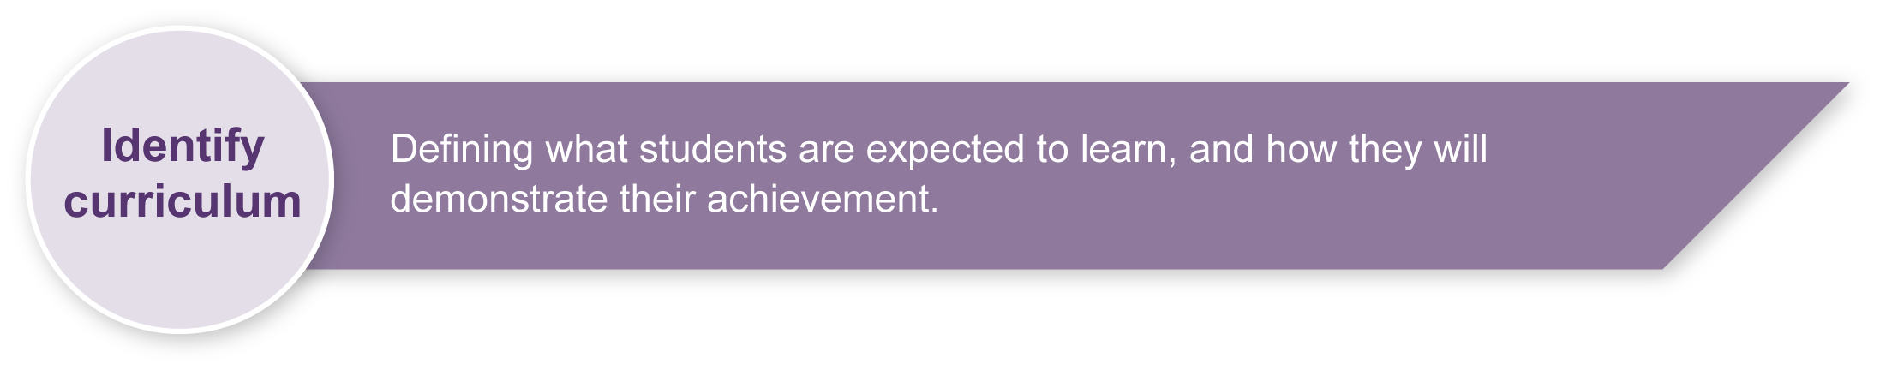
This assessment gathers evidence of learning for the following Essential Learnings:
HPE Essential Learnings by the end of Year 3
Ways of working  Students are able to:  - identify and collect information and evidence  - draw conclusions and make decisions. | Knowledge and understanding  Health  Health is multidimensional and influenced by everyday actions and environments.  - A selection of foods from the five food groups is necessary to support growth, energy needs, physical activity and health and wellbeing.

Assessable elements
- Knowledge and understanding
- Investigating
Source: Queensland Studies Authority 2007, HPE Essential Learnings by the end of Year 3, QSA, Brisbane.
This assessment also gathers evidence of learning for the following Essential Learnings:
English Essential Learnings by the end of Year 3
Ways of working  Students are able to:  - identify audience, purpose and text type  - recognise and select vocabulary to describe subject matter  - construct simple literary and non-literary texts by planning and by using prior knowledge and experience to match an audience and purpose. | Knowledge and understanding  Writing and designing  Writing and designing involve using language elements to construct literary and non-literary texts for familiar contexts.  - The purpose of writing and designing includes reporting and conveying simple messages and information.  - Text users make choices about grammar and punctuation.  - Common spelling patterns of monosyllabic words, two-syllable words and high-frequency words, are used to spell familiar and unfamiliar words.  - Writers and designers refer to authoritative sources and use a number of active writing strategies, including planning, drafting, revising, editing, proofreading, publishing and reflecting.  - Writers and designers use correct formation, entries, exits and joins of Queensland Modern Cursive script.  Language elements  Interpreting and constructing texts involve exploring and using grammar, punctuation, vocabulary, audio and visual elements, in print-based, electronic and face-to-face modes (speaking and listening, reading and viewing, writing and designing) in familiar contexts.  - Statements provide information; questions seek information; commands give orders; and exclamations emphasise or express emotions.  - Text connectives are used to link and sequence things, ideas and events.  - Auditory, spoken, visual and nonverbal elements provide details necessary for making meaning about the representations of people, places and things.  Literary and non-literary texts  Exploring literary and non-literary texts involves developing an awareness of purpose, audience, subject matter and text structure.  - Texts are produced for particular audiences and their interests.

Assessable elements
- Knowledge and understanding
- Constructing texts
Source: Queensland Studies Authority 2007, English Essential Learnings by the end of Year 3, QSA, Brisbane.
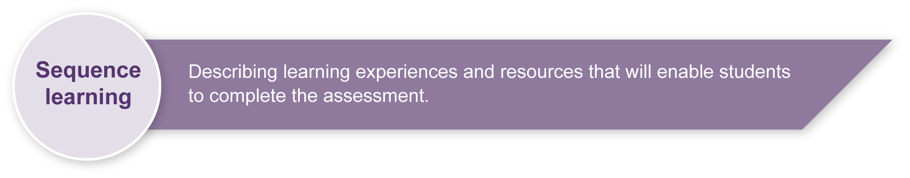
Listed here are suggested learning experiences for students before attempting this assessment.
- Classify foods according to their nutritional benefit using “Smart Choices” policy materials, including the three food categories.
- Invite a guest speaker who has been preparing healthy foods to talk about food and demonstrate how to follow a recipe (e.g. tuckshop staff or parent).
- Explore healthy choices, and alternatives to unhealthy foods.
- Compare “Smart Choices” with foods from the five food groups. Useful resources are listed in the Teacher resources.
- Explore food labels and sort according to information provided (e.g. amount of sugar or sodium).
- Practise collecting, organising and sorting data (e.g. carry out simple surveys).
- Compare the intended audience and purpose for different text types (e.g. diary writing compared with report writing) and establish an understanding of the purpose and audience for a recipe.
- Discuss who reads recipes and why they are written or recorded. Ask students to bring in copies of their favourite recipes.
- Identify language elements appropriate for recipes (e.g. text connectives, adverbs and action verbs).
- Analyse the importance of diagrams and layout (visual representations) in recipes.
- Develop a word wall of words used in recipes.
- Explore how to write recipes and identify features of recipes (e.g. how to write instructions, layout, list of ingredients).
- Practise spelling strategies and discuss the importance of using standard spelling in published work.

Teacher resources
- The Queensland government has a number of sites with useful healthy eating resources.
- “Healthy food and drink supply strategy for Queensland schools” is a PDF booklet that contains posters of the five basics food groups and examples of green, orange (amber) and red foods and drinks:
<http://education.qld.gov.au/schools/healthy/food-drink-strategy.html>.
- The Smart Choices Tool Kit is a user-friendly tool to assist schools to plan, promote, manage, implement and review “Smart Choices” in their school: <http://education.qld.gov.au/schools/healthy/food-drink-toolkit.html>.
- Eat Well Be Active is a campaign run by Queensland Health: <www.communities.qld.gov.au/family/eatwell/#active>.

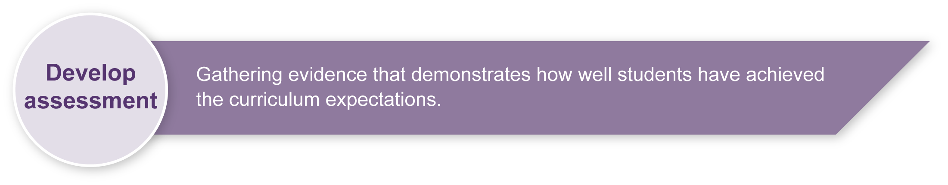
Preparing
Students' understanding of health is shaped by their experiences at home.
Investigating food and nutrition will broaden their understanding of food choices, and lay the foundation for a healthy and active lifestyle.
By exploring other views and perspectives, such as those presented in “Smart Choices” compared to those of their peers, an authentic environment is created to discuss both recipes and healthy foods.
When discussing foods it is important that all perspectives be seen as “right”. It is an opportunity to invite discussion — not judgment.

Implementation
- Display food group posters and healthy recipes in the classroom.
- It may be easier to set up a student/adult panel to conduct interviews rather than have the students work individually.
- Once all recipes are complete, a recipe booklet could be created and presented to the tuckshop. Alternatively, a recipe booklet of lunch ideas could be created and sent home.
- Students could be put into pairs to create recipes, but additional time will be needed.
- You may give students the option to create their recipes using Information and Communication Technologies (ICT).

Sample implementation plan
This table shows one way that this assessment can be implemented. It is a guide only — you may choose to use all, part, or none of the table. You may customise the table to suit your students and their school environment.
Suggested time | Student activity | Teacher role
Section 1. Investigate lunches
10–15 minutes | Review assessment with teacher guidance. | Introduce the assessment.
30–45 minutes | Discuss the concepts of healthy foods and habits.  Carry out an investigation into favourite lunches.  Record the information in the table in Section 1 of the Student booklet.  Sort lunches into “Smart Choices” categories. | Guide discussion about healthy foods and habits and their benefits.  Assist the students in deciding which three adults to interview (e.g. parents or volunteers).  Guide students as they record and sort their information.
Section 2. Making smart choices
30–45 minutes | Identify five green foods that could be substituted for orange or red foods for a healthier lunch. | Assist students as they identify green alternatives for orange and red foods.
Section 3. Write a recipe
30–45 minutes | Select or create a recipe for the tuckshop and write the recipe following the guidelines in the Student booklet.  Illustrations and visuals can be sourced from various materials and/or traced; cut and pasted or drawn. | It would be useful to have a selection of recipes available to aid students.  Assist students in choosing a recipe.
During the learning process, you and your students should have developed a shared understanding of the curriculum expectations identified as part of the planning process.
After students have completed the assessment, identify, gather and interpret the information provided in student responses. Use only the evidence in student responses to make your judgment about the quality of the student learning. Refer to the following documents to assist you in making standards-referenced judgments:
- Guide to making judgments
- Indicative A response
- Sample responses (where available).

Making judgments about this assessment
The English Essential Learning related to handwriting under Writing and designing has not been included in the Guide to making judgments. Inclusion of this Essential Learning is at the teacher’s discretion, as teachers may decide to use an ICT focus for recipe development.
Artistic ability is not being assessed, but illustrations/visuals should match the text.
For further information, refer to the resource Using a Guide to making judgments, available in the Resources section of the Assessment Bank website.

Evaluate the information gathered from the assessment to inform teaching and learning strategies.
Involve students in the feedback process. Give students opportunities to ask follow-up questions and share their learning observations or experiences.
Focus feedback on the student’s personal progress. Emphasise continuous progress relative to their previous achievement and to the learning expectations — avoid comparing a student with their classmates.

Giving feedback about this assessment
Engage students in conversation about their learning. Provide feedback that will assist them in self-assessment, which includes identifying knowledge and understanding and how there can be applied in the future.

For further information, refer to the resource Using feedback, available in the Resources section of the Assessment Bank website.

