Travelling and balancing
Year 2 | Health & Physical Education (HPE)
Students explore ways of travelling and balancing by varying their bases of support and use of space. They undertake movements that require simple combinations of the travelling and balancing skills.
Student roles | Individual.
Context for assessment
This assessment focuses on the development of locomotor and non-locomotor skills. Locomotor skills are used to propel an individual through space, such as running, skipping and hopping. Non-locomotor skills involve minimal movement on a base of support, such as twisting, turning and swaying. The assessment requires students to demonstrate control of their movements while travelling and balancing. Control is achieved through good posture, which includes positioning the centre of gravity over the base of support and managing muscular contractions and muscular relaxation, such as keeping muscles contracted when coming out of balances or softening the knees when landing.

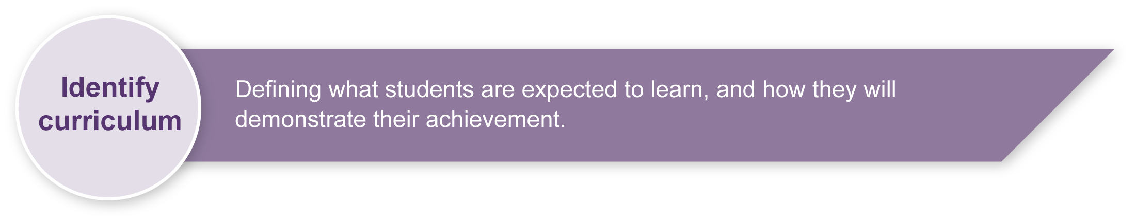
This assessment gathers evidence of learning for the following Essential Learnings:
HPE Essential Learnings by the end of Year 3
Ways of working  Students are able to:  - apply fundamental movement skills when participating in physical activities  - create and sequence simple movement patterns in response to stimuli  - follow guidelines to apply safe practices  - reflect on learning to identify new understandings. | Knowledge and understanding  Physical activity  Fundamental movement skills are foundations of physical activity.  - Development of body and spatial awareness improves movement and confidence in a variety of physical activities.  - Development of locomotor and non-locomotor movements and manipulative skills can improve the quality of physical performance and support participation in physical activities.

Assessable elements
- Knowledge and understanding
- Implementing and applying
- Reflecting
Source: Queensland Studies Authority 2007, HPE Essential Learnings by the end of Year 3, QSA, Brisbane.

Listed here are suggested learning experiences for students before attempting this assessment.
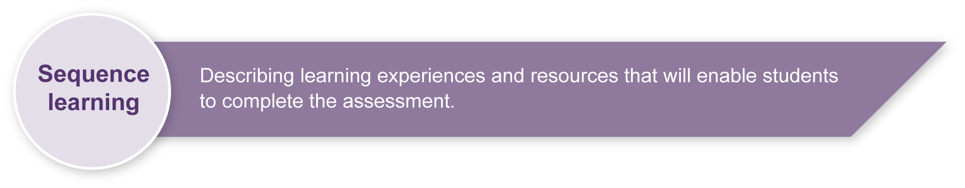
- Discuss different ways in which people travel and balance in their daily lives and in specific physical activities.
- Discuss possible hazards when travelling and balancing with others in a defined general space. See Appendix A: Safety considerations.
- In groups, discuss behaviours and rules that enable all participants to travel and balance safely in a defined area. With teacher guidance and input, students negotiate and propose appropriate rules and behaviours for travelling and balancing activities.
- Respond to activities that require them to combine travelling and balancing skills they have learnt.
- Plan and practise travelling and balancing sequences.
- Discuss the different ways they have learnt to travel and balance.
- Discuss how they have learnt to travel and balance safely.
Travelling (locomotor)
- Student find their own “personal space” within a defined general space. They walk and explore the general space to find all the empty spaces. On a signal from the teacher (e.g. a clap of the hands), students stand still in their new personal space, then explore their personal space by reaching up high, down low and all around them while making sure they do not touch anyone.
- Repeat the previous activity, jumping into the air on an identified signal and landing in their personal spaces demonstrating safe landing techniques. Students hold their landing positions as a balance.
- Explore different ways of travelling using their feet as a base of support. Students walk around the defined area at a steady pace. On a designated signal (e.g. a clap of the hands), students change the way they travel but continue to use their feet as their base of support (e.g. running, hopping, galloping, skipping). After some time for exploration, students demonstrate to a partner their favourite way of travelling on their feet and then move as a pair in follow-the-leader style. Each pair then combines three ways of travelling on their feet to create a “foot” dance.
Example: follow-the-leader. | 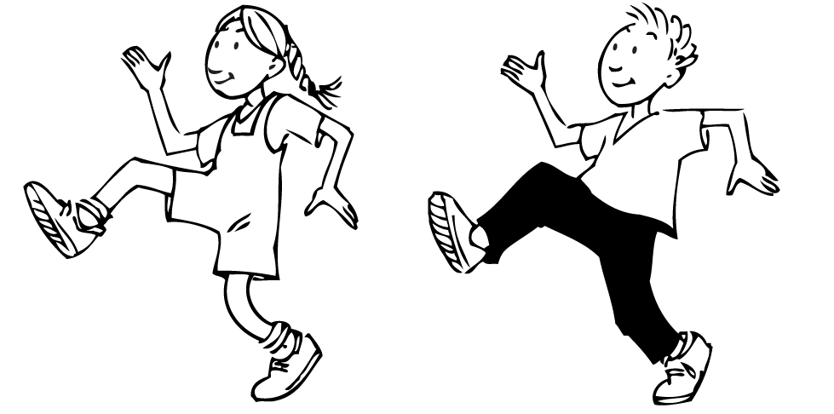

- Consider safety issues relevant to travelling on bases of support other than feet (e.g. hands and feet, bottom, stomach, one foot). Discuss ways to promote the safety of themselves or others when participating in activities that involve travelling on different bases of support (e.g. only travel in ways that allow them to move with control).
- Explore moving in the same manner as animals suggested by the teacher (e.g. kangaroo, monkey, crab). Appendix B: Animal walks gives some examples. Students demonstrate their favourite animal walk to a partner and after trying each other’s suggestions negotiate which animal walk they will do as a pair.
- In groups of five or six, students stand in single-file formation. The leader of each group is given an action card indicating a way of travelling. The leader moves in the manner identified on the card and the group follows in single-file formation. Students take turns at being the leader with each leader given a new card.
- Create an alien walk. Students imagine they are from an alien land and create an imaginative way of walking in which they maintain contact with a partner (e.g. holding hands, hands on shoulders).
- Discuss the terms “direction” and “pathway” and identify their meaning in a movement context. Students consider safety issues relevant to travelling in different directions and pathways and suggest ways to promote the safety of themselves and others when travelling in different directions (e.g. look over your shoulder when moving backwards).
- Move in a defined space and on an identified signal change their direction as nominated by the teacher (e.g. forwards, backwards, sideways).
- March to the teacher’s eight-beat count and then change direction. With a partner, create a marching sequence in which they change direction twice.
- Walk along different pathways marked with chalk or tape on the ground, then play follow-the-leader and explore travelling along the pathways in different ways (e.g. running, skipping, hopping).
Example: different pathways. | 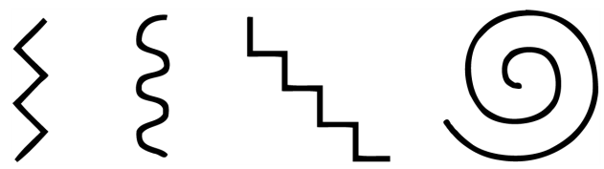
Balancing (non-locomotor)
- Discuss safety considerations relevant to balancing on different body parts (e.g. do not balance on your head or on two hands only). See Appendix A: Safety considerations.
- Move in a defined space and on an identified signal, students “freeze” in their own personal space. The teacher calls out the name of a body part/s and students balance on these parts.
- Practise a balance on an identified body part/s (e.g. students are given a card that identifies body parts using words, pictures or symbols). See Appendix C: Puzzle balances.
- Balance on four different body parts (not the head). Students then slowly lift one body part off the ground to change to a balance on three body parts, then two body parts and finally one. They hold the balances in the sequence for five seconds.
- Practise balances as individuals and in pairs that represent letters of the alphabet or numerals.
Example:
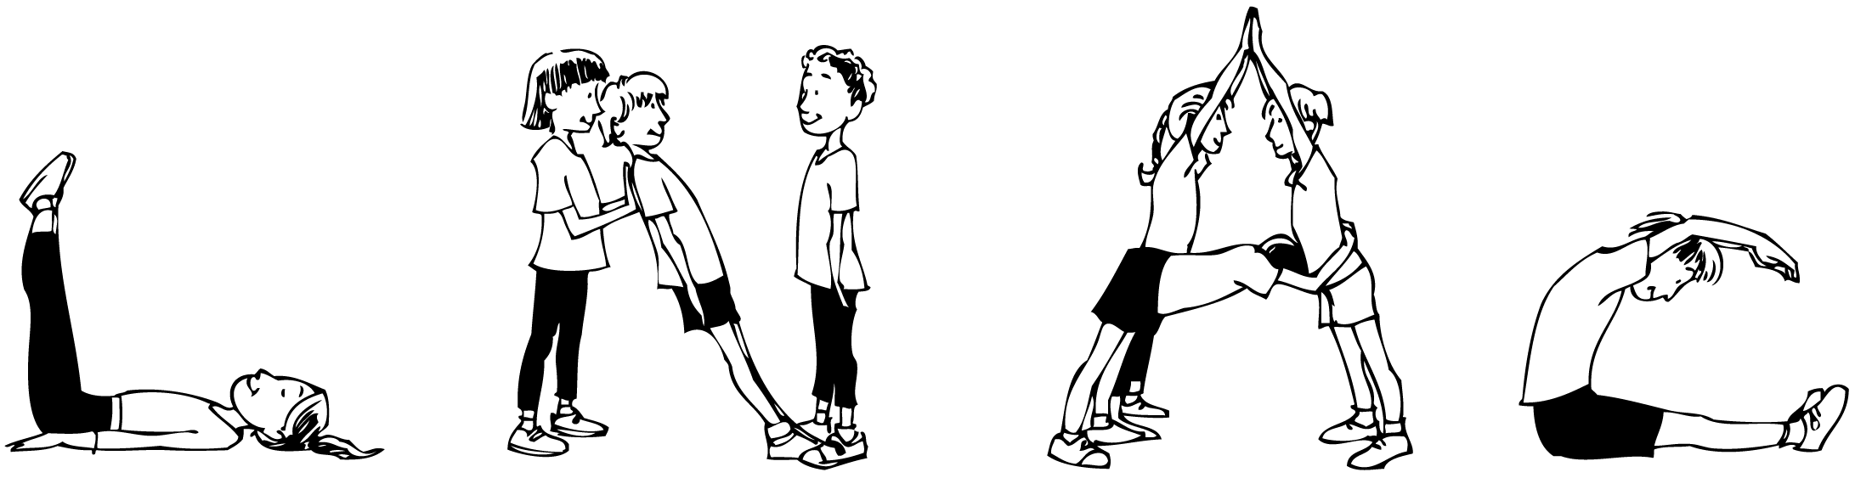
- Learn and practise a variety of set balances chosen by the teacher to suit the skill, strength and flexibility levels of students. Appendix D: Set balances gives some examples.
- Explore varying the set balances they have learned by changing the position of different body parts (e.g. arms or legs).
Example:
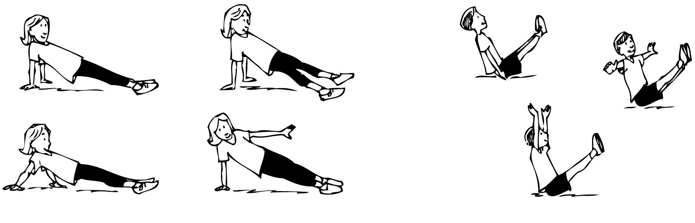
- Create a short sequence in which they change smoothly from one set balance to another. With a partner, students mirror each other’s sequences.
- Work with a partner and respond to movement activities set by the teacher that require them to demonstrate a partner balance (a balance where there is body contact between partners) that uses the previously learned set balances. Before commencing the activity, students propose ways of promoting safety when balancing with a partner.
Example:
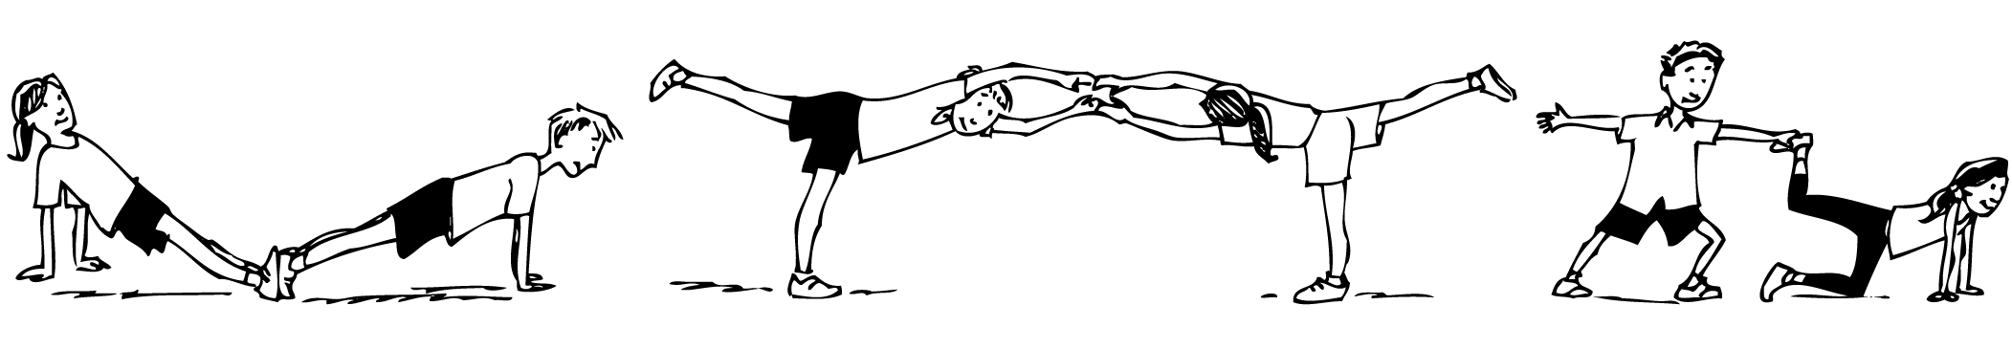
- In groups of four to six, students respond to movement activities set by the teacher that provide opportunities for them to explore using set balances in different formations. Students propose ways to promote safety when balancing in a group (e.g. wait until everyone is ready, do not encourage other students to attempt skills beyond their ability levels).

Teacher resources
Online resources
The Queensland Studies Authority website contains HPE Sourcebook modules for Years 1 to 10. A PDF of Travelling and balancing is available at: <www.qsa.qld.edu.au/syllabus/747.html>.
Books
Teaching children movement concepts and skills: Becoming a master teacher, Buschner, C 1994, Human kinetics, Lower Mitcham, SA.
Physical education unit plans for grades 1–2: Learning experiences in games, Logsden, B J et al 1994, Human Kinetics, Lower Mitcham, SA.
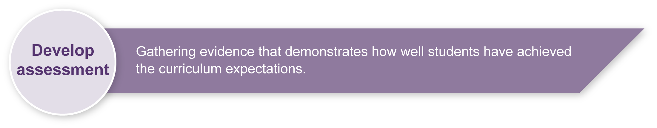
Aussie gymfun, Schembri, G 1991, Australian Gymnastics Federation Inc, Melbourne.
Introductory gymnastics, Schembri, G 1983, Australian Gymnastics Federation Inc, Melbourne.

Preparing
Consider these points before implementing the assessment.
- Safety discussions must be a formal component of every lesson with warm-ups and cool-downs mandatory (see Appendix A: Safety considerations).
- Ensure learning experiences are implemented in an area free of hazards and on a suitable surface.
- Students must have had significant opportunity for practical travelling and balancing skill development prior to commencing this assessment.
- One-on-one modelling, peer demonstrations, peer feedback and positive teacher feedback must be a part of every lesson leading up to the assessment.
- Students must be familiar with the terms used when travelling and balancing (e.g. balance, circular, control, direction, forward, hazards, hop, partner, pathway, personal space, sideways, skip).

Implementation
- In Sections 1–3, assessment of students’ travelling and balancing is by observation.
- In the sequence activity students are not to be assessed on their creativity or the smoothness of the sequence.
- In Section 4, assessment is based on student’s oral or written response to Appendix E: Student reflection.

Sample implementation plan
This table shows one way that this assessment can be implemented. It is a guide only — you may choose to use all, part, or none of the table. You may customise the table to suit your students and their school environment.
Suggested time | Student activity | Teacher role
Section 1. Basic travelling skills
45 minutes | Demonstrate travelling skills safely as indicated in the Guide to making judgments. | Create a circuit of travelling (locomotor) activities. As students follow each other through the circuit teachers can stand at each station, recording their observations of each student.
Section 2. Basic balancing skills safely
45 minutes | Demonstrate balancing skills safely as indicated in the Guide to making judgments. | Create a circuit of balancing (non-locomotor) positions. As students follow each other through the circuit teachers can stand at each station, recording their observations of each student.
Section 3: Sequence of travelling and balancing skills
45 minutes | Create and demonstrate a sequence of movements and balances in a defined area safely. | Place five markers four metres apart in a hexagonal shape. At each marker students demonstrate a specific balance. When travelling between markers they use a different method each time (e.g. skip, hop, crawl).  Model a sequence of movements and balances to demonstrate what is required.  Provide safety guidelines and a defined space for students.  Allow students time to create their sequence of movements that link several balances.
Section 4: Student reflection
15 minutes | Complete Student reflection worksheet. | Print and distribute copies of Appendix E: Student reflection.  If students are not able to write their responses, they may orally provide an answer for the teacher, aide or helper to write for them.

Resources for the assessment
Appendix A Safety considerations
Appendix B Animal walks
Appendix C Puzzle balances
Appendix D Set balances
Appendix E Student reflection
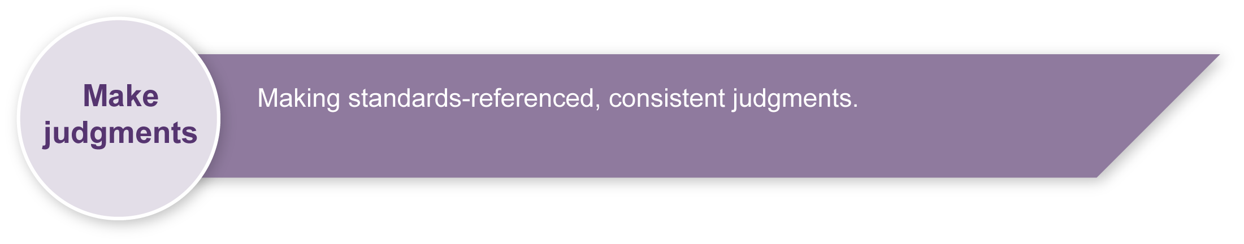
Equipment — Gym mats, markers
During the learning process, you and your students should have developed a shared understanding of the curriculum expectations identified as part of the planning process.
After students have completed the assessment, identify, gather and interpret the information provided in student responses. Use only the evidence in student responses to make your judgment about the quality of the student learning. Refer to the following documents to assist you in making standards-referenced judgments:
- Guide to making judgments
- Indicative A response
- Sample responses (where available).

Making judgments about this assessment
The Guide to making judgments serves as a recording sheet (checklist) to assist teachers in making accurate observations of each student’s travelling and balancing skills. All students must have sufficient time to practise the skills before formal judgments are made.
For further information, refer to the resource Using a Guide to making judgments, available in the Resources section of the Assessment Bank website.
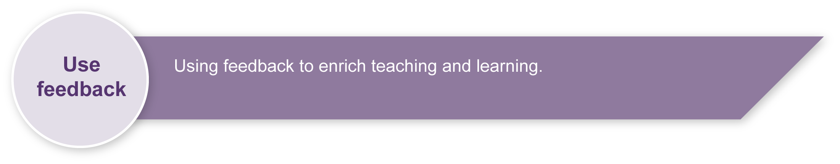
Evaluate the information gathered from the assessment to inform teaching and learning strategies.
Involve students in the feedback process. Give students opportunities to ask follow-up questions and share their learning observations or experiences.
Focus feedback on the student’s personal progress. Emphasise continuous progress relative to their previous achievement and to the learning expectations — avoid comparing a student with their classmates.

Giving feedback about this assessment
It is essential that students receive individual feedback on their technique when practising the various travelling and balancing skills. One-on-one modelling, peer demonstrations, peer feedback and positive teacher feedback must be a part of every lesson leading up to the assessment.
For further information, refer to the resource Using feedback, available in the Resources section of the Assessment Bank website.

Safety considerations
Constantly reinforce rules and behaviours related to safety throughout all physical activities. Ask students to identify rules and behaviours relevant to particular activities as new activities are introduced.
Safety considerations when sharing a defined space should include:
- watch where you are going
- move at a safe pace
- be aware of where others are moving and how close they are to you
- listen for the teacher’s signals and obey them
- move sensibly and with control.

Safety considerations when balancing should include:
- make sure you have enough personal space
- move into and out of balances with control
- do not balance on your head or neck
- do not perform a balance using only two knees
- do not lift hips above shoulders if balancing on two hands.

Consider safe landings as students may choose to use springing, jumping and hopping activities when exploring ways of travelling. Safety considerations when landing could include:
- land on the balls of your feet first
- place your feet parallel and slightly apart
- land with your arms out in front of you, looking at your fingers as if sitting you were on a bicycle
- bend your ankle, knee and hip joints
- hold your head erect
- hold your landing position before travelling again.

Animal walks
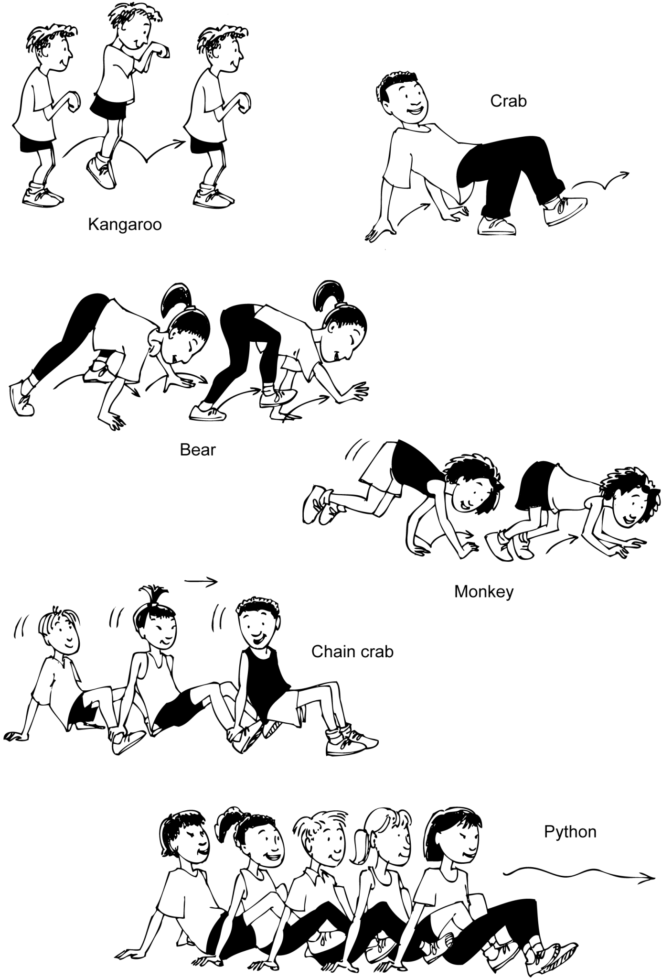

Puzzle balances
Key
foot | bottom | shoulders | knee | 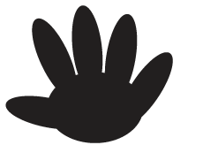  hand | back | elbow

Examples
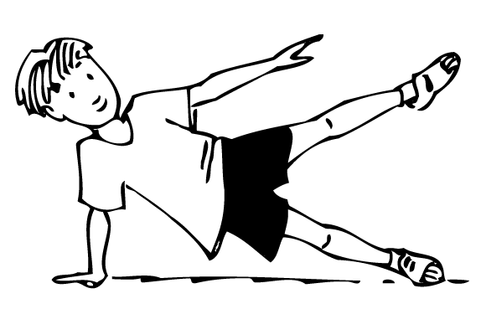
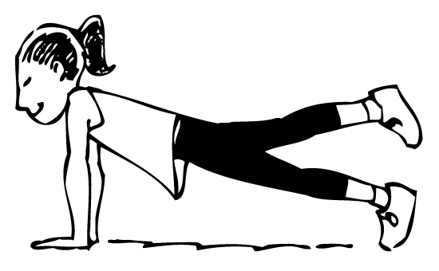
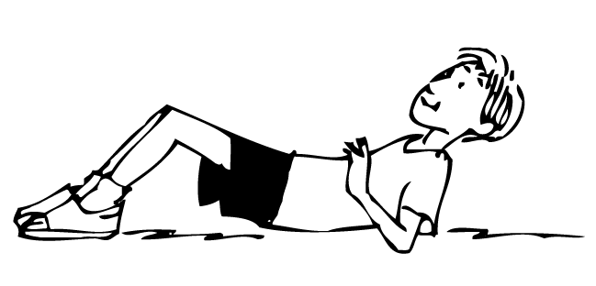
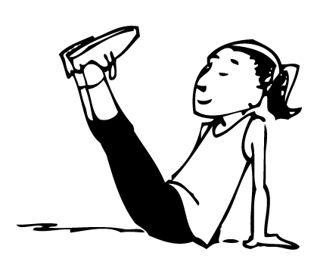
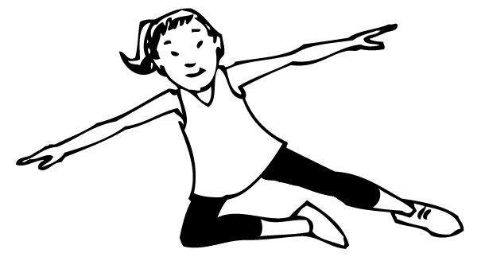
AVOID |  | Now make your own cards!
Source: Aussie Gymfun, Schembri, G 1991, Australian Gymnastics Federation Inc, Melbourne, p.164.

Set balances
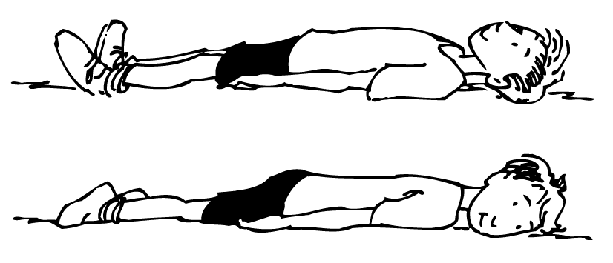  Rear and front lying positions | 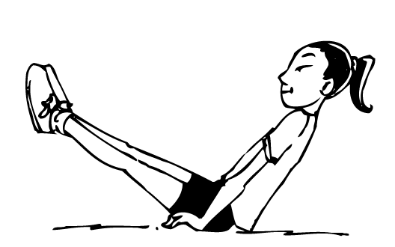  V-sit
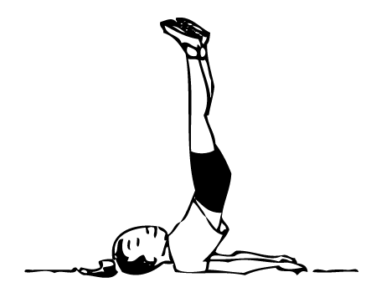
Inverted shoulder support
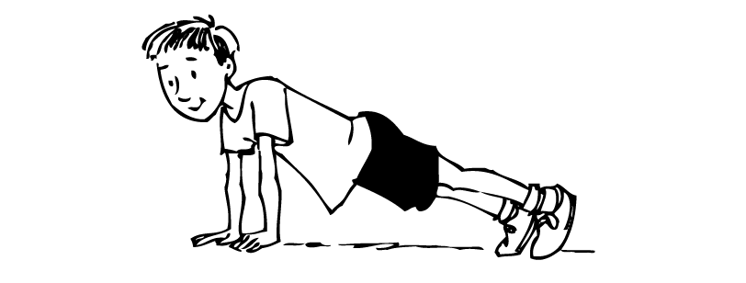  Front support | 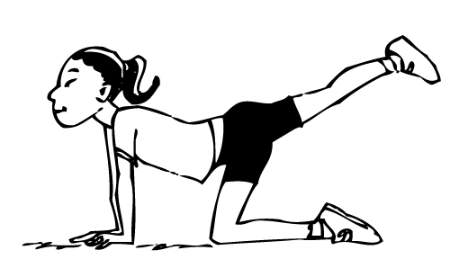  Knee scale
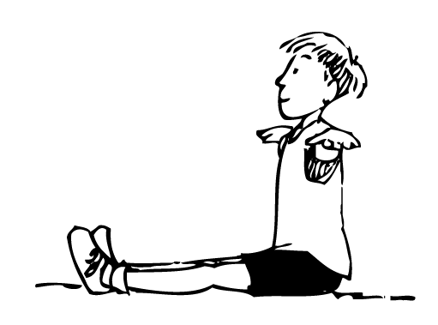  Sit with arms raised | 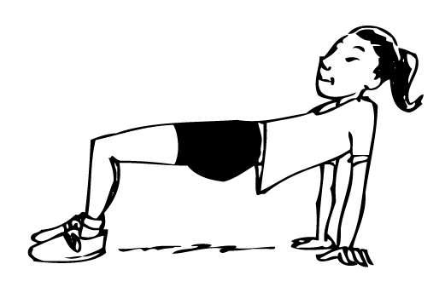  Bent body rear support
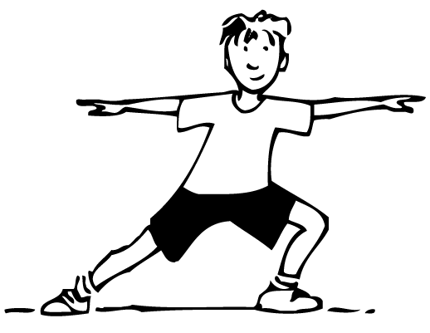  Side lunge | 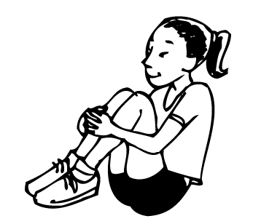  Tuck sit
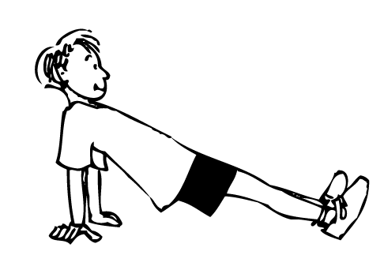  Rear support | 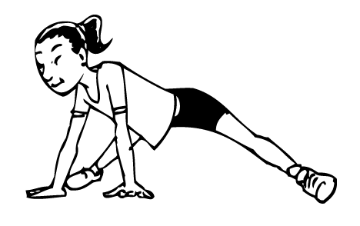  Supported straddle stand
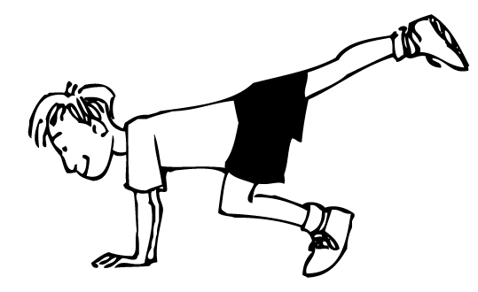  Scorpion stand | 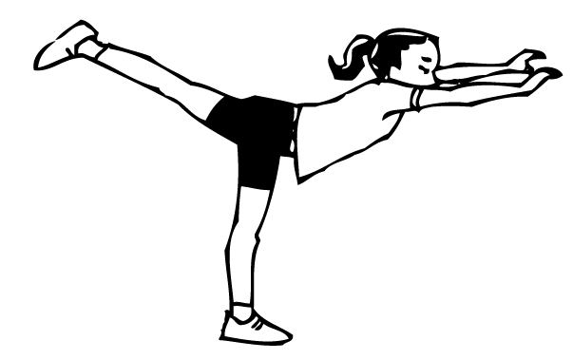  Arabesque

Student reflection
- How do you perform one of these balances? Think about the things you do with your body and safety.
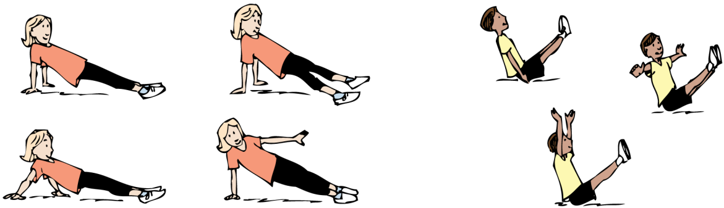

- Imagine you are in one of these drawings. Describe what is happening.

- How can you use the things you have learnt about travelling and balancing when you are older?

