Transport safety test
Year 3 | Health & Physical Education (HPE)
Students analyse a transport scene to identify dangerous behaviours. They identify possible risks and harms and suggest alternative behaviours that would minimise risks to themselves and others.
Time allocation | The suggested time for this assessment is 30–45 minutes.
Student roles | Students will analyse the stimulus picture individually.
Context for assessment
Students examine the risks and harms associated with a range of transport-related contexts (e.g. rail, passenger, road, and bicycle). In doing so, they develop an understanding of the need to behave safely to reduce risk of personal injury or harm.

This assessment gathers evidence of learning for the following Essential Learnings:
HPE Essential Learnings by the end of Year 3
Ways of working  Students are able to:  - identify and collect information and evidence  - draw conclusions and make decisions  - reflect on and identify how behaviours, skills and actions influence health and wellbeing, movement capacities and personal development. | Knowledge and understanding  Health  Health is multidimensional and influenced by everyday actions and environments.  - Individual behaviour and actions, including adopting safe strategies at home, on and near roads, near water, and in relation to the sun, can promote health and wellbeing and safety.

Assessable elements
- Knowledge and understanding
- Reflecting
Source: Queensland Studies Authority 2007, HPE Essential Learnings by the end of Year 3, QSA, Brisbane.

Listed here are suggested learning experiences for students before attempting this assessment.
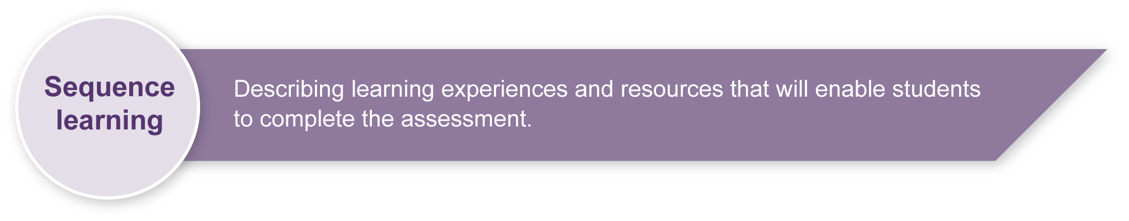
- Share personal stories about safe and dangerous behaviour.
- Discuss the meaning of key words, including pedestrian, passenger and cyclist.
- Examine messages in campaign resources such as brochures, websites and advertisements related to traffic, cycle, train and bus safety.
- Interview transport personnel from, for example, Queensland Rail, the Queensland Police, and a bus company about safe and dangerous behaviour.
- Analyse a range of transport-related contexts to identify safe and dangerous situations and behaviour.
- Suggest possible risks and injuries associated with dangerous situations and behaviour.
- Suggest behaviours that help promote personal safety and discuss how these reduce risk and harm.
- Use “because” to give reasons or to justify.
- Role-play possible actions in simulated traffic scenarios.
- Reflect on the health outcomes associated with safe and dangerous behaviour.

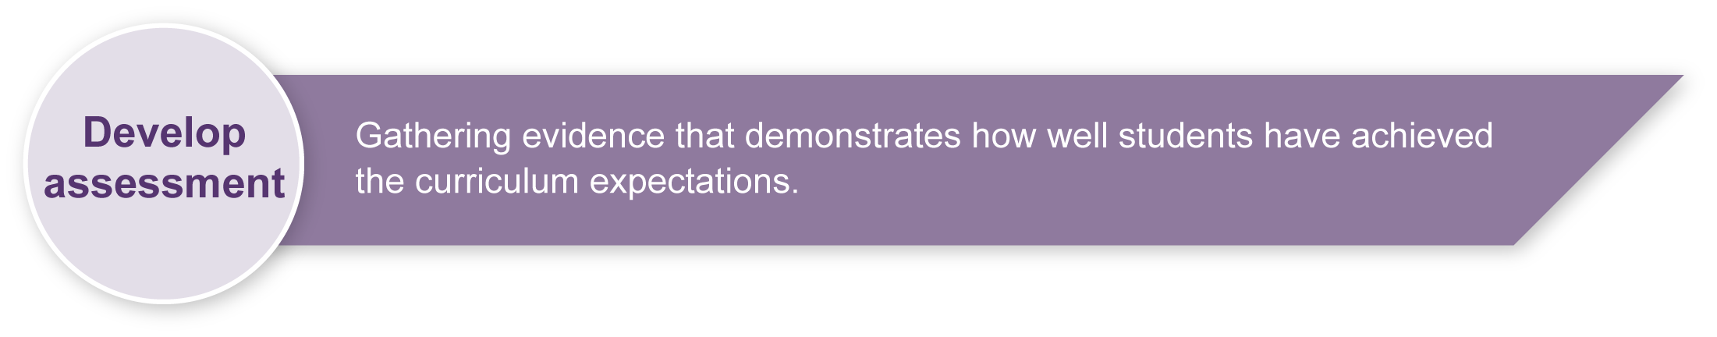
Preparing
Consider these points before implementing the assessment.
- Select the transport scene illustration that best suits your class context (urban or rural).
- Photocopy the illustration so that each student has a copy on which to circle the examples of dangerous behaviour.
- Consider colour copying and enlarging the selected scene to A3 size as an additional resource to display in the classroom.
Note: It may be advisable to combine the four answer sheets onto a single A3 page so that students can view all sections at once.
- Consider copying the instructions in the Student booklet onto an overhead transparency, or PowerPoint slide to save paper.
Inclusivity
Teachers may need to modify the assessment to give students with disabilities the best opportunity to demonstrate their learning. Those given the option of responding verbally should be allowed time to think about how best to respond. Teachers are advised to consult with parents/carers and specialist support staff to determine whether modification is necessary.

Implementation
This assessment is to be implemented with minimal scaffolding. It is expected that students will have examined the behaviours and risks associated with a range of transport contexts (e.g. rail, passenger, pedestrian, road, bicycle) prior to attempting the assessment.
Consider these points when implementing the assessment.
- Read and discuss the assessment with your class. The illustration should not have been sighted by students during the sequence learning experiences.
- Ensure children understand that they are to focus their thinking on transport safety (and not sun safety) as shown in the picture.
- Explain that there may be one or more examples of safe behaviour that can be given in the safer choices space. Encourage students to write at least one safer choice for a dangerous behaviour.
Step 1: Identify dangerous behaviour
Ask students to look at the transport picture and circle all the behaviours that are likely to put people at risk.
Step 2: Think about why this behaviour is dangerous? What would you do?
Ask students to choose one dangerous behaviour shown:
- by a pedestrian
- by a passenger
- by a cyclist
- in one other situation.
Ask students to think about:
- why the behaviour is dangerous for the person in that situation
- what behaviour would be a safer choice for the person involved
- why this choice would be safer for the person involved.
Ask students to write their reasons and ideas in the tables in the Student booklet.

Resources for the assessment
A choice of two transport scene illustrations is provided with this assessment:
Appendix A Urban (city) transport scene
Appendix B Rural (country) transport scene
During the learning process, you and your students should have developed a shared understanding of the curriculum expectations identified as part of the planning process.
After students have completed the assessment, identify, gather and interpret the information provided in student responses. Use only the evidence in student responses to make your judgment about the quality of the student learning. Refer to the following documents to assist you in making standards-referenced judgments:
- Guide to making judgments
- Indicative A response
- Sample responses (where available).
For further information, refer to the resource Using a Guide to making judgments, available in the Resources section of the Assessment Bank website.
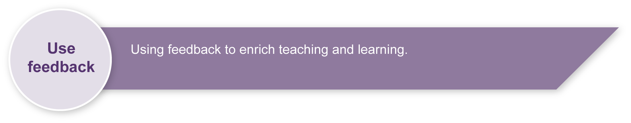
Evaluate the information gathered from the assessment to inform teaching and learning strategies.
Involve students in the feedback process. Give students opportunities to ask follow-up questions and share their learning observations or experiences.
Focus feedback on the student’s personal progress. Emphasise continuous progress relative to their previous achievement and to the learning expectations — avoid comparing a student with their classmates.
For further information, refer to the resource Using feedback, available in the Resources section of the Assessment Bank website.

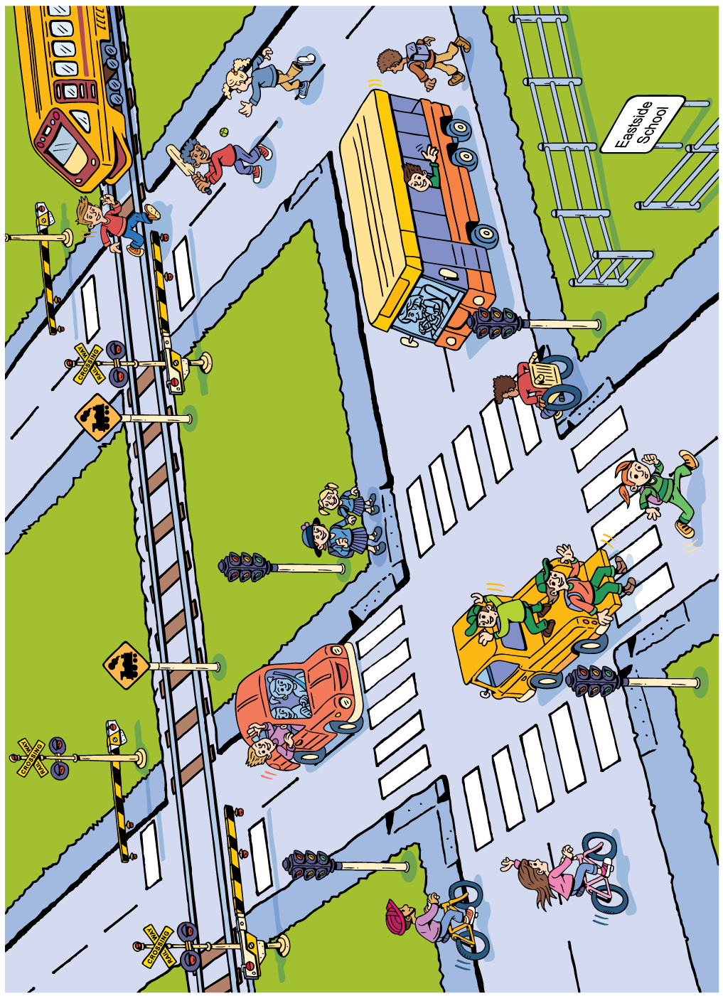
Urban (city) scene

Rural (country) scene
