Toddler toys
Years 8–9 | Technology
Students design and build a toy suitable for a three- to four-year-old child.
Time allocation | 11 hours
Students will individually:
- investigate toys for toddlers and the materials, tools and techniques used to create a toy
- design and produce a suitable toy, using available resources
- evaluate the toy and reflect on what they have learnt in the process.
Context for assessment
Quality toys for young children encourage learning through imaginative play and are safe to use. This assessment complements a unit of study that incorporates the Technology design process requiring students to investigate, ideate, produce and evaluate a toy to meet a specific design brief.
This assessment gathers evidence of learning for the following Essential Learnings:
Technology Essential Learnings by the end of Year 9
Ways of working  Students are able to:  - investigate and analyse specifications, standards and constraints in the development of design ideas  - generate and evaluate design ideas and communicate research, design options, budget and timelines in design proposals  - select resources, techniques and tools to make products that meet detailed specifications  - plan, manage and refine production procedures for efficiency  - make products to meet detailed specifications by manipulating or processing resources  - identify, apply and justify workplace health and safety practices  - evaluate the suitability of products and processes against criteria and recommend improvements  - reflect on learning, apply new understandings and justify future applications. | Knowledge and understanding  Technology as a human endeavour  Technology influences and impacts on people, their communities and environments in local and global contexts.  - New products and technologies are designed and developed to meet changing needs and wants of intended audiences, and include artefacts, systems, environments, services and processes.  - Product design and production decisions are influenced by aspects of appropriateness and by detailed specifications, constraints and standards of production.  Information, materials and systems (resources)  Resources originate from different sources, exist in various forms and are manipulated to meet specifications and standards to make products.  - Characteristics of resources are compared, contrasted and selected to meet detailed specifications and predetermined standards of production to best suit the user.  - Techniques and tools are selected, controlled and managed to manipulate or process resources to meet detailed specifications and predetermined standards of production.

Assessable elements
- Knowledge and understanding
- Investigating and designing
- Producing
- Evaluating
- Reflecting
Source: Queensland Studies Authority 2007, Technology Essential Learnings by the end of Year 9, QSA, Brisbane.
Listed here are suggested learning experiences for students before implementing this assessment.
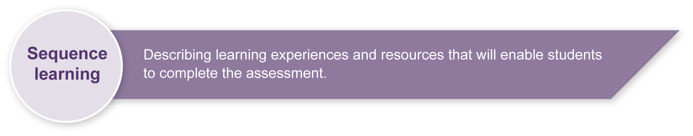
Students should have experience with technology practice using the design cycle - investigation, ideation, production and evaluation. Specific learning experiences include:
- investigation strategies, including use of multiple sources and creating an ideas folio
- ideation strategies, including documenting and critiquing design ideas
- documenting designs using basic drawing skills and equipment
- workshop tools and techniques, including use of appropriate safety strategies
(see Appendix A: In the workshop)
- appropriate peer and self assessment of products and processes
- reflection on learning.

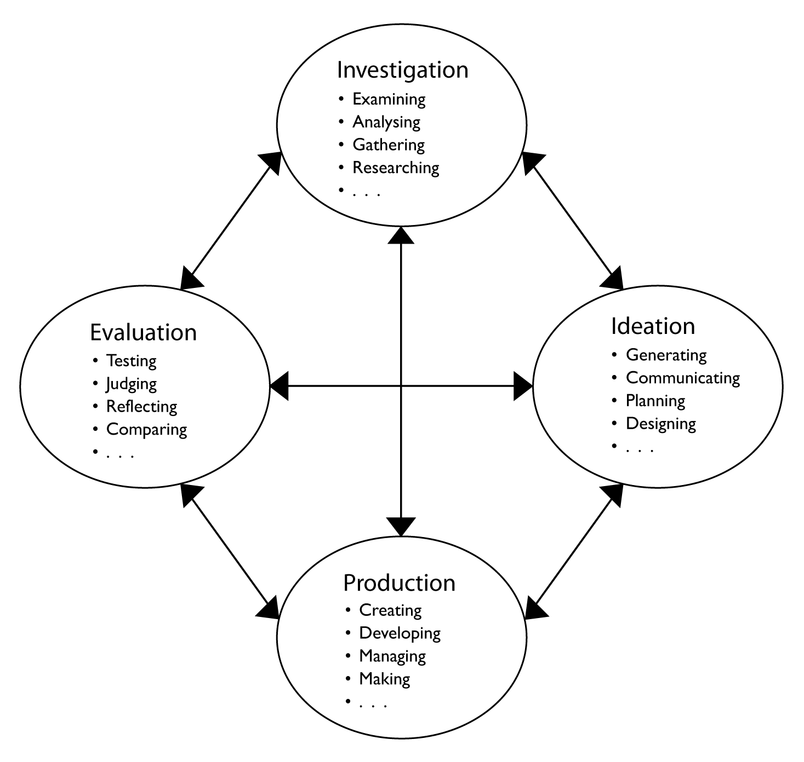

Teacher resources

Toy websites:
ABC Schools TV: Take on technology, Episode 5 — Toys, <www.abc.net.au/schoolstv/technology/ep5.htm>
So you want to design or make a toy…, BSI Education, < www.bsieducation.org > Education > Ages 14-19 > Topic areas > Toys > Design or make a toy (PDF).
Wooden toys: <www.woodentoy.com> A useful brochure on safety guidelines for toy design.

Books:
Toy Designer: Technology and Energy, Drew, David 1993, Rigby. ISBN: 0731206711
The History of Toys: From Spinning Tops to Robots, Jaffe, Deborah 2006, The History Press, Charleston USA. ISBN: 0750938498
Constructional Toys – Shire Album, Harley, Basil 1990, Shire Publications, London. ISBN: 0747800812
Toys, Tools & Teachers: The Challenges of Technology, Cambre, Marge & Hawkes, Mark 2004, Rowman & Littlefield Education, USA. ISBN: 1578861640

Health and safety:
“Appendix 2: An introduction to the use of tools, equipment and associated items in Technology”, Technology sourcebook guidelines 2003, Queensland Studies Authority, QSA, Brisbane. Available at <www.qsa.qld.edu.au> Search for “Technology (2003) sourcebook guidelines”. Accessed 17.06.2008.

Suggested tools:
- saws for wood, plastic, metal
- hand drills
- bench drill with hole saw
- files, rasps, sandpaper and sanding blocks
- bench vices and clamps
- screwdrivers
- hammers
- protective clothing e.g. goggles, aprons.
Suggested materials:
- wood — various shapes and sizes including ply and dowel
- plastics — acrylic sheet, various sizes of PVC pipe and extrusion
- fasteners — screws, nails, bolts, glues
- finishes — paint, varnish, oils.

Notes on toys for young children
What features make a toy fun and interesting for this age group?
Children like to manipulate toys to represent something that is meaningful to them. Toys with a narrow focus or that cannot be used in different contexts tend to be played with only briefly and then ignored once the child has mastery.
What features make a toy safe for this age group?
Toys used by this age group need to be robust, using materials that won’t develop sharp or rough edges, rusty parts, etc. Edges need to be suitably rounded.
Toys in early childhood settings are washed and disinfected regularly, so the design should be easy to clean, with materials and finishes suitably water resistant.
Moving parts need to avoid any scissor or lever actions that could injure small fingers. The brochure So you want to design or make a toy (see Teacher resources) provides a useful starting point for student discussion on these issues.

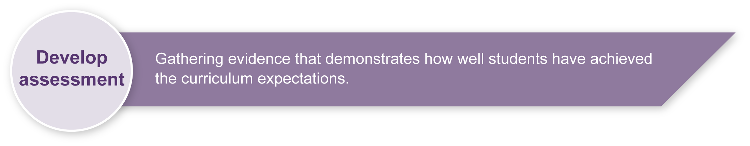
Student booklet
Students will document their process in a design journal, which becomes the key assessment item. Ensure students have time in each lesson to record their progress in investigating, ideating/designing, producing and evaluating.
The journal may take different forms:
- printed copies of the Student booklet (students will need to insert extra pages for their notes and drawings)
- electronic copies of the Student booklet (this method makes it easier to include digital photos, but students may need to scan in sketches)
- students create their own electronic journal, compiling their data in a blog or PowerPoint presentation.

Sample implementation plan
This table shows one way that this assessment can be implemented. It is a guide only — you may choose to use all, part, or none of the table. You may customise the table to suit your students and their school environment.
Suggested time |  | Student activity | Teacher role
Section 1. Investigation
90 minutes |  | Investigate different types of toys for three- to four-year-old children.  Create an ideas folio of images and ideas. | Provide access to books, websites, brochures, etc.  If possible, allow students to visit a Kindergarten or Prep class to observe children at play and talk to them and their teacher about toys.  Model creation of an ideas folio.
1 hour |  | Investigate which materials, tools and techniques are suitable for building the toy.  Create a Resources wish list and identify required skills. | Provide guidelines on available resources.  Outline appropriate tools and construction techniques.
Suggested time |  | Student activity | Teacher role
Section 2. Ideation/design
1 hour |  | Sketch three different ideas for toy design.  Discuss and evaluate each others’ concepts. | Facilitate class discussion and evaluation of design ideas. Model appropriate feedback.
2 hours |  | Based on feedback about the three design ideas, develop a final design and draw it in more detail. Use labels to show all parts and materials. Use “close-up” drawings to show details such as moving parts.  Create a component list. | Model appropriate styles for design drawing and component list.
Section 3. Production
30 minutes |  | Create a step-by-step production plan. | Model appropriate planning.
30 minutes |  | Tools and safety — create a list of tools that will be used and describe safety routines for each. | Support students to develop their own safety plan (see Appendix A: In the workshop).
4 hours |  | Construct the toy. | Provide appropriate workshop resources and support students in production of their toy.
Section 4. Evaluation and reflection
1 hour |  | Students evaluate their own and others’ products and production processes against the specifications.  If possible, let children in the target age group trial toys and provide feedback.  Students reflect on what they have learnt. | Support group critique and model appropriate feedback. Provide guidelines for individual evaluation and reflection.
 | Resources for the assessment
Appendix A In the workshop
During the learning process, you and your students should have developed a shared understanding of the curriculum expectations identified as part of the planning process.
After students have completed the assessment, identify, gather and interpret the information provided in student responses. Use only the evidence in student responses to make your judgment about the quality of the student learning. Refer to the following documents to assist you in making standards-referenced judgments:
- Guide to making judgments
- Indicative A response
- Sample responses (where available).

Making judgements about this assessment
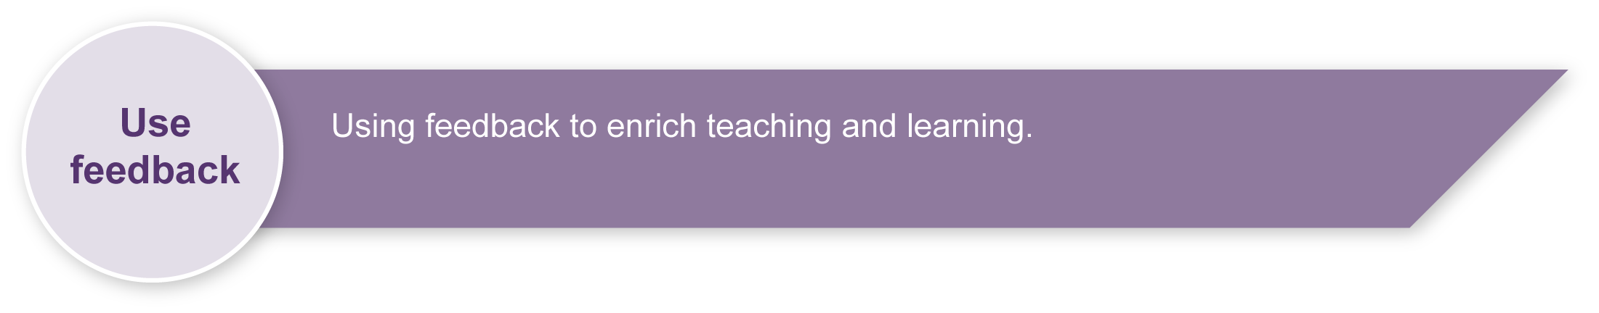
Supporting students to document their progress in a design journal such as the Student booklet at each stage of the process will generate the data for making judgments. This will help to focus on development of students’ conceptual knowledge and skills which may not be apparent in the finished product.
For further information, refer to the resource Using a Guide to making judgments, available in the Resources section of the Assessment Bank website.
Evaluate the information gathered from the assessment to inform teaching and learning strategies. Involve students in the feedback process with peer assessment throughout the task. Give students opportunities to ask follow-up questions and share their learning observations or experiences.
Focus feedback on the student’s personal progress. Emphasise continuous progress relative to their previous achievement and to the learning expectations — avoid comparing a student with their classmates.

Giving feedback about this assessment
Support students to reflect on their learning throughout the project. Base feedback on new knowledge and understanding rather than the finished product.
For further information, refer to the resource Using feedback, available in the Resources section of the Assessment Bank website.

In the workshop

Workshop tools
Identify the tools shown in the photo below and use the list that follows to select the correct names to fill in the blanks: marking gauge, steel rule, brad awl, tenon saw, warrington pein hammer, carpenter’s mallet, hole saw, bevelled edge chisel.

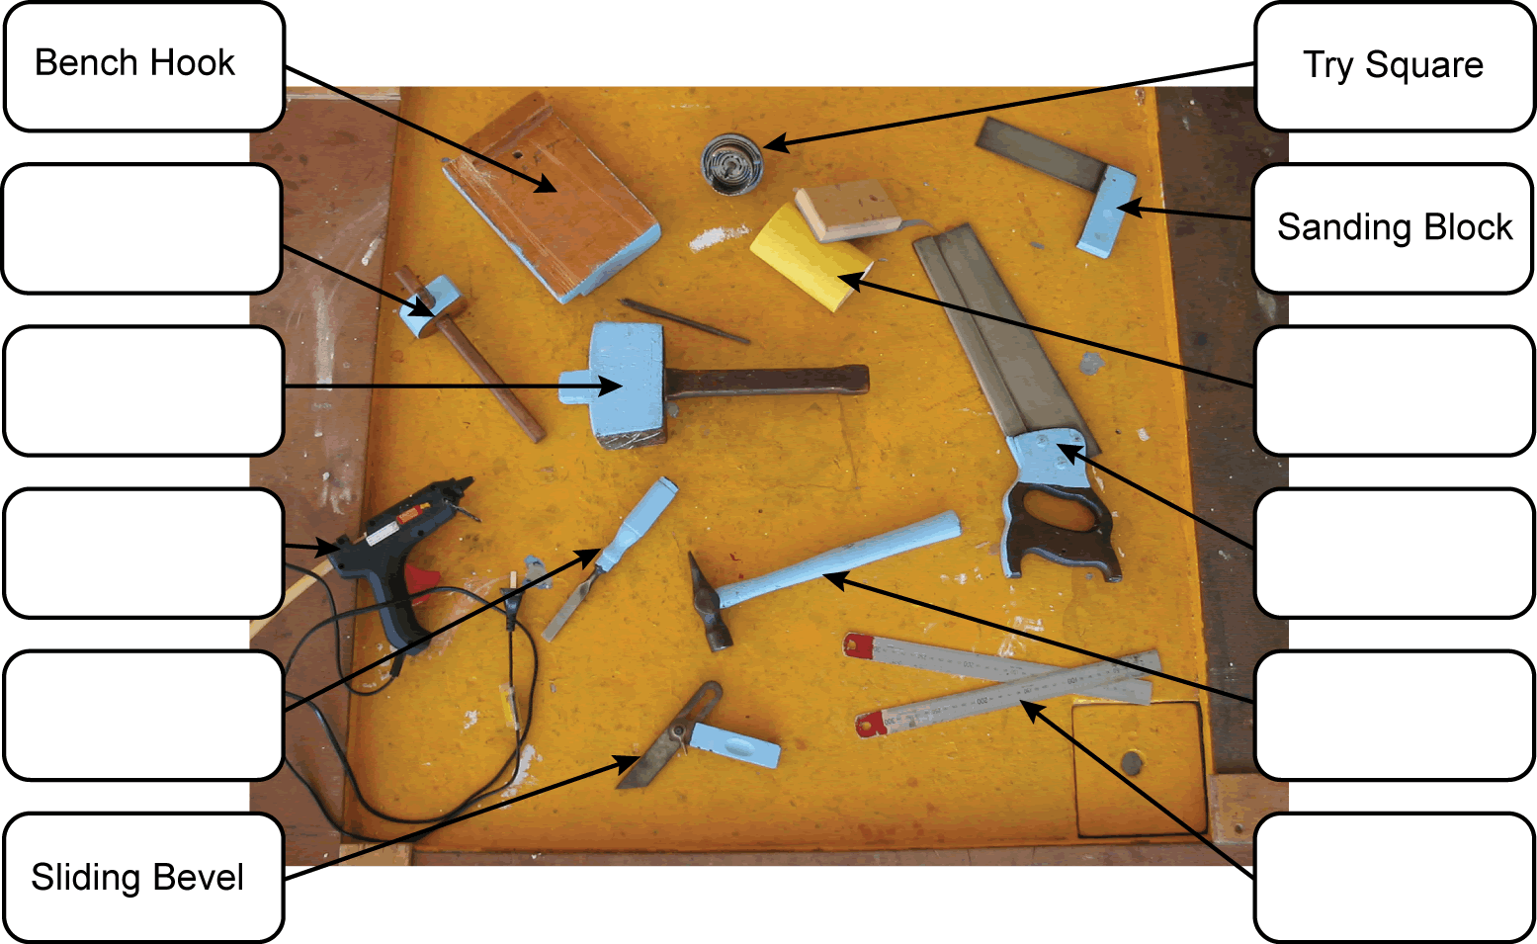

Workshop safety
What safety procedures are required for each of these tasks?
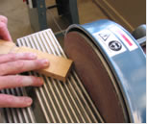 | 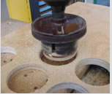 | 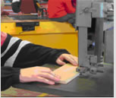 | 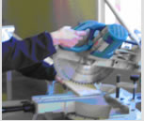
1. | 2. | 3. | 4.

