Throwing and catching
Year 2 | Health & Physical Education (HPE)
Students understand the basic principles of throwing and catching and demonstrate these skills in simple combinations. They then reflect on their learning.
Student roles | Individual and group work
Context for assessment
Throwing and catching skills are an important component of many games and activities played by students in lower primary school. It is important that students in the early phase of schooling be given many opportunities to develop these skills to prepare them for the games and sports they may play in the middle phase of schooling. Netball, softball, Newcomb, football, basketball and cricket are some of the games that require good skills in throwing and catching.
This assessment provides an introduction to a variety of throwing and catching skills, and activities that can be developed further in later teaching and learning. For students who are vision impaired, balls and beanbags should be large, brightly coloured and have bells inside them.
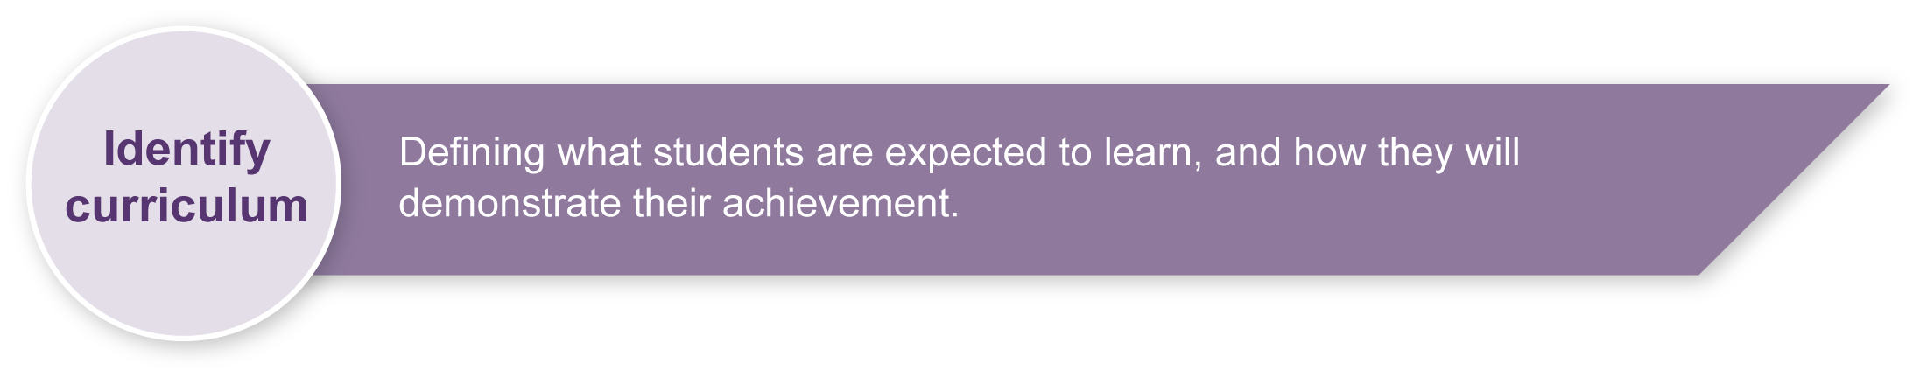
This assessment gathers evidence of learning for the following Essential Learnings:
HPE Essential Learnings by the end of Year 3
Ways of working  Students are able to:  - propose and take action to promote health and wellbeing, movement capacities and personal development  - apply fundamental movement skills when participating in physical activities  - reflect on learning to identify new understandings. | Knowledge and understanding  Physical activity  Fundamental movement skills are foundations of physical activity.  - Development of locomotor and non-locomotor movements and manipulative skills can improve the quality of physical performance and support participation in physical activities.  - Regular participation in physical activity develops movement capacity and promotes health and wellbeing.

Assessable elements
- Knowledge and understanding
- Implementing and applying
- Reflecting
Source: Queensland Studies Authority 2007, HPE Essential Learnings by the end of Year 3, QSA, Brisbane.

Listed here are suggested learning experiences for students before attempting this assessment.
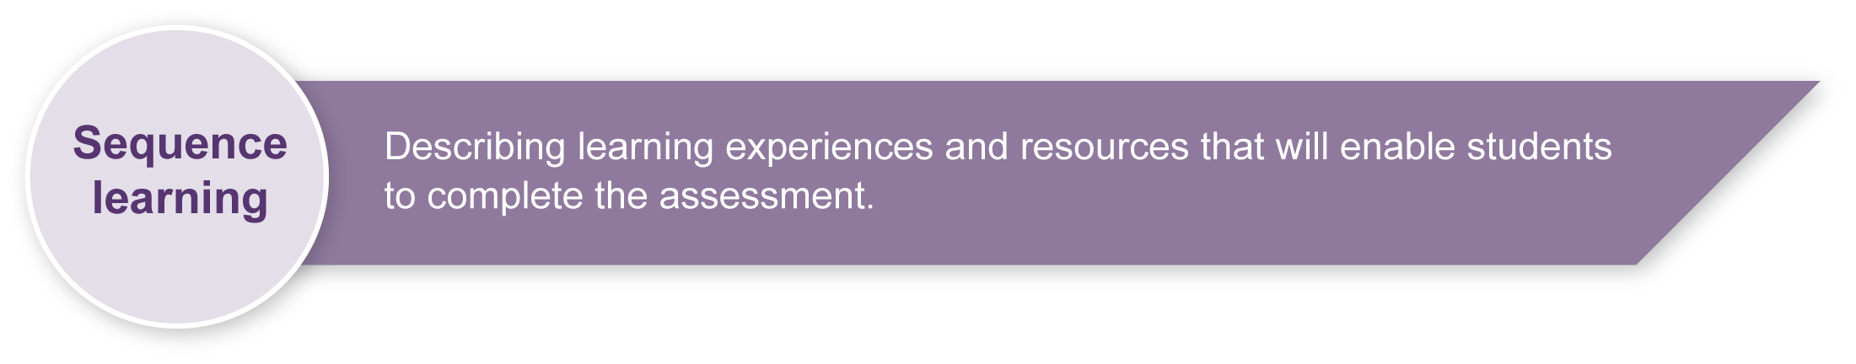
- Describe ball games that require throwing and catching and explain the types of movements they make in those games. For example, students may say that they have to run to catch the ball, throw with two hands, throw underarm or throw the ball high.
- Describe how different parts of the body are used when throwing and catching. Students are able to point to the muscles and limbs they use and suggest how they contribute to the actions of throwing and catching.
- Throw and catch medium-sized balls in pairs. Students explore as many ways as possible for throwing and catching and describe which of these they found best.
- Watch the teacher demonstrate and explain the correct throwing technique, including ball grip, for underarm, overarm, one-handed, two-handed, chest and overhead pass. Students then practise throwing using the correct techniques (refer to Appendix A, Throwing and catching skills).
- Demonstrate and explain to students the correct catching technique for using two hands, catching both small and large balls from different heights and angles. They then practise catching using the correct techniques (refer to Appendix A, Throwing and catching skills).
- Challenge students by increasing the distance they have to throw, and changing the size and shape of the ball. Students explain why it is more difficult to throw and catch over a longer distance, and provide a logical explanation, based on what they know, as to which type of throw is better over distance, better for accuracy and is easiest to catch.
- Rank different balls according to the distance they can throw underarm, overarm, or with a chest or overhead pass, and according to the degree of effort required to throw them in each way. For example, more effort is required to throw a basketball a long distance underarm than a tennis ball.
- Predict what feedback a partner would give about a student’s throwing and catching skills and what suggestions they would make to improve skills and knowledge. Students discuss their predictions with their partners and compare ideas.
- Reflect on and explain the information gathered about throwing and catching, the terms used and knowledge gained.
- Provide a simple commentary on what students are doing while throwing and catching. Students explain the techniques being used and the effort required to participate in different activities. They repeat the exercise while observing a partner.
- Play leader ball and captain ball — games that require students to throw and catch the ball over varying distances. Use a variety of balls.
- Visualise, explain and then demonstrate how to throw a ball so that it bounces into a hoop or on a line and then is caught by a partner. Students experiment with different types of throws to determine the most effective. Alternatively, a student rolls a hoop along the ground through which a partner throws a ball.
- Combine throwing and catching skills to develop a sequence. Students use different types of balls to demonstrate this sequence individually or in small groups.
- Students use a medium-sized ball to create their own modified game using throwing and catching skills. They discuss their ideas with others in the group and decide on a game to practise.
- Assess improvement in throwing and catching. Students nominate the skills they have developed and identify those they would like to further improve.
- Discuss throwing and catching used in different sports. Demonstrate which body movements are used to throw and catch in these sports and explain how these actions may vary in different sports.
- Speculate as to which of the throwing and catching sports require the most effort and use up the most energy. Rank sports according to the energy required to play and give reasons that support the ranking — for example, the energy expended by cricketers would not be as great as that expended by rugby players, yet both teams throw and catch.
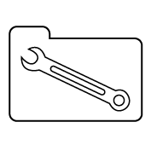 | Teacher resources
Australian Sports Commission 1994, Sport It! Towards 2000, Tactical Directions, Canberra.
Harris, J. & Elbourne, J. 1997, Teaching Heath-related exercise at Key Stages 1 and 2, Human Kinetics, Lower Mitcham, SA.
Lees, R. & Lees, A. 1994, Personal Development, Health and Physical Education, McGraw-Hill, Sydney.
Years 1 to 10 Sourcebook Module, Throwing and catching, The Office of the Queensland School Curriculum Council. Available on the QSA web site: <www.qsa.qld.edu.au>.
ACHPER, Professional association for PE teachers: <www.achper.org.au>.
Australian Baseball Federation, links to coaching information: <www.baseball.org.au>.
Australian Football League, links to coaching information: <www.afl.com.au>.
Australian Rugby League, links to coaching information: <www.australianrugbyleague.com.au>.
Basketball Australia, links to coaching information: <www.basketball.net.au>.
Cricket Australia, links to coaching information: <www.cricket.com.au>.
Football Australia, links to coaching information: <www.footballaustralia.com.au>.
Netball Australia, links to coaching information: <www.netball.asn.au>.
PE Central, lesson plans for PE teachers: <www.pecentral.org>.
Rugby Union Australia, links to coaching information:<www.rugby.com.au>.
Softball Australia, links to coaching information:<www.softball.org.au>.
Volleyball Australia, links to coaching information:<www.avf.org.au>.

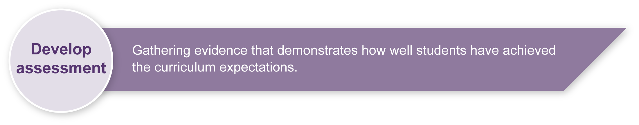
Preparing
Consider these points before implementing the assessment.
- Give students significant opportunity for hands-on practice at developing throwing and catching skills using a variety of balls.
- Teach specific throwing and catching techniques, as exemplified in Appendix A, Throwing and catching skills. Give individual follow-up and feedback to students where necessary.
- Discuss how each of the skills relate to team sports (e.g. basketball, netball, football) and their impact on a player’s enjoyment and success when playing that sport.

Safety
Some safety issues that teachers should consider are:
- providing adequate warm-up and cool-down exercises prior to and following lessons
- having students throw in the same direction during drill activities to avoid possible injury
- encourage students to be sun-safe.

Sample implementation plan
This table shows one way that this assessment can be implemented. It is a guide only — you may choose to use all, part, or none of the table. You may customise the table to suit your students and their school environment.
Suggested time | Student activity | Teacher role
Section 1. Demonstrate throwing skills
45 minutes | Demonstrate skills as indicated in the Guide to making judgments: Observation record — throwing skills. | A suggested strategy is to organise several small ball games in which all class members play. You could then select a group of 4 students at a time for assessment purposes.
Section 2. Demonstrate catching skills
45 minutes | Demonstrate skills as indicated in the Guide to making judgments: Observation record — catching skills. | A suggested strategy is to organise several small ball games in which all class members play. You could then select a group of 4 students at a time for assessment purposes.
Section 3. Reflection
15 minutes | Complete the Reflection worksheet. | Prepare copies of the Appendix B: Reflection.  If students are not able to write their response they may orally provide an answer for the teacher, aide or helper to write.

Resources for the assessment
Appendix A Throwing and catching skills
Appendix B Reflection
A variety of balls of different shapes, sizes, texture and densities.
A level, flat surface (e.g. a tennis, netball or basketball court).
During the learning process, you and your students should have developed a shared understanding of the curriculum expectations identified as part of the planning process.
After students have completed the assessment, identify, gather and interpret the information provided in student responses. Use only the evidence in student responses to make your judgment about the quality of the student learning. Refer to the following documents to assist you in making standards-referenced judgments:
- Guide to making judgments
- Indicative A response
- Sample responses (where available).

Making judgments about this assessment
The Guide to making judgments serves as a recording sheet to assist the teacher to make accurate observations of each student’s throwing and catching skills. It may be possible to record some observations for some students prior to the implementation of the assessment, however all students must have sufficient time to practise the skills before formal assessment occurs and judgments are made.
For further information, refer to the resource Using a Guide to making judgments, available in the Resources section of the Assessment Bank website.

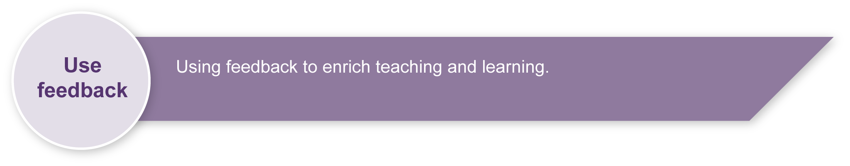
Evaluate the information gathered from the assessment to inform teaching and learning strategies.
Involve students in the feedback process. Give students opportunities to ask follow-up questions and share their learning observations or experiences.
Focus feedback on the student’s personal progress. Emphasise continuous progress relative to their previous achievement and to the learning expectations — avoid comparing a student with their classmates.

Giving feedback about this assessment
It is essential that students receive individual feedback on their technique when practising the various throwing and catching skills. One-on-one modelling of hand positions, finger grips, body position, foot and arm movements, wrist movements, weight transfer, follow-through etc. must be a part of every lesson leading up to the assessment.
For further information, refer to the resource Using feedback, available in the Resources section of the Assessment Bank website.

Throwing and catching skills
Ball grip: small ball
The grip on a small ball will vary, depending on the size and shape of the ball, and the size of the person’s hand.
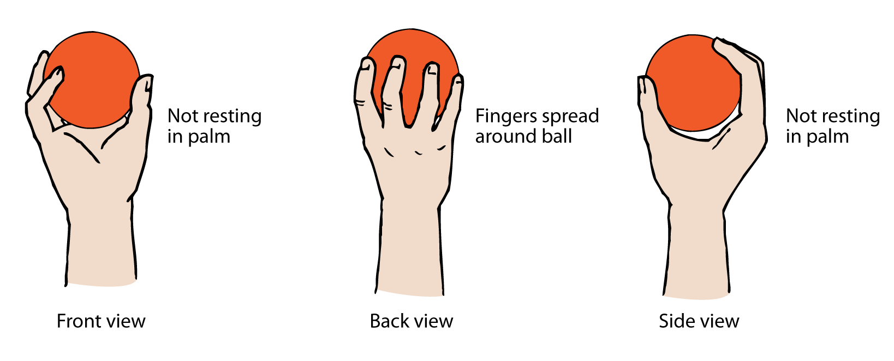
Note: Hold the ball in the fingers (not in the palm of the hand).
Throwing a small ball: one-handed underarm
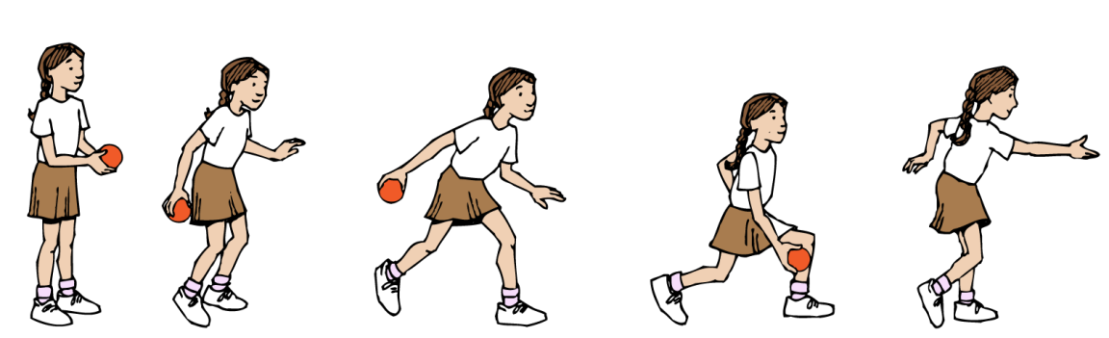
- Face the direction of the throw and focus on the target.
- Step onto the foot opposite the throwing arms while it arcs backwards.
- Move body weight forward and bend at the knees.
- Keep arm straight and eyes focused on the target.
- Release ball with final wrist action; the wrist should snap forward.
- Follow through in the direction of the target.

Throwing a small ball: one-handed overarm
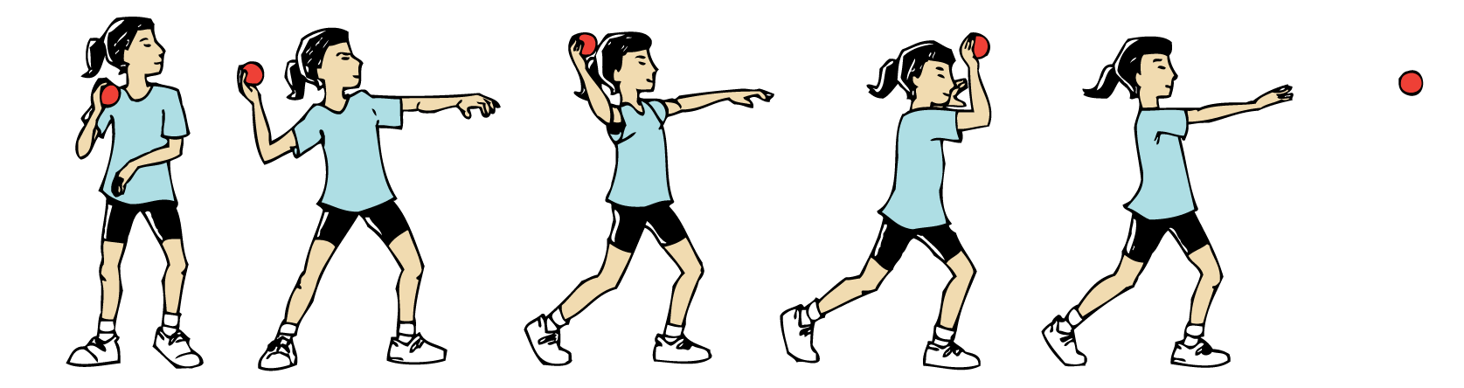
- Grip ball between thumb and fingertips (not in the palm of the hand).
- Focus on the target and stand side-on to it with weight on the rear foot.
- Take the ball behind the head, at about eye level, and cock the wrist backwards.
- Bend the elbow at shoulder height behind the body and then extend the arm so that it is almost straightened.
- Step forward onto the foot opposite the throwing arm, shift weight onto the front foot and rotate the trunk towards the throwing arm.
- Swing the upper arms and elbow forward as the body is rotated and the weight is transferred onto the front foot.
- Release the ball as the body faces the target and the hand is just in front of the shoulder.
- Snap the wrist forward and down as the ball is released.
- Follow through and across the body with the throwing arm, at the same time taking the opposite arm backwards to add force to the throw.
Throwing a larger ball: two-handed underarm
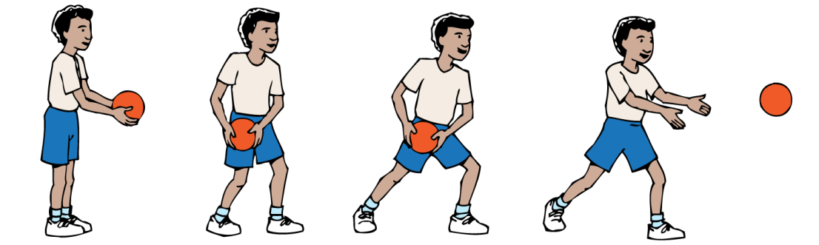
- Face the direction of the throw and focus on the target.
- Step onto the foot opposite the side of the body that the ball will be thrown from.
- Move body weight forward and rotate hips, positioning the body so that it is side-on to the direction of the throw.
- Keep arms relaxed and eyes on the target as arms swing forward.
- Release ball.
- Follow through in the direction of the target.
Throwing a larger ball: two-handed overarm
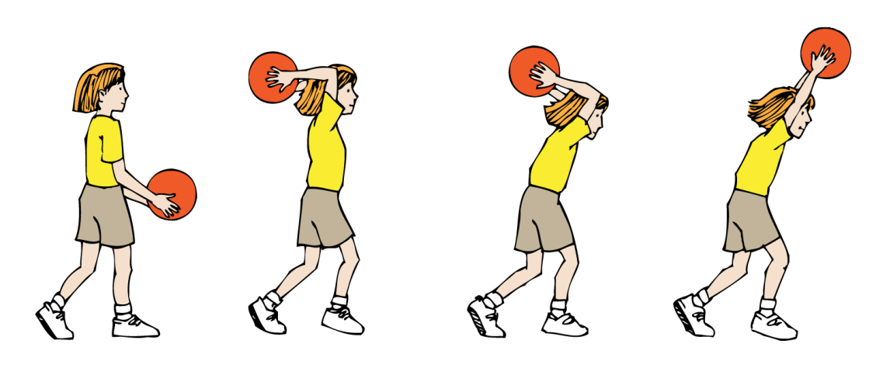
- Hold the ball with the fingers spread and hands positioned on the back of the ball.
- Focus on the target and place one foot slightly in front of the other for stability.
- Take the ball back behind the head, at the same time bending the body backwards from the hips.
- Take a step forward as the ball is released. (Note there is no hip rotation.)
- Extend the arms and throw the ball over the head, following through with hands and wrists.
Throwing a larger ball: one-handed overarm
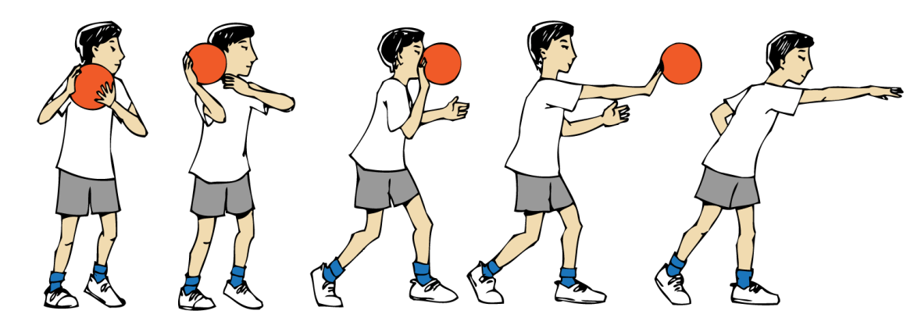
- Focus on the target, with the body slightly turned away from it.
- Hold the ball on the preferred side with the throwing hand behind the ball. Spread fingers of both hands and use the non-throwing hand to steady the ball.
- Move the foot opposite the throwing arm forward.
- Draw the ball back in readiness for the throw.
- Push the ball forward, at the same time taking a step onto the opposite foot.
- Release the ball, extending the arm and transferring the weight onto the front foot.
- Extend the wrist and hand to follow the flight of the ball.
Throwing a larger ball: two-handed from the chest
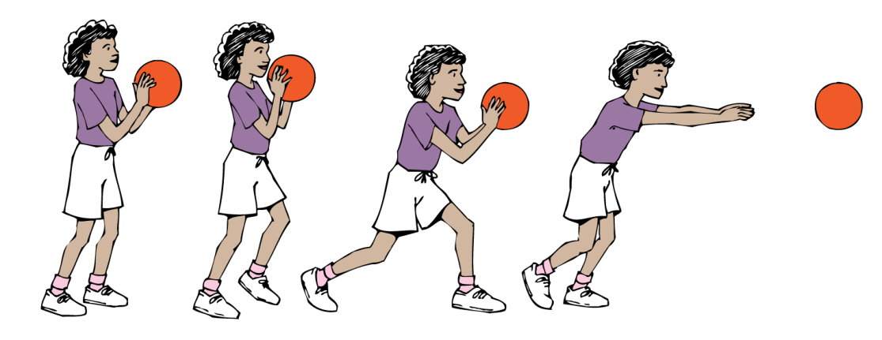
- Focus on the target and place one foot slightly in front of the other.
- Hold the ball so that the hands are behind it and fingers spread, elbows tucked in to the sides.
- Draw the ball back and down.
- Push the ball forward evenly with both hands. Step forward onto one foot as the throw is made.
- Extend the hands and wrists as the ball is released. Follow through into the pushing action.
Catching a larger ball: two-handed
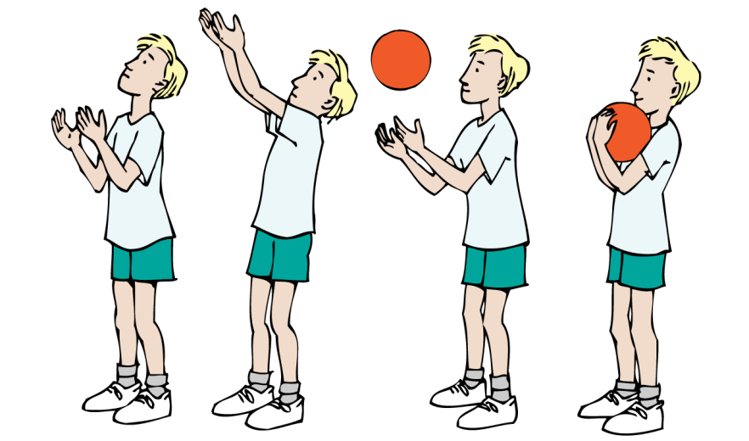
- Focus on the ball.
- Move body so that it is in line with the ball.
- Extend arms and hands, keeping elbows tucked in.
- Catch the ball in outstretched hands and relax the arms to absorb the force of the ball.
- Pull the ball in towards the body.
Progression
- To catch balls above waist height, place thumbs together.
- To catch balls below waist height, place little fingers together.

Reflection
- How do you throw a small ball overarm?

- How do you catch a large ball?

- What sports could you play that have throwing and catching?

- What did you find difficult or challenging when throwing and catching?

- How have you improved your throwing or catching skills?

