I’m the critic!
Years 6–7 | The Arts — Dance, Drama, Music
After watching a live or recorded performance, students analyse and evaluate the show, then respond in the role of a theatre critic for a local radio station.
Time allocation | This assessment will take 5 to 6 hours to complete.
Student roles | Students will work individually to:  - complete a reflection worksheet to analyse and evaluate a performance  - present their response to the performance in a roleplay as a theatre critic.
Context for assessment
The theatre critic serves a useful role in society by providing critical opinions on arts performances. They examine the interaction of arts elements to shape their opinions. Critics interpret and assess what takes place in a performance by recognising, evaluating and celebrating creative talent.
A unit attached to this assessment should be structured around the viewing of live or recorded performances of dance, drama and music, where students reflect on performance features and audience appeal.
Teachers can choose Dance, Drama or Music for Section 1 of this assessment, and therefore Section 1 will only gather evidence of learning for this choice. Section 2 gathers evidence of learning for Drama.
This assessment gathers evidence of learning for the following Essential Learnings:
The Arts Essential Learnings by the end of Year 7
Ways of working  Students are able to:  - select and develop ideas for arts works, considering intended audiences and intended purposes, and make decisions about arts elements and languages  - create and shape arts works by modifying arts elements to express purpose and to include influences from their own and other cultures and times  - modify and polish arts works, using interpretive and technical skills  - present arts works to informal and formal audiences for intended purposes, using arts techniques, skills and processes  - respond by analysing and evaluating arts works in social, cultural, historical and spiritual contexts, using arts elements and languages. | Knowledge and understanding  Dance  Dance involves using the human body to express ideas, considering intended audiences and intended purposes, by modifying dance elements in movement sequences.  - Combinations of locomotor and non-locomotor movements are used to create actions for movement sequences.  - Directional focus is used to draw attention in space in movement sequences.  - Combinations of simple and compound time signatures are used to modify timing of movements in sequences.  - Suspending and vibrating movement qualities are used to modify energy.  - Structuring devices, including transitions, motifs and improvisation forms, are used to organise movement sequences.
(continued on next page)
Drama
Drama involves modifying dramatic elements and conventions to express ideas, considering intended audiences and intended purposes, through dramatic action based on real or imagined events.
- Roles and characters can be presented from different perspectives and in different situations, using variations in voice, movement and focus.
- Purpose and context are considered when modifying mood, time frames, language, place and space, and are used to express ideas.
- Dramatic action is interpreted, prepared and shaped through scenarios and scripts.
Music
Music involves singing, playing instruments, listening, moving, improvising and composing by modifying the music elements to express ideas, considering intended audiences and intended purposes, through sound.
- Duration, beat, time values and metre are used to create rhythm.
- Pitch and intervals are used to create melody.
- Tonalities and harmonies are used to organise music in vertical arrangements.
- Contemporary and traditional musical forms are used to structure music.
- Vocal, instrumental and electronic sound sources have characteristic sound qualities (tone colour).
- Relative softness and loudness and emphasis of sounds are used to change dynamic levels and expression of music.

Assessable elements
- Knowledge and understanding
- Presenting
- Responding
Source: Queensland Studies Authority 2007, The Arts Essential Learnings by the end of Year 7, QSA, Brisbane.

Listed here are suggested learning experiences for students before they attempt this assessment.
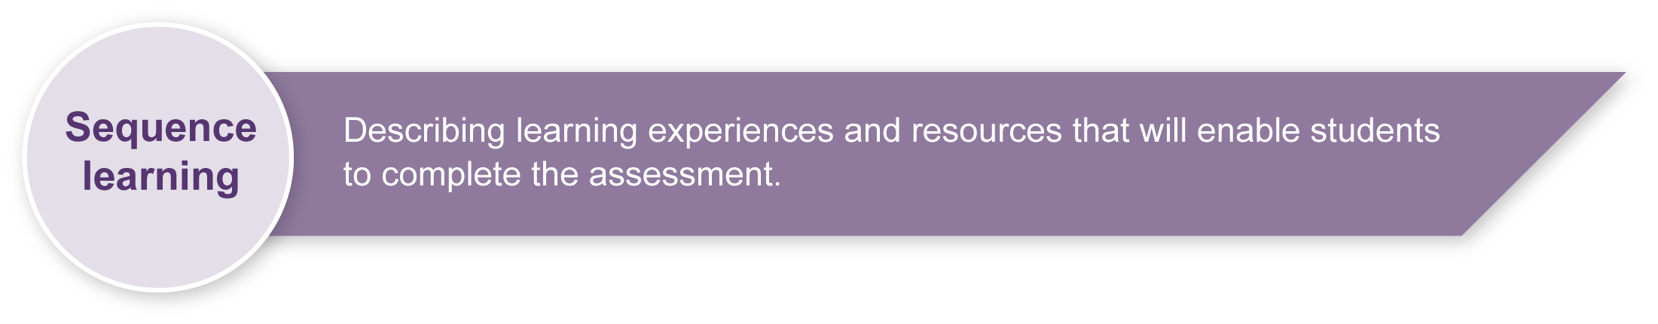
- Respond to questions identifying the use of specific arts elements in dance, drama and music performances.
- Collect and create displays of play, film and television reviews from newspapers and magazines, both local and national.
- Read, listen to and watch reviews (e.g. TV and radio arts programs, podcasts).
- Develop vocabulary lists for theatre critic responses in the areas of dance, drama and music.
- Discuss the function of reviews and the role of critics — who are they and why do they exist?
- Discuss respect and sensitivity issues regarding responses to performances, performers and roleplay characters.
- Examine and compare the content of reviews and styles of individual critics (e.g. ABC radio critic Nigel Munro Wallis, available at <www.abc.net.au/brisbane>).
- Respond to and rehearse exercises for vocal skills (expression, projection, audibility, pace, pitch and clarity) to develop a radio character.
- Explore roleplays, investigating specific presentation styles appropriate for critics.

Teacher resources
Arts education: A curriculum guide for grade six (Looking at plays), Saskatchewan Education 1994, Regina, SK, Canada, accessed 25 January 2008,
<www.sasked.gov.sk.ca/docs/artsed/g6arts_ed/g6rlpae.html>.
Arts education: A curriculum guide for grade six (Responding to dance presentations), Saskatchewan Education 1994, Regina, SK, Canada, accessed 25 January 2008,
<www.sasked.gov.sk.ca/docs/artsed/g6arts_ed/g6dresae.html>.
Arts education: A curriculum guide for grade six (Listening to music), Saskatchewan Education 1994, Regina, SK, Canada, accessed 25 January 2008,
<www.sasked.gov.sk.ca/docs/artsed/g6arts_ed/g6mlmae.html>.
Ontour inschools: Primary teacher resource kit, Queensland Arts Council. (This is produced every year for specific shows and is available through the Queensland Arts Council <www.qac.org.au>.)

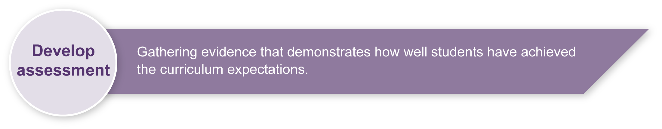
Preparing

Consider these points before implementing Section 1 of this assessment.
- Select a performance that is suitable for students’ age and level of comprehension. Suitable performances could include an Arts Council touring company or artist, a Wakakirri production, Rock Eisteddfod Challenge or polished student work (live or recorded).
- Ensure that students understand the appropriate arts elements, and are given the Student reflection sheet before watching the performance. Discuss and clarify questions vital to the critique.
- Give students access to background information or allow them to research the performance before they see it. This will give them a context in which to watch and better understand the performance.
- If the performance you select has a great deal of variety, many sections, or multiple scene changes, you may choose to advise students to concentrate on one scene, section or feature when completing the Student reflection worksheet.
- If the performance you select has a combination of dance, music and dramatic elements, you may adapt the reflection sheets accordingly. Alternatively, you may ask different students to review different aspects of the performance.
- Photocopy the Student reflection sheet onto A3 paper to allow students sufficient writing space for responses.

Consider these points before implementing Section 2 of this assessment.
- Warm-ups will help students to focus and avoid vocal strain during the performance. See Appendix G: Vocal and physical warm-ups.
- If providing costumes or a simple setting, remember that only vocal qualities will be assessed.
- Roleplay performances could be presented on the school radio station, if available. For the less confident students, a prerecording of their presentations could be played to the class.
- Explain to students that a “polished improvisation” is prepared by taking an idea and rehearsing a performance of it, but without a script (“improvised”).
- If possible, record the performance so that students can watch themselves as a form of feedback.

Sample implementation plan
This table shows one way of doing this assessment. It is a guide only — you may choose to use all, part, or none of the table. You may customise the table to suit your students and their school environment.
Suggested time | Student activity | Teacher role | Resources
Section 1. Student reflection
Dependant on selected performance. | Read through the Student reflection sheet.  View a performance.  Complete the “what” reflection questions. | Provide background notes, if available.  Reinforce appropriate audience etiquette skills. | Appropriate Student reflection sheet — Drama (Appendix A), Dance (Appendix B) or Music (Appendix C).
1/2–1 hour | Participate in a group discussion about the “what” reflection questions.  Complete the Student reflection sheet individually. | Discuss and clarify questions on appropriate Student reflection sheet.  Guide and assist students as required.
Section 2. Roleplay
2 hours | Prepare a 1–2 minute roleplay in the form of a script or polished improvisation. | Guide and assist students as required. | Appropriate Guidelines for structuring your roleplay — Drama (Appendix D), Dance (Appendix E) or Music (Appendix F).
1/2–1 hour | Rehearse roleplay, concentrating on refining vocal skills — expression, projection, audibility, pace, pitch and clarity. | View rough drafts of scripts and improvisations, and provide feedback.  Use the Performance checklist in the Student booklet to provide peer or teacher feedback.
1 hour | Perform roleplays for radio audience. | Set order of performers. | If possible, record performances so that students can watch or listen to themselves as a form of feedback.

Resources for the assessment
Appendix A Student reflection — Drama performance
Appendix B Student reflection — Dance performance
Appendix C Student reflection — Music performance
Appendix D Guidelines for structuring your roleplay — Drama
Appendix E Guidelines for structuring your roleplay — Dance
Appendix F Guidelines for structuring your roleplay — Music
Appendix G Vocal and physical warm-ups
During the learning process, you and your students should have developed a shared understanding of the curriculum expectations identified as part of the planning process.
After students have completed the assessment, identify, gather and interpret the information provided in student responses. Use only the evidence in student responses to make your judgment about the quality of the student learning. Refer to the following documents to assist you in making standards-referenced judgments:
- Guide to making judgments
- Indicative A response
- Sample responses (where available).
Making judgments about this assessment
This assessment will provide you with valuable information about your students’ understanding of arts elements and their manipulation in performance. It will also allow you to make a judgment regarding their vocal skills in a roleplay situation.
You should focus on the content of the performance and vocal skills rather than costumes or set design as these are not assessable aspects of this assessment.
For further information, refer to Using a Guide to making judgments, available in the Resources section of the Assessment Bank website.
Evaluate the information gathered from the assessment to develop teaching and learning strategies.
Involve students in the feedback process. Give students opportunities to ask follow-up questions and share their learning observations or experiences.
Focus feedback on the student’s personal progress. Emphasise continuous progress relative to their previous achievement and to the learning expectations — avoid comparing a student to their classmates.
For further information, refer to Using feedback, available in the Resources section of the Assessment Bank website.

Student reflection — Drama performance
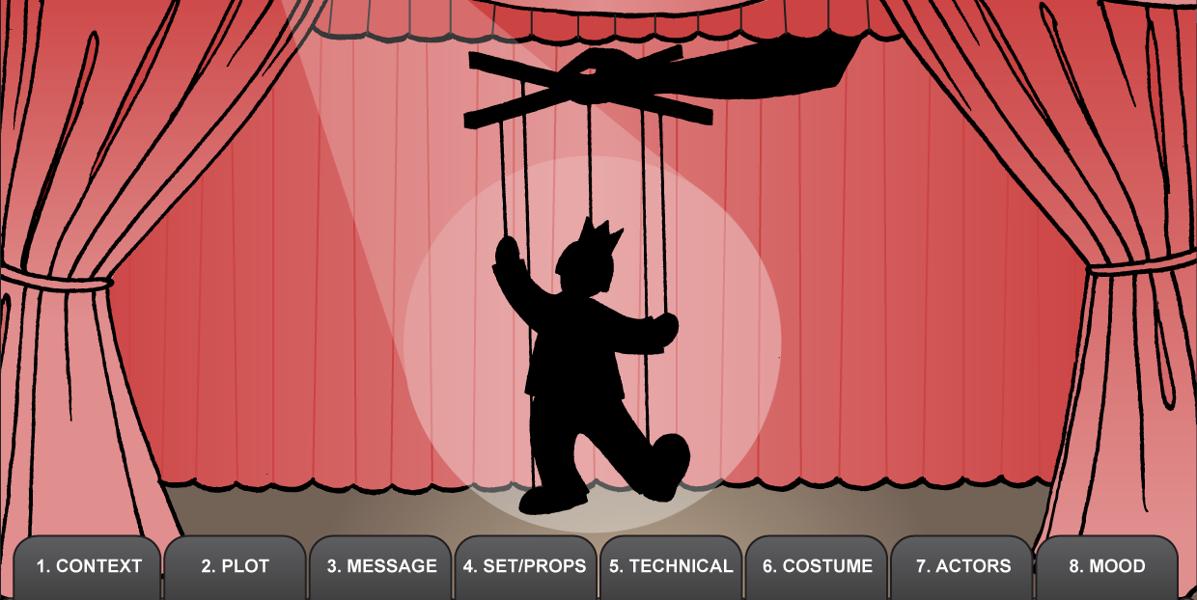
- What is the title? Who is the writer? Who are the performers?
When and where is it set?
- Write the plot or storyline in a few sentences.
- What is the purpose or message of the performance?
- What are the set and/or props?
How do they help the message of the performance?
- What lighting/sound/media/special effects are used in the performance?
How do they help the message of the performance?
- What costumes and/or make-up are used?
How do they support the performance?
- Are the actors believable in their role? Can you see and hear them?
How do they use language or movement to stand out in their roles?
- What is the mood of the performance?
How do the other elements help create this mood?
What aspects of the performance appeal to an audience? Why?

Student reflection — Dance performance
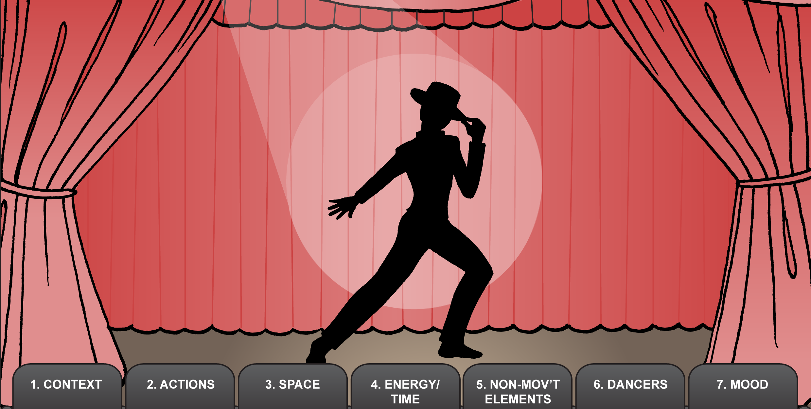
- What is the title? Who is the choreographer? Who are the dancers?
- What are the most common movements used?
- What are the most common spatial directions, levels and shapes?
How do they help express the dance theme or idea?
- What are the most common energy/time elements (stillness, qualities of movement, tempo, duration)?
How do these elements help express the dance theme, idea or mood?
- What are the main costumes, music, set and props?
How do they help express the dance theme, idea or mood?
- What dancers are strong in their performance?
How do they stand out?
- What is the theme, idea or mood?
How do the dance elements help create this theme, idea or mood?
What aspects of the performance appeal to an audience? Why?

Student reflection — Music performance
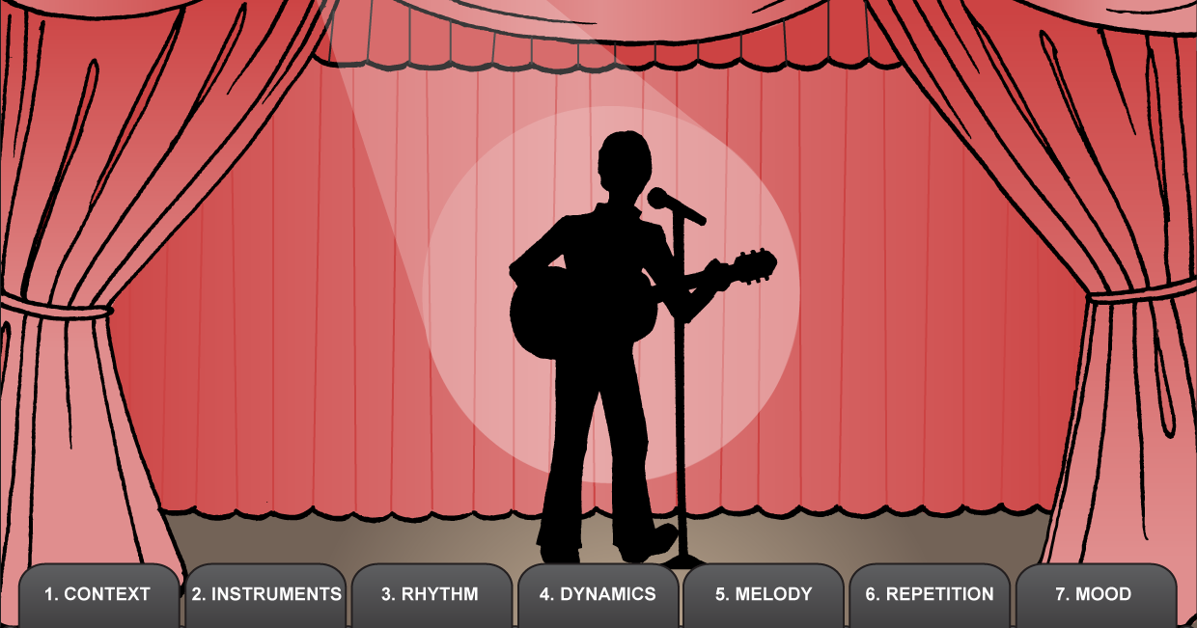
- What is the title? Who is the composer? Who are the performers?
- What instruments can you hear?
What instruments have the main role in the music? What do you hear the main instruments doing? How do they help express the mood?
- What instruments contribute most to the rhythm?
- What dynamics are used in the music (loud, soft, crescendo, decrescendo)?
How do the dynamics affect the overall performance of the music?
- What instrument/s play/s the melody?
How would you describe the melody (is it high or low, smooth or jumpy)? Do you like it? Why?
- Where in the music can you hear repetition (repeated patterns)? Is it in the melody or the rhythm, at the beginning, throughout, or at the end? What instruments play these repeated patterns?
How would you describe the repetition you hear?
- What is the mood of the music?
How is this created?
What aspects of the performance appeal to an audience? Why?

Guidelines for structuring your roleplay — Drama
Note: You do not have to include all information in your roleplay. You may be writing about the specific section or scene you want to focus on.

Introduction
- What was the title of the drama performance?
- Who wrote it?
- Who performed it?
- When is the performance set?
- Where is it set?
- Write the plot or storyline in a few sentences.
- Was it written for a specific purpose?
- Was there a particular message in the performance?

Body
What aspects of the performance would appeal to an audience? Why?
- What were the set and/or props? How did they help the message or mood of the play?
- How did the costumes support the play?
- How did the make-up support the play?
- How did the lighting/sound/media/special effects help the message of the play?
- Were the actors believable in their roles?
- Could you see and hear them?
- Did any actors stand out? How did they use language and/or movement to do this?

Conclusion
What are your recommendations for the audience?
- What was the mood of the performance? How did the dramatic elements help create this mood?
- Who was the performance aimed at?
- Do you think they enjoyed it?
- What is your final recommendation or thought about the show?

Guidelines for structuring your roleplay — Dance
Note: You do not have to include all information in your roleplay. You may be writing about the specific section or scene you want to focus on.

Introduction
- What was the title of the dance performance?
- Who choreographed the dance?
- Who performed it (dancers, dance company)?

Body
What aspects of the performance would appeal to an audience? Why?
- Describe the most common actions seen. How did they help communicate the dance theme or idea?
- Describe how the space was used (directions, levels, shapes). How did they help communicate the dance theme or idea?
- Describe the energy dynamics (stillness, qualities of movement, tempo, duration) of the actions seen. How did they help express the dance theme or idea?
- How did the costumes, music, set and/or props help support the dance theme or ideas?
- Were the dancers capable in their performance of the dance? How did they stand out? Give reasons.

Conclusion
What are your recommendations for the audience?
- Was the dance expressing a particular theme, idea or mood? How did the dance elements help create this mood?
- Who was the performance aimed at?
- Do you think they enjoyed it?
- What is your final recommendation or thought about the show?

Guidelines for structuring your roleplay — Music
Note: You do not have to include all information in your roleplay. You may be writing about the specific section or scene you want to focus on.

Introduction
- What was the title of the music performance?
- Who composed the music?
- Who performed it?

Body
What aspects of the performance would appeal to an audience? Why?
- Which instruments can you hear? What instruments have the main role in the music? What do you hear the main instruments doing? How do they help express the mood?
- Which instruments contribute most to the rhythm?
- Where in the music can you hear repetition (repeated patterns)? Is it in the melody or the rhythm, at the beginning, throughout, or at the end? What instruments play these repeated patterns? How would you describe the repetition you hear?
- Which instrument/s play/s the melody? Is it high or low, smooth or jumpy? How would you describe the melody?
- What dynamics were used in the music? Is it loud or soft? Does it crescendo or decrescendo? How did the dynamics affect the overall performance of the music?

Conclusion
What are your recommendations for the audience?
- What was the theme or mood of the music? How did the music elements help create this mood?
- Who was the performance aimed at?
- Do you think they enjoyed it?
- What is your final recommendation or thought about the show?

Vocal and physical warm-ups
It is vital to do these vocal and physical warm-ups before performing. They will help you avoid vocal or physical strain during the performance. It is also useful to do some warm-ups before any rehearsal to help you focus on the task that follows. Daily practice with these exercises will improve your vocal and physical flexibility.
Only do those exercises that you have already experienced in class.
Vocal
One of the most important things to do to maintain good vocal health is to keep your vocal chords lubricated. When you are rehearsing, performing, or just doing a lot of talking, keep water nearby and sip it as often as you can. Don’t let your vocal chords dry out.
Clarity of speech can be helped by exercises and tongue twisters. It is important to try to make the sounds as clearly and quickly as possible. Try these:
- Divide the group into four. Each sub-group takes a turn at the following phrases:
- Boom boom boom boom (keeping a steady beat)
- Baba baba baba bah
- Dah digga digga digga digga digga dah
- Shika tika shika tika shika tika shah
- Look around the space and name everything you see with its real name. Then give them gibberish names such as ‘blof’ for clock.
- Choose a phrase to ‘speak’ silently. Open your mouth wide and exaggerate the articulation so observers can guess the phrase.
- Give a ‘silent’ scream.
Breathing and projection
The basis of all voice projection is breathing and breath control. Follow these steps:
- Lie on your back on the floor. Rest your hands lightly on your diaphragm (just above your stomach).
- Breathe in, trying to fill the lowest part of your lungs. Feel your diaphragm working.
- Breathe in 1, 2, 3; hold 1, 2, 3; breathe out 1, 2, 3.
- With soft knees, bend forward from the hips, keeping a nice, straight back, breath in and out.
- Breathe out as much as you can. Holding your nose, scrunch as small as you can then release your nose and slowly stand up, allowing the vacuum to pull air back into your lungs.
- Walk, 2, 3 and jump on ‘Ha!’.
- To gauge how your capacity and control have improved, choose a fixed spot some distance away from where you are standing and count how many times you can clearly speak the letters of the alphabet, projecting your voice to that spot.
Physical
Physical warm–ups help you avoid tension in workshops and performance. Try these:
- A gentle body roll. Start in neutral stance. Gradually, and in turn, push your knees forward, then your hips, then stomach, chest, nose. Go back to the knees and establish a gentle pattern and rhythm.
- Repeat above and freeze in one position. Carry this position through to a walk around the room.
- Exaggerate the posture and add a letter of the alphabet to develop a voice for this character walk, e.g. a stomach person may walk with a big, round “O” sound, and a nose person may use “E”.
- Milk carton volleyball. Hit a milk carton up into the air and see how many hits the group can count before the carton drops to the floor.
- Let your little light shine. Start in neutral stance. Pretend you have little lights on different parts of your body and shine those lights in little, slow circles. Use your big toes, knees, finger tips, shoulders, elbows, nose and so on. Change the direction of the circles.
- Fixed point. Choose a fixed point somewhere in the room. Run around the room and, when the leader calls a part of the body, freeze and point that part of the body to the fixed point. It may be right knee, left elbow, forehead, and so on.
Adapted from “Warm-ups: Student resource 4”, The Office of the Queensland School Curriculum Council 2002.

