The artistic audience — KITE Arts Education Program @ QPAC

|  |  |
| --- | --- |
| Year 3 | The Arts — Drama |
| Students respond to a drama performance. | |
| **Time allocation** | 3 hours |
| Context for assessment  Children should be encouraged to learn in, through, and about the arts by actively engaging in the processes of responding to quality arts experiences. Using a theatre experience allows them to think critically about what they are seeing, and to critique and express their ideas clearly, articulately and honestly. Students become participants in the interactive process between artist and audience rather than passive consumers of the arts. The responding process supports the development of a dramatic language and a deeper understanding of the meaning of the production. This assessment will provoke students to interpret the production to support their responding experience.  This responding process could be adapted and applied to any live or recorded performance. | |

******This assessment gathers evidence of learning for the following **Essential Learnings**:

|  |  |
| --- | --- |
| The Arts Essential Learnings by the end of Year 3 | |
| Ways of working Students are able to:   * respond to arts works and describe initial impressions and personal interpretations, using arts elements and languages. | Knowledge and understanding *Drama*  Drama involves using dramatic elements and conventions to express ideas, considering particular audiences and particular purposes, through dramatic action based on real or imagined events.   * Role can be established using movement, voice, performance space, cues and turn-taking. * Purpose and context are used to shape roles, language, place and space to express ideas. * Dramatic action is structured by being in role and building storydramas. |
| Assessable elements  * Knowledge and understanding * Responding | |
| Source: Queensland Studies Authority 2007, The Arts Essential Learnings by the end of Year 3, QSA, Brisbane. | |

Links to other KLAs

This assessment could be expanded to assess the following **Essential Learnings**:

|  |  |
| --- | --- |
| English Essential Learnings by the end of Year 3 | |
| Ways of working Students are able to:   * recognise and select vocabulary to describe subject matter * interpret how people, characters, places, events and things have been represented * make judgments and justify opinions about their enjoyment and appreciation of texts using personal knowledge, experiences and direct references to the texts. | Knowledge and understanding *Writing and designing*  Writing and designing involve using language elements to construct literary and non-literary texts for familiar contexts.   * Words and phrases, symbols, images and audio have meaning.   *Language elements*  Interpreting and constructing texts involve exploring and using grammar, punctuation, vocabulary, audio and visual elements, in print-based, electronic and face-to-face modes (speaking and listening, reading and viewing, writing and designing) in familiar contexts.   * Vocabulary describes, labels and sequences, and can represent people, characters, places, events and things. * Auditory, spoken, visual and nonverbal elements provide details necessary for making meaning about the representations of people, places and things.   *Literary and non-literary texts*  Exploring literary and non-literary texts involves developing an awareness of purpose, audience, subject matter and text structure.   * Non-literary texts can convey an opinion that may be positive or negative. |
| Source: Queensland Studies Authority 2007, English Essential Learnings by the end of Year 3, QSA, Brisbane. | |

If teachers wanted to develop the drawing aspect of this assessment or use other forms of visual art to express ideas about the performance, they may also expand this assessment to assess the following **Essential Learnings**:

|  |  |
| --- | --- |
| The Arts Essential Learnings by the end of Year 3 | |
| Ways of working Students are able to:   * select ideas for arts works, considering particular audiences and particular purposes, using arts elements and languages * create and shape arts works by combining arts elements to express personal ideas, feelings and experiences * practise arts works, using interpretive and technical skills * present arts works to familiar audiences, using arts techniques, skills and processes. | Knowledge and understanding *Visual Art*  Visual Art involves using visual arts elements, concepts, processes and forms (both 2D and 3D) to express ideas, considering particular audiences and particular purposes, through images and objects.   * Warm (red, orange, yellow) and cool (blue, green, purple) colour schemes, and mixed and complementary colours, are used to create tone and variation. * Line is used to suggest movement and direction. * Regular, irregular, open, enclosed, overlapped and adjacent shapes are used to create categories and position. * Texture is used to create variation and repetition. |
| Source: Queensland Studies Authority 2007, The Arts Essential Learnings by the end of Year 3, QSA, Brisbane. | |

Listed here are suggested **learning experiences** for students before attempting this assessment.

* 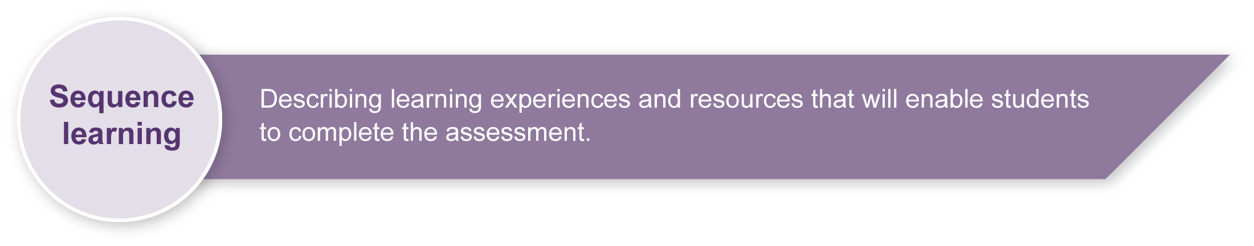Respond to performances using drama elements, focusing on role, place and mood. Teachers could use Appendix A: Queensland Arts Council resource — written response as a framework for this activity.
* Participate in drama activities to develop soundscapes and freeze frames. Teachers could use Appendix B: Queensland Arts Council resource — visual/practical response as a framework for this activity.
* Look at and interpret visual stimuli (e.g. posters, drawings, flyers, advertisements).
* Construct word banks or word walls to develop suitable words for discussing theatre and drama. Teachers could use Appendix C: Word bank and/or Appendix D: Drama glossary to guide students in this process.
* Respond to live or recorded performances using other art forms and elements (e.g. creating a dance in response to a performance, painting a picture that expresses how they felt about a performance).
* Practise giving and receiving feedback on written responses to performances.
* Talk to students about the theatre they will be attending (it may be useful to show a picture) and discuss the concept of lights going down. Explore:
* Who has seen a play in a theatre before?
* How is it different to watching television or a film?
* What should they do if they are feeling scared or uncomfortable?
* Discuss behaviour expectations when attending a theatre performance. (See Appendix E: Audience etiquette).

|  |  |
| --- | --- |
| Icon_Resource | Teacher resources |

* *Pretending to Learn: Helping children learn through Drama*, O’Toole, J & Dunn, J 2002, Pearson Education, Australia.

Provides information on teaching drama in the primary classroom including drama teaching structures, techniques, strategies, and approaches for the classroom, exemplars of extended drama work and ideas for planning, assessment strategies and classroom management.

**Accessing live performances**

* KITE Arts Education Program @ QPAC: <www.qpac.com.au/education>.

This is an early childhood arts education initiative that delivers relevant contemporary arts education experiences for Prep to Year 3 students across Queensland. Archived Teacher guides from past productions including alternate visual stimulus can also be found on this site.

* Queensland Arts Council’s Ontour inschools program provides arts access statewide. Details on touring shows and resources can be found at: <www.qac.org.au/htm/inschools.asp>.

## redesign headings_developPreparing

Consider these points before implementing the assessment.

* Appendix D: Drama glossary and Appendix E: Audience etiquette should be copied or transferred onto OHTs for class review.
* Appendix F: Visual stimulus — poster for the productionshould be copied to A3 size for student viewing.

## Possible extension activities

Students create and shape a prop using collage materials.

Teachers could develop the drawing aspect of this assessment or use other forms of visual art to express ideas about the performance.

|  |  |
| --- | --- |
| Icon_Resource | Resources for the assessment |

Appendix A Queensland Arts Council resource — written response

Appendix B Queensland Arts Council resource — visual/practical response

Appendix C Word bank

Appendix D Drama glossary

Appendix E Audience etiquette

Appendix F Visual stimulus — poster for the performance

Detailed teacher notes for *Boat*, a performance commissioned and produced by QPAC for KITE Arts Education Program, are available in PDF form at: <www.qpac.com.au/education/images/boat\_teachers\_notes.pdf>.

## Sample implementation plan

This table shows one way that this assessment can be implemented. It is a guide only — you may choose to use all, part, or none of the table. You may customise the table to suit your students and their school environment.

|  |  |  |  |
| --- | --- | --- | --- |
| **Suggested time** | **Student activity** | **Teacher role** | |
| **Section 1. Before the performance** | | |
| 15 minutes | Students interpret a visual stimulus by examining a flyer or poster of the performance and discussing its meaning (with teacher direction).  Listen to background information on the performance. | Lead discussion on Appendix F: Visual stimulus — poster for the performance using guiding questions from the *Student booklet*.  Explain roles like director, designer, writer, etc. Use Appendix D: Drama glossary.  Discuss key words and themes relating to the performance, without giving away the plot — a synopsis is available in the Teacher notes referenced in Resources for the assessment. | |
| **Section 2. Watch the performance** | | |
| 10 minutes (prior discussion)  1 hour (performance) | Watch the performance. | Reinforce audience etiquette and how to approach a theatre performance. Use Appendix E: Audience etiquette. | |
| **Section 3. After the performance** | | |
| 1 hour | Work in pairs to reflect on initial impressions of the performance.  Join in a class discussion about the production.  Work in groups to create freeze frames.  Discuss and complete details on mood in their journals.  Work in small groups or pairs to create a soundscape.  Complete individual responses that reflect on their experience after watching the performance. | Start generating thoughts about the production — share ideas around the class.  Clarify any confusion.  Use Appendix C: Word bank and brainstorm with class to add more words.  Encourage students to visualise the drama to enable them to formulate written work and stimulate thinking post production.  Refer to the visuals to encourage more detail and entry points for the writing of responses.  Guide and assist as needed. | |
| 15 minutes | Students display their journals around the class so that they can be read by others. | Remind students to be sensitive to the work of others. | |

During the learning process, you and your students should have developed a shared understanding of the curriculum expectations identified as part of the planning process.

After students have completed the assessment, identify, gather and interpret the information provided in student responses. Use only the evidence in student responses to make your judgment about the quality of the student learning. Refer to the following documents to assist you in making standards-referenced judgments:

* *Guide to making judgments*
* *Indicative A response*
* *Sample responses* (where available).

### Making judgments about this assessment

When making an overall judgment of the quality of student learning, consideration and observation of individual student participation during groupwork will be required (e.g. freeze frames and soundscapes). Teachers are encouraged to take video or digital evidence of the assessment to support their judgments.

|  |  |
| --- | --- |
| Icon_ForFurtherHelp | For further information, refer to the resource *Using a Guide to making judgments*, available in the Resources section of the Assessment Bank website. |

Evaluate the information gathered from the assessment to inform teaching and learning strategies.

Involve students in the feedback process. Give students opportunities to ask follow-up questions and share their learning observations or experiences.

Focus feedback on the student’s personal progress. Emphasise continuous progress relative to their previous achievement and to the learning expectations — avoid comparing a student with their classmates.

### Giving feedback about this assessment

Teachers will need to provide feedback on how students respond to drama. This may be given individually to students, to small groups or to whole class as particular needs are identified.

When students are providing feedback for each other it is important to encourage the use of appropriate drama languages.

|  |  |
| --- | --- |
| Icon_ForFurtherHelp | For further information, refer to the resource *Using feedback*, available in the Resources section of the Assessment Bank website. |

Queensland Arts Council resource — written response

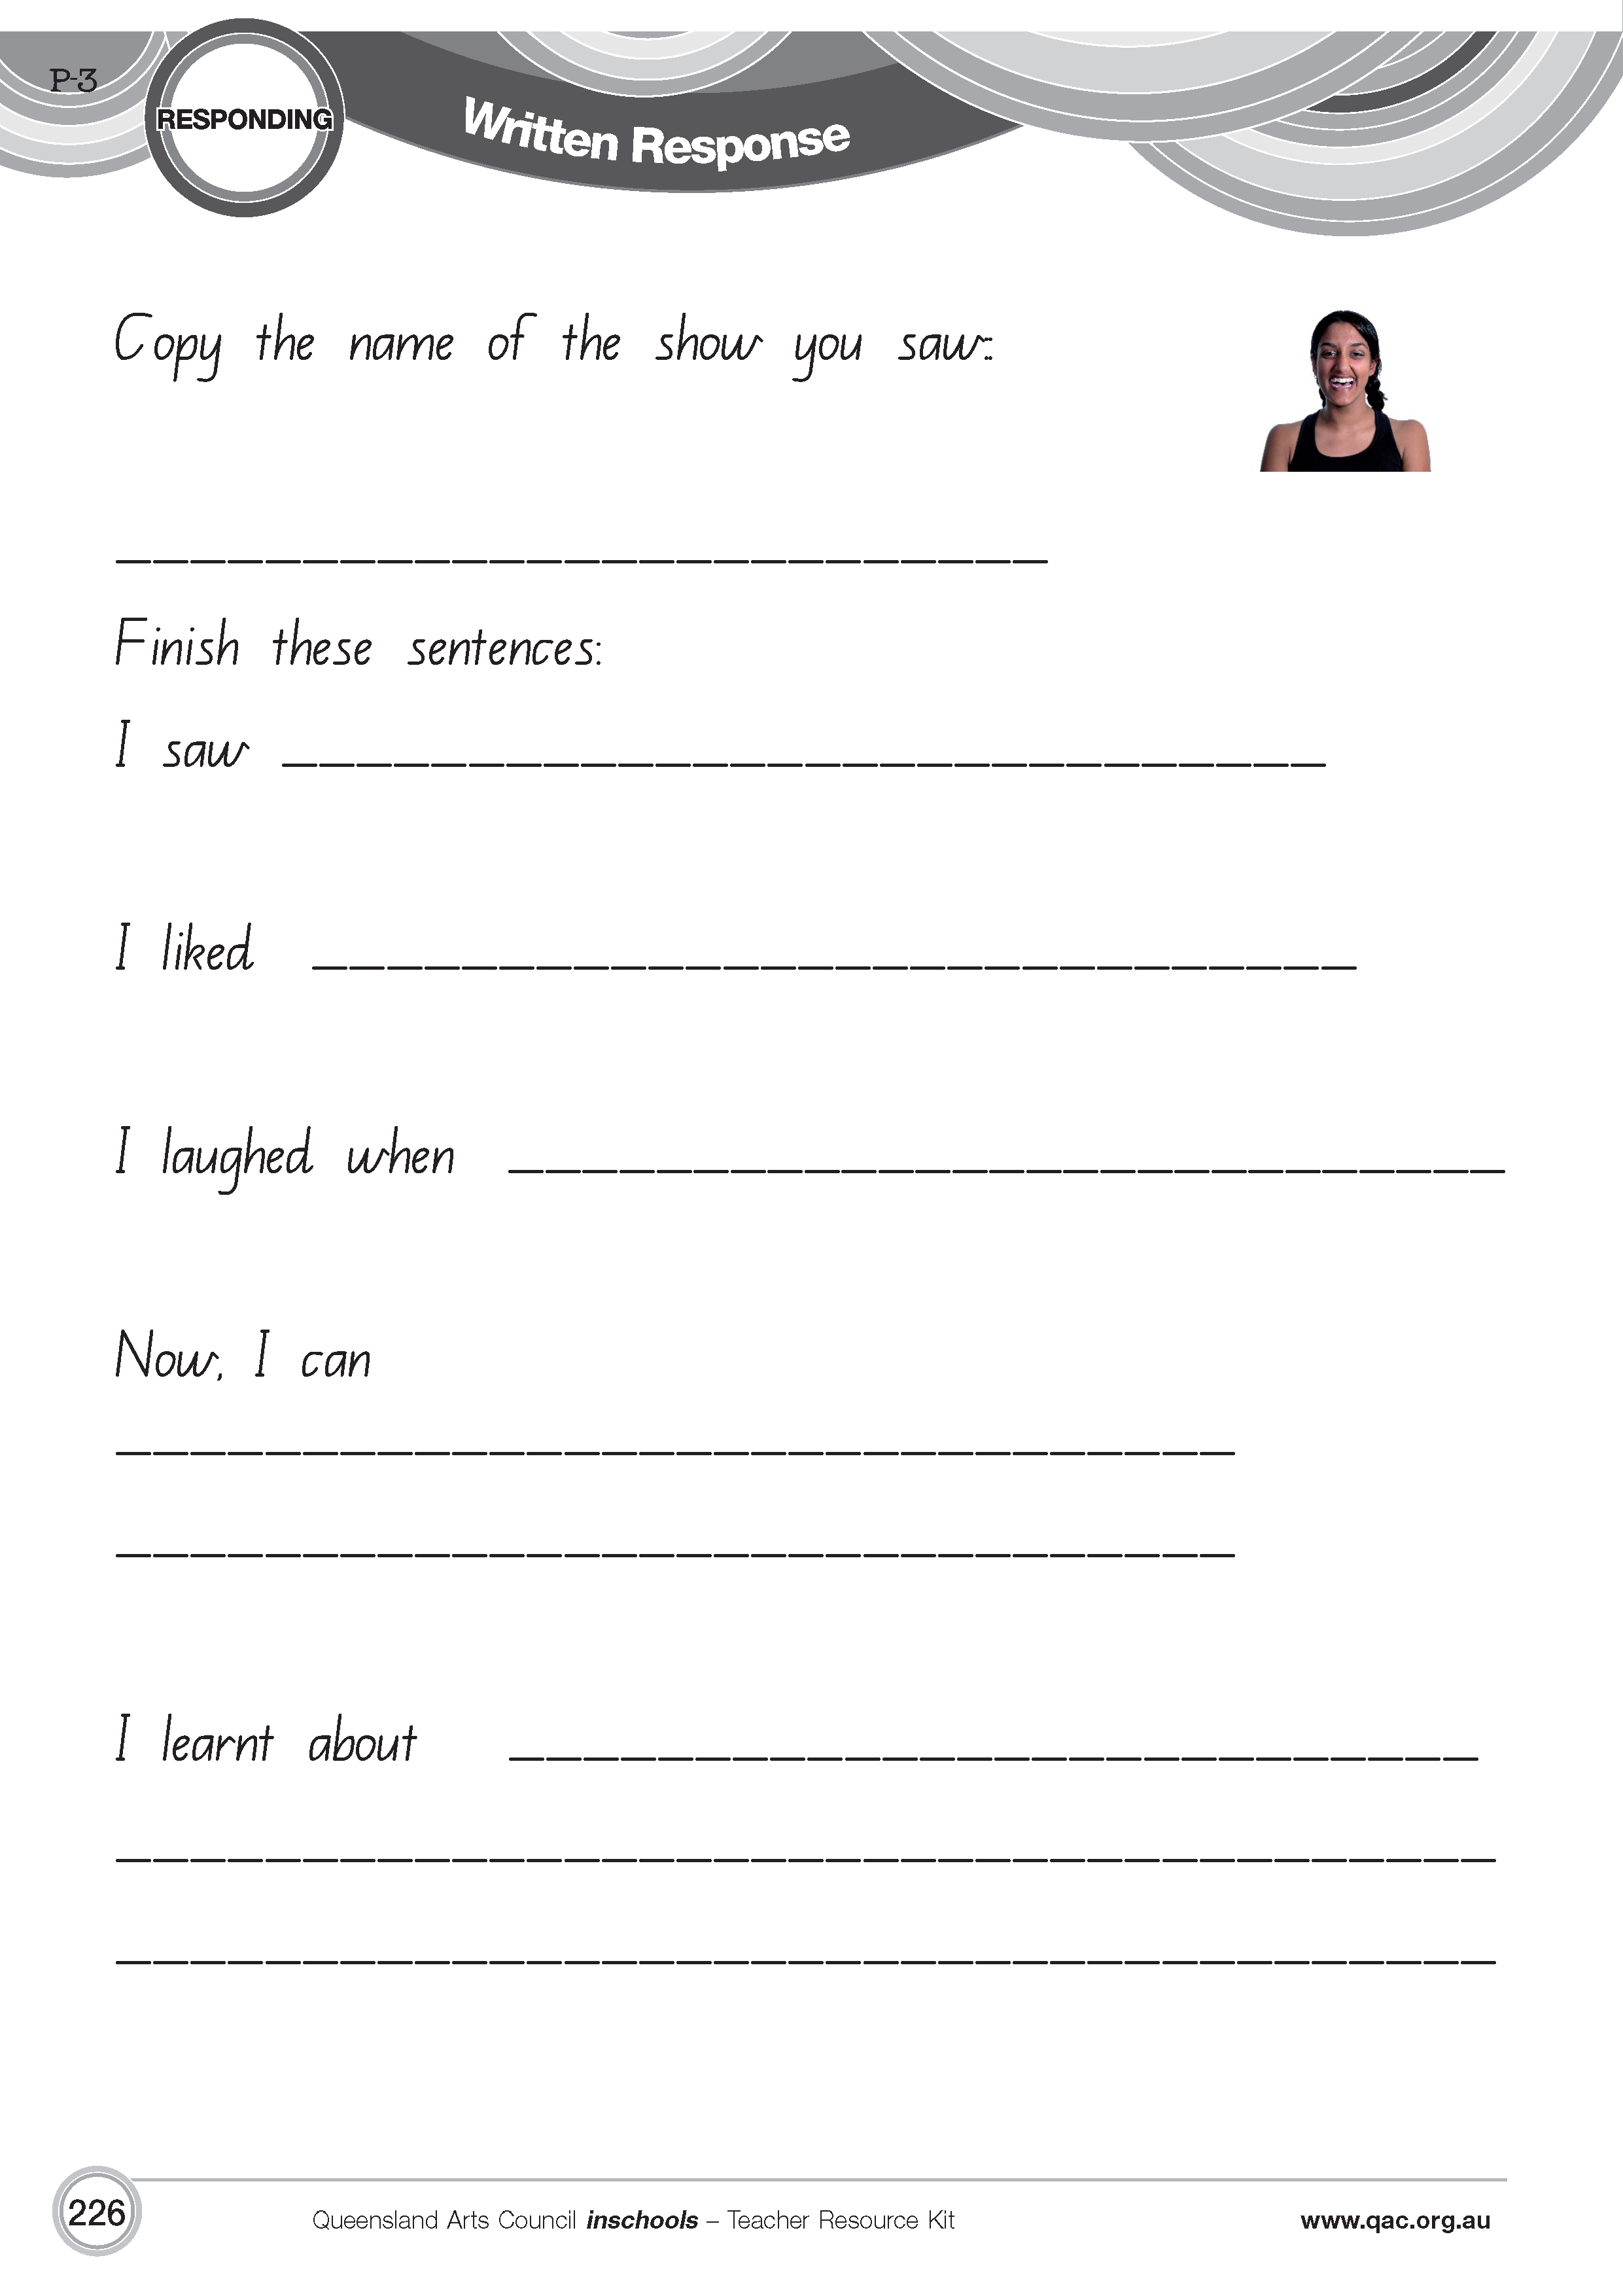

Queensland Arts Council resource — visual/practical response

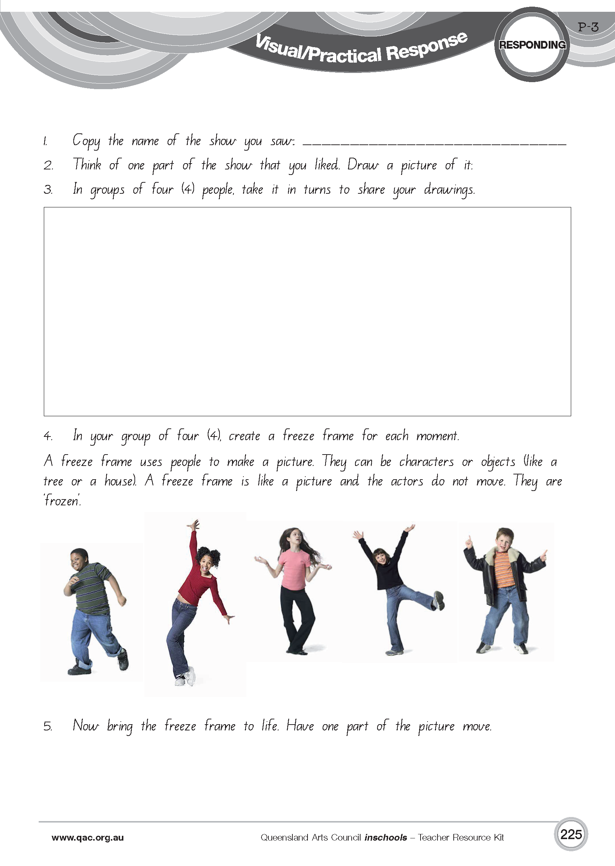

|  |  |  |  |  |  |  |  |  |  |  |  |  |  |  |  |  |  |  |  |  |  |  |  |  |  |  |  |  |  |  |  |  |  |  |  |  |  |  |  |  |  |  |  |  |  |  |  |  |  |  |  |  |  |  |  |  |  |  |  |  |
| --- | --- | --- | --- | --- | --- | --- | --- | --- | --- | --- | --- | --- | --- | --- | --- | --- | --- | --- | --- | --- | --- | --- | --- | --- | --- | --- | --- | --- | --- | --- | --- | --- | --- | --- | --- | --- | --- | --- | --- | --- | --- | --- | --- | --- | --- | --- | --- | --- | --- | --- | --- | --- | --- | --- | --- | --- | --- | --- | --- | --- |
| Word bank   |  |  |  |  |  |  | | --- | --- | --- | --- | --- | --- | | smileys 2 | smileys 9 rgb | | smileys 3 | | smileys 8 rgb | | exciting | | shy | | role | | | believable | | confident | | place | | | happy | | cheeky | | mood | | | sad | | safe | | sound | | | strong | | risky | | lighting | | | powerful | | appealing | | prop | | | friendly | | peaceful | | plot | | |  | |  | |  | | |  | |  | |  | |   You will be adding to this list with the help of your teacher and other classmates. |

|  |  |  |  |  |  |  |  |  |  |  |  |  |  |  |  |  |  |  |  |  |
| --- | --- | --- | --- | --- | --- | --- | --- | --- | --- | --- | --- | --- | --- | --- | --- | --- | --- | --- | --- | --- |
| Drama glossary   |  |  | | --- | --- | | Prop | Object used by individuals when in role. | | Role | Acting "as if " they are someone else. | | Place | Where the action happens (time and setting). | | Mood | The tone, atmosphere or feeling of the performance, often created by the music, setting, or lighting. | | Freeze frame | A convention in which the members of a group use their bodies to make an image or tableau capturing an idea, theme or moment in time, also called a group sculpture, tableau or still image. | | Soundscape | An atmosphere or environment created by or with sound. | | Plot | A brief outline of the events in the narrative of a drama or play text. | | Director | The person who is responsible for the overall interpretation of a dramatic work, bringing all the elements together to create a unified production. | | Designer | The person responsible for planning visual and sound aspects of a production, including costumes, set, props, lights, makeup, and sound. | | Writer | The person responsible for documenting the ideas for dramatic action. | |

Adapted from ”Drama Glossary”, *The Arts Years 1 to 10 Curriculum Materials,* Queensland School Curriculum Council 2002 (CD-ROM) and <www.ket.org/artstoolkit/drama/glossary.htm>.

|  |  |  |  |  |  |  |  |  |  |  |  |  |  |  |  |
| --- | --- | --- | --- | --- | --- | --- | --- | --- | --- | --- | --- | --- | --- | --- | --- |
| |  |  |  |  |  | | --- | --- | --- | --- | --- | | Audience etiquette | | | | | |  | Looks like …   * people watching attentively * people sitting focused and looking towards the performers * may see people laughing. | | |  | | Sounds like …   * praise and encouragement with clapping at end of performance * positive, respectful comments * laughter and enjoyment of the performance. | |  | Feels like …   * everyone is valued * worthwhile contributions by all students * audience is motivated, engaged and interested * performers try their best * warm, fun and supportive atmosphere. | |   theatre_audience |

Visual stimulus — poster for the production

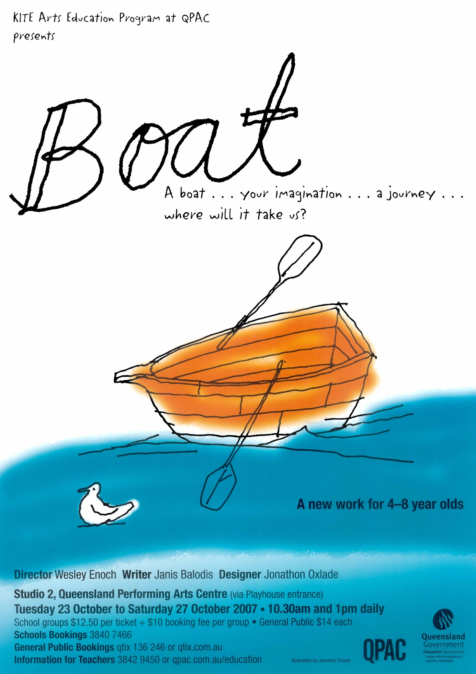

*Boat* was commissioned and produced by QPAC for KITE Arts Education Program. Boat image created by Jonathon Oxlade.