Textile production
Year 8 | Technology
In response to a production company’s design brief, students create a textile product that has a protective function and appeals to the teenage market.
Time allocation | 4–5 weeks
Student roles | Students develop a production plan, make a product and incorporate one embellishment technique. They will then evaluate the product and production process.
Context for assessment
In this assessment, students produce a textile product that appeals to teenage consumers and has a protective function. Teachers could develop this assessment further to include a design phase. Another Technology assessment, Textile design, gives an example of design phase.
This assessment gathers evidence of learning for the following Essential Learnings:
Technology Essential Learnings by the end of Year 9
Ways of working  Students are able to:  - investigate and analyse specifications, standards and constraints in the development of design ideas  - select resources, techniques and tools to make products that meet detailed specifications  - plan, manage and refine production procedures for efficiency  - make products to meet detailed specifications by manipulating or processing resources  - identify, apply and justify workplace health and safety practices  - evaluate the suitability of ideas, products and processes against criteria and recommend improvements  - reflect on learning, apply new understandings and justify future applications. | Knowledge and understanding  Information, materials and systems (resources)  Resources originate from different sources, exist in various forms and are manipulated to meet specifications and standards to make products.  - Characteristics of resources are compared, contrasted and selected to meet detailed specifications and predetermined standards of production to best suit the user.  - Techniques and tools are selected, controlled and managed to manipulate or process resources to meet detailed specifications and predetermined standards of production.

Assessable elements
- Knowledge and understanding
- Investigating and designing
- Producing
- Evaluating
- Reflecting
Source: Queensland Studies Authority 2007, Technology Essential Learnings by the end of Year 9, QSA, Brisbane.

Information and Communication Technologies (ICTs)
Cross-curriculum priority by the end of Year 9
Inquiring with ICTs
Students explore, select and use ICTs in the processes of inquiry across key learning areas. They:
- identify the inquiry focus, data and information requirements and a range of digital information sources
- plan, conduct and refine advanced searches, and select appropriate sources of digital information in response to research questions
- classify, organise, analyse and interpret data and information from a variety of sources to respond to inquiries, or to identify new paths for inquiries.
Source: Queensland Studies Authority 2007, Cross-curriculum priority by the end of Year 9, QSA, Brisbane.

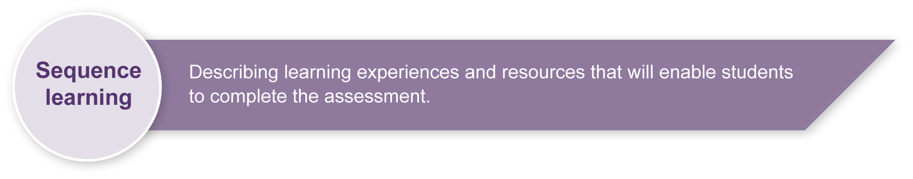
Listed here are suggested learning experiences for students before implementing this assessment.
- Review technology practice — investigation, ideation, production and evaluation.
- Look at production organisation, including how to write a production plan.
- Read and interpret instructions for cutting out and construction of product.
- Work with patterns — pinning, cutting, storage.
- Review functions of textile items and the characteristics of some fibres.
- Investigate embellishment and decoration ideas.
- Identify workplace health and safety practices.
- Practise machine sewing skills — practical experiences on scraps of different fabrics.
- Experiment with different types of fabric paints and stencilling on scraps of fabric.
- Design and make a garment label — experiment with techniques.
- Learn how to compose a reflection.

Teacher resources

Web resources
- About.com: Sewing, accessed 5 June 2008 <http://sewing.about.com/>, includes links to sewing machine basics, sewing terms and a glossary, fabric information and care.
- A glossary of useful sewing terms, accessed 5 June 2008: <www.diceyhome.free-online.co.uk/KatePages/Learning/Useful-sewing-terms.htm>.
- Australian Country Craft and Decorating, available from newsagents with additional tips and patterns on the website: <www.accmagazine.com.au>.
- The Australian Forum for Textile Arts is a source of inspiration and background reading for textile arts and has online forums: <www.ggcreations.com.au/tafta>.
- The Thread Studio, accessed 6 June 2008, <www.thethreadstudio.com>.
This site allows students to explore the work of 10 different textile artists. They can see samples of their work, and read about their inspiration and the type of textile art they use.

Print resources
- Pattern books
- Magazines about sports, surfing, skateboarding, mountain bike and fashion that appeal to young teens (e.g. Dolly, Teen Vogue, Inside Sport)

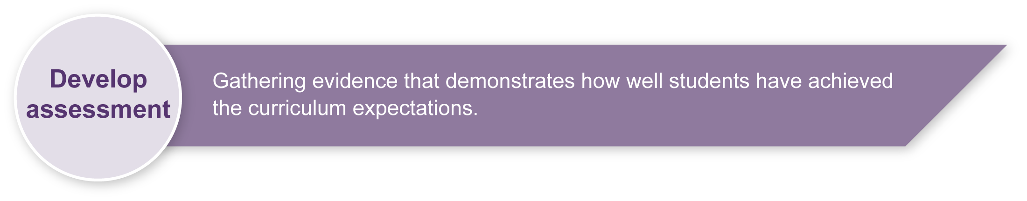
Preparing
Consider these points before implementing the assessment.
- Teachers should choose suitable options and patterns for supply to students (e.g. blanket or pillowcase, pencil cases, drawstring bags, sun safe shirts, apron).
- Students will complete a production plan for the design they are going to use to make the product. Students will need:
- a journal or paper suitable for recording their ideas and decisions for their production plan
- sufficient access to sewing machines.
- Students should not be disadvantaged through lack of access to materials needed to make the product. The product does not need to be large or require large amounts of fabric. It could be small enough to be made from remnants available at the school and decorated with fabric or inexpensive items.
- Resources such as patterns or products to examine may need to be supplied by the school.

Implementation
Consider these points when implementing the assessment.
- The assessment should be completed over 4–5 weeks but the time needed will depend on school timetabling, availability of resources and students prior experiences.
- Student work will be self-paced. Give guidance on establishing timelines so that students are able to complete the assessment by the due date.

Resources for the assessment
- patterns
- fabrics
- sewing notions
- sewing equipment (pins, scissors, tape measures, etc.)
- sewing machines
During the learning process, you and your students should have developed a shared understanding of the curriculum expectations identified as part of the planning process.
After students have completed the assessment, identify, gather and interpret the information provided in student responses. Use only the evidence in student responses to make your judgment about the quality of the student learning. Refer to the following documents to assist you in making standards-referenced judgments:
- Guide to making judgments
- Indicative A response
- Sample responses (where available).
For further information, refer to the resource Using a Guide to making judgments, available in the Resources section of the Assessment Bank website.
Evaluate the information gathered from the assessment to inform teaching and learning strategies.
Involve students in the feedback process. Give students opportunities to ask follow-up questions and share their learning observations or experiences.
Focus feedback on the student’s personal progress. Emphasise continuous progress relative to their previous achievement and to the learning expectations — avoid comparing a student with their classmates.
For further information, refer to the resource Using feedback, available in the Resources section of the Assessment Bank website.

