Textile design
Year 9 | Technology
Time allocation | 6 hours
Student roles | Individual research, design, evaluation and reflection
Context for assessment
A production company wants to break into the protective clothing market with products that appeal to teenagers, meet safety regulations and provide protection. Students, in the role of designers for the production company, design a textile product that has a protective function and appeals to teenage consumers.
Teachers could build on the technology process within this assessment by asking students to develop a production plan and create a product from their design. Another Technology assessment, Textile production, gives an example of production plans.
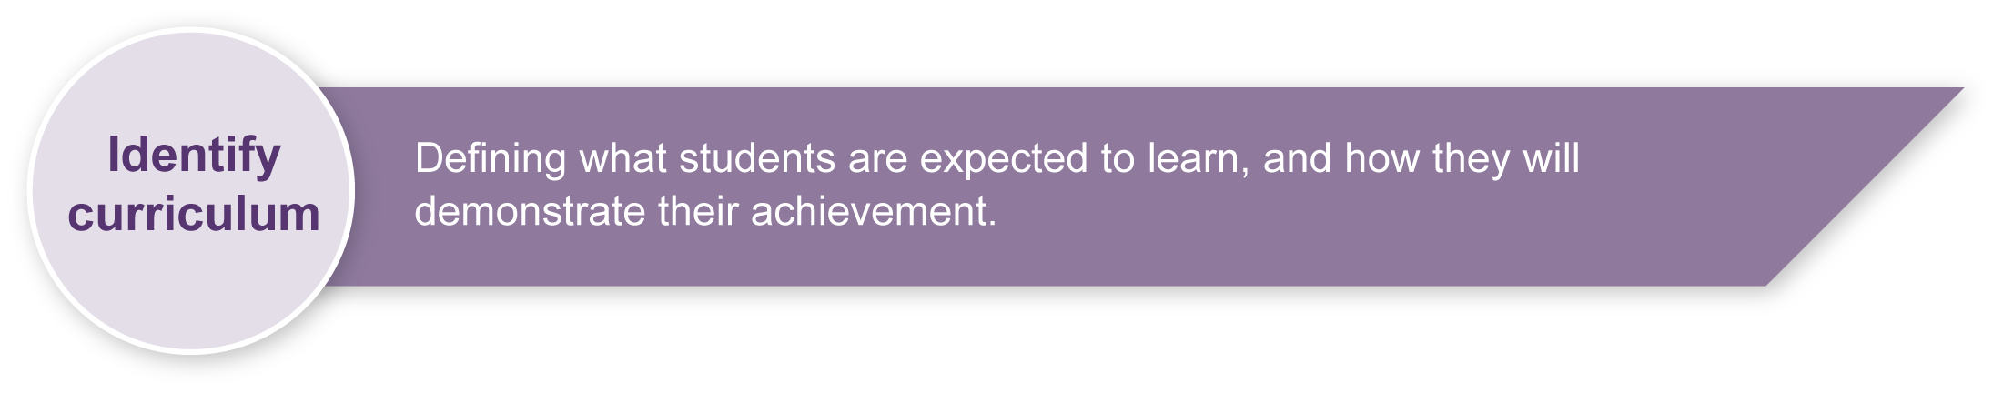
This assessment gathers evidence of learning for the following Essential Learnings:
Technology Essential Learnings by the end of Year 9
Ways of working  Students are able to:  - investigate and analyse specifications, standards and constraints in the development of design ideas  - generate and evaluate design ideas and communicate research, design options, budget and timelines in design proposals  - select resources, techniques and tools to make products that meet detailed specifications  - evaluate the suitability of products and processes against criteria and recommend improvements  - reflect on learning, apply new understandings and justify future applications. | Knowledge and understanding  Technology as a human endeavour  Technology influences and impacts on people, their communities and environments in local and global contexts.  - Product design and production decisions are influenced by aspects of appropriateness and by detailed specifications, constraints and standards of production.  Information, materials and systems (resources)  Resources originate from different sources, exist in various forms and are manipulated to meet specifications and standards to make products.  - Characteristics of resources are compared, contrasted and selected to meet detailed specifications and predetermined standards of production to best suit the user.

Assessable elements
- Knowledge and understanding
- Investigating and designing
- Evaluating
- Reflecting
Source: Queensland Studies Authority 2007, Technology Essential Learnings by the end of Year 9, QSA, Brisbane.
Information and Communication Technologies (ICTs)
Cross-curriculum priority by the end of Year 9
Inquiring with ICTs
Students explore, select and use ICTs in the processes of inquiry and research across key learning areas. They:
- identify the inquiry focus, data and information requirements and a range of digital information sources
- plan, conduct and refine advanced searches, and select appropriate sources of digital information in response to research questions
- classify, organise, analyse and interpret data and information from a variety of sources to respond to inquiries, or to identify new paths for inquiries.
Source: Queensland Studies Authority 2007, Cross-curriculum priority by the end of Year 9, QSA, Brisbane.
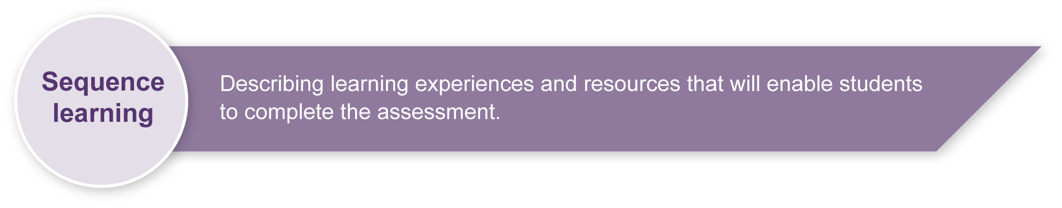
Listed here are suggested learning experiences for students before implementing this assessment.
- Investigate methods of research and data collection that could be used to gain information about products and their functions, teenage preferences, embellishments, needs and wants (e.g. surveys, interviews, product scans, internet, magazines).
- Scrutinise and collate data.
- Explore:
- design elements and principles (refer to Appendix A: Glossary of design elements and principles)
- fabric origins and properties
- how to match design ideas with design brief requirements
- use of technology in textile product design
- ways to develop and communicate ideas using appropriate methods such as sketches, drawings, labels, verbal descriptions, prototypes.
- Identify, understand and describe ways products might be constructed and embellished.
- Write and interpret feedback on design ideas and justify reasons.
- Draw conclusions to justify design and production decisions.
- Evaluate the success or challenges of a product.
- Understand the process and features of reflecting on the learning process.

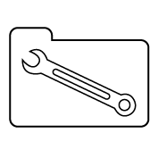 | Teacher resources

Web resources
- About.com: Sewing, accessed 5 June 2008 <http://sewing.about.com/>, includes links to sewing machine basics, sewing terms and a glossary, fabric information and care.
- A glossary of useful sewing terms, accessed 5 June 2008: <www.diceyhome.free-online.co.uk/KatePages/Learning/Useful-sewing-terms.htm>.
- Australian Country Craft and Decorating, available from newsagents with additional tips and patterns on the website: <www.accmagazine.com.au>.
- The Australian Forum for Textile Arts is a source of inspiration and background reading for textile arts and has online forums: <www.ggcreations.com.au/tafta>.
- The Thread Studio, accessed 6 June 2008, <www.thethreadstudio.com>.
This site allows students to explore the work of 10 different textile artists. They can see samples of their work, and read about their inspiration and the type of textile art they use.

Print resources
- Pattern books
- Magazines about sports, surfing, skateboarding, mountain bike and fashion that appeal to young teens (e.g. Dolly, Teen Vogue, Inside Sport)

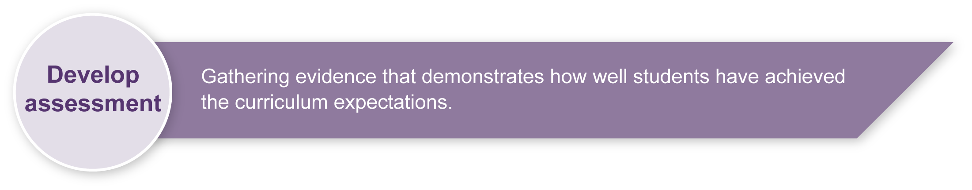
Preparing
Consider these points before implementing the assessment.
- Students will learn a range of design skills and develop an understanding of the functions of textile items and the characteristics of some fibres. Ensure they are familiar with the aspects of technology practice — investigate, ideate, produce and evaluate.

Implementation
Consider these points when implementing the assessment.
- This assessment should be completed over 3–4 weeks but the time needed will depend on school timetabling, availability of resources and students’ prior experiences.
- Implement this assessment in assignment conditions. This will allow teacher guidance while ensuring that students demonstrate their learning.
- Student work will be self-paced. Give guidance on establishing timelines so that students are able to complete the assessment by the due date.
- Students complete a design journal, working through the three Student booklet sections to:
- research products with protective functions, and teenage needs and wants
- analyse design options to meet the design brief and develop one idea into a clearly communicated design proposal that indicates construction lines (hems, seams, pockets, buttons, etc.) and justify design decisions
Note: Students could produce a prototype as a way of demonstrating their design ideas, but this is not essential. Drawings or sketches with accompanying labels and explanations are acceptable.
- complete a written reflection of their processes and ideas incorporating peer feedback.
- Ensure students have access to ICTs, facilities or materials needed to produce the assessment requirements.

Resources for the assessment
Appendix A Glossary of design elements and principles
Design proposal materials — suitable for recording ideas for the design proposal, such as unlined paper
Reflection record — notebook or paper suitable for recording ideas and decisions for the reflection
ICT and materials for developing a design
Prototype materials — suitable for developing a design prototype (optional)
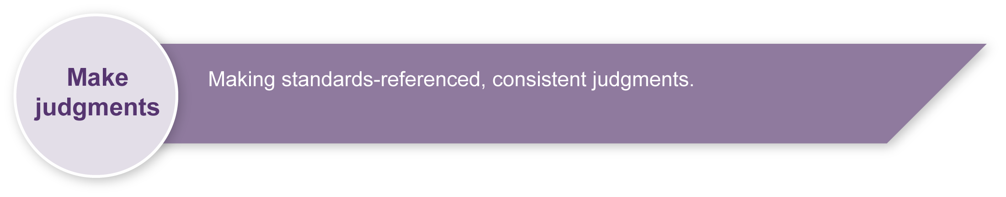
During the learning process, you and your students should have developed a shared understanding of the curriculum expectations identified as part of the planning process.
After students have completed the assessment, identify, gather and interpret the information provided in student responses. Use only the evidence in student responses to make your judgment about the quality of the student learning. Refer to the following documents to assist you in making standards-referenced judgments:
- Guide to making judgments
- Indicative A response
- Sample responses (where available).
For further information, refer to the resource Using a Guide to making judgments, available in the Resources section of the Assessment Bank website.
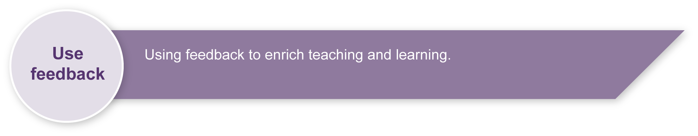
Evaluate the information gathered from the assessment to inform teaching and learning strategies.
Involve students in the feedback process. Give students opportunities to ask follow-up questions and share their learning observations or experiences.
Focus feedback on the student’s personal progress. Emphasise continuous progress relative to their previous achievement and to the learning expectations — avoid comparing a student with their classmates.
For further information, refer to the resource Using feedback, available in the Resources section of the Assessment Bank website.

Glossary of design elements and principles
When we talk about design we refer to elements and principles that are used in design work.
Elements — line, space, shape, value, texture, colour and form.
Principles — balance, movement, contrast, emphasis, repetition, unity and rhythm.
The elements are the “things” we work with, and the principles are what we do with them. In every product design there are some or all of these design elements.
Design elements
Lines | - are always combined with one or more of the other elements. Lines produce shapes  - can portray rhythm and movement. Lines can be expressive  - can be continuous, broken, implied, thick, thin, straight, curved  - can indicate a surface texture.
Shapes | - are flat, two-dimensional defined areas  - are produced by line  - can be defined by differences in colour, value or texture  - can be positive or negative  - can create pattern  - can be regular or free-form.
Forms | - are shapes with depth, length and width  - are three-dimensional  - have substance and occupy space. Forms cast a shadow when light fall on them.
Space | - is three-dimensional, in that it exists all around us. Forms have substance and occupy space  - is referred to as “positive space” when occupied  - is referred to as “negative space” when unoccupied.  There are many ways of achieving depth or space on a two dimensional surface (e.g. converging lines, overlapping shapes, objects placed higher on the picture plane, colour and value differences).
Value | - is the lightness or darkness of colour  - describes objects, shapes and spaces  - can evoke mood or emotion  - the impression of form on a two-dimensional surface  - is used by sculptors, photographers and architects to achieve effects.

Design elements (cont.)
Texture | - is the tactile quality of a surface  - can be real or implied  - can be two- or three-dimensional  - evokes an emotional response relating to our experiences  - slows our eye speed on a three-dimensional surface.
Colour | - is a sensation in the eye, caused by light  - can give a feeling of warm or cold  - can be used to express emotion  - can have symbolic meaning  - can appear to advance or recede.

Glossary of design elements and principles (cont.)

Design principles
Balance | - is a sense of stability applied to opposing visual attractions or forces  - can be symmetrical, asymmetrical or radial.
Movement | - is the path our eyes follow along a line or an arrangement of shapes  - may be kinetic (i.e. actual physical movement through space)  - may be apparent (i.e. motion perceived by the eye and the mind of the viewer)  - may be suggested (i.e. the image may evoke a sense of motion).
Repetition | - is arranging elements which have something in common, either regularly or irregularly, to create a rhythm.
Emphasis | - calls attention to important areas of a design; however, any one element should not totally dominate.
Contrast | - makes it possible to show differences (i.e. rough/smooth, light/dark, large/small).
Unity | The arrangement of elements into meaningful visual organisation is unity.

