Telling digital stories
Year 3 | The Arts — Media
Students use digital cameras and computers to create a digital photo production that tells the story of someone special to them. Students discuss their own process and digital photo production.
Time allocation | 2–3 hours, completed over one term.
Student roles | This assessment encourages collaborative planning and development of ideas, but the assessable components are undertaken individually.
Context for assessment
Media encourages young people to tell their own stories using forms that are familiar to them. In this assessment, students create their own media content consisting of photos and their own voice-over sound. Students will be involved in learning experiences that develop their ability to communicate visually and verbally. A unit encompassing this assessment could have links to family, documentary production and storytelling.
This assessment gathers evidence of learning for the following Essential Learnings.
The Arts Essential Learnings by the end of Year 3
Ways of working  Students are able to:  - select ideas for arts works, considering particular audiences and particular purposes, using arts elements and languages  - create and shape arts works by combining arts elements to express personal ideas, feelings and experiences  - practise arts works, using interpretive and technical skills  - respond to arts works and describe initial impressions and personal interpretations, using arts elements and languages  - reflect on learning to identify new understandings. | Knowledge and understanding  Media  Media involves constructing meaning by using media languages and technologies to express representations, considering particular audiences and particular purposes.  - Still and moving images, sounds and words are used in media texts.  - Media techniques and practices, including crop, print, record/capture and sequence images, sounds and words, are used to create media texts.  - Representations in media texts can be either real or imagined, and are created for particular audiences and purposes.

Assessable elements
- Creating
- Responding
- Reflecting
Source: Queensland Studies Authority 2007, The Arts Essential Learnings by the end of Year 3, QSA, Brisbane.

Links to other KLAs
This assessment could be expanded to assess the following Essential Learnings.
English Essential Learnings by the end of Year 3
Ways of working  Students are able to:  - identify audience, purpose and text type  - identify main ideas and the sequence of events, and make simple inferences  - recognise and select vocabulary to describe subject matter  - interpret how people, characters, places, events and things have been represented  - construct simple literary and non-literary texts by planning and by using prior knowledge and experience to match an audience and purpose  - make judgments and justify opinions about their enjoyment and appreciation of texts using personal knowledge, experiences and direct references to the texts  - reflect on and identify how language elements in texts represent people, characters, places, events and things in similar and different ways  - reflect on learning to identify new understandings. | Knowledge and understanding  Reading and viewing  Reading and viewing involve using a range of strategies to interpret and appreciate written, visual and multimodal texts in familiar contexts.  - Purposes for reading and viewing are identified and are supported by the selection of texts based on an overview that includes titles, visuals and headings.  - Readers and viewers make connections between their prior knowledge and the subject matter of the text.  - Words, groups of words, visual resources and images elaborate ideas and information, and portray people, characters, places, events and things in different ways.  Writing and designing  Writing and designing involve using language elements to construct literary and non-literary texts for familiar contexts.  - Writers and designers can adopt different roles for different audiences.  - Words and phrases, symbols, images and audio have meaning.  - Text users make choices about grammar and punctuation.  - Writers and designers refer to authoritative sources and use a number of active writing strategies, including planning, drafting, revising, editing, proofreading, publishing and reflecting.  - Writers and designers use correct formation, entries, exits and joins of Queensland Modern Cursive script.
Source: Queensland Studies Authority 2007, English Essential Learnings by the end of Year 3, QSA, Brisbane.
(Continued on next page)

English Essential Learnings by the end of Year 3
Literary and non-literary texts
Exploring literary and non-literary texts involves developing an awareness of purpose, audience, subject matter and text structure.
- Texts are produced for particular audiences and their interests.
- Formal and informal texts are ways of communicating for different purposes.
- Texts created by Aboriginal and Torres Strait Islander peoples reflect a range of ideas and information, relationships and connections.
- Literary texts entertain, evoke emotion and convey simple messages and information.
- Simple narratives, rhymed verse, fables and fairytales are types of literary texts.
- Narratives have structural features that include orientation, complication and resolution, and descriptions of characters and settings.
- Non-literary texts inform, report on events and issues, explain, explore ideas, express opinions, conduct transactions and negotiate relationships, goods and services, and give directions.
- Personal and factual recounts, reports, personal letters and emails, descriptions, explanations, conversations, discussions and informal presentations are types of non-literary texts.
- Non-literary texts can convey an opinion that may be positive or negative.
- Main ideas and events can be sequenced and subject matter described, including supporting ideas and details.
- Non-literary texts use a range of structures, including hyperlinks in electronic texts.
Source: Queensland Studies Authority 2007, English Essential Learnings by the end of Year 3, QSA, Brisbane.

Information and Communication Technologies (ICTs)

Cross-curriculum priority by the end of Year 3

Knowledge and understanding
Creating with ICTs
Students experiment with and use ICTs to create a range of responses to suit the purpose and audience. They use ICTs to develop understanding, demonstrate creativity, thinking, learning, collaboration and communication across key learning areas. They:
- represent ideas, information and thinking
- develop imaginative responses
- record evidence of their learning
- reflect on their use of ICTs as a creative tool and identify how their responses could be improved.
Communicating with ICTs
Students experiment with and use ICTs across key learning areas to collaborate and enhance communication in different contexts for an identified audience. They:
- share and communicate ideas, understandings and responses
- consider how ICTs can be used to communicate different meanings in different situations
- apply basic communication conventions
- apply digital media to communicate
- recognise some elements of image and identity in communication
- reflect on their use of ICTs and identify ways to improve their collaboration and enhance their communication.
Source: Queensland Studies Authority 2007, ICTs Cross-curriculum priority by the end of Year 3, QSA, Brisbane.

Listed here are suggested learning experiences for students before attempting this assessment.
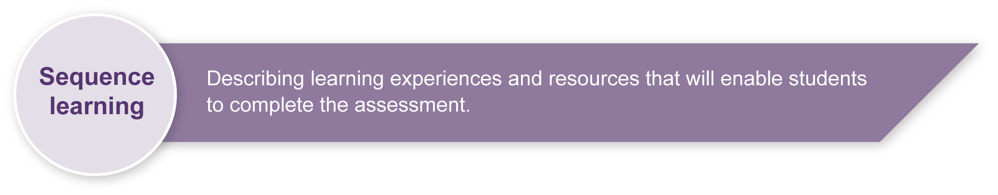
- View video sequences and/or photos that show effective composition and framing (see Appendix A: Composition and framing tips) and consider different shot sizes (see Appendix B: Shot sizes).
- Teachers could take photos of a person or bring in old family photographs to share with the group. These could be used to discuss selecting appropriate and well-composed photos for the assessment.
- Experiment with how to use digital cameras. Take photographs in class that demonstrate effective composition and framing.
- Discuss families, enabling students to talk about members of their family with other students.
See the Sensitivity statement on page 8.
- Discuss significant members of the school community that students could focus on if family members or friends are unavailable.
- Read and discuss children’s books about family (see Teacher resources for suggestions). Focus on how the story of family is told in this medium. Discussion points could include, narrative structure, telling a story in the first person, matching a sentence to an image, telling a story to interest your audience.
- View sequences of drama television programmes that use the voice-over of a character to tell the story, discuss how this technique focuses the audience on this character’s point of view (e.g. Malcolm in the Middle or The Wonder Years).
- View storyboards and discuss their features. See Appendix C: Glossary and Appendix D: Storyboard example.
Note: Appendixes C and D are for teacher reference only.
- Explore narrative and recount genres (see Appendix C: Glossary). Students analyse and discuss the genres considering generic structure and language features.
- Practise using the appropriate technology for the production and presentation, such as PowerPoint, iPhoto, iMovie and Movie Maker. See Appendix E: Technology and equipment resources.

Teacher resources
Books
Todd Parr books: The Grandma book, The Mummy book, The Daddy book, and The Grandpa book, (ABC Books, Sydney).
Jeanette Rowe books: My new baby, My Dad, My Mum, My Grandad, My Grandma, and My pet, (ABC Books, Sydney).
Cultural studies goes to school: Reading and teaching popular media, Buckingham, D & Sefton-Green, J 1994, Taylor & Francis Ltd, London.
Media Education: Literacy, learning and contemporary culture, Buckingham, D 2003, Polity Press, Cambridge.
Producing videos: A complete guide, Mollison, M 2003, 2nd edn, Allen & Unwin, St Leonards, NSW.
Directing the documentary, Rabiger, M 2004, 4th edn, Focal Press, Boston.
Media: New ways and meanings, Stewart, C & Kowaltzke, A 2008, 3rd edn, John Wiley & Sons, Brisbane.
Websites
ABC Television for kids: <http://abc.net.au/children>.
Australian Centre for the Moving Image (ACMI): <www.acmi.net.au>.
Australian Children’s Television Foundation (ACTF): <www.actf.com.au>.
Australian Film Commission (AFC): <www.afc.gov.au>.
Australian Film Institute (AFI): <www.afi.org.au>.
Australian Film, Television and Radio School (AFTRS): <www.aftrs.edu.au>.
Australian Teachers of Media Queensland (ATOM): <www.atomqld.org>.
Movie Maker (editing software): <www.microsoft.com/windowsxp/downloads/updates/moviemaker2.mspx>.
Pacific Film and Television Commission (PFTC): <www.pftc.com.au/pftc/home/default.asp ?f=1>.
Queensland Art Gallery (QAG): <www.qag.qld.gov.au/kids>.
Journals
Australian Screen Education: <www.atomvic.org>.
Australian Teachers of Media (METRO): <www.metromagazine.com.au/metro>.

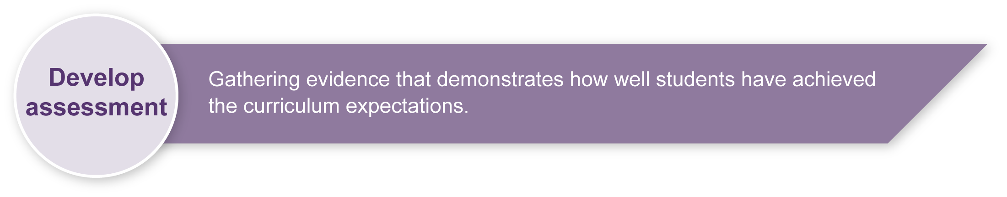
Preparing
Consider these points before implementing the assessment.

Technology and equipment
- Assess the technology and equipment available for this assessment. See Appendix E: Technology and equipment resources for a list of ideas to guide use.
- Electronic and electrical audiovisual equipment should be routinely tested and tagged according to individual school policies.
- Check that all leads are secured and do not use unsafe electrical cords.
- Students should not be responsible for moving, setting up, plugging, unplugging electronic and electrical audiovisual equipment.
- When using computers, students and teachers should be working in a safe and ergonomically sound environment (i.e. avoiding eyestrain, headaches, and physical stress on neck, back, arms and hands). Consider seating heights, angles and distances and the lighting in your work area.

Sensitivity statement
- This assessment involves students focusing on a chosen family member or friend. Teachers should consider the individual circumstances of each student in the class before the assessment is implemented. This assessment could be implemented later in the year when all of the students’ backgrounds are more easily understood.
- Class learning experiences should also involve discussion of different types of families, particularly those relevant to your students’ contexts. This could include single-parent families, extended families, and foster families.
- The learning experiences give ideas for enabling students to focus on other significant members of their community if they do not have access to taking photos of their own family member or friends.
- A template for a letter informing families of this assessment is provided (see Appendix F).

Sample implementation plan
This table shows one way that this assessment can be implemented. It is a guide only — you may choose to use all, part, or none of the table. You may customise the table to suit your students and their school environment.
Suggested time | Student activity | Teacher role |  | Resources
Section 1. Make a digital photo production
30–40 minutes | Develop ideas, choose a family member or friend to focus the presentation on, a title and focus of the story.  Develop a written storyboard plan that considers narrative and recount writing structure, props, and composition and framing.  Work in pairs to refine ideas, prepare for their shoot and complete storyboard plan. | Show links to prior class topics (e.g. families, communities, storytelling, composition and documentary production).  Guide a discussion about family. Show examples of titles and brainstorm ideas as a class and give individual assistance to develop ideas.  Model narrative and recount genres.  Give students handouts (Appendixes A and B) to help them develop their production.  Book cameras. |  | Appendix A  Appendix B
30–60 minutes  Can take place over one week. | Take a number of photos of the chosen family member or friend. Photos could be taken or selected outside class time.  Consider composition, framing and shot size elements when taking photos, as well as what the photos will show. | Demonstrate camera use.  Rework Appendix F: Letter template. Print for all students to give to parents/guardians.  Remind students of effective composition and the importance of photos being student-devised.  Check that students have completed their storyboard plan with drawings and key words to remind them of the photos they want to take. |  | Cameras  Appendix A  Appendix B  Appendix F
10–20 minutes | Select 10–12 photos and arrange them in the order that best tells their story. Capture them on the computer. | Model appropriate use of the computer program/s. |  | Appendix E
10–20 minutes | Combine photos and sound. Record their own voice talking about their family member or friend. | Remind students that it is important to consider how photos and sounds are matched.  If you do not have access to sound recording equipment you could present your photos with a live voice-over. |  | Sound recording equipment (if available)
Section 2. Present your digital photo production
5–10 minutes per student | Present the digital photo production to the class, speaking the voice-over if this is not already part of the production.  Answer questions from the audience about the digital photo production and how they made it.  Devise questions that incorporate key words from the assessment. | Set up equipment, facilitate class discussion and question the presenters.  Teacher questions could focus on how students chose the title and focus, which is their favourite photo, which photo they would improve and why, and what they wanted to communicate.  Assess students, using the Guide to making judgments | Digital media equipment for presenting the production (DVD player, computer or data projector)

Resources for the assessment
Appendix A Composition and framing tips
Appendix B Shot sizes
Appendix C Glossary
Appendix D Storyboard example
Appendix E Technology and equipment resources
This resource lists technology and equipment that can be used for this assessment and makes suggestions for use.
Appendix F Letter template
During the learning process, you and your students should have developed a shared understanding of the curriculum expectations identified as part of the planning process.
After students have completed the assessment, identify, gather and interpret the information provided in student responses. Use only the evidence in student responses to make your judgment about the quality of the student learning. Refer to the following documents to assist you in making standards-referenced judgments:
- Guide to making judgments
- Indicative A response
- Sample responses (where available).
For further information, refer to the resource Using a Guide to making judgments, available in the Resources section of the Assessment Bank website.
Evaluate the information gathered from the assessment to inform teaching and learning strategies.
Involve students in the feedback process. Give students opportunities to ask follow-up questions and share their learning observations or experiences.
Focus feedback on the student’s personal progress. Emphasise continuous progress relative to their previous achievement and to the learning expectations — avoid comparing a student with their classmates.
For further information, refer to the resource Using feedback, available in the Resources section of the Assessment Bank website.

Appendix A

Composition and framing tips

Framing
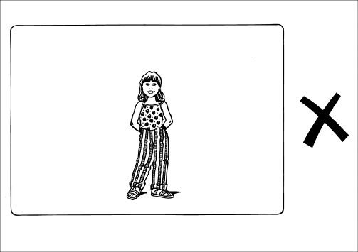 | Too small
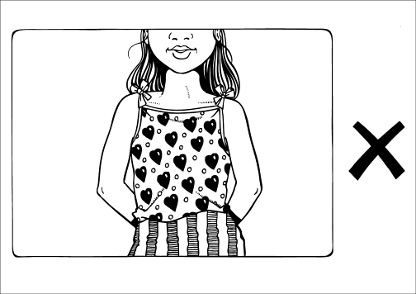 | Too tight
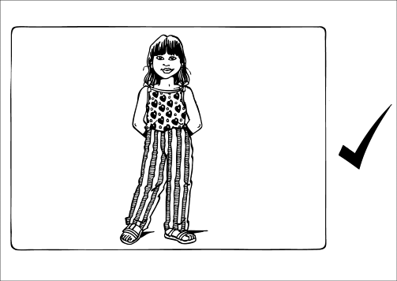 | Well framed  (suitable for location news reporter)
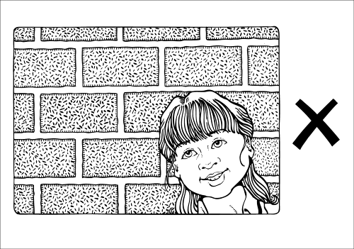 | Too much head room

Appendix A

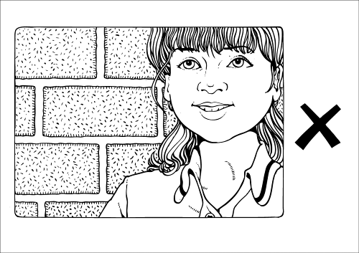 | Too little head room
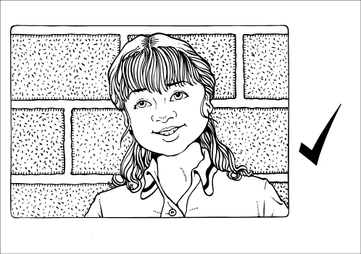 | Well framed  (suitable for studio news reader)
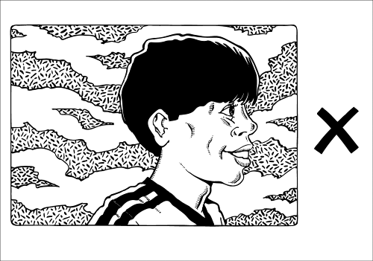 | Not enough looking room or talking room  We need to see both eyes
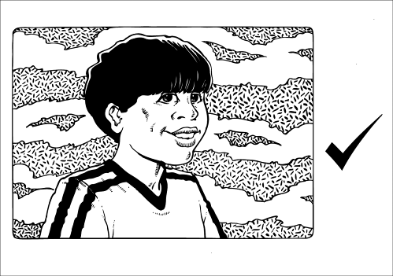 | Well framed

Appendix B

Shot sizes
Most productions look better with a range of different shot sizes.
Many filmmakers use these terms:
LS – long shot | VLS – very long shot
MS – mid shot | MLS – medium long shot
CU – close-up | MCU – medium close-up
ECU – extreme close-up | BCU – big close-up

Appendix C

Glossary
There are a number of Media words that teachers and students will need to become familiar with in this assessment. They include:
Capture | refers to students putting the photos they have taken onto the computer.
Arrange | refers to the editing of the photos into a sequence using the computer.
Combine | refers to the linking of photos and sounds together using the computer.
Storyboard | A storyboard is a design tool used by filmmakers to plan the images that they intend to film or photograph. There are many different templates available for storyboarding. They usually include a box in which an image can be drawn and a written description to accompany the drawing. A more complex template could include a shot number, shot size, shot angle, description of action and description of sound.  The storyboard example (Appendix D) shows a box for a drawing and text. This should serve as a planning list or reminder which is suitable for Year 3 students to use while they are taking their photos.  The key to all good storyboarding is to make sure that the images and written text work together to successfully explain the filmmaker’s intentions. They can be drawn with stick figures.
A story for the purposes of this assessment is meant to be told primarily by the photo images themselves. The student voice-over could link to the following text types:
Narrative  Purpose  - to entertain, amuse, or instruct.  Structure  - series of events presented in logical progression  - resolution/conclusion  - may contain a series of complications.  Language elements  - time words used to connect events  - use of action words  - description of characters and settings. | Recount  Purpose  - to retell what happened  - to tell a series of events.  Structure  - introduction/orientation  - events sequenced in chronological order.  Language elements  - descriptive language  - past tense  - time words to connect events  - words that use when, where, with whom, and how.
Media Education Key Concepts — Media encourages young people to explore their own culture by creating their own media texts. By engaging with popular culture forms Media enables young people to become critical and creative communicators. The interrelated key concepts of media languages, technologies, audiences, institutions and representations underpin Media Education syllabus documents in Queensland. Although all of these key concepts are evident in all media education assessments, Telling digital stories focuses on the key concepts of languages, technologies and audiences.
Students develop a knowledge and understanding of media languages associated with creating media texts. This includes composition, framing, shot sizes, storyboarding, capturing, voice-over, recording, editing, arranging and sequencing.
Students develop a knowledge and understanding of how to use camera and editing technologies to create their digital photo production.
Students develop a knowledge and understanding of media audiences. They create, respond and reflect with the audience of their class and their teacher in mind.

Appendix D
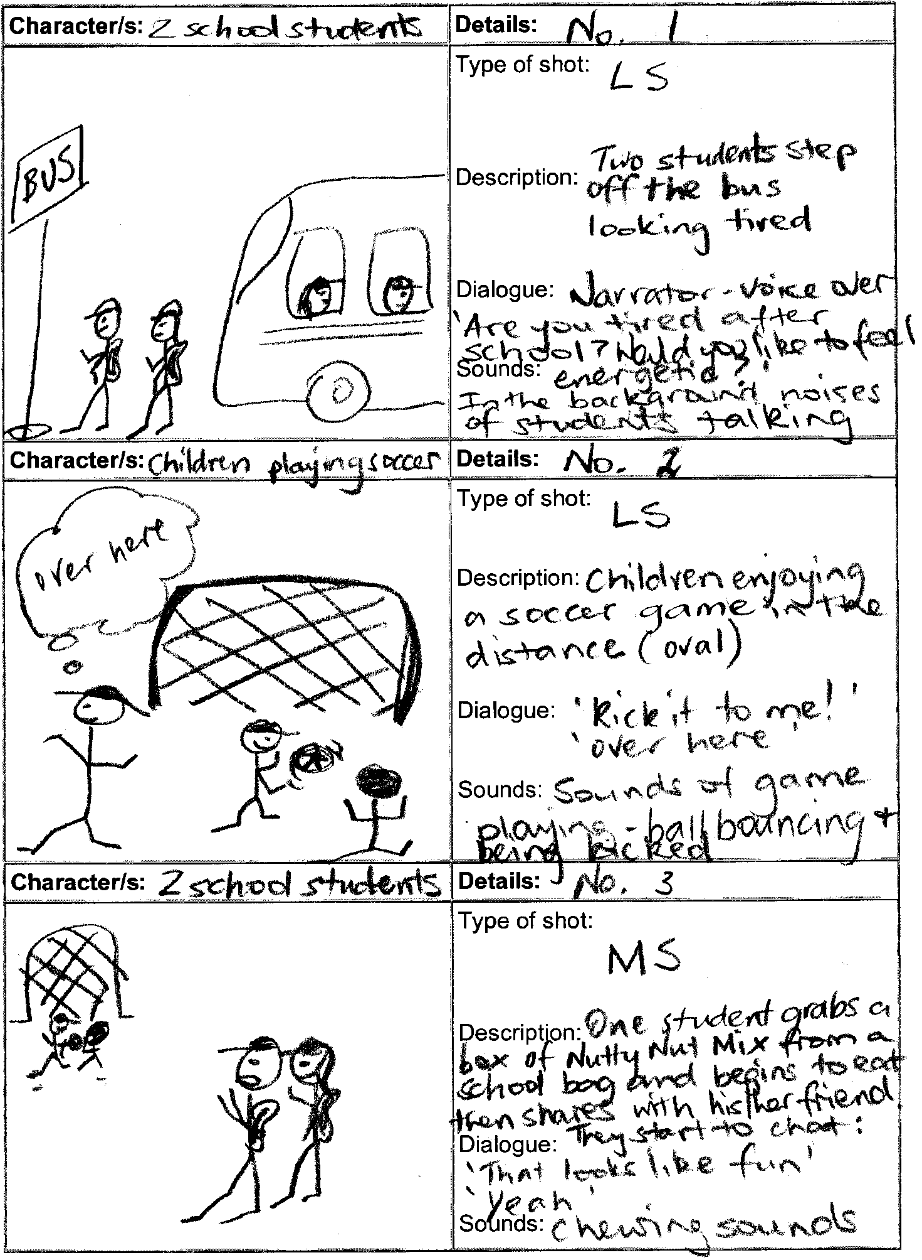
Storyboard example

Appendix E

Technology/equipment resources
Some Media assessments incorporate the use of technology. Teachers are encouraged to adapt this Media assessment to fit with the resources that they have access to in their teaching context. This assessment has been written with flexibility of equipment resources in mind. The following is a list of ideas to help you consider how you could make changes to suit your own particular context.

Photo options
This assessment could be completed using photos that pre-exist the assessment. For example using old or archival photos. The selection and arranging of these photos connects strongly to the assessable components of the assessment.
These photos could be scanned into a computer program if a scanner is available. The same process could apply if an SLR camera were used to take photos.
Photos could be taken with a digital camera and downloaded directly onto a computer using the appropriate Firewire or USB cables or students could use their own cameras and email photos to the school.

Computer software options
Some of the relevant programs that could be used for the creation and presentation of this assessment include PowerPoint or Movie Maker 2 (which is a free program you can download), or Apple Mac’s iMovie or iPhoto.
Each one of these programs has the capacity to combine photos with voice-over and text — others you have access to may not. If this is the case, students could speak their voice-over when they present their digital productions.

Other content adaptation ideas
If you have no access to computers or cameras or old family photos you could adapt the assessment to focus on stories of people from the local or national community using newspapers and magazines.
If your students have limited support from home with the taking of photos or selecting old photos this assessment could be adapted to focus on members of the school community — for example, a day in the life of the class teacher aide or school secretary.

Presentation ideas
Students could present their digital photo productions to the class on a data projector, on a television monitor or on the computers on which they created their work.
Technology extension ideas
If the software technology allows, students could add transitions, titling, music and effects to their digital photo production. It is important, however, that these be used to clarify the communication of their story rather than a demonstration of their technical expertise. Students are not being assessed on their ability to demonstrate the complexity of computer software programs.

Tips for recording voice-over
Many newer computers have built in microphones. This saves having to use another piece of equipment. Students should aim to record their voice-over with minimal background noise. They should speak as close to the computer as they can.

Appendix F
Letter template

Dear Parents/Guardians
This term, Year 3 students will be completing an assessment called, Telling digital stories. This assessment is part of our work in The Arts — Media strand. Students will be using school digital cameras and image editing software to create a digital photo production that tells the story of someone who is special to them. Telling digital stories enables students to create their own media text consisting of photos and their own voice-over sound. It highlights the importance of young people telling stories that are relevant and important to them.
The assessment focuses on communicating the story of a member of their family, so there are many ways that you may be able to help them. Students are encouraged to focus on someone in their family that they have access to, so that they can easily take photos. It can be of anyone in their immediate or extended family or even a family friend.
In most cases students will need to take their photos at home, after school. This will require Year 3 students hiring our digital cameras for a maximum of one night each. Please see attached school hiring policy document. Alternatively, if you have your own digital cameras students can take their photos with these; please check with your class teacher regarding compatibility queries.
When students are taking their photos at home they may need you or a family member or friend to be the subject of their photos. This will mean posing for at least 10 photos. It is important that the ideas for the photos come from the student. The students will have planned their ideas using a class brainstorming sheet and storyboard planner. They may need simple props and simple backdrops to help tell their story. Students will also need to consider their class work on composition and framing. Please see the Student booklet and associated handouts for more detail.
In class time, students will then use computer editing software to select and combine their digital photos with their own voice-over to communicate key aspects of their family member or friend to their classmates. They will present their finished digital photo production to an audience of their classmates and then discuss their production and the associated process with their class. Together the class and teacher will ask questions of the presenter.
Please do not hesitate to contact your student’s class teacher or the Head of Curriculum if you require any more details.
Kind Regards

Class teacher

Head of Curriculum

