Team games — Touch
Year 9 | Health & Physical Education (HPE)
Students participate in Touch, applying specialised movement skills, tactics and teamwork. They write a reflective report evaluating their own performance.
Time allocation | 3–5 hours over a number of sessions.
Student roles | Students work:  - cooperatively in game play  - individually on their reflective report.
Context for assessment
Touch allows students to develop specialised movements, tactical thinking and teamwork which they can use to support their participation in a range of team games. This assessment is designed to fit into a unit where students are provided with multiple opportunities to work collaboratively to develop and demonstrate their skills, and individually to reflect on their performance. The assessment can be easily modified to suit other games.
This assessment gathers evidence of learning for the following Essential Learnings:
HPE Essential Learnings by the end of Year 9
Ways of working  Students are able to:  - refine movement skills and apply movement concepts, and the principles of training  - select and apply positive, respectful and inclusive personal development skills and strategies  - reflect on learning, apply new understandings and justify future applications  - create and perform movement sequences by manipulating and combining movement skills and applying movement concepts  - identify risks and devise and apply safe working practices  - select and apply positive, respectful and inclusive personal development skills and strategies. | Knowledge and understanding  Physical activity  Regular active and purposeful participation in physical activity promotes health and wellbeing, and supports the achievement of goals.  - Developing and refining specialised movements skills through applying movement concepts supports improved physical performance and participation in physical activities.  - Developing teamwork, tactical knowledge and strategic thinking supports and enhances physical performance and participation in physical activities.

Assessable elements
- Knowledge and understanding
- Implementing and applying
- Reflecting
Source: Queensland Studies Authority 2007, HPE Essential Learnings by the end of Year 9, QSA, Brisbane.

Listed here are suggested learning experiences for students before attempting this assessment.
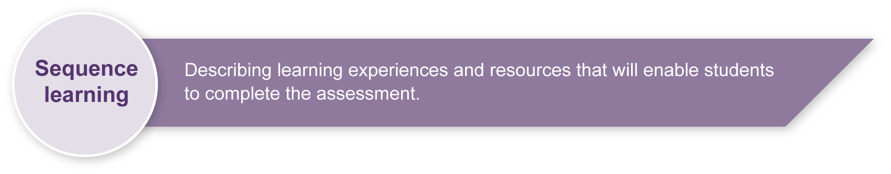
- Practise the specialised movement skills and tactics of Touch in group activities and modified games.
- Discuss (in groups) actions that individuals can take to support their own and others’ participation in Touch.
- Allow Touch game play with modifications (e.g. no acting half-touched rule, continue play after dropped ball, cross the line to score).
- View demonstrations of advanced game play and practices to identify the specialised skills, tactics and teamwork used in Touch.
- Demonstrate how movement sequences can be created and performed by manipulating and combining movement skills and applying movement concepts.
- Identify risks and devise and apply safe working practices.
- Discuss and enact positive, respectful and inclusive personal development skills and strategies that should be utilised in team games.
- Listen to or read Touch rules and discuss etiquette. Appendix F provides a glossary of Touch terms.
- Outline safety considerations of active play including sun safety.
- Teach students an active warm-up routine and implement it in every lesson.
- Handout Stages of skill development (Appendix G) and discuss how to judge skill levels.
- Outline appropriate comments for peer feedback.
- Reflect on and analyse own participation and performance, making use of a reflective journal, or game analysis software and criteria or both.
- Set guidelines for the types of comments to write journal entries.
- Review reflective report writing.

Teacher resources
The Australian Touch Association has several resources — including the latest edition of the rulebook— for purchase on the following website: <www.austouch.com.au>.
Appendix F Glossary of terms
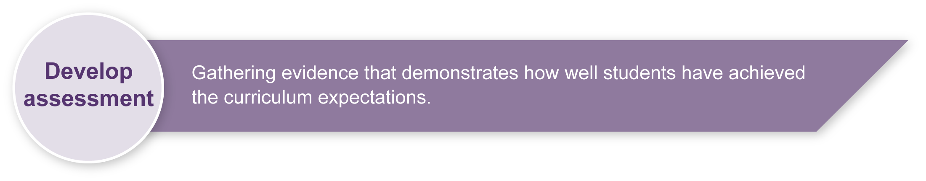
Appendix G Stages of skill development
Preparing
Consider these points before implementing the assessment.
- Inform students that practical assessment will be conducted over a number of sessions.
- Discuss with students the value of reflecting on their performance and of keeping a reflective journal. See the Reflective journal (Appendix A), Guide to thinking reflectively (Appendix B), Example of a touch reflective journal entry for guidelines. Appendix D provides an example entry template.
- Remind students to bring their journals to the final lesson of each week so they can write a reflection on their learning.
- Decide how much class time you will allocate to skill acquisition, game play, reflective journal writing and ongoing assessment of practical performance. Touch lends itself to a games sense approach.
- Discuss the skill acquisition stages and the Touch skills checklist (Appendix E) — remember that this checklist is aspirational and includes all the things you may see from an advanced player — you can alter the checklist to suit your context and your students.
- Discuss safe behaviours including sun safety and hydration.
- Set a due date for the reflective report.

Implementation
Consider these points when implementing the assessment.

Section 1. Practical performance
- All students should be provided with the opportunity to experience success and enjoy participation in physical activity sessions. Modifications support participation.
- For judgments to be valid, it is essential that students be provided with multiple opportunities to demonstrate their skill in a variety of contexts. An ongoing record of judgments in the form of a skills checklist is an excellent way to track individual performances. See Touch skills checklist (Appendix E).
- Whilst it may be advantageous for students to prepare for tactical play by working in ability groups, care needs to be taken to ensure no student is disadvantaged by the skill level of their peers. It will be necessary to make changes to teams and positions so that all students have the opportunity to demonstrate what they can do.
- Remind students and give them time to complete their reflective journal entries.

Section 2. Reflective report
- The reflective report provides an opportunity to collect further information about student understanding of the specialised skills, tactics and teamwork of Touch, and of the actions that they can take to support their own and others’ participation in physical activity.
- Before writing their report, encourage students to review entries in their reflective journal.
- If available, video material or game analysis software could be used to assist students to reflect on their performance.

Resources for the assessment

Documents
Appendix A Reflective journal
Appendix B Guide to thinking reflectively
Appendix C Example of a Touch reflective journal entry
Appendix D Touch reflective journal entry template
Appendix E Touch skills checklist
Appendix F Glossary of terms
Appendix G Stages of skill development

Physical resources
Touch field area with markers for try-line, dead ball line, half-way and 5-metre lines
Touch balls
Bibs or similar
Video footage of game play (optional)

During the learning process, you and your students should have developed a shared understanding of the curriculum expectations identified as part of the planning process.
After students have completed the assessment, identify, gather and interpret the information provided in student responses. Use only the evidence in student responses to make your judgment about the quality of the student learning. Refer to the following documents to assist you in making standards-referenced judgments:
- Guide to making judgments
- Indicative A response
- Sample responses (where available).

Making judgments about this assessment
Base judgments about student practical performance on information collected across multiple sessions.
For further information, refer to the resource Using a Guide to making judgments, available in the Resources section of the Assessment Bank website.
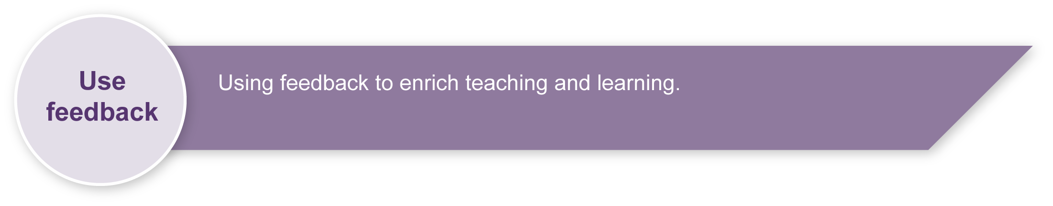
Evaluate the information gathered from the assessment to inform teaching and learning strategies.
Involve students in the feedback process. Give students opportunities to ask follow-up questions and share their learning observations or experiences.
Focus feedback on the student’s personal progress. Emphasise continuous progress relative to their previous achievement and to the learning expectations — avoid comparing a student with their classmates.
For further information, refer to the resource Using feedback, available in the Resources section of the Assessment Bank website.

Reflective journal

What is reflective learning?
Reflection is an approach to thinking. Reflective learning is the purposeful thinking about what has been learned with a view to further improving learning.
What is a reflective journal?
A reflective journal is an individual’s record of their reflective thoughts, including the meanings they make from engaging in learning experiences. Journals are unique to the individual.
What is a physical activity reflective journal?
A physical activity reflective journal is an individual’s record of their reflective thoughts, including the meanings they made from engaging in games, sports and other physical activity-related learning experiences.
How will keeping a reflective journal help you?
A reflective journal will help you develop the reflective thinking and learning skills required to improve your performance and participation in physical activity. It will help you think introspectively, be more aware of your strengths and weaknesses, more self-critical and open to feedback, and will motivate you to improve your performance.
How often should you write in the journal?
Reflect on what you have learned in each physical activity lesson.
It is best to record your reflections while they are fresh in your mind. If possible, write your reflections on the day of the lesson so that your thoughts do not become lost or distorted. You may be provided with some class time to do this or you may be expected to do it in your own time.
What does a reflective learning entry contain?
Each entry in your reflective journal should contain your thinking in two parts:
- an objective part — statements of fact about what you actually did and what you learned
- a subjective part — statements about what you think, feel and conclude about aspects of your performance, and what you need to do to improve aspects of your performance.
Use the questions in the Guide to thinking reflectively to help you think reflectively and write journal entries.

Guide to thinking reflectively
Reflective thinking | Probing deeper | Sentence starters
Reflect objectively (i.e. record the facts)
Focus question: What was the focus of learning and what did you do to apply this learning?
What was the focus of learning in the lesson? | What specific movement skills, tactics or teamwork were of major and minor focus? | Today the lesson focused mostly on how to …
What concepts or facts did you learn? | What specific technique tips, tactics or rules did you learn? | One thing I learned about performing the … was …  I also learned that …
How did you try to apply what you learned?  What were your personal learning goals for this lesson? | What specific movement skills, tactics and teamwork did you focus on in order to improve your performance and participation? | My aim today in game play was to …  In relation to teamwork, I tried to ...
Reflect subjectively (i.e. record your opinion)
Focus question: How do you think you went? What do you need to do to improve?
How well did you apply your learning and achieve your learning goals? | How well did you apply the selected movement skills, tactics and teamwork in drills and games? | I think that I was quite successful at … because …
 | What do you think you did well? Not so well? Badly? | I had difficulty with …
 | Why did something go well, not so well or badly? | I say this because …
 | What do you believe helped or hindered your learning and performance today? (e.g. feedback from your teacher or team, the net height). | I think … helped or hindered because …
What can you do next lesson to improve your learning and its application? | What do you think you need to do in the next lesson to further improve your learning, performance and participation in this physical activity? | Next lesson, I need to concentrate on …  The benefits of this will be ...

Example of a Touch reflective journal entry
Date: 15 March 2008

Reflect objectively — what was the focus of learning and what did you do to apply this learning?
The focus of learning was …

Reflect subjectively — how do you think you went? What do you need to do to improve?
I think I was fairly successful at participating as part of the team. I felt most comfortable out on the wing because I know what to do out there and I don’t get the ball much so there is less pressure. I was fairly good at passing and catching the ball in most of the activities because I knew what to expect and I could be ready.
I didn’t do so well when we played the mini game because I was slow at reading the play and slow to get back on side after making a touch.
I think everyone in my team was happy because we shared the ball around enough.
In future, I need to keep concentrating on watching my team and our opponents setting up plays so I can read them earlier and get in position more quickly.

Touch reflective journal entry template
Date:
Reflect objectively — What was the focus of learning and what did you do to apply this learning?

Reflect subjectively — How do you think you went? What do you need to do to improve?

Touch skills checklist
Specialised movements | Peer or personal rating
catch and pass to both sides during drills and game play
ruck correctly
initiating the touch and rolling the ball
situation specific passes — wrap, switch
left or right pass and/or scoop in an acting half role
dump on a defensive player
evasive running (jink, step etc.)
positioning in anticipation and repositioning
attack space — angle running, hitting a hole, wrap, switch, draw and pass
apply knowledge and understanding of rules in game play
Tactics
initiate appropriate offensive strategies such as: hole running, wrap, switch, scoot
initiate touch in offence
initiate touch in offence and draw multiple defenders
position self appropriately during offence in game play
create space or opportunity for space in offence
dump on a defensive opponent
two and three player rucking to gain distance and momentum
defend space
realign defensively in game play
Teamwork
communicate and coordinate with others when setting up for offence or defence:
- call for the ball appropriately
- consistently back up
- praise and encourage others appropriately
provide options for 2nd phase plays by supporting ball carrier
perform a variety of rucking options to set up second phase plays
maintain attacking pressure using width, depth and speed in building attacking phases
communicate effectively during slide and cover defence
initiate appropriate defensive strategies including: numbering off, slide and changes
create opportunities to score by selectively choosing attacking options including: draw and pass, dummy, switch, charge and dump, scoot in game play
reflect on defensive lapses and communicates effective alternative strategies

Glossary of terms
Dump | A quick play-the-ball to further attacking opportunities from the ensuing play.
Acting Half or Dummy  or Dummy-Half | The player who receives the ball following the play-the-ball.
Ruck | A basic attacking move intended to promote the ball down the field rather than specifically result in a touchdown.
Scoop or Scoot | An attacking move following the dump, whereby a player runs from the half position in an attempt to get past the defensive line.
Switch | A "scissors" move between two attacking players.
Wrap | A variation on the switch move involving an additional pass back to the original ball carrier.
Fade | An angled run forwards and towards the wing or sideline in an attempt to draw defenders out of position.
Phantom | A defensive player claiming a touch when no touch has been made. Frowned upon by the vast majority of players.
Jink | To make a quick sideways movement in order to evade somebody or something.
Snap | To beat (i.e. run past) your opposite number with the ball in hand.
Squeeze | A type of zone defence used to force attacking players to move the ball to the wings to gain and/or take advantage of an overlap (by which time the defence should have had time to re-align).

Stages of skill development

Rating scale
Definitions for rating — rate yourself or your peer as L, P or E — almost like driving!

Learning or cognitive stage
The cognitive stage involves the novice performer, who generally makes many errors that produce highly variable results. Many errors will be made throughout this stage as learners become aware that they are making errors but cannot isolate the specific problems. All the learner is really trying to achieve is an understanding of the basic skill itself.

Practice or associative stage
Once a performer grasps the mechanics of the skill and can execute that skill with few frequent errors, he or she has entered the associative stage of learning. Characteristics of this stage include minor errors and an emphasis on refining the skill rather than establishing new movement sequences. The athlete or performer has a “feel” for the desirable actions and can make minor adjustments to their movement from their own feedback. Improvement during this stage is gradual, but practising the correct movement patterns is essential for performers at this stage in order to advance to the third and final stage.

Established or autonomous stage
An athlete or performer at the autonomous stage consistently achieves the desired result without consciously thinking about the separate subroutines of skill production. Their movement responses are automatic and they pay more attention to improving specific components of the actions, as well as thinking about when to use a particular skill within the game situation.
The focus is on factors such as skill selection, tactics and responses to competitive situations. Practice in the competitive situation is crucial in this stage of learning. The individual performer is able to identify problems and adjust appropriately, whether during practice or in a competitive situation.

