Soundscapes
Year 5 | The Arts — Music
Students create and perform a soundscape to tell a sound story about a particular event or environment.
Time allocation | 9 weeks
Student roles | Students work in groups of 3–4  All group members need to contribute to all sections of the assessment and complete their own Student booklet.
Context for assessment
A soundscape is a combination of sounds used to create a musical story or “landscape”. This assessment allows students to experiment with a variety of sound sources as potential musical instruments, and to explore the use of graphic notation.
This assessment gathers evidence of learning for the following Essential Learnings:
The Arts Essential Learnings by the end of Year 5
Ways of working  Students are able to:  - select and develop ideas for arts works, considering different audiences and different purposes, using arts elements and languages  - create and shape arts works by organising arts elements to express personal and community values, beliefs and observations  - rehearse and rework arts works, using interpretive and technical skills  - present arts works to informal and formal audiences, using arts techniques, skills and processes. | Knowledge and understanding  Music  Music involves singing, playing instruments, listening, moving, improvising and composing by selecting the music elements to express ideas, considering different audiences and different purposes, through sound.  - Musical forms are used to structure music.  - Familiar and unfamiliar sound sources, including vocal, instrumental and environmental sources, have characteristic sound qualities (tone colour).  - Relative softness and loudness and articulation of sounds are used to change dynamic levels and expression of music.

Assessable elements
- Knowledge and understanding
- Creating
- Presenting
Source: Queensland Studies Authority 2007, The Arts Essential Learnings by the end of Year 5, QSA, Brisbane.

Listed here are suggested learning experiences for students before attempting this assessment.
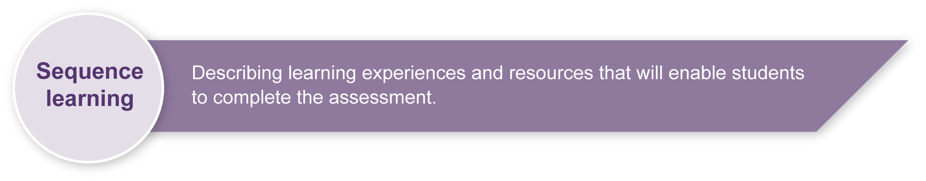
- Learn about the genre of soundscapes.
- Develop an understanding about how to explore and develop creative ideas.
- Use creative processes.
- Explore and experiment with sound sources to represent specific ideas.
- Experience reading, creating and using performance notes in a variety of contexts.
- Experience ordering and sequencing sounds in a variety of contexts.
- Learn about and practise using graphic notation and graphic notation scores.
- Play songs from graphic notation scores.
- Play a variety of soundscapes from different contexts (with or without graphic notation scores).
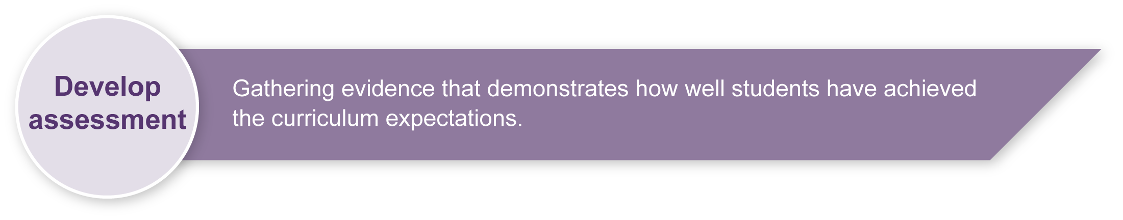
- Understand how to reflect on decisions made and modify choices made to create refined arts works.

Preparing
Consider these points before implementing the assessment.
- Students complete this assessment in small groups of about 3–4 people. Consider whether you will allow students to choose their own groups or whether you will guide this choice.
- Students need to source a variety of sound sources. These could be traditional and non-traditional instruments or everyday items from which sounds can be produced
(e.g. cardboard, plastic bottles, desk top).
- Large sheets of cardboard will be required for students to complete the final copy of the graphic notation score (one per group).

Implementation
Monitor each group’s activity carefully to ensure that all members are actively contributing to the creation and performance of their soundscape.

Sample implementation plan
This table shows one way that this assessment can be implemented. It is a guide only — you may choose to use all, part, or none of the table. You may customise the table to suit your students and their school environment.
Suggested time | Student activity | Teacher role | Resources
Section 1. Soundscape story
2 sessions | Determine what the soundscape story is going to be about and brainstorm ideas.  Write the soundscape story. | Remind students about using creative processes.  Monitor students to ensure that all are contributing.  Move around the room and help students where necessary.
Section 2. Sound sources and performance notes
3 sessions | Create individual sounds for the soundscape.  Write the graphic symbols for the sound sources and the performance notes in the Student booklet. | Remind students about using creative processes.  Monitor students to ensure that all are contributing.  Move around the room and help students where necessary. | Appendix A: The Arts — A creative process  Access to a variety of sound sources
Section 3. Graphic notation score
3 sessions | Order and sequence the sound sources and graphic symbols to construct a 1–2 minute soundscape and graphic notation score.  Construct the final copy of the graphic notation score on a large sheet of cardboard. | Remind students about using creative processes and about graphic notation scores.  Monitor students to ensure that all are contributing.  Move around the room and help students where necessary. | Large sheet of cardboard (one per group)
Section 4. Soundscape performance
3 sessions | Practise playing the soundscape, ensuring that sound sources are played according to their performance notes.  Give feedback to each other.  Perform the soundscape for the class. | Monitor students to ensure that all are contributing.  Encourage positive student feedback.  Make judgments about the quality of each student’s performance. | A variety of sound sources  Appendix B: Music word bank

Resources for the assessment
Appendix A The Arts — A creative process
Describes the process of creative reflection and refinement that students are encouraged to use throughout this assessment.
Appendix B Music word bank
Suggests “safe” words that students can use when giving peer feedback.
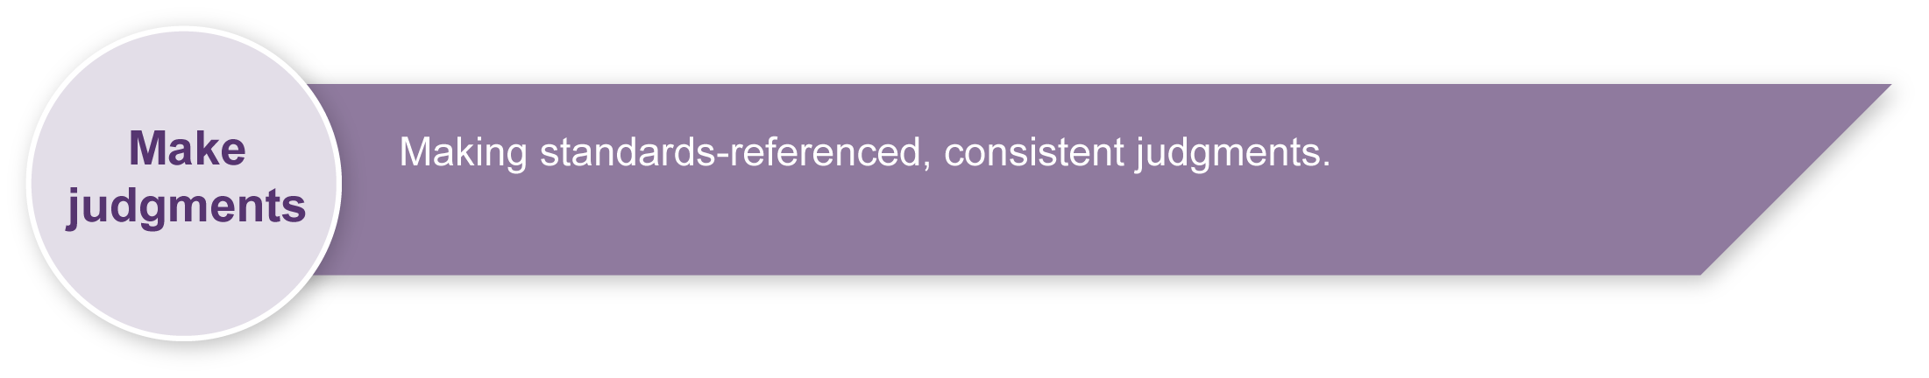
During the learning process, you and your students should have developed a shared understanding of the curriculum expectations identified as part of the planning process.
After students have completed the assessment, identify, gather and interpret the information provided in student responses. Use only the evidence in student responses to make your judgment about the quality of the student learning. Refer to the following documents to assist you in making standards-referenced judgments:
- Guide to making judgments
- Indicative A response
- Sample responses (where available).

Making judgments about this assessment
Although students are working in groups, their performance will need to be monitored and judged individually. It is possible for two students in the same group to receive different grades.
For further information, refer to the resource Using a Guide to making judgments, available in the Resources section of the Assessment Bank website.
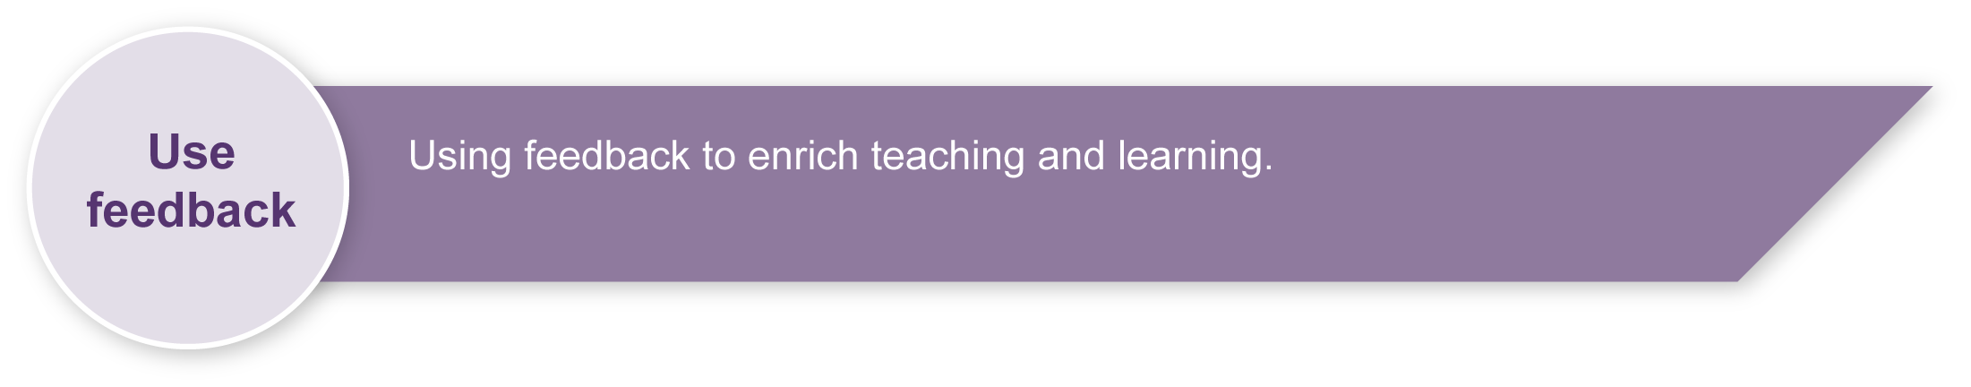
Evaluate the information gathered from the assessment to inform teaching and learning strategies.
Involve students in the feedback process. Give students opportunities to ask follow-up questions and share their learning observations or experiences.
Focus feedback on the student’s personal progress. Emphasise continuous progress relative to their previous achievement and to the learning expectations — avoid comparing a student with their classmates.

Giving feedback about this assessment
Give students regular feedback about how they can enhance their creative process and develop their performance.
Have students listen to each others’ performances, during both the rehearsal and performance phases, and give each other feedback. Guide students in how to give positive and constructive feedback. It may be useful to create a list of “safe” words that students can use for peer feedback (see Appendix B: Music word bank).
For further information, refer to the resource Using feedback, available in the Resources section of the Assessment Bank website.

The Arts — A creative process

- Creating is an important aspect of The Arts.
- It is essential that students are taught how to create,
rather than just being asked to create.
- The creative process is iterative.
- Students' creative skills develop over time.
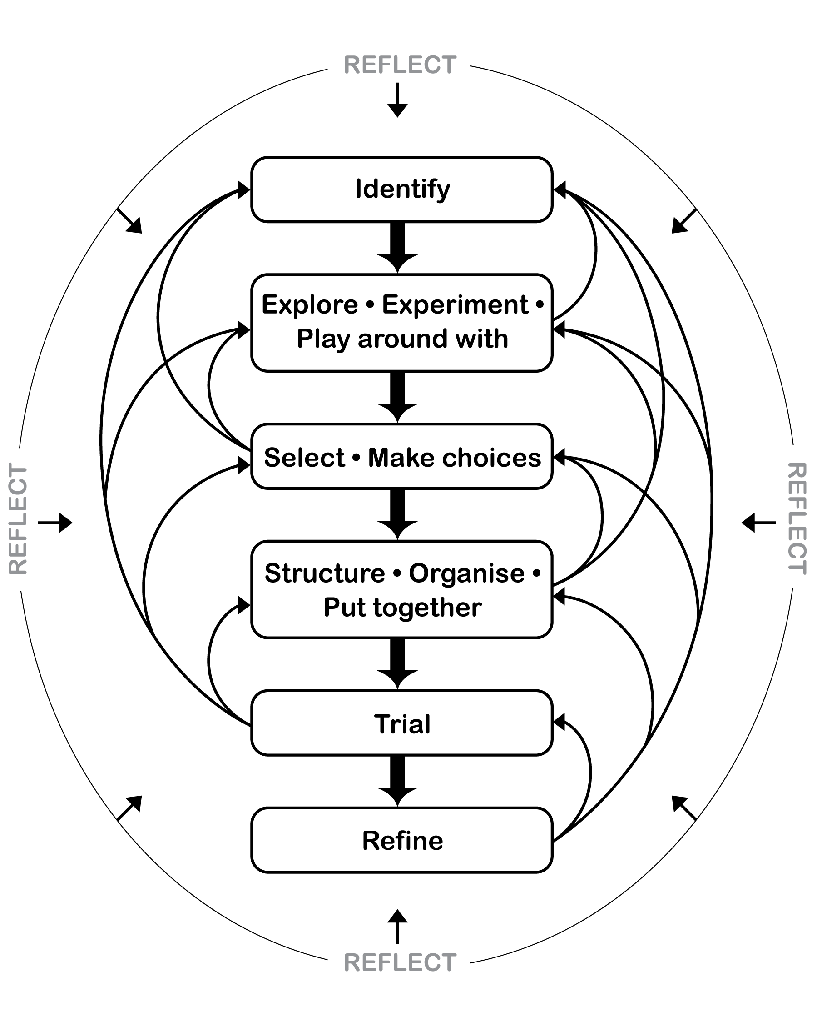

Music word bank
Teachers should be sensitive to issues that may arise as students respond to their own work and that of other students. It may be useful to develop a list of appropriate and “safe” words (see below) that can be used to describe peer performances. This will help increase students’ Arts vocabulary and allow them to show empathy toward others. Brainstorm ideas with students and add to this list.

“Safe” words to help discuss music
Words for performance
energetic | fluent | interesting | exciting
clear | interactive | collaborative | accurate
musical | balanced | contrasting | used dynamics
interesting textures | creative sound sources | dramatic | clearly tells a story
paints a musical picture

