Shape dance
There are currently no sample responses for this package. If you are trialling these assessment packages in your school please consider contacting the Assessment Bank Manager. QSA officers will annotate your student work in the Sample Responses to exemplify the Standards.
assessbank.manager@qsa.qld.edu.au.

Year 1–2 | The Arts — Dance
Students will use direction, level and shape to create a dance that responds to mathematical shapes and objects. They will identify, describe and express opinions about their response on a worksheet.
Context for assessment
Students will consider 2D shapes and 3D objects as the stimulus for creating movements for a dance. They will use dance elements to structure and express ideas about shapes and objects.
The Years 1–2 Mathematics assessment What am I? is also located in the Assessment Bank; this would provide valuable learning and linking experiences for this Dance assessment.
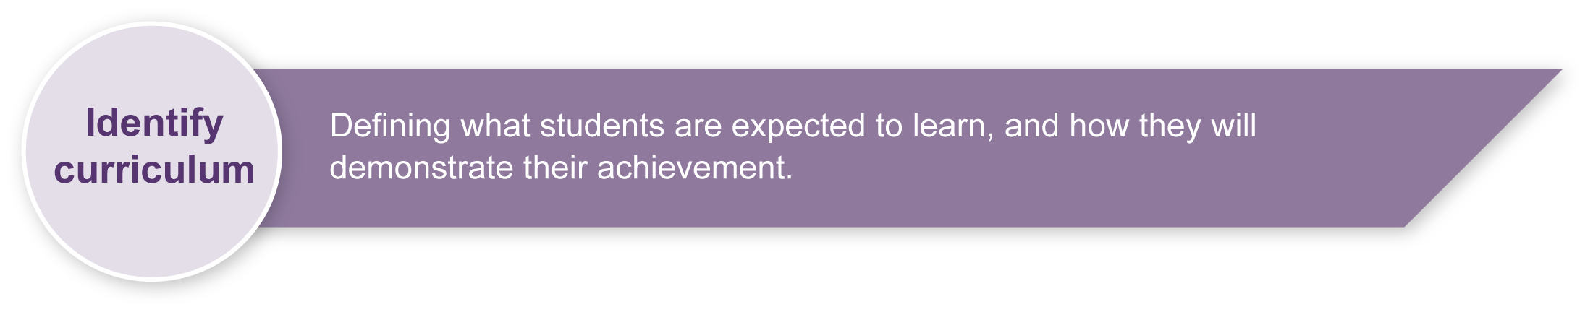
This assessment gathers evidence of learning for the following Essential Learnings:
The Arts Essential Learnings by the end of Year 3
Ways of working  Students are able to:  - select ideas for arts works, considering particular audiences and particular purposes, using arts elements and languages  - create and shape arts works by combining arts elements to express personal ideas, feelings and experiences  - respond to arts works and describe initial impressions and personal interpretations, using arts elements and languages. | Knowledge and understanding  Dance  Dance involves using the human body to express ideas, considering particular audiences and particular purposes, through dance elements in movement phrases.  - Gross motor movements, including locomotor and non-locomotor, are used to create actions for movement phrases.  - Directions, levels, shapes and pathways are used to move in space within movement phrases.  - Structuring devices, including repetition and narrative forms, are used to organise movement phrases.

Assessable elements
- Knowledge and understanding
- Creating
- Responding
Source: Queensland Studies Authority 2007, The Arts Essential Learnings by the end of Year 3, QSA, Brisbane.
Suggested learning experiences for students before attempting this assessment.
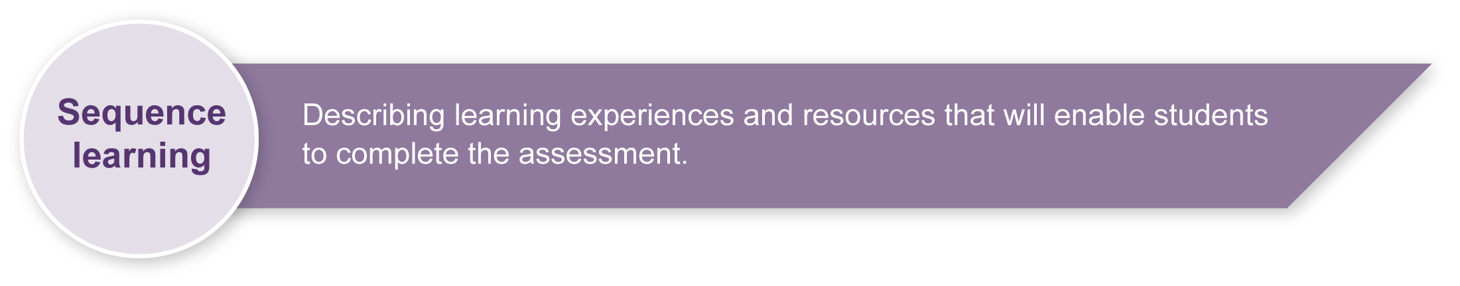
- Conduct a “shape walk” around the school, identifying shapes and objects in the local environment.
- Respond in movement to visual illustrations of shapes and objects.
- Experiment with and use 2D and 3D mathematical shapes to inspire dance elements (direction, level, shape).
- Experiment with locomotor or travelling movements (e.g. walk, run, skip, hop) to link sections of movement.
- Explore and experiment with dance ideas while working in pairs.
- Develop simple performance skills — flowing and linking movements, and making a clear start and finish.
- Develop simple linking of ideas into a movement sequence.
- Identify, describe and express opinions about the dance elements of direction, level and shape.
If the class has already completed the Year 1–2 Mathematics assessment What am I? students could revisit previous activities.
- Describe shapes and objects.
- Write poems, rhymes and instructions about shapes and objects.
- Create movement phrases using poems, rhymes and instructions.
- Physically construct shapes or objects in space using ropes, ribbons and the body.

Teacher resources
Appendix A The Arts — A creative process
This resource describes the creative process, as it relates to the Arts. You may find this a useful resource when introducing the concept of creating as a process to your students.
Appendix B Dance classroom management
This resource gives guidelines for managing a dance classroom, covering organisation, preparation for movement, and safety considerations.
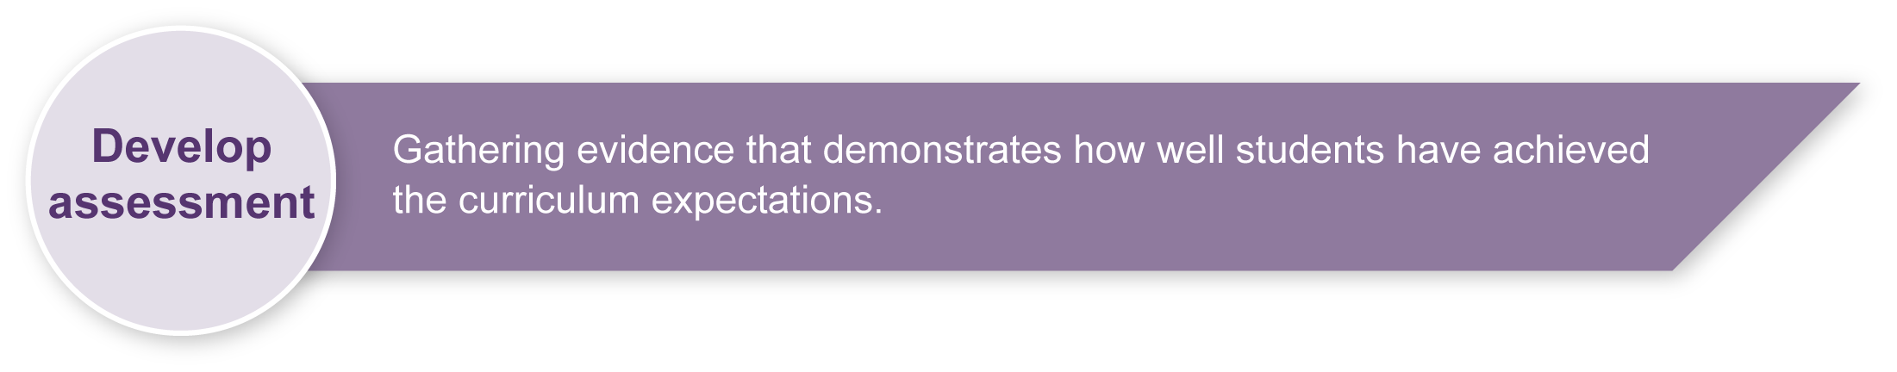
Preparing
Consider these points before implementing this assessment.
- If possible, record the performance and work in progress on video so that students can watch themselves as a form of feedback. Digital photographs could also be taken during the creative process to highlight shapes created, or even provide stimulus for further ideas.
- Access to mirrors for viewing body shapes would provide direct visual feedback for the students. Using an overhead projector to light a classroom space would allow students to experiment with shadows and shape-making. This would enrich the creative process for this dance-making activity.
- Resources for the assessment and the students’ activity sheets from the Student booklet may be photocopied onto A3 paper for use in the classroom.
- You will need to prepare a safe working environment — a large uncluttered area where students can move safely without bumping into each other, the walls or furnishings. Read through “Organising a dance classroom” in the resource, Appendix B: Dance classroom management, for guidelines.
- A warm-up and cool-down is an essential part of any movement lesson. The resource, Appendix B: Dance classroom management, has suggested activities you may wish to use.
- Be sensitive to issues that may arise as students critique their own work and that of other students. It may be useful to develop a list of appropriate and “safe” words that students can use to describe dances. This will help increase students’ Arts vocabulary and allow them to show empathy toward others. Appendix F, Dance word bank, is a good starting point for a word bank. Brainstorm ideas with students and add to this list.

Sample implementation plan
This table shows one way that this assessment can be implemented. It is a guide only — you may choose to use all, part, or none of the table. You may customise the table to suit your students and their school environment.
Suggested time | Student activity | Teacher role
Section 1. The shape dance
60–80 minutes | Working in pairs, students complete Section 1 of their Shape dance worksheet, then create their first dance sequence.  They get feedback from another pair or the teacher.  Students repeat the process for Sections 2 and 3 of the worksheet.  Students link their three dance sequences with travelling steps to create their shape dance. | Organise pairs and space.  Guide students through Appendix C: Creating my shape dance.  Provide students with appropriate protocols for feedback and classroom behaviour.  Move around the group assisting where necessary.  Encourage students to use a variety of direction, level and shape options in their dance.  Check for clarity and fluency of linking in the dances.
20 minutes | Students present dances to the rest of the class.  They will repeat their dance twice, performing it as one continuous sequence. | Designate clear performance and audience areas for students.  If possible, video students to provide them with visual feedback.
Section 2. Shape dance reflection
20 minutes | Students complete the Shape dance reflection sheet in the Student booklet. | Check for understanding, and assist students where necessary.

Resources for the assessment
Appendix C Creating my shape dance
Use this resource to guide students through the shape dance creation process.
Appendix D Ideas for creating triangle shapes at different levels
Use this resource to demonstrate ways that students can create shapes.
Appendix E Performance and audience etiquette
Use this Y-chart graphic organiser to encourage students to think critically about performing dance and being an audience member in their classroom. This chart helps students to identify appropriate behaviours for achieving a positive environment using “looks like”, “sounds like” and “feels like”.
Appendix F Dance word bank
This chart lists appropriate and “safe” words that students can use to describe dances. Brainstorm ideas with students and add to this list.
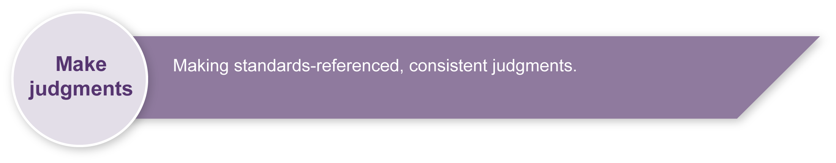
During the learning process, you and your students should have developed a shared understanding of the curriculum expectations identified as part of the planning process.
After students have completed the assessment, identify, gather and interpret the information provided in student responses. Use only the evidence in student responses to make your judgment about the quality of the student learning. Refer to the following documents to assist you in making standards-referenced judgments:
- Guide to making judgments
- Indicative A response
- Sample responses (where available).

Making judgments about this assessment
Performance skills will not be assessed; only the dance itself and how it displays the dance elements will be assessed. Teachers will need to monitor the involvement of both students in the pair to ensure that each contributes to the creative process.
For further information, refer to the resource Using a Guide to making judgments, available in the Resources section of the Assessment Bank website.
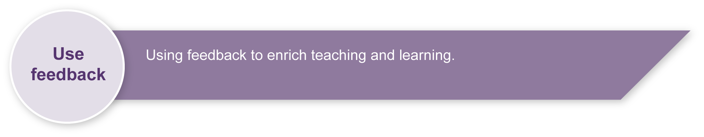
Evaluate the information gathered from the assessment to inform teaching and learning strategies.
Involve students in the feedback process. Give students opportunities to ask follow-up questions and share their learning observations or experiences.
Focus feedback on the student’s personal progress. Emphasise continuous progress relative to their previous achievement and to the learning expectations — avoid comparing a student with their classmates.
For further information, refer to the resource Using feedback, available in the Resources section of the Assessment Bank website.

The Arts — A creative process

- Creating is an important aspect of The Arts.
- It is essential that students are taught how to create,
rather than just being asked to create.
- The creative process is iterative.
- Students' creative skills develop over time.
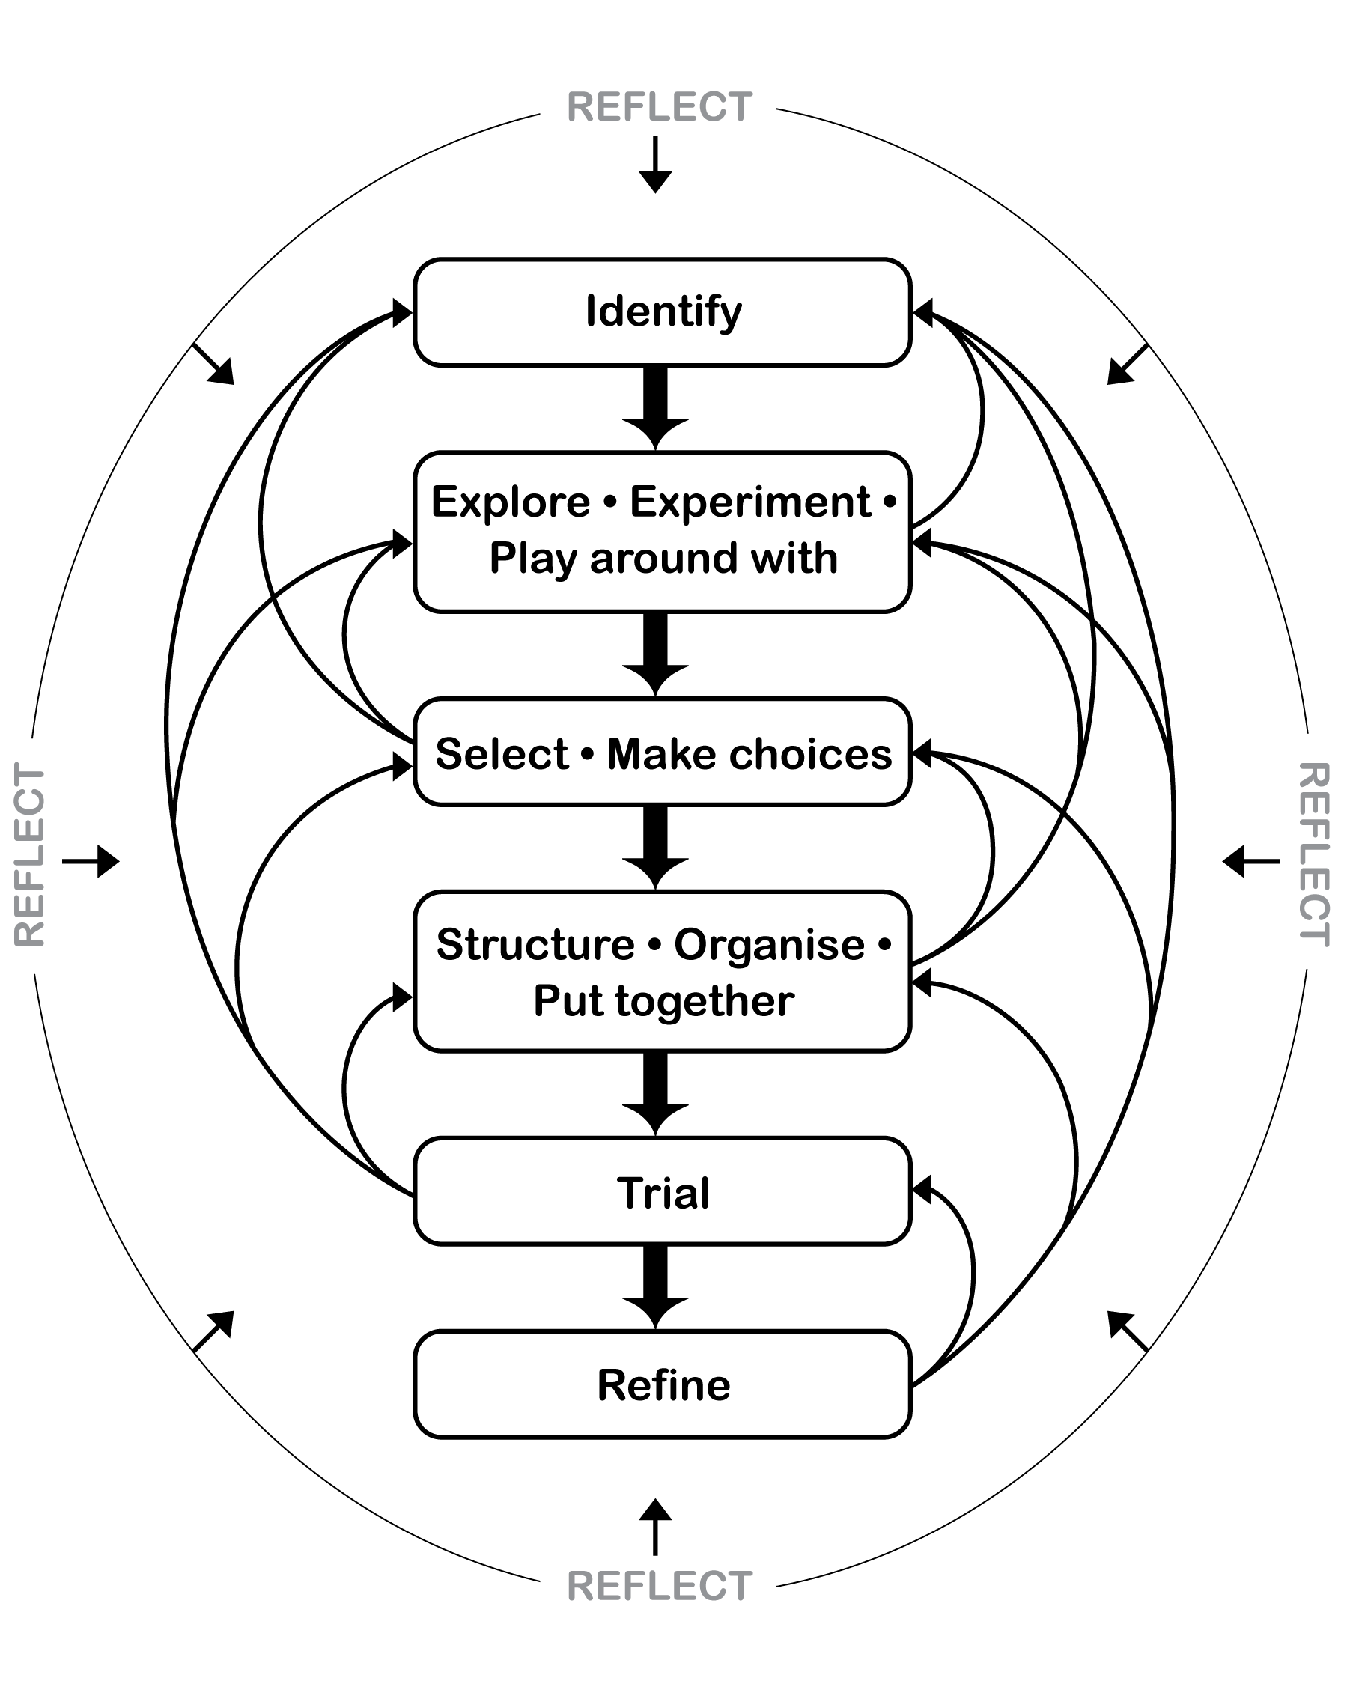

Dance classroom management

Organising a dance classroom
For a dance lesson to be a positive experience for all, consideration needs to be given to the space where the lesson is to take place, as well as the way the lesson is conducted.
- Clear the space of any desks, chairs and other moveable objects, so that all students are able to move freely, on their own or in small groups in the space, without bumping into others or objects.
- Ideally, a bare wooden floor, not lying directly in contact with concrete, is the most suitable flooring for dance. If a carpet-covered, concrete floor is all that is available, it is advisable that no jumping action takes place.
- When using media equipment, it is important that it is on a table or shelf out of the way of the movement that is taking place. Be aware of the volume of the accompanying recorded or live music. If the music is too loud students will not be able to hear teacher instructions, there will be risk of voice strain, and nearby classes will be interrupted.
- The duration of a dance lesson should run approximately 35 to 45 minutes. This time does not include set-up and pack-up time. The actual number of activities in a lesson will depend on how much development or expansion of the activities takes place.
- It is beneficial to revisit movement sequences or activities from previous lessons, so that students build their movement vocabulary.
- If students are required to remove their shoes, establish a place for the shoes that is out of the way of the movement.
- Encourage the students to wear clothing that is not restrictive, is modest, and offers protection from the sun if dance is to take place outdoors.

Preparation for movement — warm-up and cool-down
Prior to beginning any movement lesson, a warm-up is essential. An ideal warm-up should involve visual and verbal instructions from the teacher. During warm-up exercises it is important that each student is able to follow teacher instructions.
Warm-up could include:
- simple stretching and bending movements that involve the entire body
- small gentle movements that isolate and prepare joints such as ankles and wrists
- locomotor and non-locomotor aerobic exercises that raise heart rate and increase blood circulation.
The warm-up should be connected to the content or stimulus of the lesson to develop the understanding that warm-up is preparation for movement and not an isolated experience. Using music that reflects the stimulus of the lesson, or incorporating simplified versions of movements the students may use in the lesson, is an easy way to do this.
During the cool-down, students should stretch slowly using movements that reflect the content of the lesson in addition to familiar movements from the warm-up. Encourage students to reflect on what has occurred during the lesson.

Safety considerations
Students should:
- respect other students; allow them enough room to move without bumping into each other
- remove shoes so that other students are not injured while moving on the floor
- remove socks if the floor surface is slippery
- not make physical contact with other students unless specifically requested by the teacher when performing partner or group activities
- be aware of the objects around the room that may need to be avoided — for example, the edges of desks, chairs, windows or doorways.
Adapted from “Dance classroom management”, The Office of the Queensland School Curriculum Council 2002.
Creating my shape dance
1. Collect your Shape dance worksheet from your teacher.
Think
2. What directions, levels and shapes could you use for the first shaded section of the worksheet?

3. Circle your ideas on your Shape dance worksheet.

4. Try moving with the direction, level and shape you have circled.
Think
5. Show your sequence to another pair of children (or your teacher). Discuss:
- Did the movements match with your selections?
- Was it a wide shape or object?
- How well did you and your partner move in the shape or object at the
direction and level chosen?
- Can you offer some other ideas or suggestions that might help?
After listening to feedback, experiment with other ideas or suggestions and then select the direction, level and shape that work best for the first section.

Think
6. Complete Section 2 and Section 3 on the Shape dance worksheet.
Show your sections to another pair (or your teacher) to receive feedback.
After listening to feedback, select the direction, level and shape that work best for each section.

7. Organise your three sections to form a short movement phrase. Link your sections together with your choice of travelling steps (e.g. run, jump, march).
This short movement phrase of shape sections linked together is your shape dance. You will be performing it twice as one continuous dance.

8. Dance your shape dance.
- Do the shapes, directions, levels and travelling steps link together to make
the dance flow?
- Do you like it? Could it be better? Are there changes you would like to make?
Think

9. Decide what you would like to change.

Go through the creating steps as many times as you need!
Ideas for creating triangle shapes at different levels
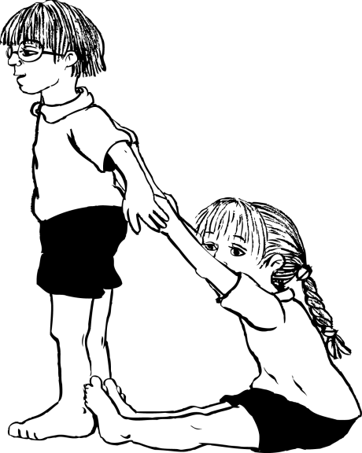 | 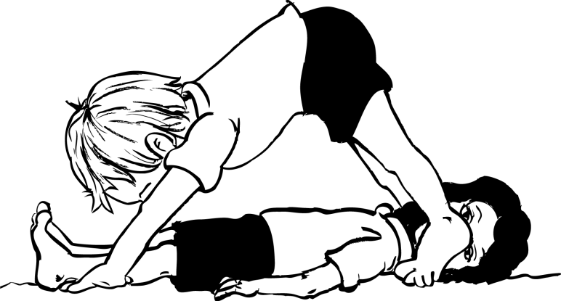
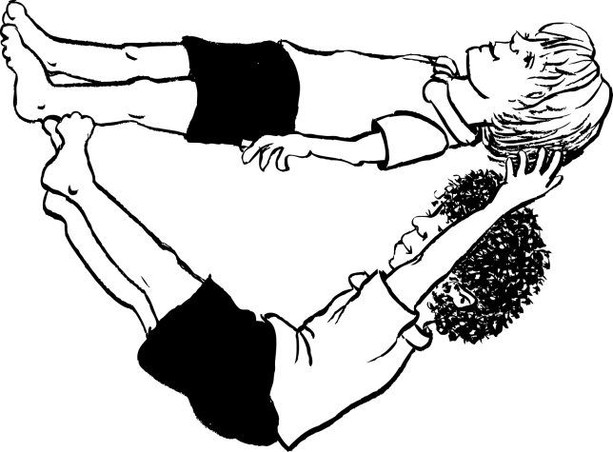 | 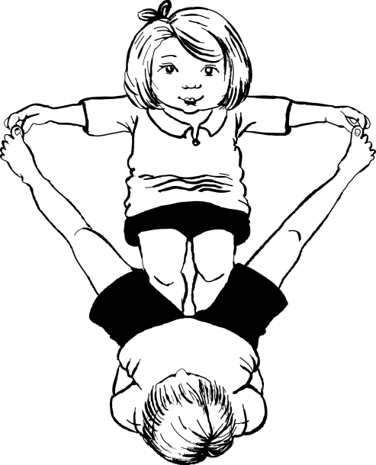
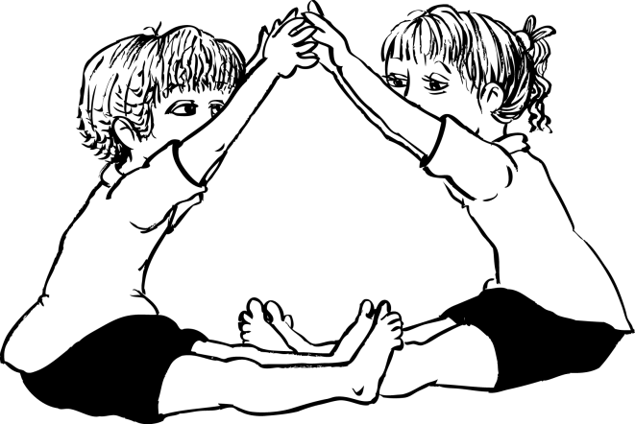 | 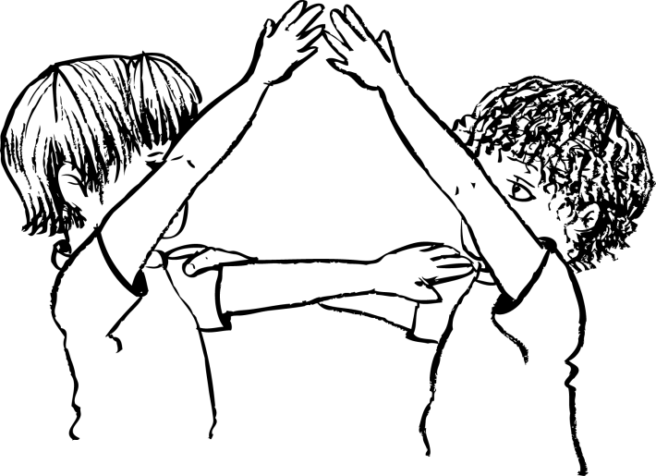

Performance and audience etiquette
Performance etiquette
Looks like …
- dance, with movements flowing together; no stops and starts unless planned
- clear, still starting position
- clear, frozen pose to end the dance
Sounds like …  - quiet, so dancers can concentrate and focus on their dance  - positive comments and praise  for dancers |  |  | Feels like …  - excited, worthwhile, valued  - motivated, engaged, happy  - comfortable in performing, purposeful, satisfied

Audience etiquette
Looks like …
- people watching attentively
- everyone is quiet and respectful
- audience is seated, focused and looking towards performers
Sounds like …  - quiet during performance  - praise and encouragement with clapping at end of performance  - positive, respectful comments |  |  | Feels like …  - everyone is valued  - all students make worthwhile contributions  - audience is motivated, engaged and interested  - performers try their best

Dance word bank
Words for performance
strong | energetic | powerful | gentle | smooth
fast | slow | graceful | interesting | exciting
controlled | concentrating | linked
Words for the dance
low-level | medium-level | high-level | forwards | backwards
sideways | diagonal | in a circle | stretched | zig-zag
angular | round | sharp | long | curved
open | small | big | twisted | bent
Mathematical shapes and objects
triangle | rectangle | cube | circle | cylinder
cone | pyramid | star

