See our toys move 4 — design
Teacher guidelines
Year 4 | Technology
Students identify the design features of toy planes and analyse their purpose. They investigate the materials and tools used to make a toy plane, and evaluate given statements about the toy planes.
Time allocation | 30 minutes
Context for assessment
An effective product design considers the product’s purpose, its target audience, and specific design features (such as components, shape and texture) and available resources (materials, tools and techniques). This assessment could be used in conjunction with others in this series:
- See our toys move 1 — energy and forces (Science)
- See our toys move 2 — dancing doll (Science)
- See our toys move 3 — boat builder (Science and Technology)
- See our toys move 5 — expo (Technology).
In this assessment, students have opportunities to demonstrate the identified Literacy Indicators in Reading and Viewing and Writing and Designing.

© The State of Queensland (Queensland Studies Authority) and its licensors 2011

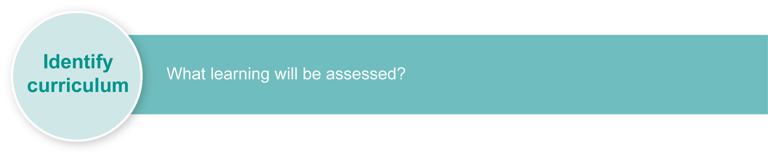
This assessment gathers evidence of learning for the following Essential Learnings:
Technology Essential Learnings by the end of Year 5
Assessable elements | Ways of working
Evaluating | Students are able to:  - identify and analyse the purpose and context for design ideas  - evaluate products and processes to identify strengths, limitations, effectiveness and improvements.
 | Knowledge and understanding
Knowledge and understanding | Technology as a human endeavour  Technology influences and impacts on people, their communities and environments.  - Different ideas for designs and products are developed to meet needs and wants of people, their communities and environments.  - Aspects of appropriateness influence product design and production decisions.
Source: Queensland Studies Authority 2007, Technology Essential Learnings by the end of Year 5, QSA, Brisbane.

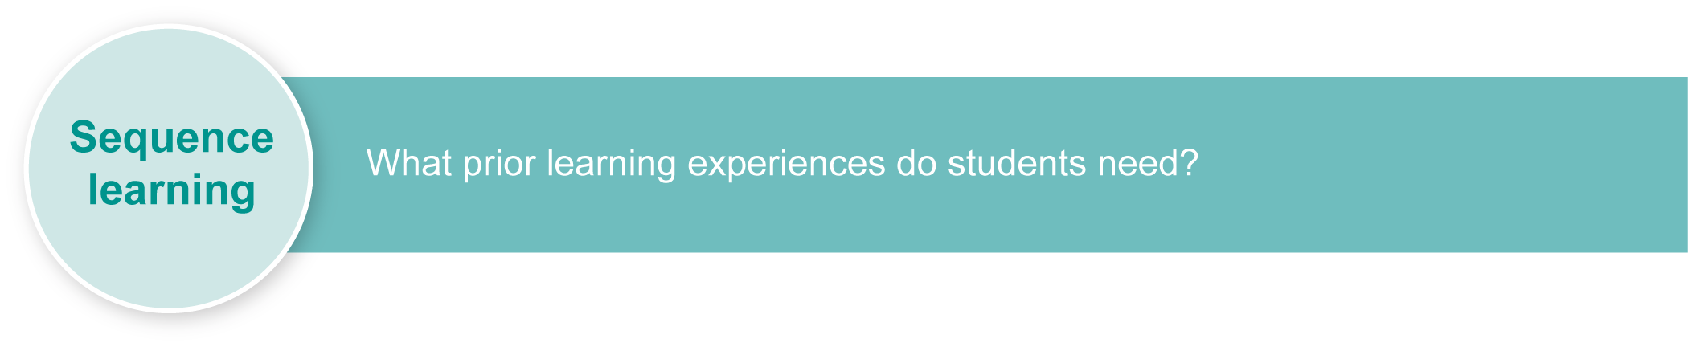
Listed here are suggested learning experiences for students before implementing this assessment.
Suggested learning experiences
- Compare and contrast the properties and usefulness of groups of materials such as various types of plastics, paper, cardboard, woods, metals.
- Compare similar objects such as shoes, balls or bags for their different design features: components, materials, shape and texture.
- Match design features with an object’s purpose.
- Evaluate the performance and suitability of objects, devices or products, and suggest changes in materials, design, tools and techniques to improve performance or suitability.
Ensure that all students have access to learning experiences. Consider the following Inclusive strategies and make any required adjustments to teaching and learning to meet specific individual learning needs.
Inclusive strategies
Inclusive strategies enable a learner with disabilities to participate in learning experiences on the same basis as a learner without disabilities. This is achieved by making adjustments to the delivery or mode of assessment, without changing the way the assessment is judged or marked.
A teacher makes required adjustments to teaching, learning and assessment to enable a student with disabilities to demonstrate knowledge, skills or competencies (Disability Discrimination Act 1992 and Disability Standards for Education 2005 Cwlth).
Adjustments made to teaching, learning and assessment should not impact on judgments made about student achievement.
Adjustments to teaching, learning and assessment can be grouped into five broad areas:
- Timing: the amount of time allocated
- Scheduling: when assessment occurs
- Setting: where assessment is completed
- Presentation: how an assessment appears or is communicated to a student
- Response: how a student responds to the assessment.
Note: More than one inclusive strategy can be used.

Teacher resources
- Why was this material used? is a QSA Assessment Bank package in Science that assesses student learning about the properties and uses of materials.
- Materials-related online activities are available via the BBC:
- Sorting and using materials <www.bbc.co.uk/schools/scienceclips/ages/5_6/sorting_using_mate.shtml>
- Grouping and changing materials <www.bbc.co.uk/schools/scienceclips/ages/6_7/grouping_materials.shtml>.
- Primary design and technology teaching units from the UK: <www.nationalstemcentre.org.uk/elibrary/technology/collection/231/nuffield-primary-design-technology>. For example:
- How will your roly poly move? <www.nationalstemcentre.org.uk/elibrary/technology/resource/727/how-will-your-roly-poly-move>
- Will your party hat be funny or fantastic?
<www.nationalstemcentre.org.uk/elibrary/technology/resource/796/will-your-party-hat-be-funny-or-fantastic>.
- PrimaryConnections are science and literacy teaching resources: <www.science.org.au/primaryconnections>. For example:
- Material world <www.science.org.au/primaryconnections/curriculum-resources/material-world.html >.
- QSA Science (1999) sourcebook modules <www.qsa.qld.edu.au> Kindergarten–Year 9>
Essential Learnings & Standards (Years 1–9) > Past syllabuses > Science > Sourcebook modules. For example, Changing materials to make them useful.
For a resource to support planning for teaching, learning and assessment of literacy and numeracy for students from Year 4 to Year 9, refer to the “Years 4–9 Literacy Indicators” and the “Years 4–9 Numeracy Indicators”: <www.qsa.qld.edu.au> under Kindergarten–Year 9 > Literacy & Numeracy Indicators
(P–Year 9).
This assessment identifies relevant Literacy Indicators on page 7.

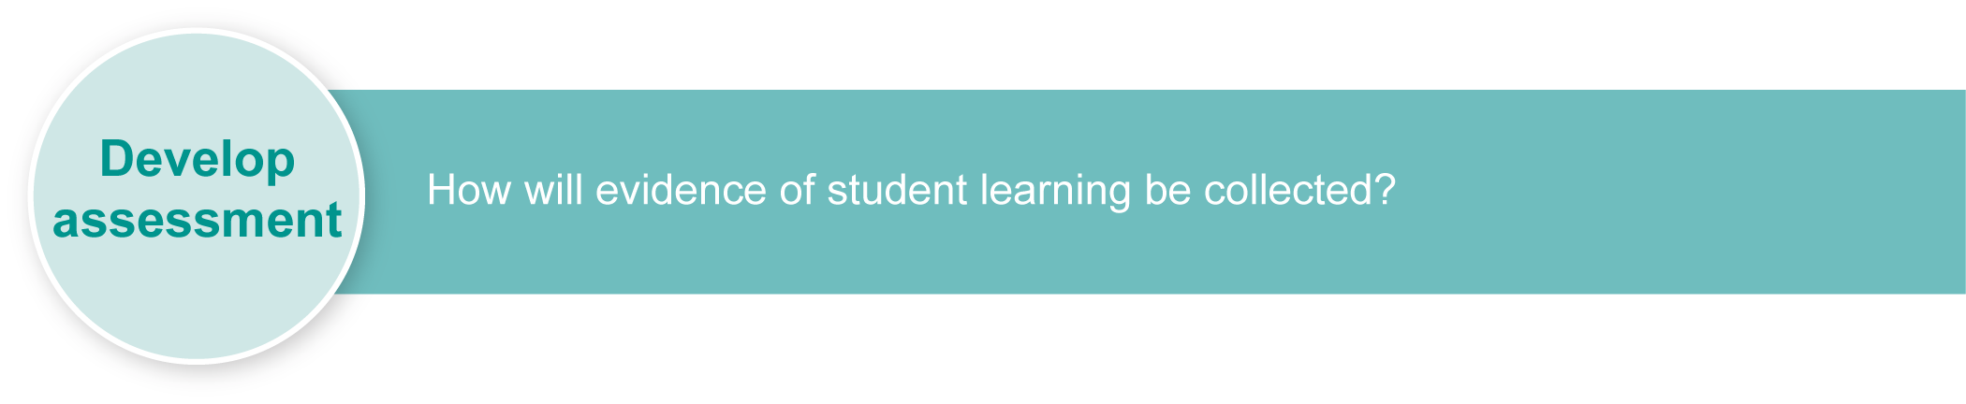
Preparing
Consider these points before implementing the assessment.
- The assessment could be expanded to gather evidence on additional Technology Essential Learnings. For example, a task could be included in which students are given specifications (purpose, target audience, etc.) and are required to design a toy, show drawings, identify suitable materials, tools and techniques, and suggest a production plan to construct the toy.
- If resources permit, examples of each type of plane could be made available for students to examine during the assessment. Where appropriate, the pictures in the Student booklet could be deleted and replaced with pictures of these examples.
- Teachers may wish to display the toy plane images on a data projector or computer screen. See the Assessment-related resource: Toy planes: Images to support the assessment.
- This assessment addresses only the Evaluating phase of the design cycle, so teachers will need to gather evidence of students’ Investigating and designing, Producing and Reflecting to support comprehensive assessment of Technology process.

Resources for the assessment
- Assessment-related resource: Toy planes: Images to support the assessment.

Implementation
Consider these points when implementing the assessment.
- Encourage students to write in point form in order to express their ideas more succinctly.
- Provide writing support or scribing where necessary so literacy limitations do not compromise a student’s ability to demonstrate their learning.
Using the Guide to making judgments (GTMJ)
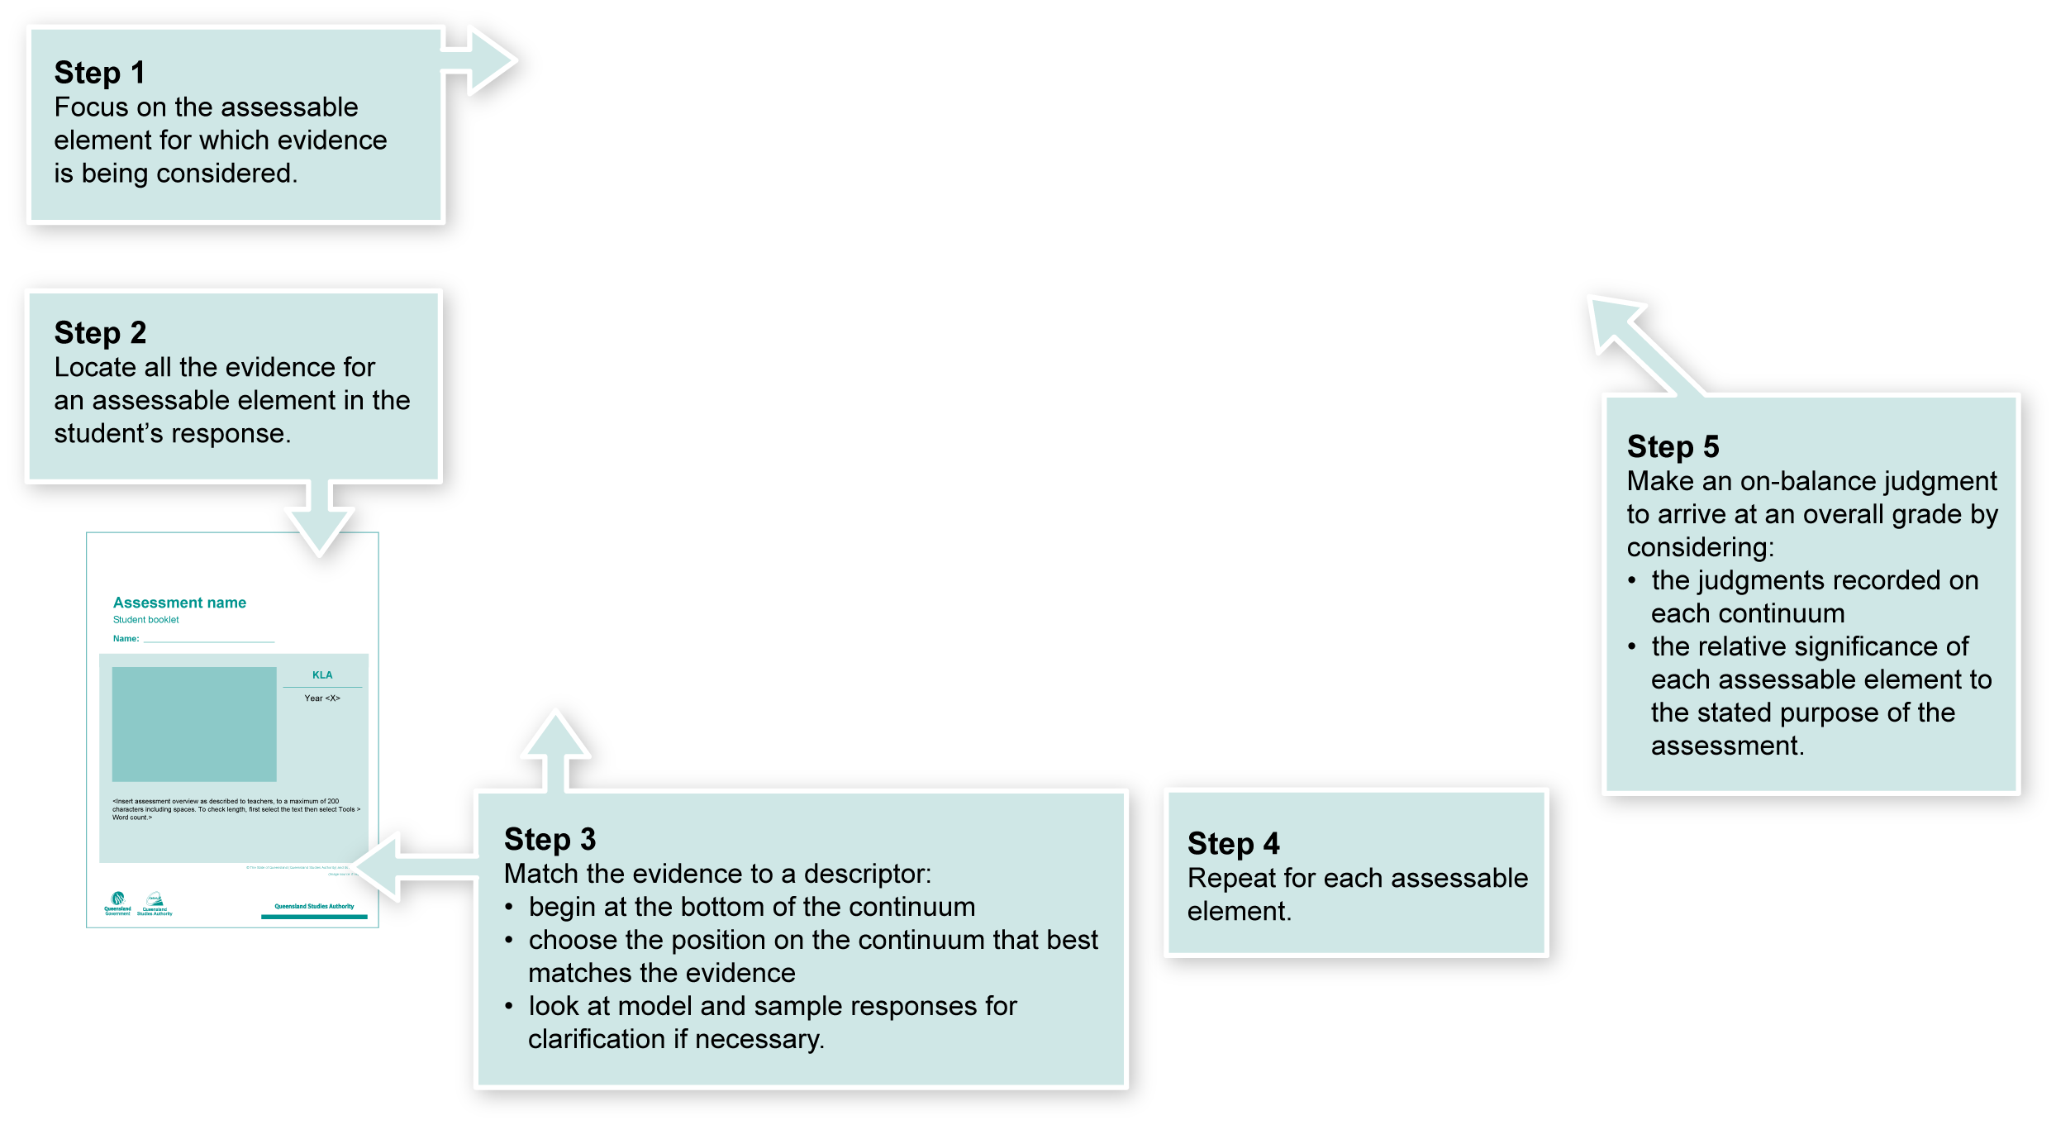
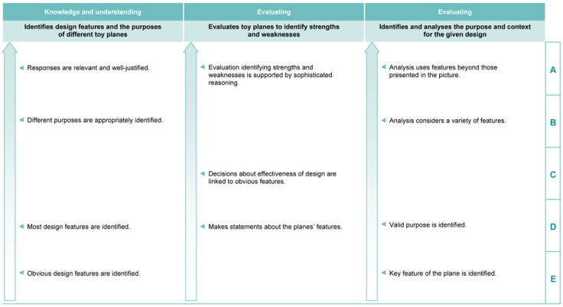

Making judgments about this assessment
In this assessment, teachers have been asked to make A to E judgments around the identified assessable elements.

Where to find the evidence
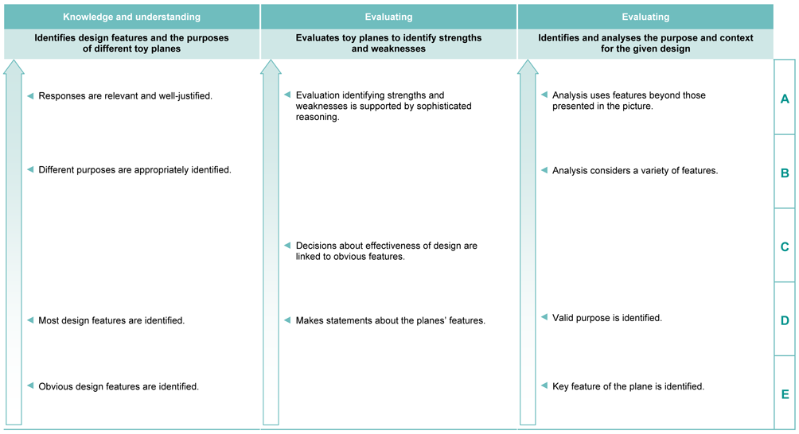
Demonstrated in the Student booklet, Questions 1–10.
Look for evidence of:
- making relevant assumptions about designers’ intended purpose for different designs
- identifying issues a designer would have had to consider.
Demonstrated in the Student booklet, Questions 1–10.
Look for evidence of:
- making logical evaluations of each model’s attributes
- applying understanding of purpose, materials and construction to critiques.
Demonstrated in the Student booklet, Questions 1–10.
Look for evidence of:
- identifying components and materials in different models
- linking design features and materials to intended purpose, e.g. lightweight for flying, durable so suitable for use by toddlers.

Literacy Indicators
This assessment provides opportunities for students to identify the following Literacy Indicators. Teachers will be able to monitor and assess progress using the Indicator checklist provided in the GTMJ.
Demonstrated in Section <X> of the Student booklet.
Look for evidence of:
- example
- example
- final example.
Literacy Indicators By the end of Year 4
Indicators |  | Source of evidence
Reading and Viewing
Students:
RV 4 iii | Predict, confirm and make meaning from literary and non-literary texts by activating a range of comprehension strategies, including:  - using prior knowledge about text type and subject matter  - monitoring meaning of information represented in the text to confirm meanings and continue predictions  - visualising the major features in texts to enhance understanding  - questioning texts about context and subject matter  - seeking clarification when meaning is not clear  - self-correcting to repair comprehension breakdowns  - drawing conclusions using stated and inferred information about significant events, ideas or descriptions from the text. | Section 1  Evident in student interpretation of the text in response to Questions 1–10.
RV 4 v | Independently read and make meaning of most familiar words including:  - high-frequency words  - regularly used words  - words of significance, and specialised language and terminology from year-level texts.
Writing and Designing
Students:
WD 4 ix | Write varied sentence types and structures, including direct and indirect speech, and make use of conjunctions to signify relationships between ideas, including:  - to compare and contrast, e.g. “but”, “like”, “or”  - to indicate when, how long or how often, e.g. “while”, “as long as”, “since”, “every time”  - to show the reason, purpose or result of an idea, action or information, e.g. “as”, “since … then”, “so … that”, “in case”, “unless”. | Section 1  Demonstrated in responses to Questions 2, 8, 9 and 10.
WD 4 x | Select words that define and describe concepts using familiar technical language to add detail.
Source: Queensland Studies Authority 2009, Years 4–9 Literacy Indicators, QSA, Brisbane.
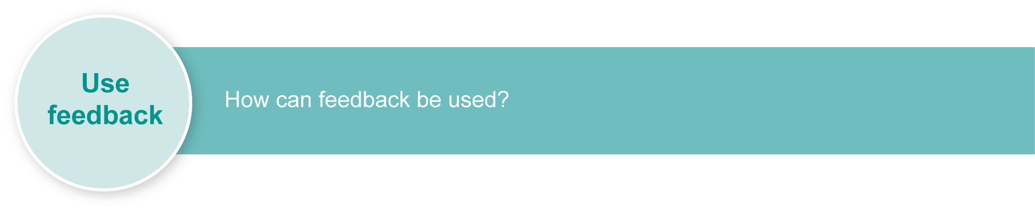
Evaluate the information gathered from the assessment to inform teaching and learning strategies.
Involve students in the feedback process. Give students opportunities to ask follow-up questions and share their learning observations or experiences.
Focus feedback on the student’s personal progress. Emphasise continuous progress relative to their previous achievement and to the learning expectations — avoid comparing a student with their classmates.

Giving feedback about this assessment
- Encourage students to discuss their responses to questions in the assessment, particularly Question 4 where a variety of justifications may be given within the class.
- Emphasise that reasoning and justification are important aspects of decision making, and provide model responses for students to consider and discuss.
More information about providing feedback to students is contained in a series of professional development packages entitled Assessment for learning, available in the resources section of the Assessment Bank.
See <www.qsa.qld.edu.au> Prep–Year 9 > Assessment Bank.

