Seasons — reading
Teacher guidelines
Elementary Year 7 | Languages — Japanese
Students read about seasonal variations in Japan, including weather patterns, cultural activities, events and seasonal foods. Then they respond to questions and compare seasons in Australia and Japan.
Context for assessment
Seasonal variation in Japan is a key to understanding a variety of cultural events and traditions. Each season is distinct and reflected in the weather, types of special foods available and special events, including festivals. This assessment links to other packages in this suite, Seasons — investigation, Seasons — listening and Seasons — speaking. This assessment should be completed as the fourth assessment in the suite.

© The State of Queensland (Queensland Studies Authority) and its licensors 2010

This assessment gathers evidence of learning for the following Essential Learnings:
Languages Essential Learnings by the end of Elementary stage
Assessable elements | Ways of working
Comprehending texts | Students are able to:  - interpret a range of spoken and written texts in different contexts where familiar and some unfamiliar language is used.
 | Knowledge and understanding
Knowledge and understanding | Comprehending and composing in the target language  Comprehending and composing skills are used to understand language input, to convey information and express ideas and opinions and to engage in interactions in the target language for different purposes, contexts and audiences.  - Verbal language and non-verbal language are adapted according to purpose, context and audience.  - Familiar language can be used in new contexts to help interpret and convey main ideas and supporting details.
Source: Queensland Studies Authority 2007, Languages Essential Learnings by the end of Elementary stage, QSA, Brisbane.

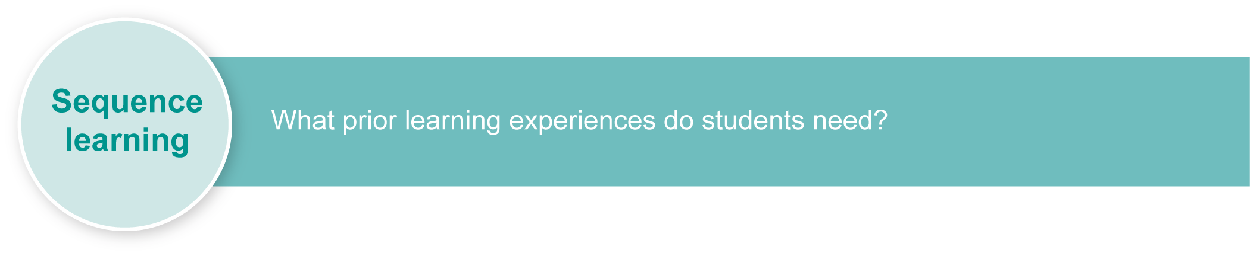
Listed here are suggested learning experiences for students before implementing this assessment.
These learning experiences are suggested as learning activities for students to complete. In this assessment, the activity should be purposeful and allow for active use of the target language. During the activity, ensure that students are provided with opportunities to use their language resources spontaneously to meet the needs of a given situation. The activity should be a real or realistic assessment that involves students in using their target language to solve a problem or fill an information gap.
Suggested learning activities:
- Compare seasonal variations all over the world and discuss the impact of weather.
- Watch weather reports from Japan.
- Watch videos or DVDs of famous festivals in different seasons.
- Create a seasons poster depicting major events with captions.
- Read about seasons in Japan.
- Write to a pen-pal enquiring about seasonal activities.
- Research and complete a project on a famous festival or event. (See Appendix A: Japanese web resources.)
- Write menus based on seasonal variations in food choices.
- Read brochures about famous festivals and events.
- Learn relevant kanji.
- Plan a trip to Japan in different seasons.
Ensure that all students have access to learning experiences. Consider the following Inclusive strategies and make any required adjustments to teaching and learning to meet specific individual learning needs.
Inclusive strategies
Inclusive strategies enable a learner with disabilities to participate in learning experiences on the same basis as a learner without disabilities. This is achieved by making adjustments to the delivery or mode of assessment, without changing the way the assessment is judged or marked.
A teacher makes required adjustments to teaching, learning and assessment to enable a student with disabilities to demonstrate knowledge, skills or competencies (Disability Discrimination Act 1992 and Disability Standards for Education 2005 Cwlth).
Adjustments made to teaching, learning and assessment should not impact on judgments made about student achievement.
Adjustments to teaching, learning and assessment can be grouped into five broad areas:
- Timing: the amount of time allocated
- Scheduling: when assessment occurs
- Setting: where assessment is completed
- Presentation: how an assessment appears or is communicated to a student
- Response: how a student responds to the assessment.
Note: More than one inclusive strategy can be used.

Teacher resources
Appendix A: Japanese web resources
Supporting resources for this assessment include images of seasons and events in Japan. See the Assessment-related resources accompanying this assessment.
Niko Niko; Moshi, Moshi and Pera, Pera from the Yoroshiku series, Department of Education, Queensland & Ministry of Education, Western Australia 1993, Curriculum Corporation, Canberra.

Preparing
Consider these points before implementing the assessment.
- Explain the assessment to your class.
- Consider equity issues. Ensure all students have access to the resources required for this assessment.
- Revise any key text structures and language elements targeted for the assessment. Students should have significant opportunity for hands-on practice of the required language elements before the formal assessment.
- Consider what objects could be offered as stimulus for students to complete the assessment. (See the Assessment-related resources accompanying this assessment.)
- Employ the support strategies used in everyday practice for students who may require additional support to complete the assessment (e.g. provide access to a hiragana and/or katakana chart; use of furigana).
- Make any necessary modifications to Appendix B: Sample reading script, or prepare another script for students to read. (Note: The first paragraph of Appendix B: Sample listening script in the Seasons — listening assessment can be modified for use in this reading assessment.)

Resources for the assessment
Appendix B Sample reading script
The sample reading script can be modified by adding furigana to make it more accessible. The first paragraph of the sample reading script can also be modified to become an introduction to the
Seasons — listening assessment.

Using the GTMJ
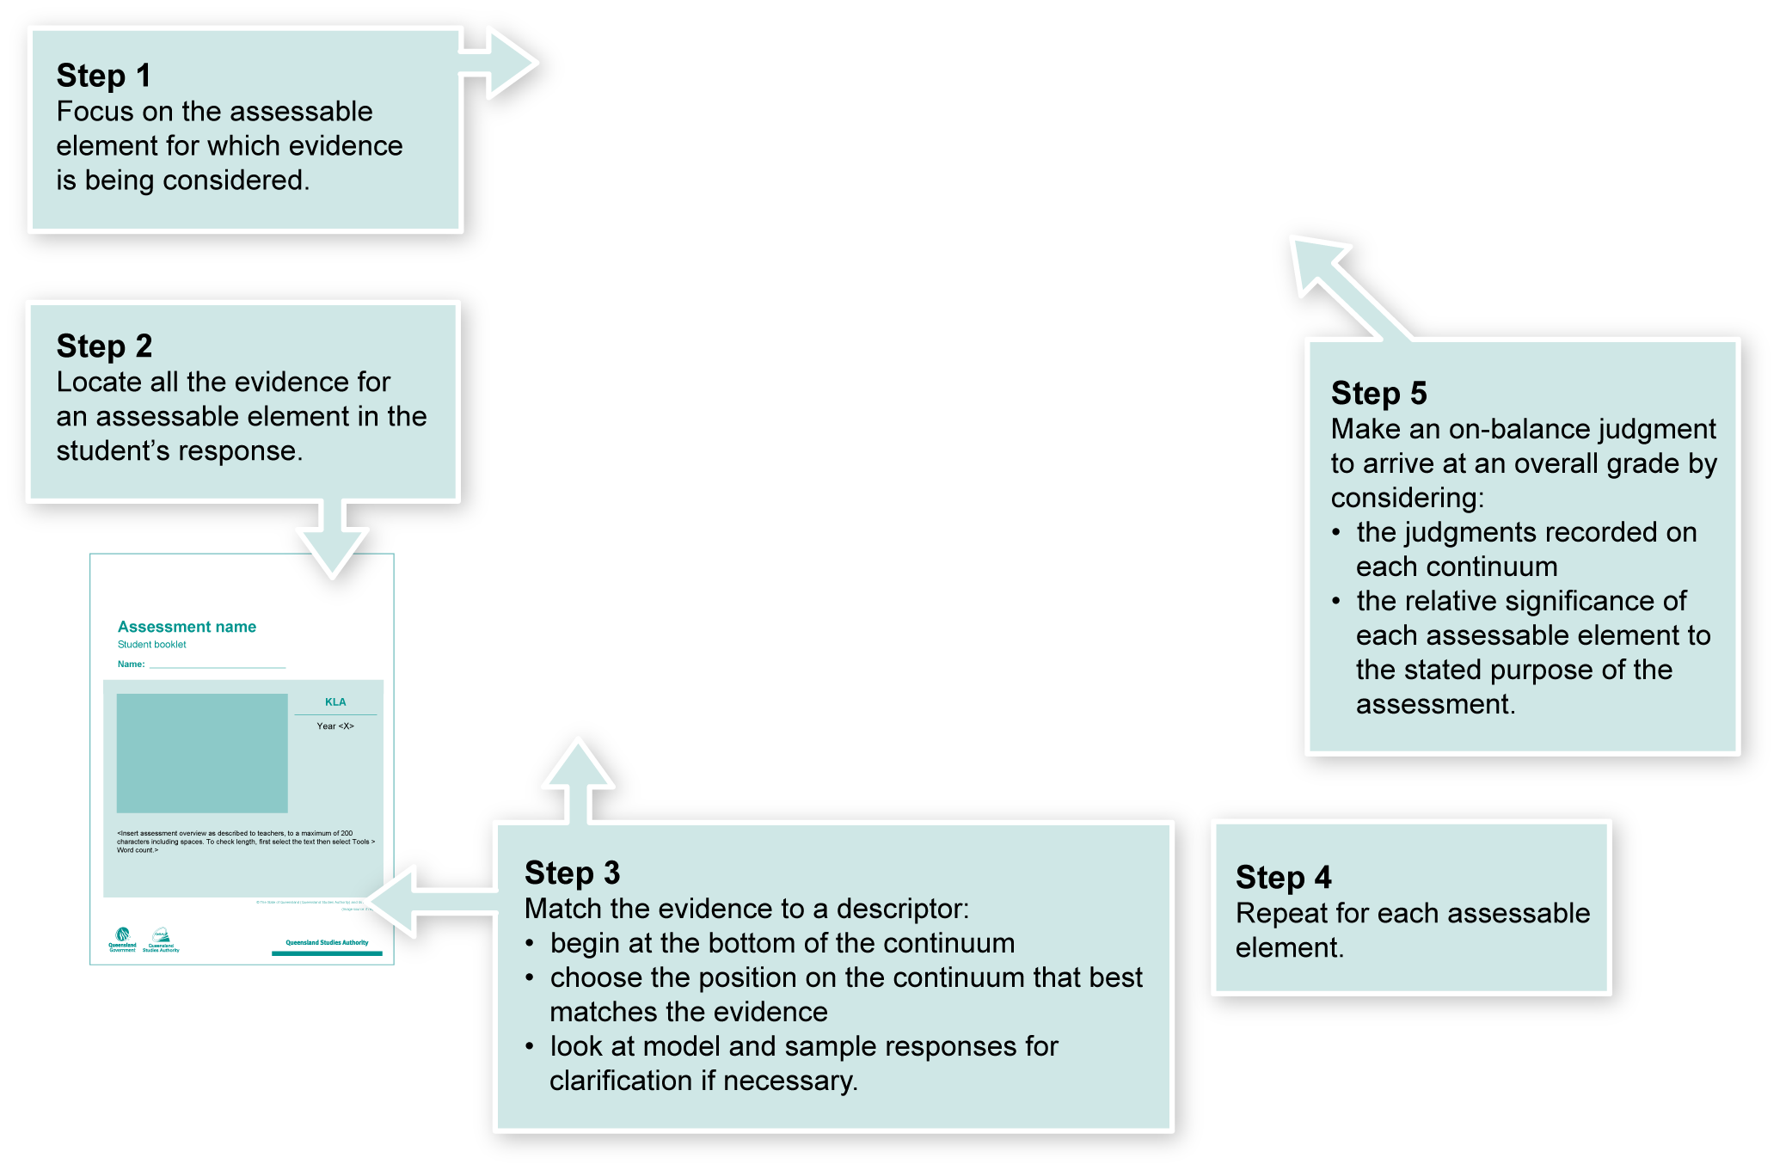
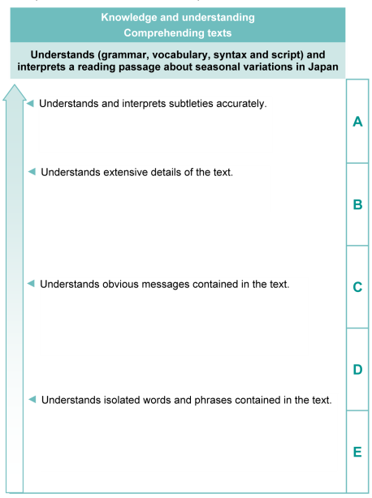

Making judgments about this assessment
In this assessment teachers have been asked to make A to E judgments around the identified assessable elements.

Where to find the evidence

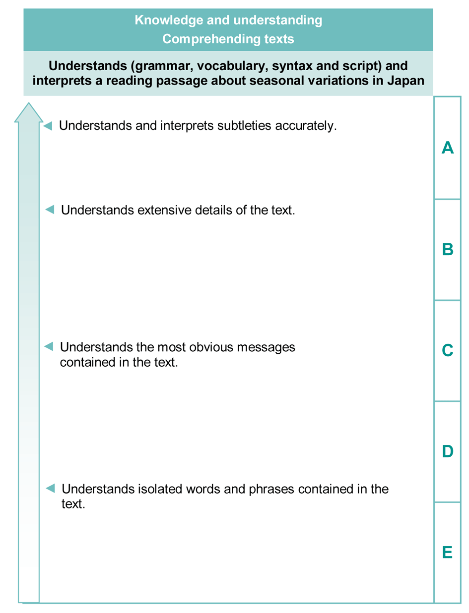
Demonstrated in the Student booklet.
Look for evidence of:
- Understanding and interpretation of subtitles
- Understanding and interpretation of detail in the text
- understanding and interpretation of gist.
Evaluate the information gathered from the assessment to inform teaching and learning strategies.
Involve students in the feedback process. Give students opportunities to ask follow-up questions and share their learning observations or experiences.
Focus feedback on the student’s personal progress. Emphasise continuous progress relative to their previous achievement and to the learning expectations — avoid comparing a student with their classmates.

Giving feedback about this assessment
Teachers may choose to give individual feedback to students or whole-class comments as needed.
More information about providing feedback to students is contained in a series of professional development packages entitled Assessment for learning, available in the resources section of the Assessment Bank.
See <www.qsa.qld.edu.au> Prep–Year 9 > Assessment Bank.

Japanese web resources
Teachers should always check websites before recommending them to students. These websites were accessed in February 2011.
- The Japan Web Guide's FAQ of Japan — Japanese festivals and celebrations: <http://www.thejapanfaq.com/celebrations.html>.
- Wikipedia on Japanese festivals: <http:/en.wikipedia.org/wiki/Japanese_festivals>.
- Darkchilde's Sanctuary on the Web — Japanese food: <http://www.bookmice.net/darkchilde/japan/jfood.html>.
- AsiaRecipe.com — History of Japanese cuisine: <http://www.asiarecipe.com/japeathistory.html>.
- Search Flickr for images of Japan: <http://www.flickr.com>.
- Japanese website directory: <http://loquela-education.net/mod/data/view.php?d=22> (teacher reference only)
- Online shop: <http://loquela-education.net/course/view.php?id=21#section-3> (teacher reference only)
About Japan
- Search for images of Japan on Flickr photosharing website: <http://www.flickr.com>.
- Japan zone — travel guide, information and culture:
<http://www.japan-zone.com/culture/dishes.shtml>.
- Japan guide — Japan living and travel guide: <http://www.japan-guide.com/e/e2035.html>.
- About.com — Japanese language and culture: <http://japanese.about.com>.
- Earthy Family — Culture of Japan: <http://www.earthyfamily.com/J-Culture.htm>.
- Japan Culture Club, online catalogue of Japanese cultural items: <http://japan-cc.com>.
- Babychatter — Japanese names. Select Japanese girls or boys names: <http://www.babychatter.com>.
- Virtual Museum of Japanese Arts: <http://web-japan.org/museum/menu.html>.
- Web Japan — sponsored by Japanese Ministry of Foreign Affairs (MOFA):
<http://web-japan.org>.
- Japan Foundation resources: <http://minnanokyozai.jp/kyozai/home/en/render.do>.
- Culture at work — Japanese culture: <http://www.culture-at-work.com/jpnlinks.html>.
- Japanese web links: <http://ww2.lafayette.edu/~stocktoj/home/japanl.html>.
- Japan National Tourist Organisation: <http://www.jnto.go.jp/eng>.
- Explore Japan — online Japanese gift shop: <http://www.explorejapan.com>.
- YesJapan.com Culture Centre: <http://www.yesjapan.com/culture/culture2.mv>.
- Asahi guide to Japanese culture: <http://www.asahi-net.or.jp/~py3y-knd/culture.html>.

Japanese web resources (cont.)
- Traditional Japanese Culture and Modern Japan: <http://www.japanlink.co.jp/ka/home.html>.
- Loquela education — Japan online:
- <http://loquela-education.net/course/view.php?id=21#section-3>
- <http://loquela-education.net/mod/data/view.php?d=22>.
- Japanese Streets — magazine about Japanese street fashion and culture: <http://japanesestreets.com>.

Language resources
- Japanese language resources for teachers:
<http://loquela-education.net/course/view.php?id=21#section-3>
- New South Wales through the NSW Department of Education and Training Japanese Language Unit: <http://www1.curriculum.edu.au/nalsas/explorers/japanese/index.html>.

Sample reading script

日本の 天気は 季節に よって 変わります。日本には 季節が 四つ あります。冬と春と
夏と 秋が あります。冬は １２月と １月と ２月です。春は ３月と ４月と ５月です。
夏は ６月と ７月と ８月です。秋は ９月と １０月と １１月です。オーストラリアに
比べて、反対です。季節に よって、特別な 食べ物と 行事と 祭りが あります。
日本の 冬は 寒いです。場所に よって、雪が ふります。冬に スキーが できます。冬に
日本人は 特別な 食べ物を 食べます。おせち料理です。冬に 特別な 日が あります。
元日です。１月１日は 元日です。日本人は よくお寺と 神社に 行きます。そして もちを
よく食べます。特別な 行事は 「成人の日」と「節分」です。
一番好きな 季節は 春です。なぜかというと 春に 桜が 咲きます。桜は すごく きれい
で 日本の シンボルの 一つです。天気は よくなって、暖かくなります。急に 草と 芝生
がみどりに なります。春に 花見パーティが たくさんあります。皆は 木の下に 座って、
桜を 見て、桜もちを 食べて、遊びます。楽しくて、大好きな ハッパニングです。３月に
ゆうめいな ひな祭りが おこのわれます。皆様は 特別な 食べ物を 食べます。あまざけを
食べます。特別な 祭りは「ひな祭り」と「子供の日」です。

