Seasons — listening
Elementary Year 7 | Languages — Japanese
Context for assessment
Seasonal variation in Japan is a key to understanding a variety of cultural events and traditions. Each season is distinct and reflected in the weather, types of special foods available and special events, including festivals. This assessment links to other packages in this suite, Seasons — investigation, Seasons — reading and Seasons — speaking. This package should be completed as the first assessment in the suite.

This assessment gathers evidence of learning for the following Essential Learnings:
Languages Essential Learnings by the end of Elementary stage
Ways of working  Students are able to:  - interpret a range of spoken and written texts in different contexts where familiar and some unfamiliar language is used. | Knowledge and understanding  Comprehending and composing in the target language  Comprehending and composing skills are used to understand language input, to convey information and express ideas and opinions and to engage in interactions in the target language for different purposes, contexts and audiences.  - Verbal language and non-verbal language are adapted according to purpose, context and audience.  - Familiar language can be used in new contexts to help interpret and convey main ideas and supporting details.

Assessable elements
- Knowledge and understanding
- Comprehending texts
Source: Queensland Studies Authority 2007, Languages Essential Learnings by the end of Elementary stage, QSA, Brisbane.

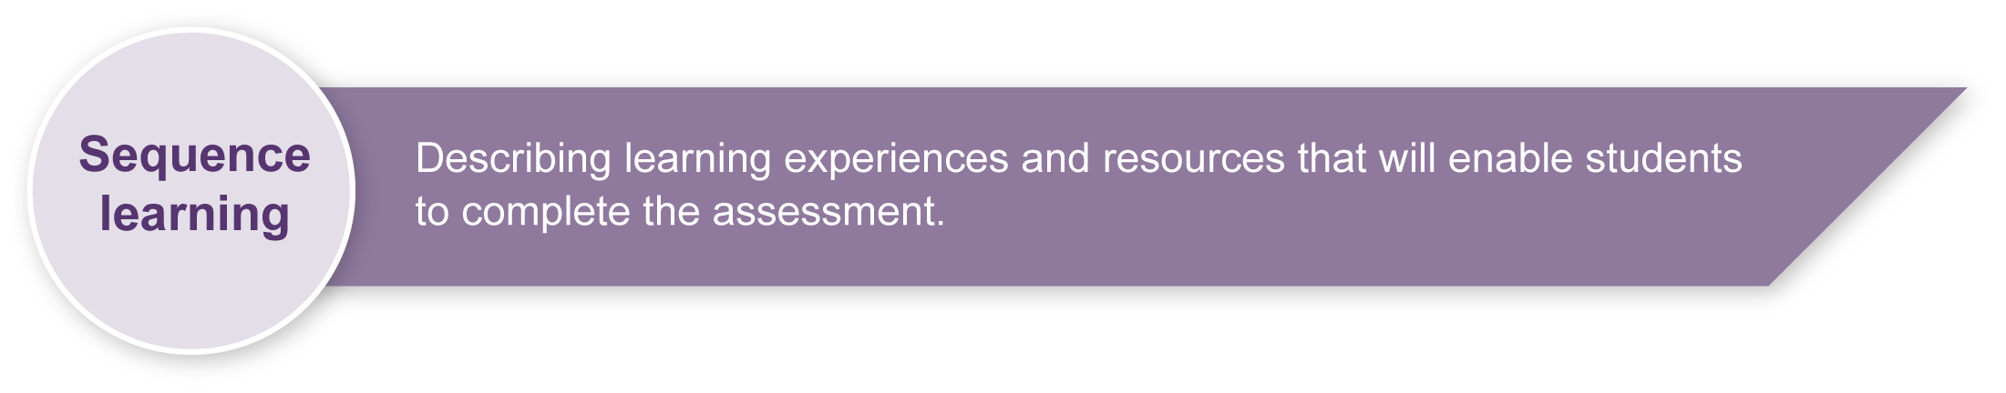
These learning experiences are suggested as learning activities for students to complete. In this assessment, the activity should be purposeful and allow for active use of the target language. During the activity, ensure that students are provided with opportunities to use their language resources spontaneously to meet the needs of a given situation. The activity should be a real or realistic task that involves students in using their target language to solve a problem or fill an information gap.
Suggested learning activities:
- Compare seasonal variations all over the world and discuss the impact of weather.
- Watch weather reports from Japan.
- Watch videos or DVDs of famous festivals in different seasons.
- Research and complete a project on a famous festival or event. (See Appendix A: Japanese web resources.)
- Listen to and interpret passages about seasonal variations in Japan.
- Create a seasons poster depicting major events with captions.
- Write menus based on seasonal variations in food choices.
- Read and interpret brochures about famous festivals and events.
- Plan a trip to Japan in different seasons.

Teacher resources
Appendix A Japanese web resources
Supporting resources for this assessment include images of seasons and events in Japan. See the Assessment-related resources accompanying this assessment.
Niko Niko; Moshi, Moshi and Pera, Pera from the Yoroshiku series, Department of Education, Queensland & Ministry of Education, Western Australia 1993, Curriculum Corporation, Canberra.

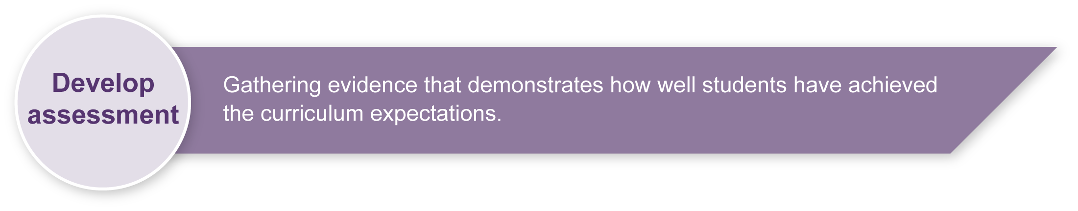
Implementing
Consider these points before implementing the assessment.
- Explain the assessment to your class.
- Consider equity issues.
- Revise any key text structures and language elements targeted for assessment. Students should have significant opportunity to learn the required language elements before the assessment.
- Make any necessary modifications to Appendix B: Listening script, or prepare another script suitable for the assessment. (Note: The first paragraph of Appendix B: Reading script in the Seasons — reading assessment could be modified to become an introduction to this listening assessment.)

Resources for the assessment
Appendix B Listening script
.
During the learning process, you and your students should have developed a shared understanding of the curriculum expectations identified as part of the planning process.
After students have completed the assessment, identify, gather and interpret the information provided in student responses. Use only the evidence in student responses to make your judgment about the quality of the student learning. Refer to the following documents to assist you in making standards-referenced judgments:
- Guide to making judgments
- Indicative A response
- Sample responses (where available).

Making judgments about this assessment
The Guide to making judgments for this assessment demonstrates student development along a continuum. It uses task-specific descriptors to describe the quality of student performance as a standard from A to E across each of the assessable elements. In the continua model, each higher standard grade has those below nested within it. In short, an A standard includes all qualities previously described along the continuum. Because the continua model plots noticeable differences in student performance, the descriptor shows what students can do, not what students cannot do.
Teachers will need to make judgments about the impact of students’ access or restricted access to hiragana and katakana charts when completing the assessment. Students should be encouraged to attempt the assessment initially without the use of a chart, depending on the students’ level.
For further information, refer to the resource Using a Guide to making judgments, available in the Resources section of the Assessment Bank website.

Evaluate the information gathered from the assessment to inform teaching and learning strategies.
Involve students in the feedback process. Give students opportunities to ask follow-up questions and share their learning observations or experiences.
Focus feedback on the student’s personal progress. Emphasise continuous progress relative to their previous achievement and to the learning expectations — avoid comparing a student with their classmates.
For further information, refer to the resource About feedback, available in the Resources section of the Assessment Bank website.

Japanese web resources
Teachers should always check websites before recommending them to students. These websites were accessed in August and September 2008.
- The Japan Web Guide's FAQ of Japan — Japanese festivals and celebrations: <www.thejapanfaq.com/celebrations.html>.
- Wikipedia on Japanese festivals: <http://en.wikipedia.org/wiki/Japanese_festivals>.
- Darkchilde's Sanctuary on the Web — Japanese food: <www.bookmice.net/darkchilde/japan/jfood.html>.
- AsiaRecipe.com — History of Japanese cuisine: <www.asiarecipe.com/japeathistory.html>.
- Search Flickr for images of Japan: <www.flickr.com>.
- <http://loquela-education.net/mod/data/view.php?d=22> (teacher reference only).
- <http://loquela-education.net/course/view.php?id=21#section-3> (teacher reference only).
About Japan
- Search for images of Japan on Flickr photosharing website: <www.flickr.com>.
- Japan zone — travel guide, information and culture:
<www.japan-zone.com/culture/dishes.shtml>.
- Japan guide — Japan living and travel guide: <www.japan-guide.com/e/e2035.html>.
- About.com — Japanese language and culture: <http://japanese.about.com>.
- Earthy Family — Culture of Japan: <www.earthyfamily.com/J-Culture.htm>.
- Japan Culture Club, online catalogue of Japanese cultural items: <http://japan-cc.com>.
- Babychatter — Japanese names. Select Japanese girls or boys names: <www.babychatter.com>.
- At home in Japan — Japanese home-stay tutorial: <http://athome.nime.ac.jp>.
- Virtual Museum of Japanese Arts: <http://web-japan.org/museum/menu.html>.
- Web Japan — sponsored by Japanese Ministry of Foreign Affairs (MOFA):
<http://web-japan.org>.
- Japan Foundation resources: <http://momiji.jpf.go.jp/kyozai/English/index.php>.
- Culture at work — Japanese culture: <www.culture-at-work.com/jpnlinks.html>.
- Japanese web links: <http://ww2.lafayette.edu/~stocktoj/home/japanl.html>.
- Japan National Tourist Organisation: <www.jnto.go.jp/eng>.
- Explore Japan — online Japanese gift shop: <www.explorejapan.com>.
- YesJapan.com Culture Centre: <www.yesjapan.com/culture/culture2.mv>.
- Asahi guide to Japanese culture: <www.asahi-net.or.jp/~py3y-knd/culture.html>.
- Traditional Japanese Culture and Modern Japan: <www.japanlink.co.jp/ka/home.html>.

Japanese web resources (cont.)
- Loquela education — Japan online:
- <http://loquela-education.net/course/view.php?id=21#section-3>.
- <http://loquela-education.net/mod/data/view.php?d=22>.
- Japanese Streets — magazine about Japanese street fashion and culture: <http://japanesestreets.com>.

Language resources
- Curriculum Corporation — Japanese language resources: <http://studio.qantm.com.au/onlinelanguageresources/main.htm>.
- Shunko Muroya, Japanese Advisor for Alberta Education, Canada — Information and Resources for Teachers of Japanese Language: <www.nihongomemo.com>.
- Japanese picture dictionary: <www8.plala.or.jp/y-naka/jiten.html>.
- Japanese language resources for teachers:
<http://loquela-education.net/course/view.php?id=21#section-3>.
- New South Wales through the NSW Department of Education and Training Japanese Language Unit: <http://www1.curriculum.edu.au/nalsas/explorers/japanese/index.html>.

Listening script
The first paragraph of this script can be modified for use in the reading assessment. The reading assessment package discusses winter and spring seasons in Japan.

日本の天気は季節によって変わります。日本には季節が四つあります。冬と春と夏と秋があります。冬は１２月と１月と２月です。春は３月と４月と５月です。夏は６月と７月と８月です。秋は９月と１０月と１１月です。オーストラリアに比べて、反対です。季節によって、特別な食べ物と行事と祭りがあります。
次は夏です。夏はきらいな季節です。露になって、一ヶ月間、毎日雨が降ります。そして、とても暑くなりますからいやです。毎日笠が必要だから何もできません。特別な祭りは「たなばた」と「ぼん祭り」と「しちごさん」です。
最後は秋です。秋はだんだん涼しくなって、好きな季節です。秋にこうようがあります。木の葉っぱは赤くなりますからとてもきれいです。秋には花火が行われます。皆が花火を見に行きます。よくチョコレートバナナとわがしを食べます。

