School camp
Elementary Years 6–8 | Languages — Italian
Students create a PowerPoint slide show in Italian about their favourite camp experiences and present it to the class.
Time allocation | 7 sessions
Context for assessment
This assessment uses the setting and experience of a school camp to develop the use of the target language in an interesting natural environment. Components of the camp program should focus on target language learning.
On return to school, students use diary entries, pictures and photographs from the camp to create and present a PowerPoint slide show about their favourite camp experiences.
This assessment could be completed in any target language and could be applied to other contexts, e.g. excursions, festivals or other school events.
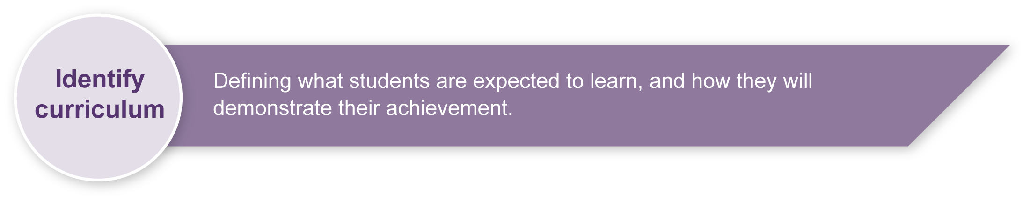
This assessment gathers evidence of learning for the following Essential Learnings:
Languages
Essential Learnings by the end of Elementary stage
Ways of working  Students are able to:  - recognise and use appropriate verbal and non-verbal language to support the development of communicative competence  - select and apply strategies to adjust verbal and non-verbal language for a variety of purposes, contexts and audiences, and respond appropriately to feedback  - construct simple, cohesive spoken and written texts for different contexts, displaying some concept of register  - reflect on and evaluate the suitability of language choices for purpose, context and audience  - reflect on learning, apply new understandings and identify future applications. | Knowledge and understanding  Comprehending and composing in the target language  Comprehending and composing skills are used to understand language input, to convey information and express ideas and opinions, and to engage in interactions in the target language for different  purposes, contexts and audiences.  - Verbal language and non-verbal language are adapted according to purpose, context and audience.  - Familiar language can be used in new contexts to help interpret and convey main ideas and supporting details.  - Familiar linguistic features and structures are manipulated to generate original target language texts and to construct simple, cohesive texts for different purposes, contexts and audiences.

Assessable elements
- Knowledge and understanding
- Composing texts
- Reflecting
Source: Queensland Studies Authority 2007, Languages Essential Learnings by the end of Elementary stage, QSA, Brisbane.

Listed here are suggested learning experiences for students before implementing this assessment.
- Ensure students have participated in a school camp experience before starting this assessment.
- Ensure that the camp program includes target language sessions as well as a variety of indoor and outdoor camp activities. Activities could include experiences of native flora and fauna, a night walk in the rainforest and involvement in camp duties.
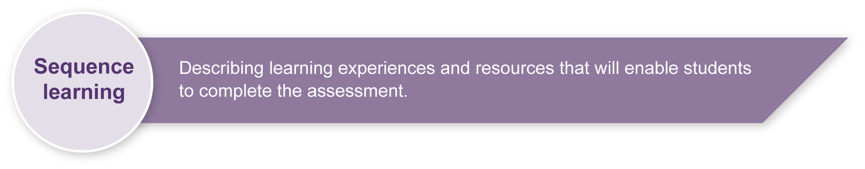
- Participate in language activities to develop knowledge and understanding of Italian associated with:
- learning about and comparing similar school camp experiences in Italy
- writing diary entries while on camp
- labelling features of a camp environment including flora and fauna
- participating in camp duties and responsibilities
- participating in indoor and outdoor camp activities.
- Language activities could include:
- identifying and asking about locations — Dove andate a camping/in campeggio?
- asking about activities — Che cosa fate a camping?
- identifying when: morning, afternoon, evening/night — Quando?
- identifying and asking about places, animals and things — Che cosa e`? Che animale e`?
- describing places, animals and things — L’albero e` alto e verde
- expressing like and dislikes and stating reasons — Mi piace molto perche’ e` carino
- describing activities — E` divertente. E` interessante. E` buono
- comparing — E` piu` lungo.
- Participate in simple conversations about what students did and saw on camp.
- Respond to familiar statements and questions using key words, phrases and memorised materials in Italian.

Teacher resources
Queensland School Curriculum Council 2000, “School camp”, in Leisure and recreation (module in the Years 4 to 10 LOTE Sourcebook modules (Upper primary) on CD-ROM, or from the QSA homepage <www.qsa.qld.edu.au> select Learning P–12 > Years 1-9 > Essential Learnings > Past syllabuses > Languages other than English > Sourcebook modules.

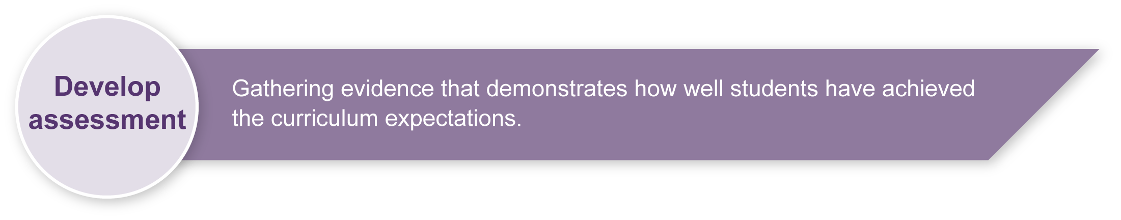
Preparing
Consider these points before implementing the assessment.
- Ensure students have access to their diary entries, pictures and photographs, other useful camp booklets or information (which can be in English) and relevant vocabulary lists used to model spoken language.
- Make extra copies of Appendix A: PowerPoint planning sheet, as necessary. Consider photocopying to A3 size.
- Revise the language exponents needed to complete the assessment. Students learning European languages should use the present tense form of the target language verbs in their presentation. Advise students of this requirement.
- Arrange access to computers so students can create the PowerPoint slide show.

Sample implementation plan
This table shows one way that this assessment can be implemented. It is a guide only — you may choose to use all, part, or none of the table. You may customise the table to suit your students and their school environment.
Suggested time | Student activity | Teacher role
Section 1. Create your PowerPoint
3 sessions | Using their diary entries, pictures and photographs from camp, students:  - identify and select the camp experiences for use in the PowerPoint  - select pictures and/or photographs to accompany each camp experience  - consider the format, layout and visual effects for each PowerPoint slide.  Students draft the written text for each slide and make each PowerPoint slide using the information from their planning sheet. | Facilitate the use of target language by presenting appropriate key words and phrases for student use.  Revise and model the use of present tense verb forms to talk about or relate events.  Lead class discussions that recount and reflect on camping experiences.  Discuss some camp events that may not be listed in diary entries but were memorable and appealing.  Advise on the appropriateness of pictures, photographs and formats.  Give feedback to students on their drafts.  Support students as required.  Arrange student access to computers.

Suggested time | Student activity | Teacher role
Section 2. Present your PowerPoint
3 sessions | Students write the spoken text to accompany each slide.  Students practise their spoken text, considering:  - pronunciation  - audibility  - stress  - intonation  - rhythm (pause and flow).  Students present their PowerPoint slide show to the class. | Model accurate and fluent pronunciation of spoken text.  Support students as required.  Consider videotaping students’ presentations as assessment evidence and for use in future teaching and learning activities.
Section 3. Reflect
1 session | Students answer the reflection questions to consider their use of Italian, both written and oral. | Support students as required.

Resources for the assessment

Appendix A PowerPoint planning sheet
Photocopy/increase to A3 size for students who require additional planning space
During the learning process, you and your students should have developed a shared understanding of the curriculum expectations identified as part of the planning process.
After students have completed the assessment, identify, gather and interpret the information provided in student responses. Use only the evidence in student responses to make your judgment about the quality of the student learning. Refer to the following documents to assist you in making standards-referenced judgments:
- Guide to making judgments
- Indicative A response
- Sample responses (where available).

Making judgments about this assessment
This assessment does not aim to assess the form of presentation, i.e. the PowerPoint. Teacher judgments should focus on the appropriate use of Italian — vocabulary, grammar and sentence structures used within the written text on the PowerPoint slides and the accuracy and fluency of the spoken presentation.
For further information, refer to the resource Using a Guide to making judgments, available in the Resources section of the Assessment Bank website.
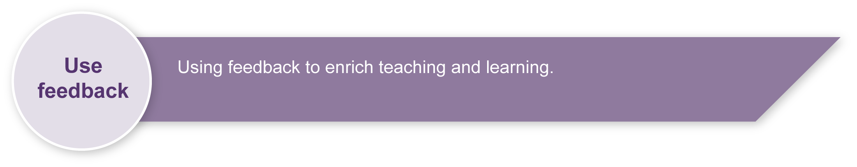
Evaluate the information gathered from the assessment to inform teaching and learning strategies.
Involve students in the feedback process. Give students opportunities to ask follow-up questions and share their learning observations or experiences.
Focus feedback on the student’s personal progress. Emphasise continuous progress relative to their previous achievement and to the learning expectations — avoid comparing a student with their classmates.
For further information, refer to the resource Using feedback, available in the Resources section of the Assessment Bank website.

PowerPoint planning sheet
Camp Experience:  Photograph/picture:  Draft written text — English:  Written text — Italian: | Camp Experience:  Photograph/picture:  Draft written text — English:  Written text — Italian:
Camp Experience:  Photograph/picture:  Draft written text — English:  Written text — Italian: | Camp Experience:  Photograph/picture:  Draft written text — English:  Written text — Italian:

