Rhythmic ostinatos
Year 2 | The Arts — Music
Students create and perform a rhythmic ostinato using simple hand-held percussion instruments to accompany a known class song.
Context for assessment
A rhythmic ostinato is a repeated rhythmic pattern.
Rhythmic ostinatos are effective and commonly used devices to create simple rhythmic accompaniments to songs.
This assessment could be used within units of work that focus on:
- understanding duration and rhythm
- developing students’ rhythmic perception
- playing hand-held percussion instruments.
The assessment emphasises the creating process and gives students a meaningful and relevant context around which to create and perform a rhythmic ostinato.
This assessment gathers evidence of learning for the following Essential Learnings:
The Arts Essential Learnings by the end of Year 3
Ways of working  Students are able to:  - select ideas for arts works, considering particular audiences and particular purposes, using arts elements and languages  - create and shape arts works by combining arts elements to express personal ideas, feelings and experiences  - practise arts works, using interpretive and technical skills  - present arts works to familiar audiences, using arts techniques, skills and processes. | Knowledge and understanding  Music  Music involves singing, playing instruments, listening, moving, improvising and composing by using the music elements to express ideas, considering particular audiences and particular purposes, through sound.  - Duration, beat, time values and metre are used to create repeated rhythmic patterns.  - Repetition is used to structure music.

Assessable elements
- Knowledge and understanding
- Creating
- Presenting
Source: Queensland Studies Authority 2007, The Arts Essential Learnings by the end of Year 3, QSA, Brisbane.
Listed here are suggested learning experiences for students before attempting this assessment.
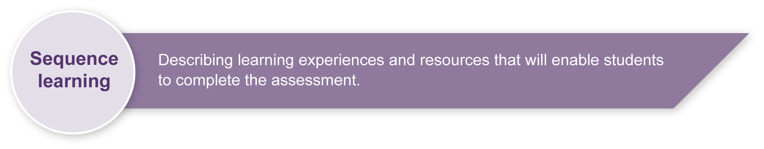
- Learn a class song. The song selected should be from the genre of children’s music — music that is specifically written for children. This includes traditional children’s music (e.g. nursery rhymes, folk songs) or contemporary children’s music (e.g. The Wiggles, Hi Five).
- Learn how to create by following a process. The resource Appendix A: A creative process gives one possible process that could be used.
- Participate in Music, Dance and Physical Education activities and games that develop students’ understanding, use and perception of rhythm (e.g. physical movements in time with music, echo-clapping activities).
- Learn how to correctly hold and play a variety of simple hand-held percussion instruments.
- Participate in classroom music activities and games based on and designed to teach students about rhythmic ostinatos (e.g. create a class rhythmic ostinato, play given rhythmic ostinatos to songs).

Teacher resources
Appendix A The Arts — A creative process
This resource maps the creative process from an Arts perspective.

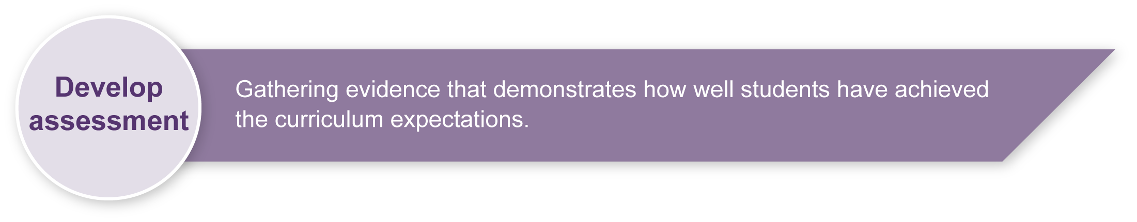
Preparing
Consider these points before implementing the assessment.
- Select a class song to use as the basis for the assessment. Students should learn and be able to sing this song. You could write the song on the Student booklet cover before printing it.
- Make sure you have enough hand-held percussion instruments to provide one for each of your students.
- Decide where students will perform their rhythmic ostinatos (e.g. in the classroom, at school assemblies, for other classes, visits to local retirement or nursing homes).

Sample implementation plan
This table shows one way that this assessment can be implemented. It is a guide only. You may choose to use all, part, or none of the table. You may customise the table to suit your students and their school environment.
Suggested time | Student activity | Teacher role
Remembering about rhythmic ostinatos
10 minutes | Students select a simple hand-held percussion instrument.  Students practise playing simple rhythmic patterns. | Remind students about rhythmic ostinatos.  Give examples and demonstrate several different ostinatos.
Re-engage students in the previously learnt class song
5 minutes | Students sing the class song several times to re-engage with the song. | Play the accompaniment, or a backing track for the song.  Sing along with students.
Activity 1. Creating my rhythmic ostinato
15 minutes | Students create a rhythmic pattern that fits with the song.  Students play this rhythm through four times to create their rhythmic ostinato. | Guide students through Creating my rhythmic ostinato in the Student booklet.  Encourage students to create rhythmic ostinatos that are different from others they may be hearing around the room.  Make anecdotal notes of each student’s learning process to assist you when making an overall judgment.
Activity 2. Playing my rhythmic ostinato
15 minutes | Students practise their rhythmic ostinatos.  Students sit in a circle.  As the rest of the class sings the song, students take turns to play their rhythmic ostinato.  Students are not required to sing while they are performing their rhythmic ostinatos. | Let students know when it is their turn to play.  Sing along with students.  Emphasise to students that they should be playing their created rhythmic ostinatos, not copying the previous student or making one up on the spot.  Make anecdotal notes of each student’s performance to assist you when making an overall judgment. You may also choose to record student performances to help with your judgments.

Resources for the assessment
Each student needs one hand-held percussion instrument (e.g. triangle, clap sticks, wood block, maracas, tambour drum, bongo drums).
During the learning process, you and your students should have developed a shared understanding of the curriculum expectations identified as part of the planning process.
After students have completed the assessment, identify, gather and interpret the information provided in student responses. Use only the evidence in student responses to make your judgment about the quality of the student learning. Refer to the following documents to assist you in making standards-referenced judgments:
- Guide to making judgments
- Indicative A response
- Sample responses (where available).

Making judgments about this assessment
The quality of student responses may be based on demonstrations of student learning over time, or on a final student demonstration at the end of the assessment.
Use your anecdotal notes of each student’s learning to assist you to make an overall judgment.
For further information, refer to the resource Using a Guide to making judgments, available in the Resources section of the Assessment Bank website.
Evaluate the information gathered from the assessment to inform teaching and learning strategies.
Involve students in the feedback process. Give students opportunities to ask follow-up questions and share their learning observations or experiences.
Focus feedback on the student’s personal progress. Emphasise continuous progress relative to their previous achievement and to the learning expectations — avoid comparing a student with their classmates.
For further information, refer to the resource Using feedback, available in the Resources section of the Assessment Bank website.

The Arts — A creative process

- Creating is an important aspect of The Arts.
- It is essential that students are taught how to create,
rather than just being asked to create.
- The creative process is iterative.
- Students' creative skills develop over time.
