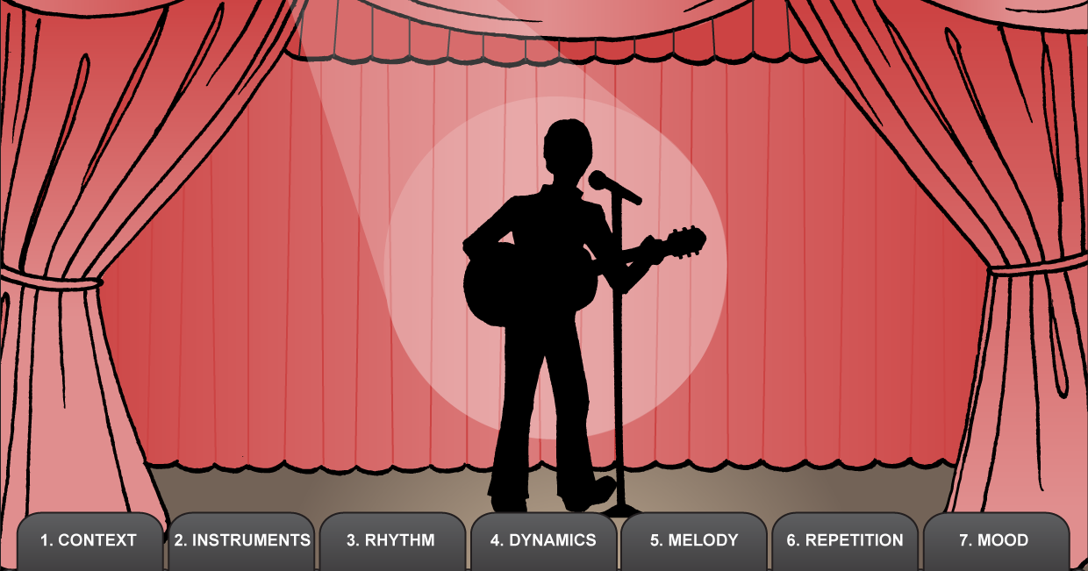

Consider the following features of a performance
Does the description/program include TITLE, COMPOSER and PERFORMERS?
What INSTRUMENTS can you hear?
What instruments have the main role in the music? What do you hear the main instruments doing?
How do they help express the mood?
What instruments contribute most to the RHYTHM?

What DYNAMICS are used in the music (loud, soft, crescendo, decrescendo)?
How did the dynamics affect the overall performance of the music?

What instrument(s) play the MELODY?
How would you describe the melody? (high or low; smooth or jumpy)
Did you like it? Why/why not?
Where in the music can you hear REPETITION (repeated patterns)? Is it in the melody or the rhythm, at the beginning, throughout, or at the end? What instruments play these repeated patterns?
How would you describe the repetition you hear?
What was the MOOD of the music?
How was this created?

What aspects of the performance would appeal to an audience? Why?

