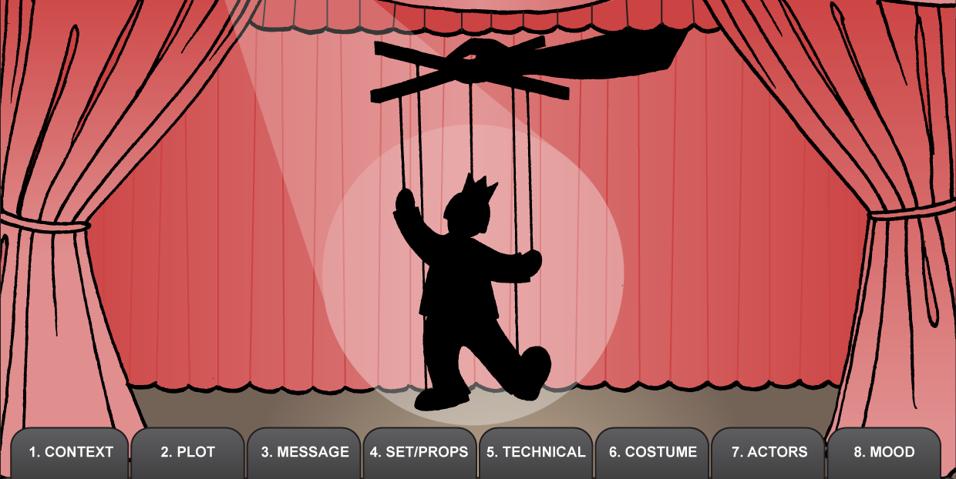

Consider the following features of a performance
Does the description/program include TITLE, WRITER, PERFORMERS?
When and where is performance set?
Write the PLOT or STORYLINE in a few sentences.
What was the PURPOSE or MESSAGE of the performance?

What were the SET and/or PROPS?
How did they help the message of the performance?
What were the LIGHTING, SOUND, MEDIA and SPECIAL EFFECTS used in the performance?
How did they help the message of the performance?
What COSTUMES and/or MAKE-UP were used?
How did they support the performance?
Were the actors BELIEVABLE in their roles? Could you see and hear them?
How did they use LANGUAGE or MOVEMENT to stand out in their roles?
What was the MOOD of the performance?
How did the other elements help create this mood?
What aspects of the performance would appeal to an audience? Why?

