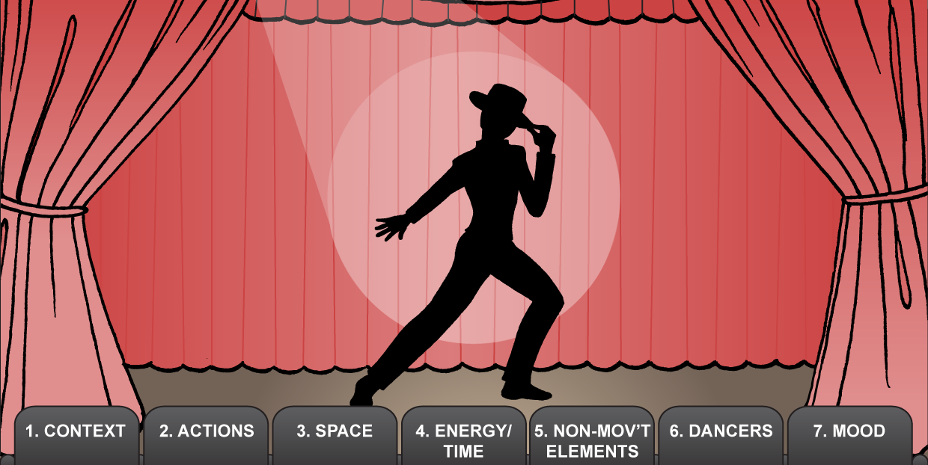

Consider the following features of a performance
Does the description/program include TITLE, CHOREOGRAPHER, and DANCERS?
What are the predominant MOVEMENTS used?
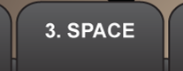
What are the predominant spatial DIRECTIONS, LEVELS and SHAPES?
How did they help express the dance theme or idea?

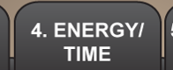
What are the predominant
ENERGY/TIME elements (stillness, qualities of movement, tempo, duration)?
How did these elements help express the dance theme, idea or mood?
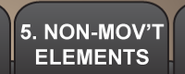
What are the main COSTUME, MUSIC, SET and PROPS?
How did they help express the dance theme, idea or mood?
What dancers were strong in their PERFORMANCE?
How did they stand out? Give reasons.
What was the THEME, IDEA or MOOD?
How did the dance elements help create this theme, idea or mood?
What aspects of the performance would appeal to an audience? Why?

